Recursion

1….

Print Decreasing Increasing Solution using Recursion

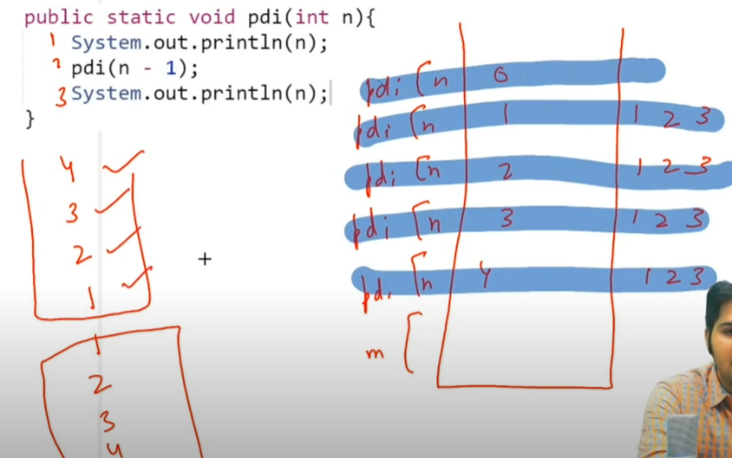

# Factorial of a number using Recursion

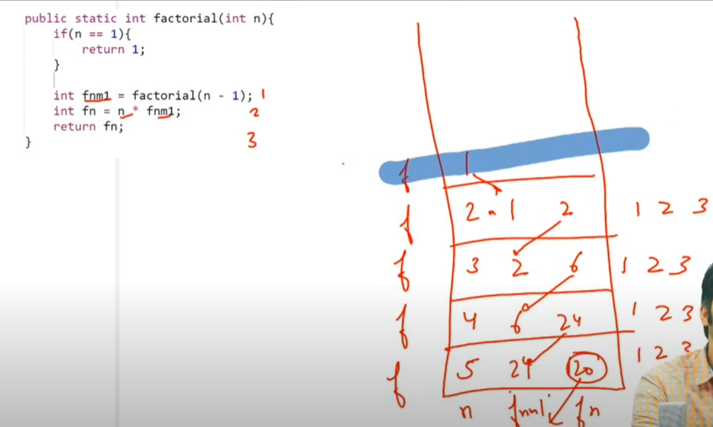

# Calculate Power (x,n) using Recursion

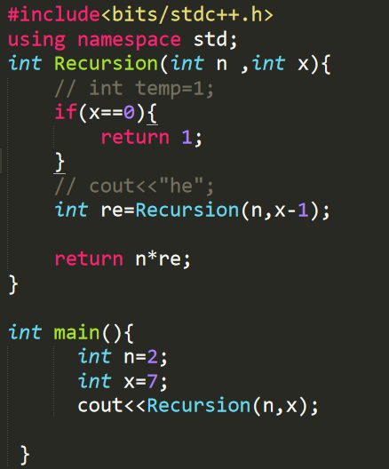

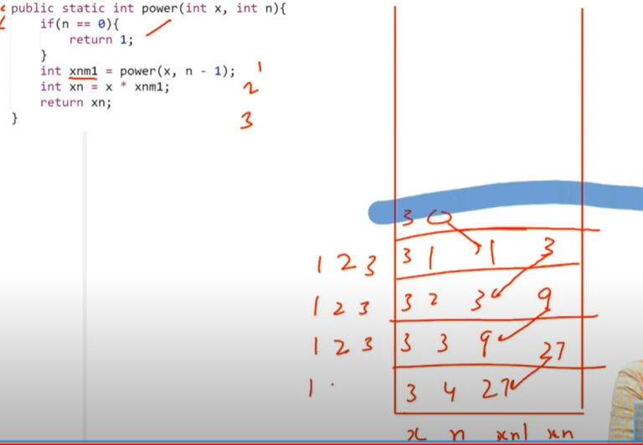

# Youtube->>https://www.youtube.com/watch?v=R7qja_gZrvI&list=PL-Jc9J83PIiFxaBahjslhBD1LiJAV7nKs&index=10

# Print Zig-Zag

This is done by stack method

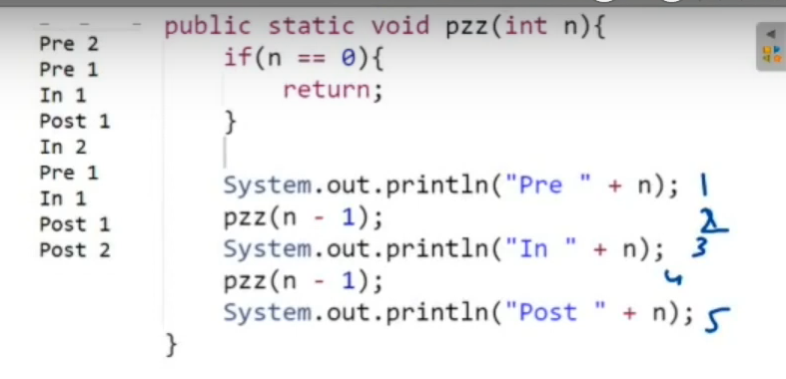

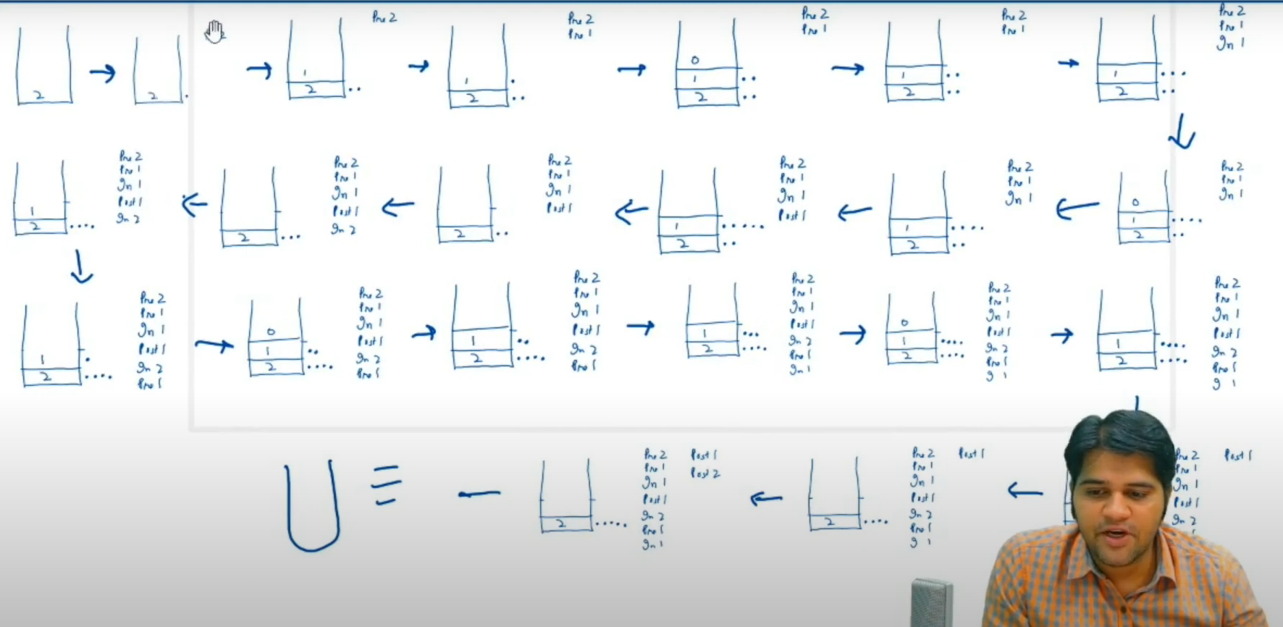

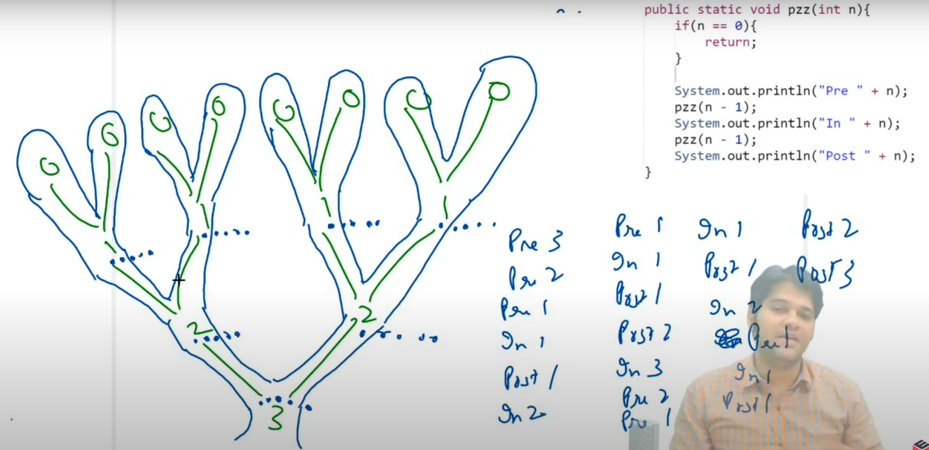

# Tower of Hanoi solved using Recursion

Link🡪https://www.youtube.com/watch?v=QDBrZFROuA0&list=PLJc9J83PIiFxaBahjslhBD1LiJAV7nKs&index=12

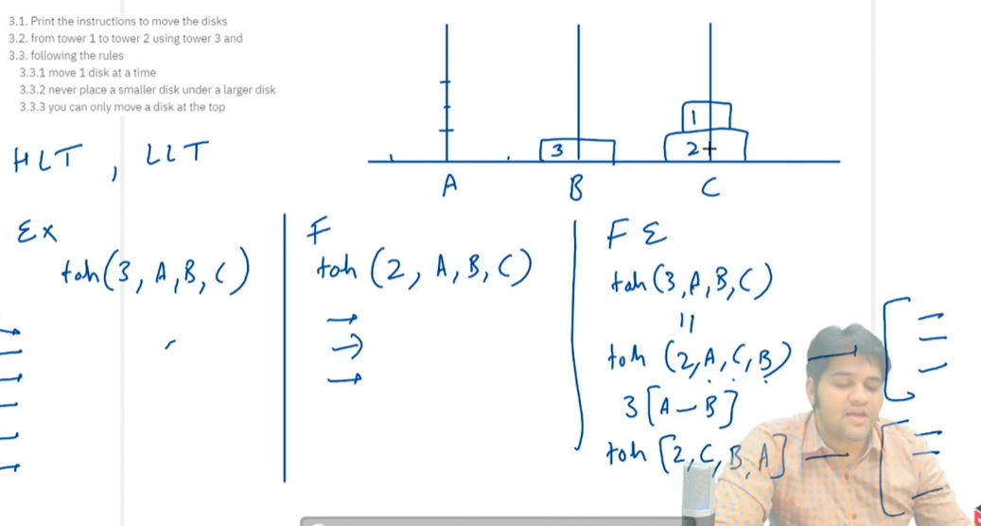



Faith1🡪is to move 2 disk from A to C using B (1 condition )

Faith2🡪is to move 2 disk from C to B using A (2 condition )

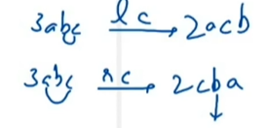her A🡪source|B🡪helper|c->destination



A🡪 helper |B🡪 destination |c->source



