**A PROJECT REPORT**

**ON**

**Uniguide : Empowering Students with**

**Personalized Career Guidance**

Submitted in partial fulfillment for the award of **Post Graduate Diploma in Advance Computing (PG-DAC) from**

**INSTITUTE OF EMERGING TECHNOLOGIES**

**Authorized Training Centre**

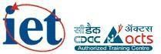

**Under the Guidance of Mr. Saleel Bagade**

**BY**

**Mr. Ashish Mahajan (230345920019)**

**Mr. Deepak Shinde (230345920027)**

**Mr. Ruturaj Hodage (230345920081)**

**Mr. Gaurav Aher (230345920034)**

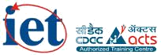

**CERTIFICATE**

This is to certify that the project report entitled **Uniguide** is a bonfire work carried out by **Mr. Ashish Mahajan, Mr. Deepak Shinde, Mr. Ruturaj Hodage, Mr. Gaurav Aher** and submitted in partial fulfilment of the requirement for the C-DAC ACTS, DAC course in Institute of Emerging Technology in the batch of September 2023.

**Course Co -ordinator** **External Examiner**

**Mr. Manoj Deshmukh Mr. Saleel Bagde**

**ACKNOWLEDGEMENT**

This project **Uniguide** was a great learning experience for us and we are submitting this work to Advanced Computing Training School (CDAC).

We are very glad to mention **Mrs. Saleel Bagde** for his valuable guidance to work on this project. Her guidance and support helped us to overcome various obstacles and intricacies during project work.

Our most heart full thanks go to ***Mr. Sangram Patil* (Director, IET)** who gave all the required support and kind coordination to provide all the necessities like required hardware, internet facility and extra lab hours to complete the project and throughout the course up to the last day here in C-DAC ACTS, Pune.

Sign of student

**Ashish Mahajan (230345920019)**

**Deepak Shinde (230345920027)**

**Ruturaj Hodage (230345920081)**

**Gaurav Aher**

**(230345920034)**

**Abstract**

UniGuide is an innovative web application designed to empower students in making well-informed decisions about their academic and career paths. In today's complex educational landscape, students often face challenges in navigating the multitude of career options and educational institutions available to them. UniGuide addresses this gap by providing personalized guidance, competency mapping, and real-time placement information. This report outlines the project's acknowledgment, problem definition, objectives, management principles, anticipated outcomes, and future scope

The system was developed using an agile software development approach, which allowed for iterative development and continuous feedback from stakeholders. The project team used various tools and technologies such as Java EE, MySQL, ReactJS, JavaScript, and HTML/CSS to build the system.

The project report provides a detailed overview of the system's design, development, testing, and deployment processes. It also discusses the challenges faced during the project and the lessons learned, along with recommendations for future improvements. Overall, the car service management system project report serves as a valuable resource for businesses looking to streamline their car servicing operations and enhance customer experience.

**Index**

|  |  |  |
| --- | --- | --- |
| **Sr. No.** | **Title** | **Page No.** |
| **1** | Introduction | 6 |
| **2** | Problem Definition & Scope | 7 |
| **2.1** | Problem Definition | 7 |
| **2.2** | Goals & Objectives | 8 |
| **2.3** | Major Constraints & Outcomes | 9 |
| **3** | Software Requirement Specification | 11 |
| **3.1** | Proposed System | 12 |
| **3.2** | Scope | 12 |
| **4** | Performance-Requirements | 16 |
| **4.1** | H/W Requirements | 16 |
| **4.2** | S/W Requirements | 16 |
| **5** | UML Diagram | 17 |
| **5.1** | DFD | 18 |
| **5.2** | ERD | 20 |
| **5.3** | Class Diagram | 21 |
| **5.4** | Sequence diagram | 22 |
| **5.5** | Activity Diagram | 23 |
| **5.6** | Deployment diagram | 24 |
| **6** | Screenshots | 25 |
| **7** | Conclusion | 33 |

1. **INTRODUCTION**

Comprehensive web application designed to assist students in making informed decisions about their academic and career paths. With a focus on marks and competency mapping, UniGuide offers personalized guidance to help students explore various career options and discover the best-fit educational institutions based on their academic achievements and the inclination test present in application which helps them to choose right career path for future.

# PROBLEM DEFINITION & SCOPE

## Problem Definition & Scope

In today's intricate educational landscape, students often grapple with the daunting task of selecting fitting academic and career trajectories. The absence of platform where students will get the information of all the colleges based on their location preferences, ranking and the marks scored in the entrance exam. Also there is no platform availale that integrates the inclination test. The absence of personalized tools hinders their ability to connect academic achievements with relevant career choices and educational institutions.

To address these challenges, uniguide project was initiated to develop a software solution that comprises all the required functionalities and provides real-time searching and analytics capabilities. UniGuide's overarching goal is to provide a user-centric platform that offers personalized guidance, competency mapping, career exploration, and educational institution matching.

The problem definition, therefore, highlights the need for a software solution that can help users to take well informed decisions about career, improvised user experience, leading to improved business outcomes.

The scope of the "UniGuide" project encompasses the development and implementation of a comprehensive web-based platform aimed at assisting students in making informed decisions about their higher education journey. The platform will offer personalized college recommendations based on academic performance and an inclination test to help students identify their fields of interest.

UniGuide is an all-encompassing solution addressing this challenge. Our overarching goal is to provide students with a user-centric platform that seamlessly integrates the following key objectives: Marks and Competency Mapping: Implement an intelligent system that accurately assesses students' academic performance and maps their competencies to various potential career options. Career Exploration: Enable students to explore diverse career paths and gain insights into the requisite skills and qualifications for each. Educational Institution Matching: Facilitate the discovery of educational institutions that align with students' academic accomplishments and chosen career paths. Personalized Recommendations: Offer tailored suggestions based on individual strengths, weaknesses, and aspirations.

The project team will follow an agile software development approach, allowing for continuous feedback and collaboration with stakeholders. The system will be tested rigorously to ensure its functionality, reliability, and security.

Overall, the scope of the car uniguide application project is to develop a comprehensive software solution that can help students to choose right college, choose right domain to pursue their future in and enhance business outcomes.

## Goals &Objectives

## Goals:

1. Marks and Competency Mapping: Uniguide leverages advanced algorithms and data analysis techniques to map students' marks and competencies, providing valuable insights into their strengths and areas for improvement.
2. Personalized Career Guidance: Using the competency profile, Uniguide offers personalized career guidance to students.
3. College Recommendation System: Uniguide assists students in finding suitable colleges based on their marks and academic performance.
4. Resource Library: The web application features a comprehensive resource library that includes articles, videos, and interactive content related to different careers, college admissions, and skill development.
5. Progress Tracking: Uniguide allows students to track their progress and development over time. They can set goals, monitor their achievements, and receive personalized recommendations for improvement.
6. User-Friendly Interface: The user interface of Uniguide is intuitive, easy to navigate, and visually appealing. Students can access the application from various devices, including desktop computers, laptops, and mobile devices, ensuring convenience and accessibility.

## Objectives:

1. Personalized Career Guidance: Develop a robust platform that offers personalized career guidance to students, considering their academic strengths, interests, and competencies.
2. Academic and Competency Mapping: Create a sophisticated system to map students' academic performance and competencies, allowing the platform to provide accurate recommendations for suitable career paths.
3. Career Exploration: Provide students with comprehensive information about various career options, including job roles, industries, skill requirements, and potential growth paths.
4. Educational Institution Matching: Implement a feature that matches students with educational institutions (universities, colleges, vocational schools) that align with their academic achievements and career aspirations.
5. Data-Driven Insights: Utilize data analytics to generate insights about trends in career choices and educational pathways, helping educational institutions adapt their offerings to meet student demands.
6. User-Friendly Interface: Design an intuitive and user-friendly interface that enables easy navigation, interactive content, and a visually appealing experience for users of all ages.
7. Resource Repository: Curate a repository of resources including articles, videos, case studies, and success stories related to different careers, industries, and educational paths.
8. Collaboration with Educators: Establish partnerships with educators, career counselors, and professionals to enhance the accuracy of guidance and advice provided on the platform.

## Major Constraints & Outcomes

A car service station management system, can have several constraints and outcomes, including:

**Constraints:**

* + 1. Technology: The uniguide relies heavily on technology, and any technical glitches or issues can impact the system's effectiveness.
    2. Internet connectivity: Uniguide system requires a stable and reliable internet connection, which can be a challenge in some areas.
    3. Data security: With sensitive customer and financial data being stored online, data security is a major concern for online car service station management systems.
    4. User adoption: The system may not be as effective if it is not adopted by all employees, including mechanics and administrative staff.
    5. Integration with Educational Institutions: Building partnerships with educational institutions and accessing their data for matching purposes might face resistance or technical challenges due to differing systems and policies.

**Outcomes:**

# Data Quality and Availability: The quality of data used for competency mapping and recommendation algorithms significantly affects the system's reliability. Limited or incomplete data could lead to suboptimal suggestions.

# Integration with Educational Institutions: Building partnerships with educational institutions and accessing their data for matching purposes might face resistance or technical challenges due to differing systems and policies.

# User Adoption and Engagement: The platform's success relies on users actively engaging with it. Encouraging students to consistently use the platform and provide accurate information is a challenge.

# Technological Infrastructure: Developing and maintaining a complex system with accurate mapping algorithms, databases, analytics tools, and user interfaces requires a robust and scalable technological infrastructure.

# User Interface and Accessibility: Designing an intuitive user interface that is accessible to users with diverse abilities, including those with disabilities, can be challenging.

# Sustainability: The project's long-term sustainability in terms of funding, resource allocation, and user engagement needs to be carefully planned.

# 3. SOFTWARE REQUIREMENT SPECIFICATION

## Document:

System Requirement Specification Document

## Title:

System Requirement Specification for Uniguide: Empowering Students with

Personalized Career Guidance

## Team:

Direct Customer, Indirect Customer, Architect, Business Analyst, Quality Assurance

Team, System Analyst

## Objective:

The objective of a Car Service Station Management System is to provide a streamlined and efficient management system for car service stations to manage their operations effectively. This system should automate the process of managing cars that need to be serviced, track the services provided, manage technician assignments, and generate invoices for the services provided.

The key objectives of a Car Service Station Management System include:

1. Efficient Personalized Career Guidance: Develop a robust platform that offers personalized career guidance to students, considering their academic strengths, interests, and competencies.
2. Academic and Competency Mapping: Create a sophisticated system to map students' academic performance and competencies, allowing the platform to provide accurate recommendations for suitable career paths.
3. Career Exploration: Provide students with comprehensive information about various career options, including job roles, industries, skill requirements, and potential growth paths.
4. Educational Institution Matching: Implement a feature that matches students with educational institutions (universities, colleges, vocational schools) that align with their academic achievements and career aspirations.
5. User-Friendly Interface: Design an intuitive and user-friendly interface that enables easy navigation, interactive content, and a visually appealing experience for users of all ages.
6. Career Assessment Tools: Integrate self-assessment tools, quizzes, and surveys that help students identify their strengths, interests, and areas for improvement, contributing to more accurate career recommendations.
7. Continuous Improvement: Implement mechanisms for collecting user feedback and utilizing it to continuously improve the platform's accuracy, relevance, and user satisfaction.

Overall, UniGuide is an all-encompassing solution addressing this challenge. Our overarching goal is to provide students with a user-centric platform that seamlessly integrates the following

above objectives.

## Scope:

The scope of the "UniGuide" project encompasses the development and implementation of a comprehensive web-based platform aimed at assisting students in making informed decisions about their higher education journey. The platform will offer personalized college recommendations based on academic performance and an inclination test to help students identify their fields of interestIt can be used by customers to login and book appointments for car service and repair and choose the service packages without having the need to visit the service center.

## Requirements:

Functional Requirements:

1. Student: Students should be able to register on the platform using their email or social media accounts. Students should be able to search and view detailed information about universities and colleges. Students should see comprehensive details about courses offered, fees, admission criteria, entrance exams, and faculty. Students should be able to input their academic details, test scores, and preferences to get personalized college predictions. Students should be able to take an inclination test to assess their skills and interests. The system should provide detailed test results and suggest suitable career paths based on the student's strengths. Students should be able to browse and search for educational and career-related events. Students should be able to search and view job vacancies posted by recruiters.

1. College:

College Registration and Authentication

Colleges should be able to register on the platform using their official email or registration form. A verification process should be in place to authenticate the legitimacy of the college.

College Profile Management

Once registered and verified, colleges should be able to create and manage their profile. Colleges should be able to update information such as courses offered, fees, admission criteria, and contact details. Colleges should be able to list and manage the courses they offer. Each course listing should include details like course name, duration, eligibility, syllabus, and faculty details.

Colleges should have the ability to list educational and career-related events they are hosting or participating in.

Event listings should include event details, dates, location, and registration information.

1. Owner :

Owners should have access to a secure admin dashboard to manage all aspects of the platform. They should be able to add, edit, and remove content such as colleges, courses, events, and job postings. Owners should be able to view and manage user accounts, including students, colleges, and recruiters. They should have the ability to suspend or ban users for violations or inappropriate behavior. Owners should have access to comprehensive analytics and reporting tools. Owners should be able to manage subscription plans for colleges and recruiters.

1. HR :

Recruiters should be able to register on the platform using their company's official email or registration form. Recruiters should be able to post job vacancies on the platform. Job postings should include details such as job title, description, required skills, location, and application instructions. Recruiters should be able to list and participate in career fairs, workshops, and networking events. They should have the option to provide event details, company information, and booth locations.

Non-Functional Requirements:

1. Security:

Registered Customer will allowed to cancel tickets within 24 hours. The System will provide access based on roles, (Authorization) like technical and developer team will be granted all permissions. System will automatically redirected to home page due to inactiveness. Sensitive information will be encrypted for security purpose. Use of high

quality firewall and secured connection for preventing data breach, cyber attacks etc. immediate action if attack occurs.

1. Reliability:

The application should be able to handle high traffic volumes without crashing or slowing down. The application should have automated backup and recovery mechanisms in place to ensure data is not lost in the event of a system failure. The application should be able to provide consistent performance under varying conditions, such as network latency or high server load.

1. Availability:

The application should be accessible to users 24/7. The application should have a disaster recovery plan in place to ensure the system can be restored in the event of an outage. The application should have mechanisms in place to minimize downtime during maintenance or upgrades.

1. Maintainability:

The application should have well-structured and modular code that is easy to maintain and update. The application should have automated testing and debugging mechanisms to help identify and fix issues quickly. The application should have version control in place to manage changes to the codebase.

1. Portability:

The application should be designed to run on multiple platforms and devices, including desktops, laptops, tablets, and smartphones. The application should be compatible with different operating systems, web browsers, and screen sizes.

1. Accessibility:

The application should be accessible to users with disabilities, such as those who are visually impaired or have limited mobility. The application should have features in place to support assistive technologies, such as screen readers or keyboard-only navigation.

1. Durability:

The application should be designed to withstand long-term use and data storage. The application should have mechanisms in place to ensure data integrity and prevent data corruption. The ticket will be in cart for 10 minutes only(so that other customers may not suffer any problem based on ticket selection). System will implementing backup periodically (if any technical glitch or data get corrupted then data is not lost).

1. Efficiency:

The application should be optimized for speed and performance. The application should be able to handle high volumes of transactions without slowing down or timing out. The

application should have caching mechanisms in place to reduce server load and improve response times.

1. Modularity:

The application should be designed as a set of modular components that can be easily maintained and updated. The application should have well-defined interfaces and dependencies between modules. The application should be able to scale individual modules as needed.

1. Scalability:

The application should be able to handle increasing traffic volumes as the user base grows. The application should be able to scale horizontally or vertically, depending on the needs of the system. The application should have load-balancing mechanisms in place to distribute traffic across multiple servers.

1. Safety:

The application should be designed to prevent harm to users or others. The application should have safety features in place to prevent misuse or abuse of the system.

# 4.PERFORMANCE REQUIREMENT

* 1. **Hardware Requirements**

1. Intel i3 processor 3rd generation or later / AMD Ryzen 200 2nd generation or later
2. 4GB RAM.
3. Windows 7 Home edition or later.
4. 200 GB data HDD Space
5. Data Connection 200 kbps
   1. **Software Requirements**
6. Eclipse 4.7
7. MySQL 5.8 with Workbench 8.0
8. Google Chrome version 119
9. Apache Tomcat Server 9.0
10. Maven Dependencies
11. Visual Studio Code

# UML DIAGRAM

## DFD Diagram

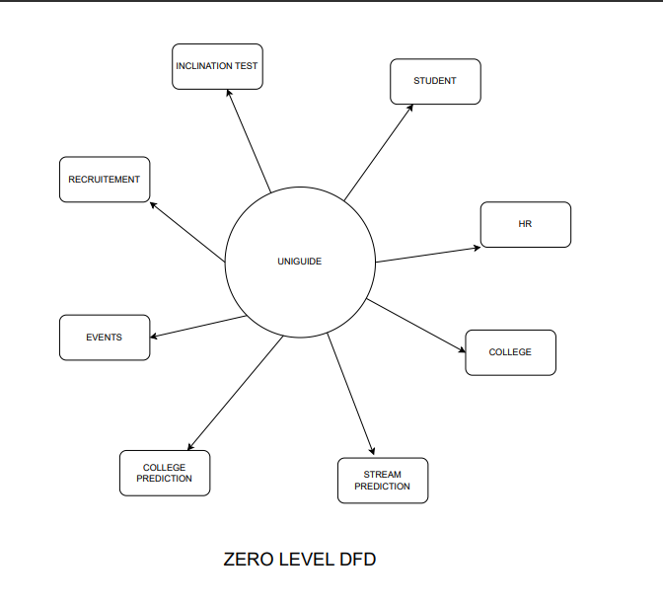

Data Flow Diagram of Uniguide (Level-0)

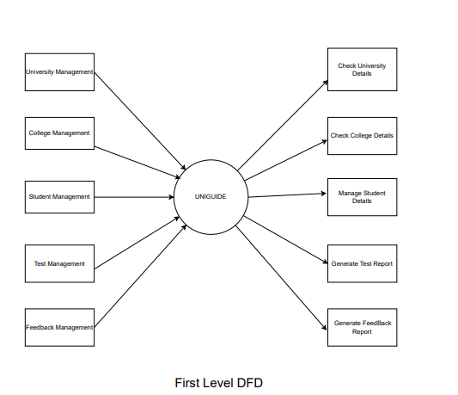

Data Flow Diagram of Uniguide(Level-1)

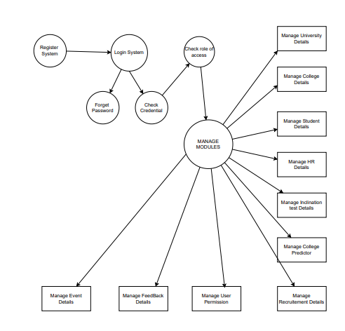

Data Flow Diagram of Uniguide(Level-2)

## ER Diagram

**5.3 Class Diagram**

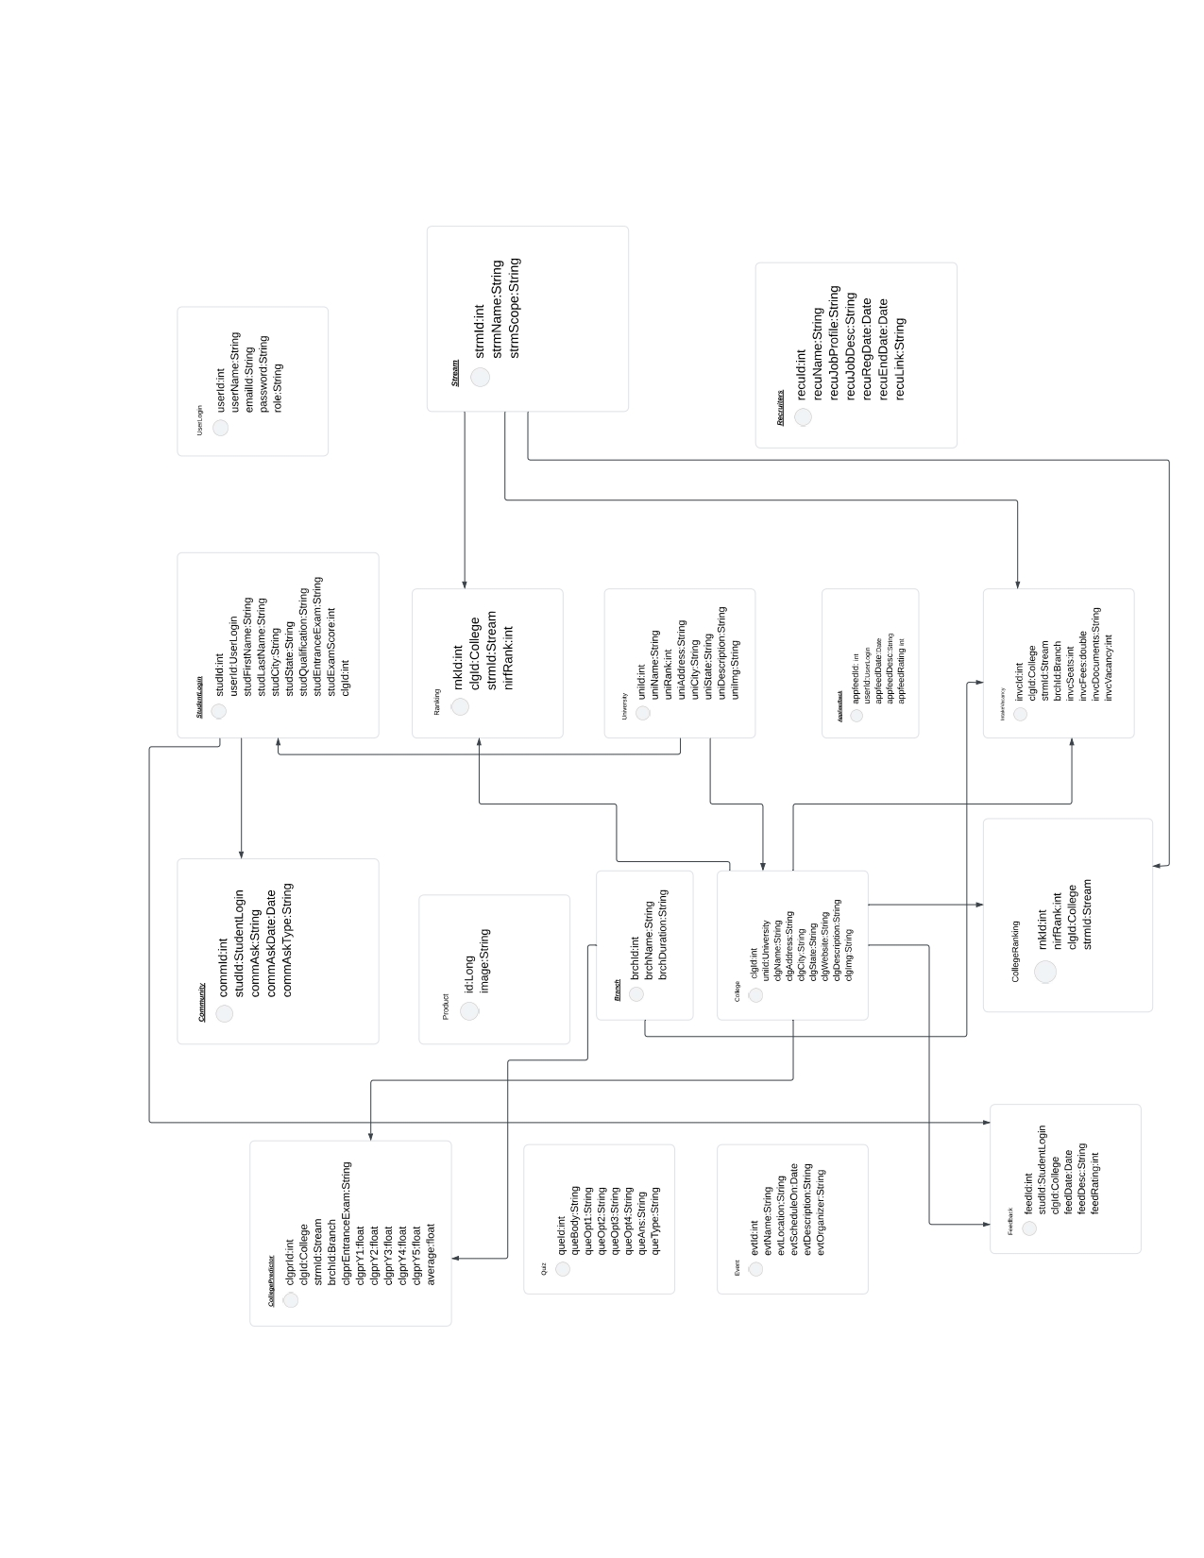

## Sequence Diagram

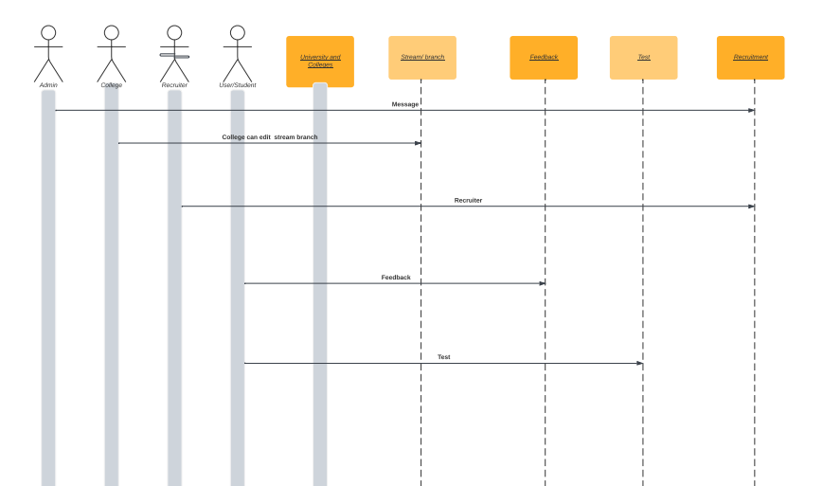

## Activity Diagram

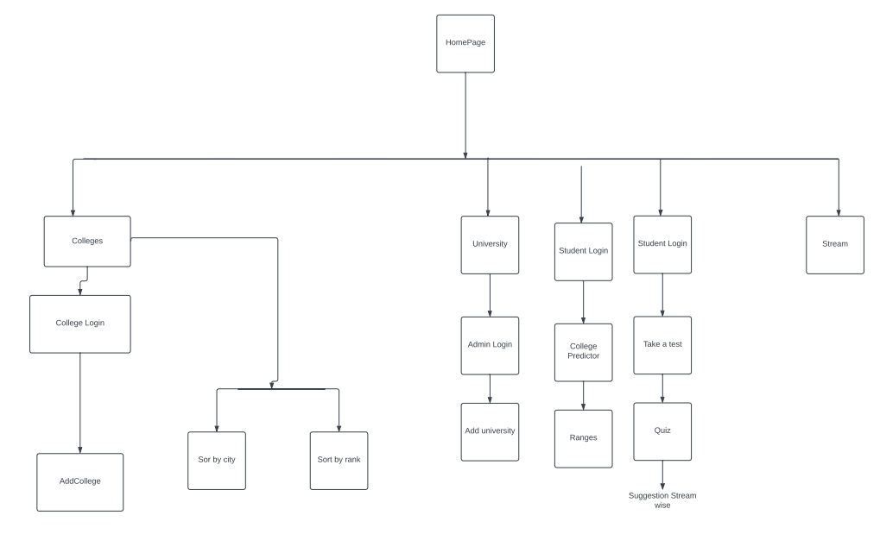

* 1. **Deployment Diagram**

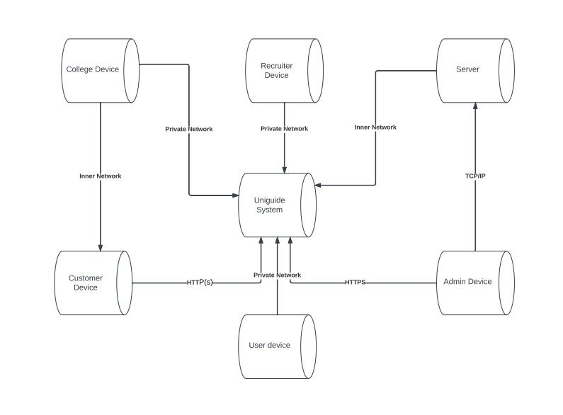

# SCREENSHOTS

## Home Page

This is a welcome page for of Uniguide. Here we have given following components:

 Home

 About Us

 Universities

 Colleges

 Streams

 Test

 College Predictor

 Recruitment

 Account

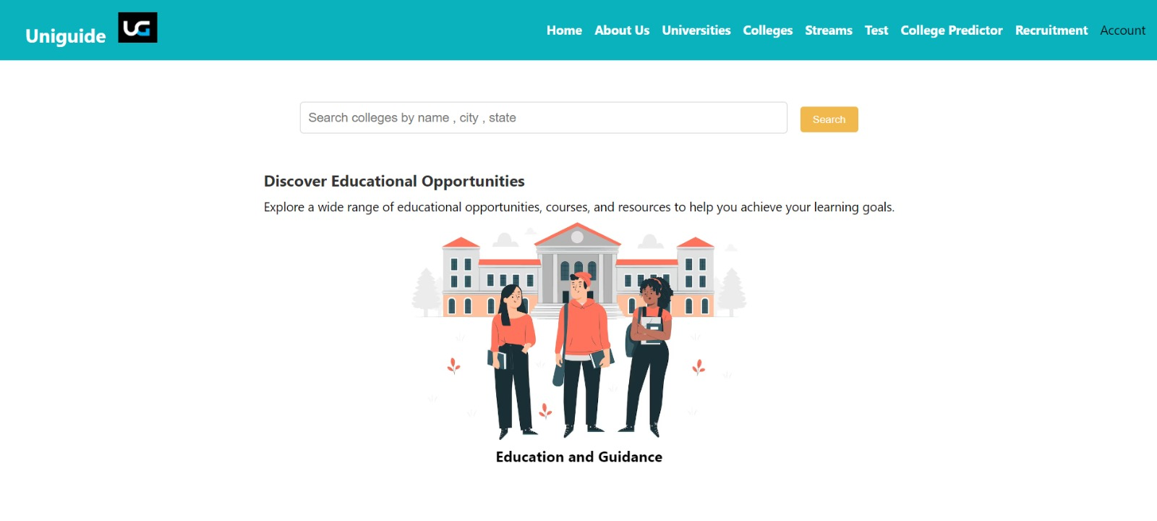

## Image 1. Home Page

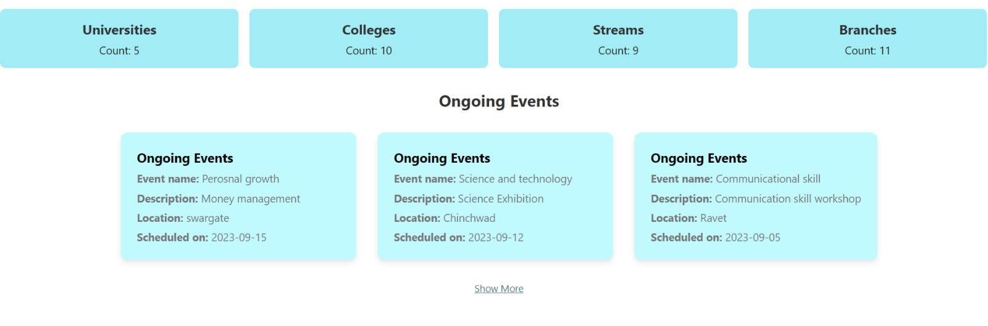

## Image 2. Home Page

## Image 3. Home Page

**2.About Us Page:**

On this page information about website is displayed.

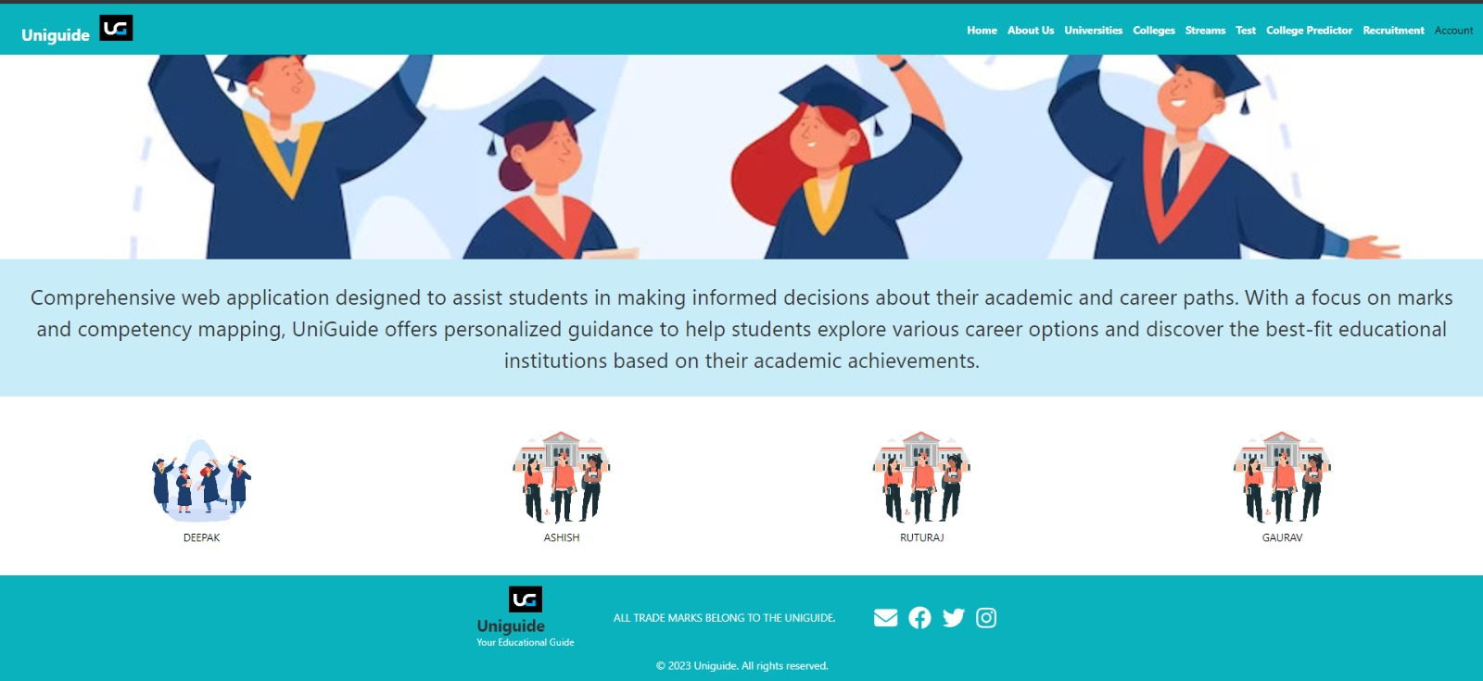

## Image 4. About us Page

**3. Login Page :**

Login page to accept user credentials

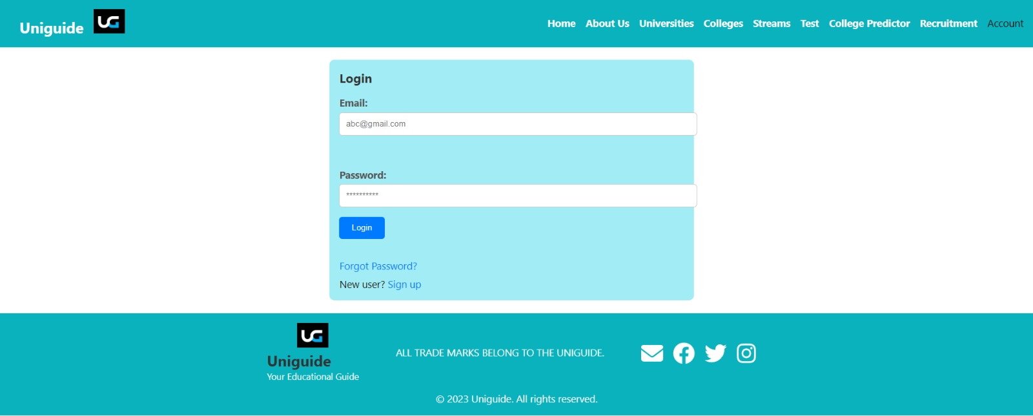

## Image 5. Login Page

**4. Registeration Page :**

Page to register a user.

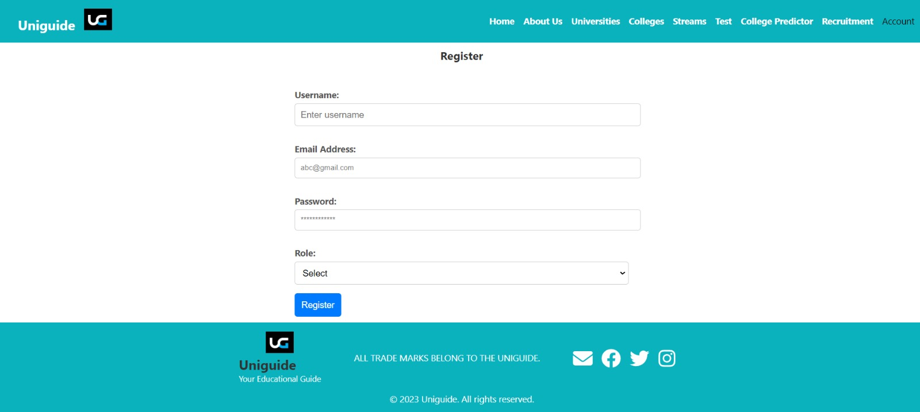

## Image 6. Registeration Page

**5.Forgot Password Page :**

Page to reset user details.

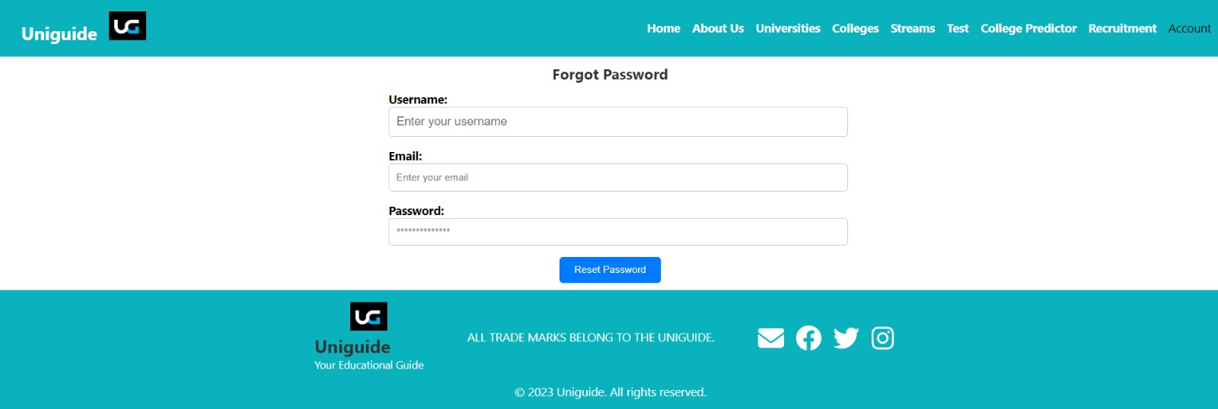

## Image 7. Forgot Password Page

**6.University Page:**

List of all registered universities will be displayed.

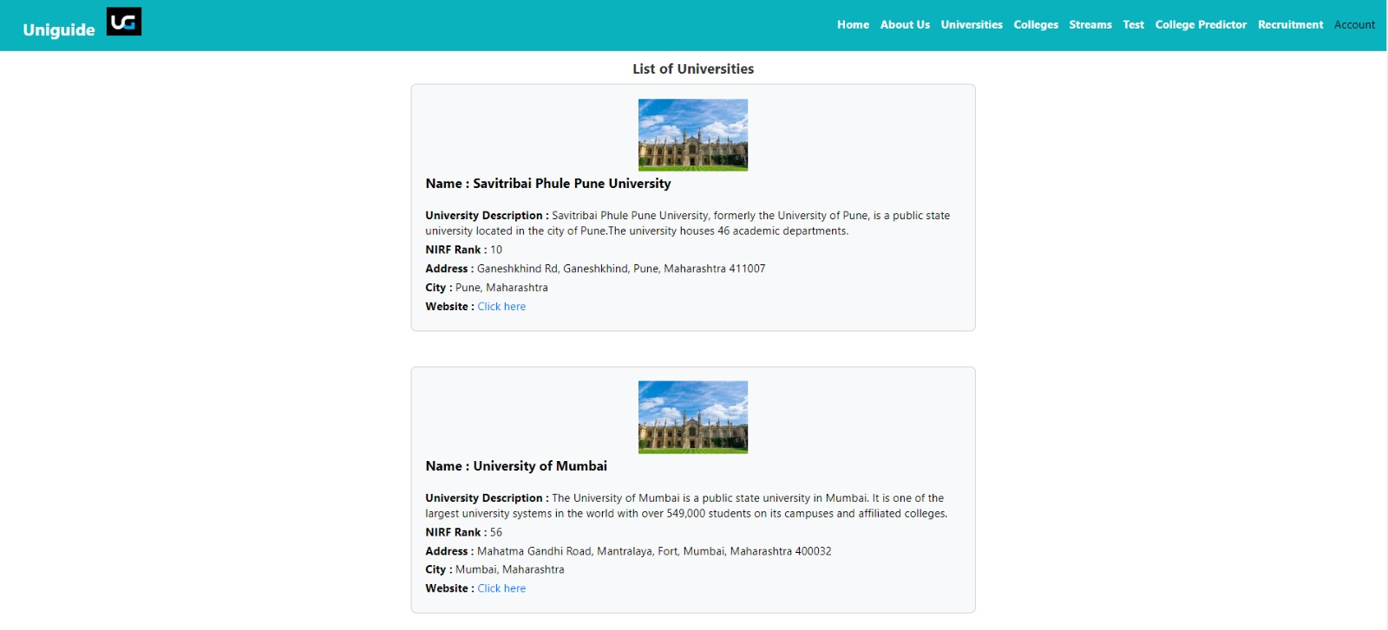

## Image 8. University Page

**7.College Page:**

List of all registered colleges is displayed with sort by city, rank options available. Add college button is also available.

## 

## Image 9. College Page

**8.Stream Page:**

All Streams with future scope available.

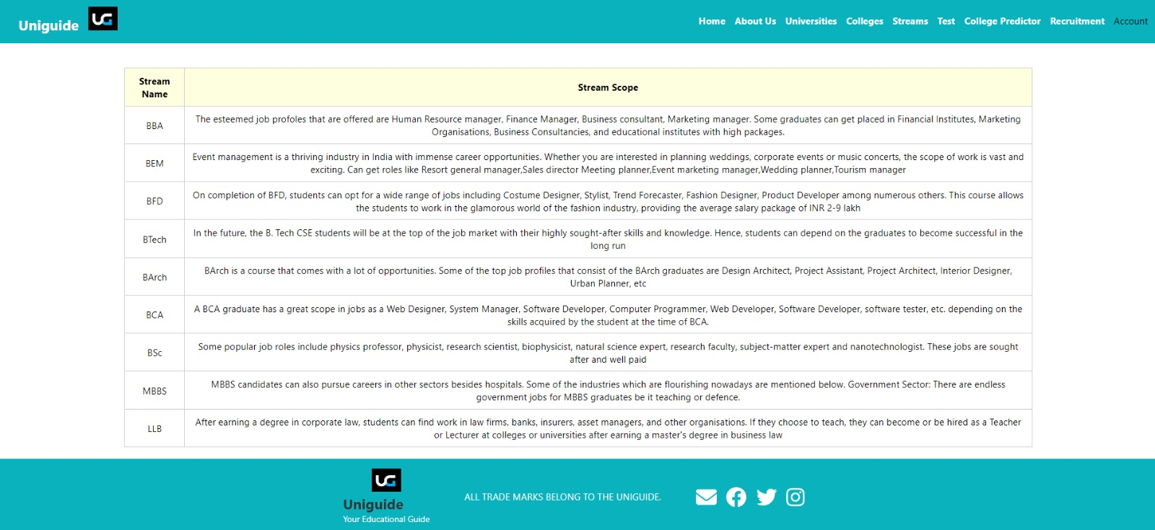

## Image 10. Stream Page

**9.Test Page:**

Inclination test page with question and options.

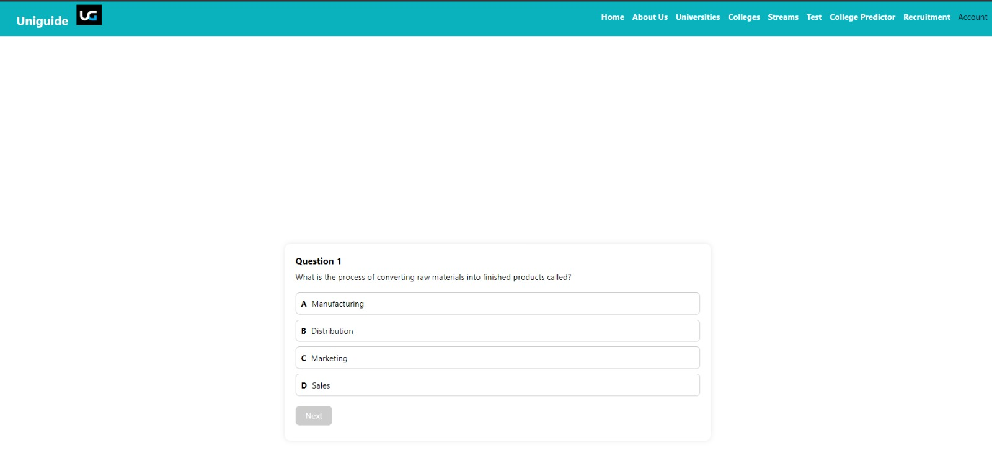

**Image 11. Test Page**

**10.College Predictor Page:**

In this page student has to enter the marks and entrance exam also have to select tolerance value from which all colleges will be displayed within range.

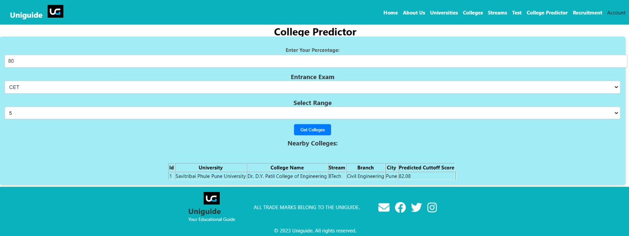

## Image 12. College Predictor Page

**11.Recruiter Page:**

List of all recruitments is displayed with add recruitment button.

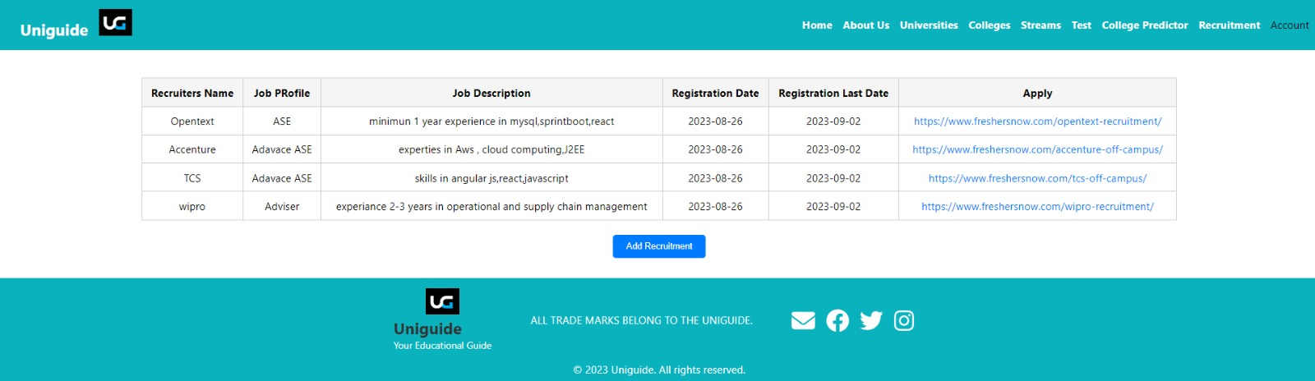

## Image 13. Recruiter Page

**12.Feedback-list Page :**

List of application feedback given by users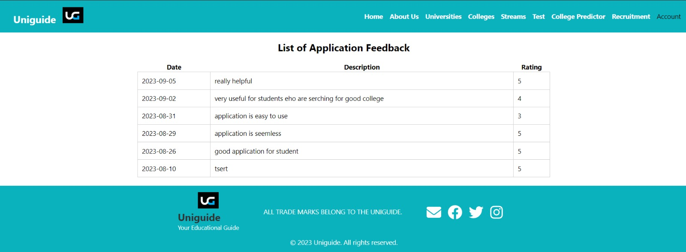

## Image 14. Application Feedback Page

**13.Event-list Page :**

List of all ongoing events.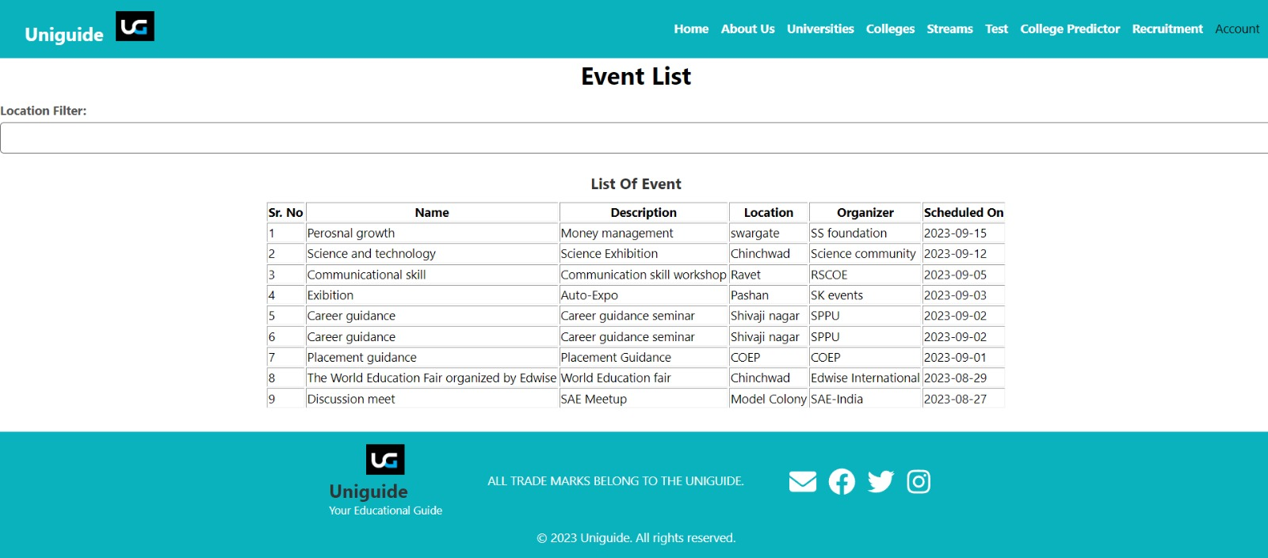

## Image15. Events-List Page

**14.Application-feedback Page :**

Application feedback page to take feedback from user.

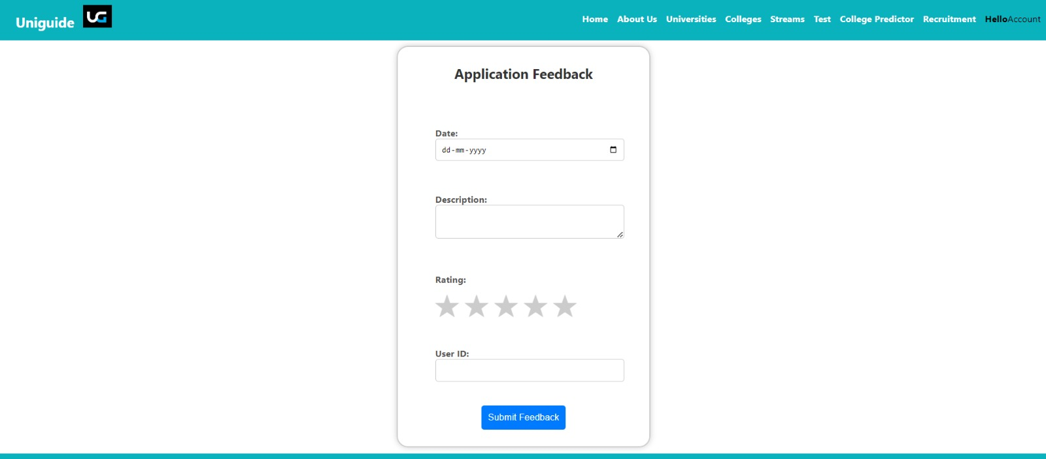

**Conclusion**

In conclusion, UniGuide stands as a pioneering solution in the realm of academic and career guidance. By seamlessly integrating marks and Inclination test marks, it empowers students to embark on a journey of self-discovery, aiding them in making well-informed decisions about their educational and professional trajectories. This comprehensive web application not only assists in identifying suitable career paths but also facilitates a personalized approach to selecting educational institutions that align with individual academic accomplishments. UniGuide is poised to revolutionize how students navigate their futures, offering a powerful tool that nurtures their aspirations and ensures a brighter, more fulfilling tomorrow.