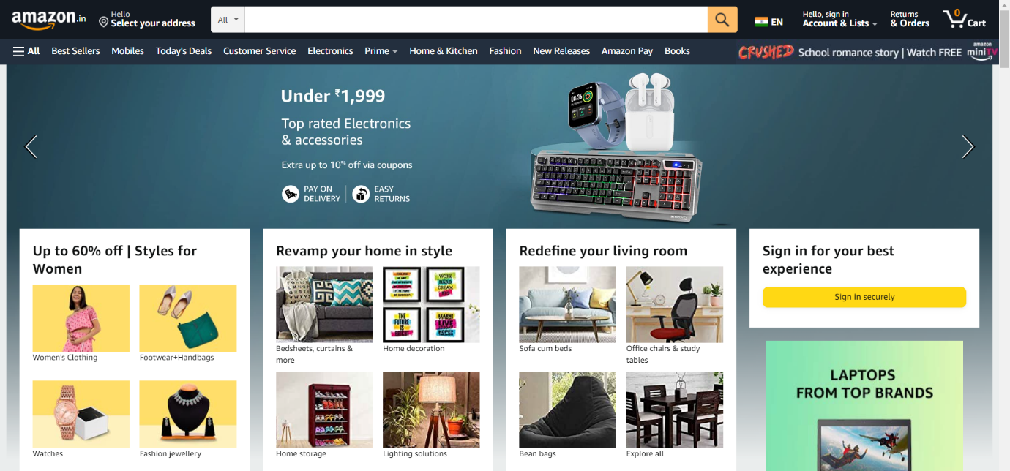

**Pages :**

Login / Sign up Page > Home page > Product Page > Buying options > Payment Gateway

+

1 user profile page which will be linked to home page .

**Page Structure :**

**Login Page:**

• Just like a usual login page, asks user to enter login id and password .

**Home page :**

•Just l Probably homepage will consist lots of things , like address , account details ,

returns & orders , cart.

• Below the navbar all sections are their like best sellers , mobiles , home & kitchen ,

Books , mini tv , amazon pay , fashion , new releases any many more …

• Under it all the products are available , the image gallery , prices , the ratings , add to

cart option , trending ones.

• Footer section is also included .

**Product page :**

• Shows description of selected product in detail

• Add to cart option

• Buy now

**Buying options:**

• Cod / google pay / card

• Payment method

• **Payment Gateway**