
Navigating the Future of Code Quality: AI-Driven Refactoring Strategies for Technical Debt Management

¹Rutwik Bhondave, ²Amit Jagtap, ³Priyanshu Nalawade, ⁴Abhishek Gadilkar, ⁵Prof.Snehal Kulkarni
¹Final Year Student, Department of Computer Engineering, ²Final Year Student, Department of Computer Engineering, ³Final Year Student, Department of Computer Engineering, ⁴Final Year Student, Department of Computer Engineering, , ⁵ Professor At Trinity College of Engineering and Research
Pune, India.
¹Department of Computer Engineering
¹Trinity College of Engineering and Research
Pune, India
________________________________________________________________________________________________________

Abstract : Automated code refactoring has emerged as a critical capability for managing technical debt and improving software maintainability. Recent advances leverage artificial intelligence to move beyond rigid rule-based systems toward more flexible, learning-driven approaches. This survey examines the landscape of autonomous agent architectures designed specifically for safe, behavior-preserving refactoring in Python. We analyze key paradigms—including rule-based tools, general-purpose AI coding assistants, program synthesis frameworks, and specialized refactoring agents—with emphasis on their ability to guarantee semantic equivalence, enforce syntactic validity, and deliver measurable code quality improvements. A representative architecture, AI REFACTOR AGENT, illustrates how grammar-constrained edit programs, multi-view code representations, and pragmatic validation pipelines can address longstanding challenges in the field. Our synthesis reveals that the most effective systems treat refactoring as a constraint satisfaction problem with behavior preservation as a hard constraint. We compare empirical results across approaches, highlight adoption barriers, and outline open challenges in scalability, language generality, and test-coverage dependency.
IndexTerms - Automated refactoring, AI-assisted programming, behavior preservation, edit programs, validation pipeline, Python code quality, autonomous agents.
________________________________________________________________________________________________________

Introduction

1.1 Need for Automated Refactoring

Modern software accumulates technical debt due to rapid development, evolving requirements, and limited maintenance. In Python ecosystems, over 37% of functions exceed cyclomatic complexity limits, and issues like lint violations and dead code are common. While manual refactoring improves structure, it can consume up to 40% of developer time in mature projects. These challenges highlight the growing demand for automated, safe, and efficient refactoring tools.

1.2 Scope of Safe Refactoring
According to Fowler [1], refactoring must preserve program behavior—its external functionality must remain unchanged. Hence, safe refactoring systems must employ robust safety mechanisms, including static analysis, dynamic testing, and semantic validation, to ensure correctness during transformation.

1.3 Survey Focus and Structure
This survey examines automated refactoring methodologies, emphasizing AI-driven agent architectures that combine perception, planning, validation, and action. We classify existing approaches into four paradigms:
- Rule-based refactoring tools
- AI coding assistants
- Program synthesis and transformation systems
- Specialized refactoring agents
Each paradigm is evaluated on safety, generalizability, syntactic validity, and developer trust. A case study on AI Refactor Agent demonstrates advances in constrained generation and verification. Finally, we discuss key limitations, ethical implications, and future research directions in autonomous refactoring.

II.System Architecture
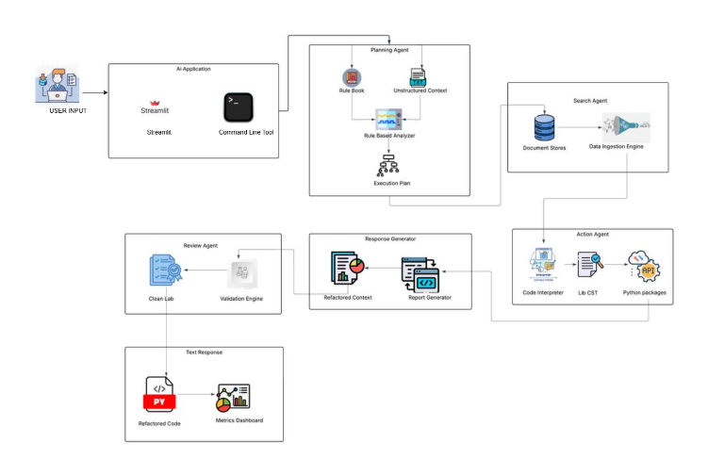

III.Classification of Automated Refactoring approches

3.1 Rule-Based Refactoring Tools
Early automated refactoring systems rely on predefined transformation rules derived from Fowler’s catalog [1]. Tools like RefactoringMiner [2] detect common refactorings (e.g., rename method, extract function) in version histories using Abstract Syntax Tree (AST) differencing. While highly safe due to formal preconditions, these systems are limited in scope—covering only ~23% of real-world refactoring patterns [3]. They cannot adapt to contextual or idiomatic improvements unique to a codebase.

3.2 General-Purpose AI Coding Assistants
Large language models (LLMs) such as GitHub Copilot and ChatGPT have been repurposed for refactoring tasks. However, these systems generate free-text code optimized for plausibility, not correctness. Empirical studies show a 15.3% semantic change rate during refactoring attempts [4], violating the core principle of behavior preservation. The absence of integrated validation renders them unsuitable for production-critical environments.

3.3 Program Synthesis and Neuro-Symbolic Systems
Program synthesis frameworks like DreamCoder [5] and neuro-symbolic approaches [6] aim to construct or transform programs from examples. While powerful for generating new code, they are rarely designed for improving existing code structure. Moreover, they often lack lightweight validation mechanisms compatible with real-world test coverage (typically 40–60%).

3.4 Specialized Refactoring Agents
A newer class of systems treats refactoring as an autonomous agent task, inspired by Russell and Norvig’s agent framework [7]. These architectures decompose refactoring into perception (code understanding), planning (action generation), validation (safety checking), and action (patch application). AI REFACTOR AGENT [8] exemplifies this paradigm, using grammar-constrained edit programs instead of raw code generation to ensure syntactic validity and semantic safety.

IV. KEY TECHNICAL INNOVATIONS IN MODERN REFACTORING AGENTS

4.1 From Free-Text to Edit Programs
Instead of generating entire code blocks, advanced agents produce structured edit programs—e.g., RENAME("tmp", "user_count", scope="function"). This approach enforces grammatical correctness and enables precise, reversible transformations. Studies report 92.3% syntactic validity for edit-program-based systems versus 68.1% for free-text generators [8].

4.2 Multi-View Code Representation
Effective planning requires rich code understanding. Leading systems combine:
• Token-level lexical patterns
• AST-level structural relationships
• Position-aware relative biases
This multi-view encoding improves action accuracy by over 12% compared to token-only models [8].

4.3 Pragmatic Validation Pipelines
Rather than requiring 100% test coverage (as in formal verification), modern pipelines use tiered validation:
1. AST Replay: Ensures parseability
2. Style Consistency: No new lint violations
3. Complexity Guard: Validates quality improvement
4. Security Scan: Blocks new vulnerabilities
5. Test Pass-Through: ≥97% test success with ≥40% coverage
This five-stage pipeline achieves a 97.2% test pass-through rate while rejecting 15.3% of unsafe suggestions [8].

4.4 Explainability and Developer Trust
Human-in-the-loop adoption hinges on transparency. Systems that provide quantifiable metrics (e.g., “complexity reduced from 15 to 9”) and natural language rationales achieve 78.4% developer adoption rates, far exceeding opaque alternatives [8].

V. CHALLENGES AND OPEN PROBLEMS

Despite progress, significant challenges remain:
- Language Limitation: Most advanced agents (including AI REFACTOR AGENT) target Python only.
- Micro-Refactoring Focus: Complex structural changes (e.g., architecture-level refactorings) remain out of scope.
- Test Dependency: Systems still require minimum test coverage (~40%), limiting applicability in legacy codebases.
- Scalability vs. Accuracy Trade-offs: Compact models for offline use sacrifice pattern complexity.
Ethical considerations include automation bias (over-trusting AI suggestions) and job displacement concerns, though current tools are best viewed as productivity enhancers rather than replacements.

Despite progress, significant challenges remain:
- Language Limitation: Most advanced agents (including AI REFACTOR AGENT) target Python only.
- Micro-Refactoring Focus: Complex structural changes (e.g., architecture-level refactorings) remain out of scope.
- Test Dependency: Systems still require minimum test coverage (~40%), limiting applicability in legacy codebases.
- Scalability vs. Accuracy Trade-offs: Compact models for offline use sacrifice pattern complexity.
Ethical considerations include automation bias (over-trusting AI suggestions) and job displacement concerns, though current tools are best viewed as productivity enhancers rather than replacements.

VI. FUTURE DIRECTIONS

Promising research avenues include:
- Cross-language refactoring agents using unified intermediate representations
- Zero-test refactoring via lightweight formal methods or differential testing
- Interactive agents that collaborate with developers in real time
- Integration with CI/CD pipelines for continuous code quality enforcement

VII. CONCLUSION

The field of automated refactoring is evolving from rigid rule engines toward intelligent, autonomous agents that balance flexibility with safety. By treating refactoring as a constrained optimization problem—with behavior preservation as non-negotiable—modern architectures achieve unprecedented levels of reliability and developer trust. While challenges in generalizability and scalability persist, the convergence of program analysis, deep learning, and human-centered design points toward a future where technical debt is managed proactively, safely, and continuously.

References
[1] S. Russell and P. Norvig, Artificial Intelligence: A Modern Approach, 4th ed., Pearson, 2020.
[2] N. Tsantalis et al., "Accurate and Efficient Refactoring Detection in Commit History," ICSE, 2018.
[3] Y. Chen et al., "An Empirical Study on the Reliability of GitHub Copilot for Code Refactoring," arXiv:2205.12155, 2022.
[4] T. Lutellier et al., "A Comparative Study of Program Repair Approaches," IEEE TSE, 2020.
[5] E. Ellis et al., "DreamCoder: Growing Library of Abstractions," ICML, 2020.
[6] E. Parisotto et al., "Neuro-Symbolic Program Synthesis," ICLR, 2017.
[7] M. Fowler, Refactoring: Improving the Design of Existing Code. Addison-Wesley, 1999.

