**SQL Assignment 1**

**1. Write a query to get a Product list (id, name, unit price) where current products cost less than $20.**

**Query:**

select ProductID, ProductName, UnitPrice from Products where UnitPrice<20 and Discontinued='0';

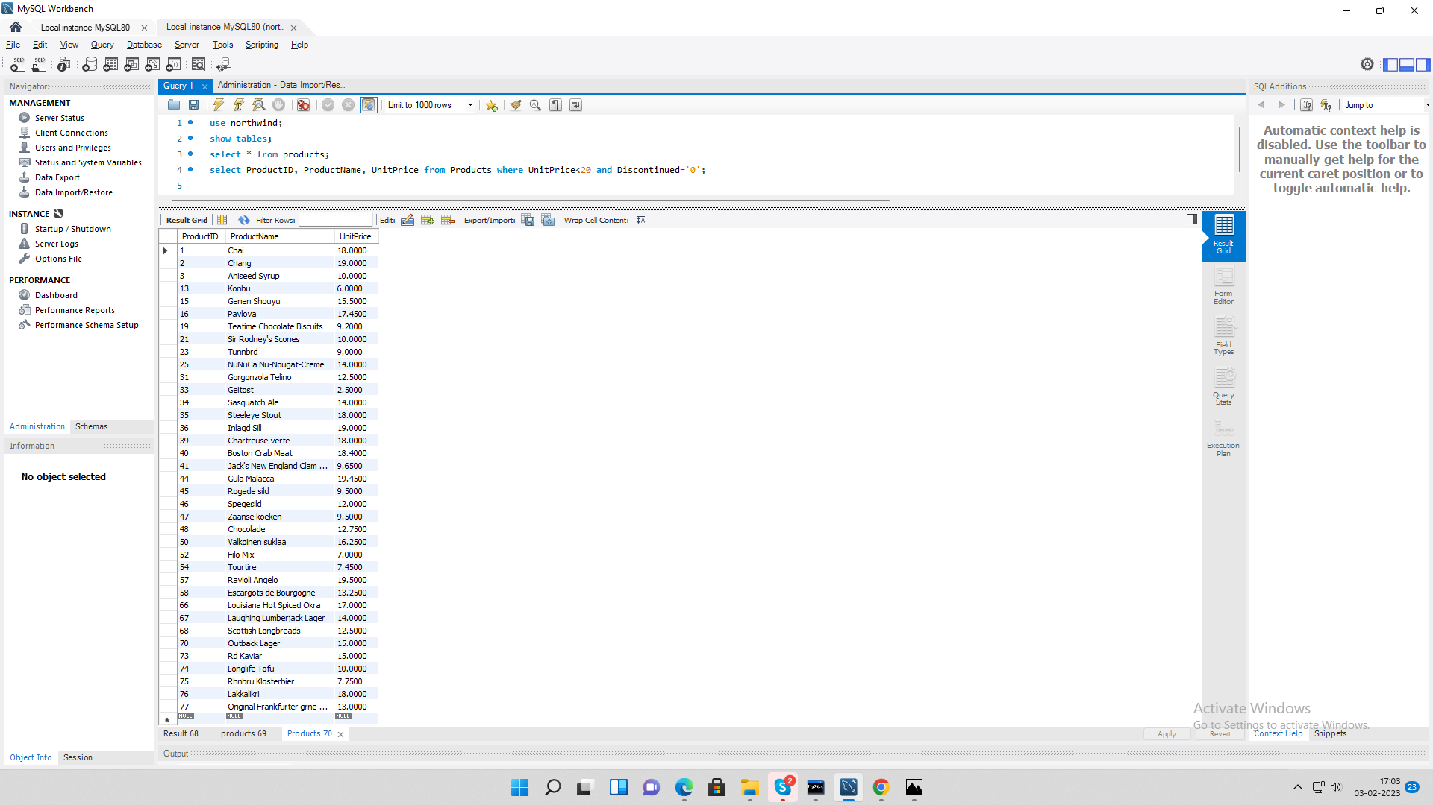**Output:**

**2. Write a query to get Product list (id, name, unit price) where products cost between $15 and $25.**

**Query:**

select ProductID, ProductName, UnitPrice from Products where UnitPrice between 15 and 25;

**Output:**

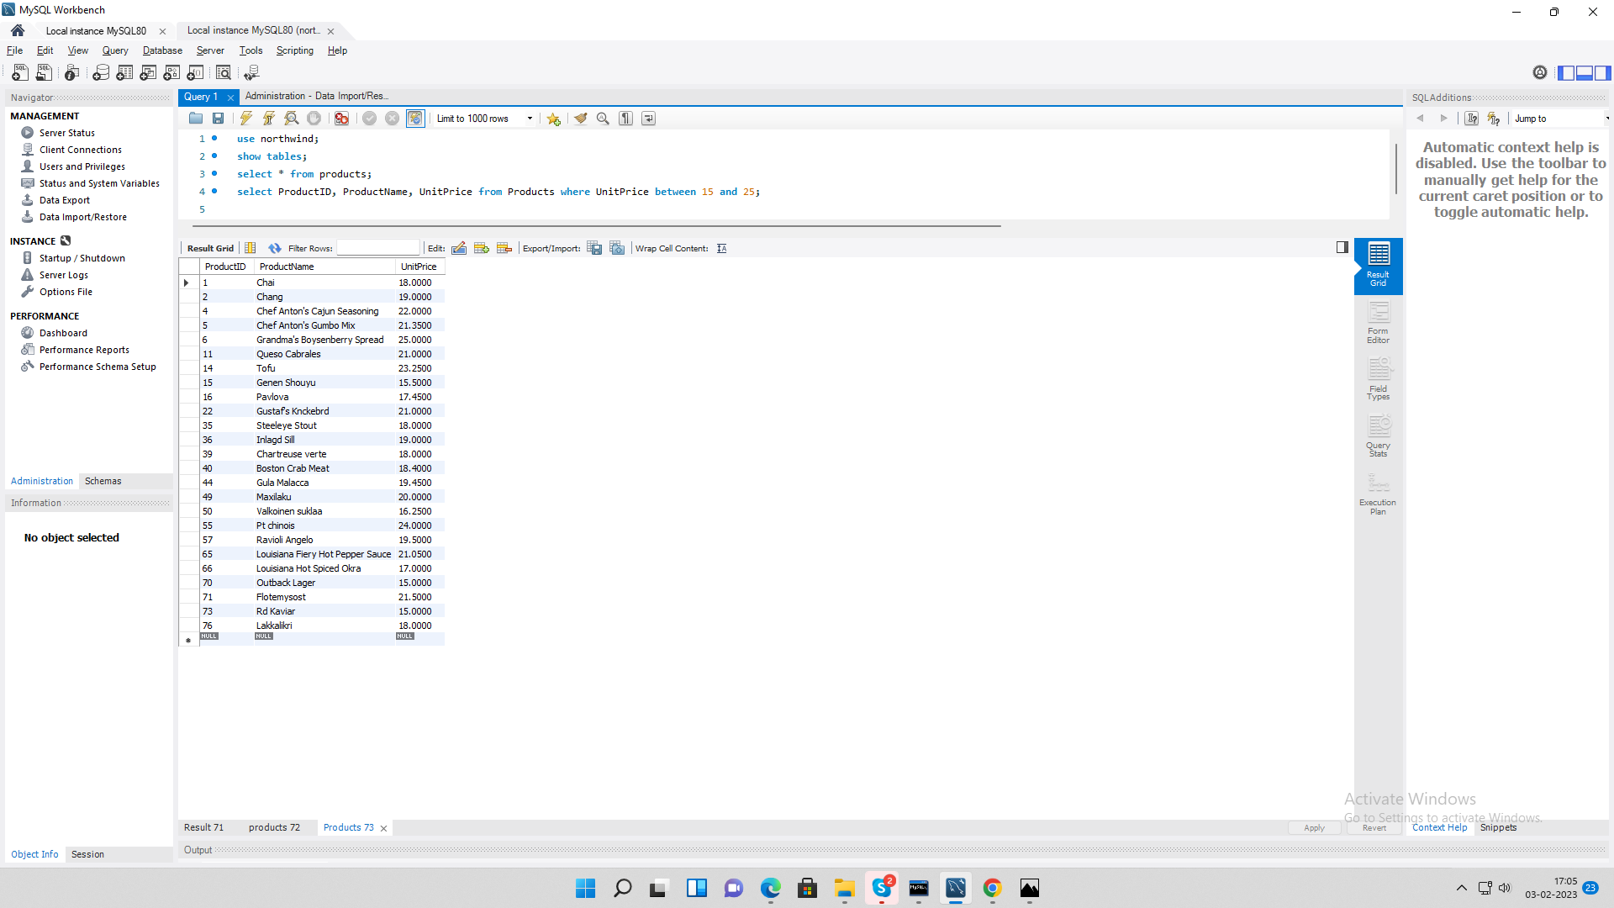

**3. Write a query to get Product list (name, unit price) of above average price.**

**Query:**

select ProductName, UnitPrice from Products where UnitPrice>(select avg(UnitPrice) from Products);

**Output:**

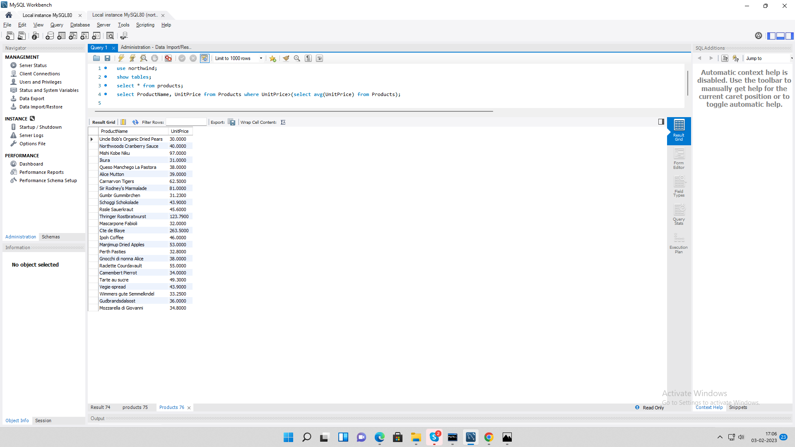

**4. Write a query to get Product list (name, unit price) of ten most expensive products.**

**Query:**

select ProductName, UnitPrice from Products order by UnitPrice desc limit 10;

**Output:**

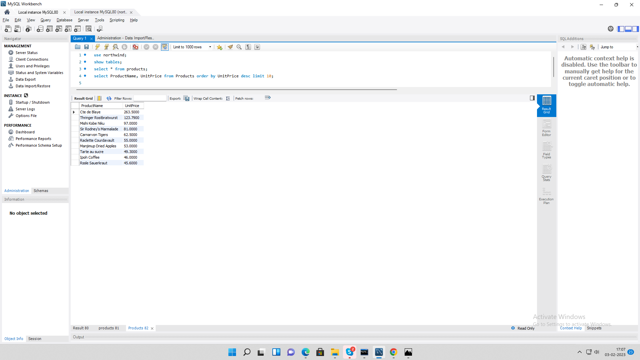

**5. Write a query to count current and discontinued products.**

**Query:**

select count(ProductName) as Name, Discontinued from Products group by Discontinued;

**Output:**

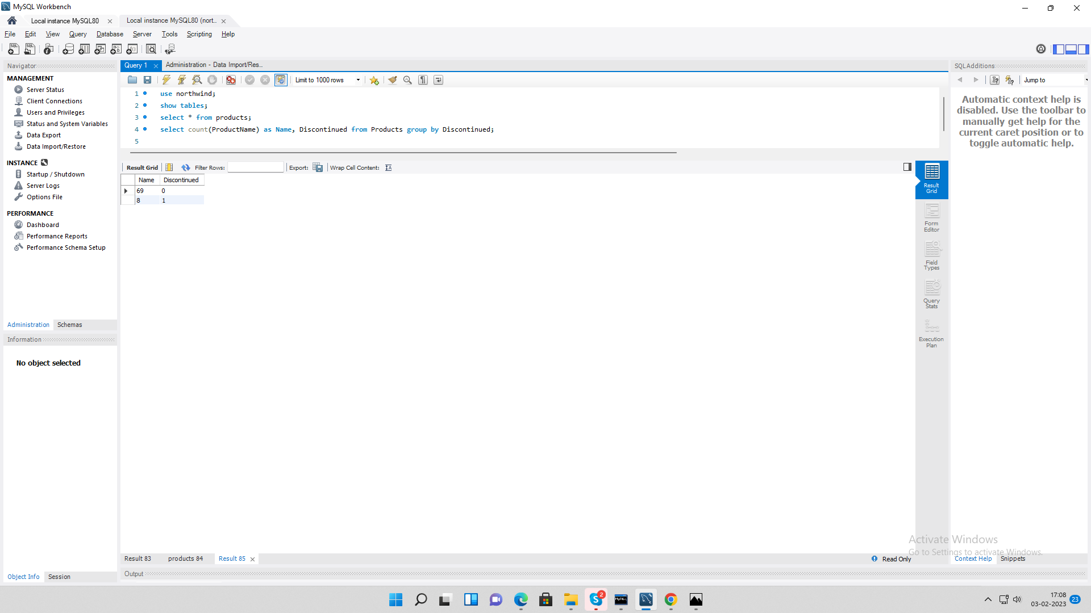

**6. Write a query to get Product list (name, units on order , units in stock) of stock is less than the quantity on order.**

**Query:**

select ProductName, UnitsOnOrder, UnitsInStock from Products where UnitsInStock < UnitsOnOrder;

**Output:**

