**SQL Assignment 3**

**1. Write a SQL query to find Employees who have the biggest salary in their Department**

**Query:**

SELECT emp_id, emp_name, salary, dept_id FROM Employee WHERE salary IN (SELECT MAX(salary) FROM Employee GROUP BY dept_id) ORDER BY dept_id;

**Output:**

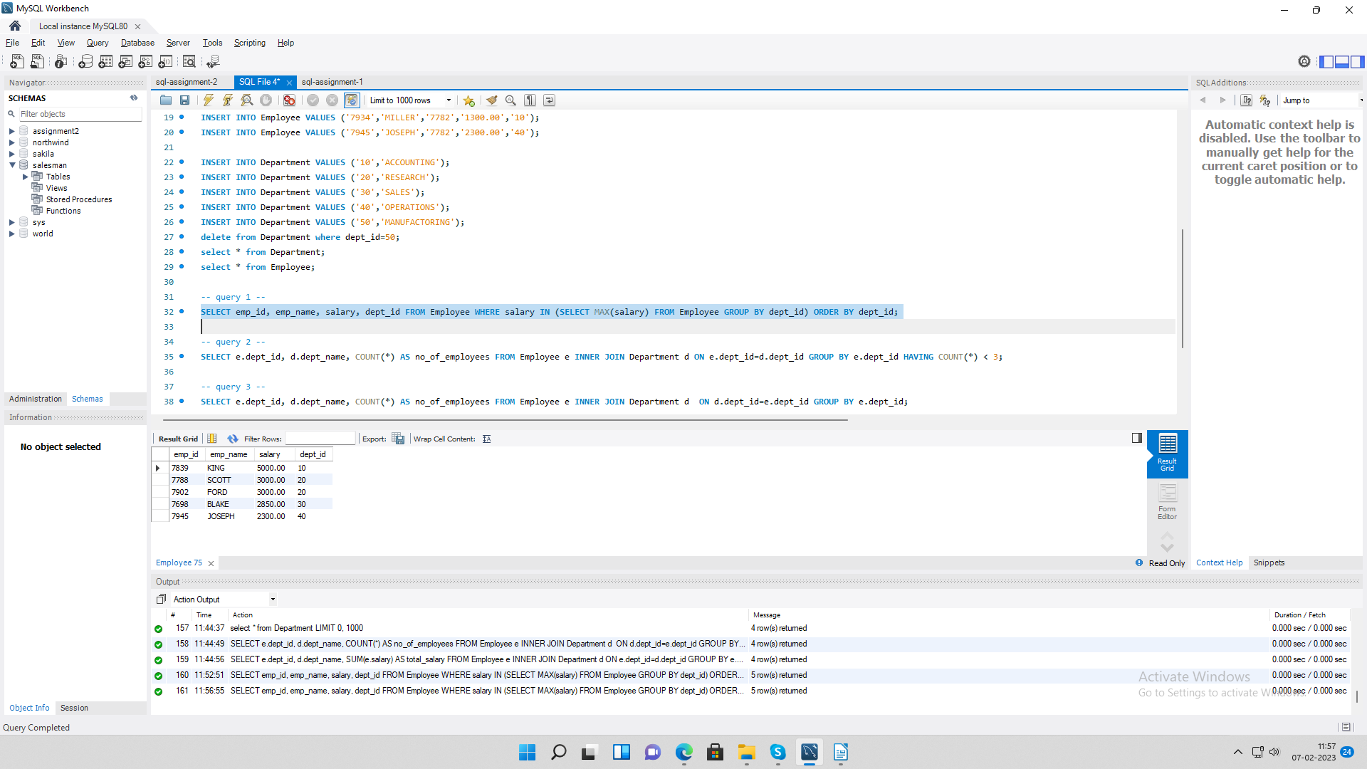

**2. Write a SQL query to find Departments that have less than 3 people in it**

**Query:**

SELECT e.dept_id, d.dept_name, COUNT(*) AS no_of_employees FROM Employee e INNER JOIN Department d ON e.dept_id=d.dept_id GROUP BY e.dept_id HAVING COUNT(*) < 3;

**Output:**

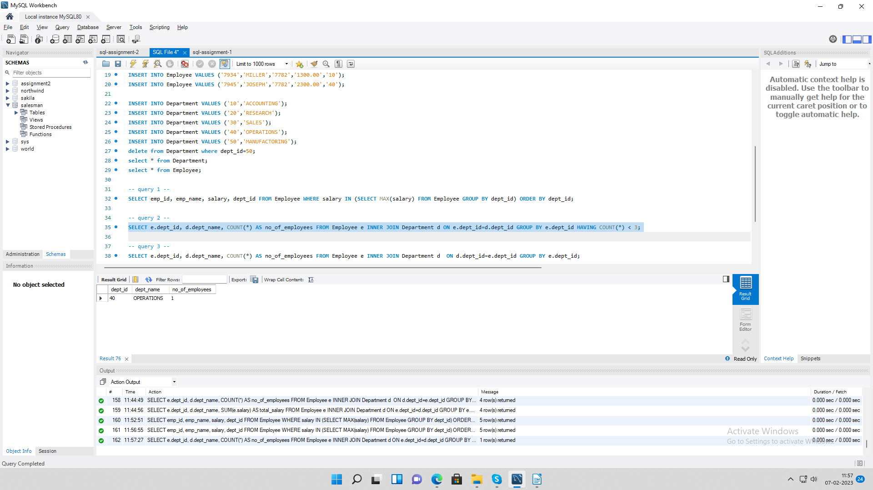

**3. Write a SQL query to find All Department along with the number of people there**

**Query:**

SELECT e.dept_id, d.dept_name, COUNT(*) AS no_of_employees FROM Employee e INNER JOIN Department d ON d.dept_id=e.dept_id GROUP BY e.dept_id;

**Output:**

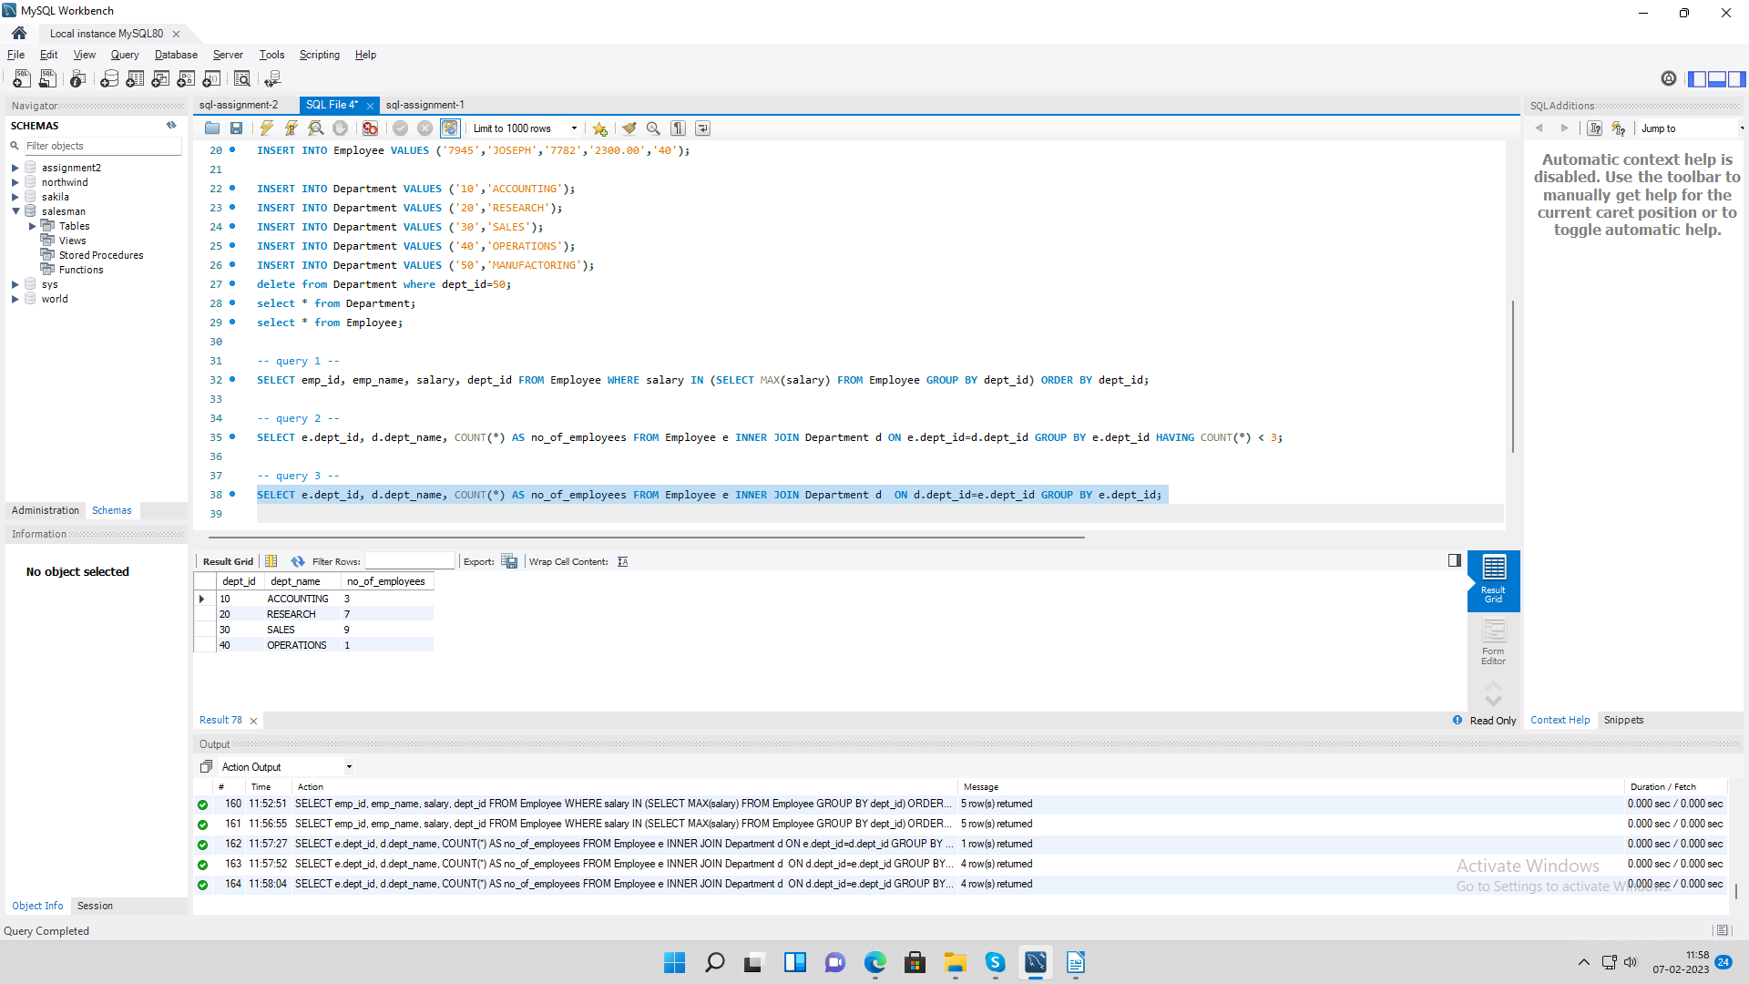

**4. Write a SQL query to find All Department along with the total salary there**

**Query:**

SELECT e.dept_id, d.dept_name, SUM(e.salary) AS total_salary FROM Employee e INNER JOIN Department d ON e.dept_id=d.dept_id GROUP BY e.dept_id;

**Output:**

