CSUC101-DIGITAL ELECTRONICS
EXTERNAL PRACTICAL EXAM

AIM: DIGITAL LOCKER SYSTEM
Design and implement a digital locker system where a student must enter a 4-bit binary code to gain access to the locker. The system accepts the student’s input in binary form through four switches, each representing a single bit. This input is then compared to a preset 4-bit access code (for example, 1010). If the input matches the preset code exactly, the system will unlock the locker by turning ON an LED indicator. If the entered code does not match, the system will recognize it as a wrong attempt and increment a 2-bit counter that tracks the number of incorrect entries. The system allows a maximum of three incorrect attempts. If a student enters an incorrect code three times, the system should lock itself permanently, indicated by turning ON a separate LOCKED LED. Once the system is locked, it should disable further attempts to enter the code, ensuring that the user cannot continue trying after exceeding the limit. The system must be built using fundamental digital logic components, including logic gates, comparators to verify if the user input matches the preset code, flip-flops to store the system state and counters, and a 2 bit binary counter to keep track of incorrect attempts. The logic design should ensure that the counter increments only when the entered code is incorrect and should prevent further attempts once the maximum number of wrong attempts has been reached. Additionally, the correct and locked conditions should be clearly indicated by LEDs: one to indicate the locker is unlocked and another to indicate the system is locked after three failed attempts. The final design should be implemented and simulated using a digital design tool such as Logisim or Deeds, allowing for clear visualization and testing of all functional aspects of the system, including code entry, comparison logic, attempt counting, and system locking behavior.

EXPLANATION OF THE CONCEPTS USED
- COMPARATORS- To verify if user inputs matches the preset code
- FLIP-FLOPS- To store the system state
- 2-bit binary Counter- To keep track of incorrect attempts
X-NOR Gate is used as a basic Comparator

We will take 4 input switches S3, S2, S1 AND S0
Then, we will set PRESET CODE,
Preset3=1
Preset2=0
Preset1=1
Preset0=0

To check if the code matches or not, we will use X-NOR Gates(Comparator)
S3 and Preset3 – XNOR1
S2 and Preset2 – XNOR2
S1 and Preset1 – XNOR3
S0 and Preset0 – XNOR4

The output of XNOR Gates will be given as input to AND Gate. The AND Gate gives output only if both are correct(Correct Code) and NOT Gate is connected for (wrong output) error detection

Now, we will use D-Flip Flop to store the data , and the output of D Flip Flop Q AND Q Dash is connected to two inputs AND Gate and its output is LOCKED LED.Also, we will connect it to NOT Gate(NOT LOCKED LED)

ROUGH WORK:

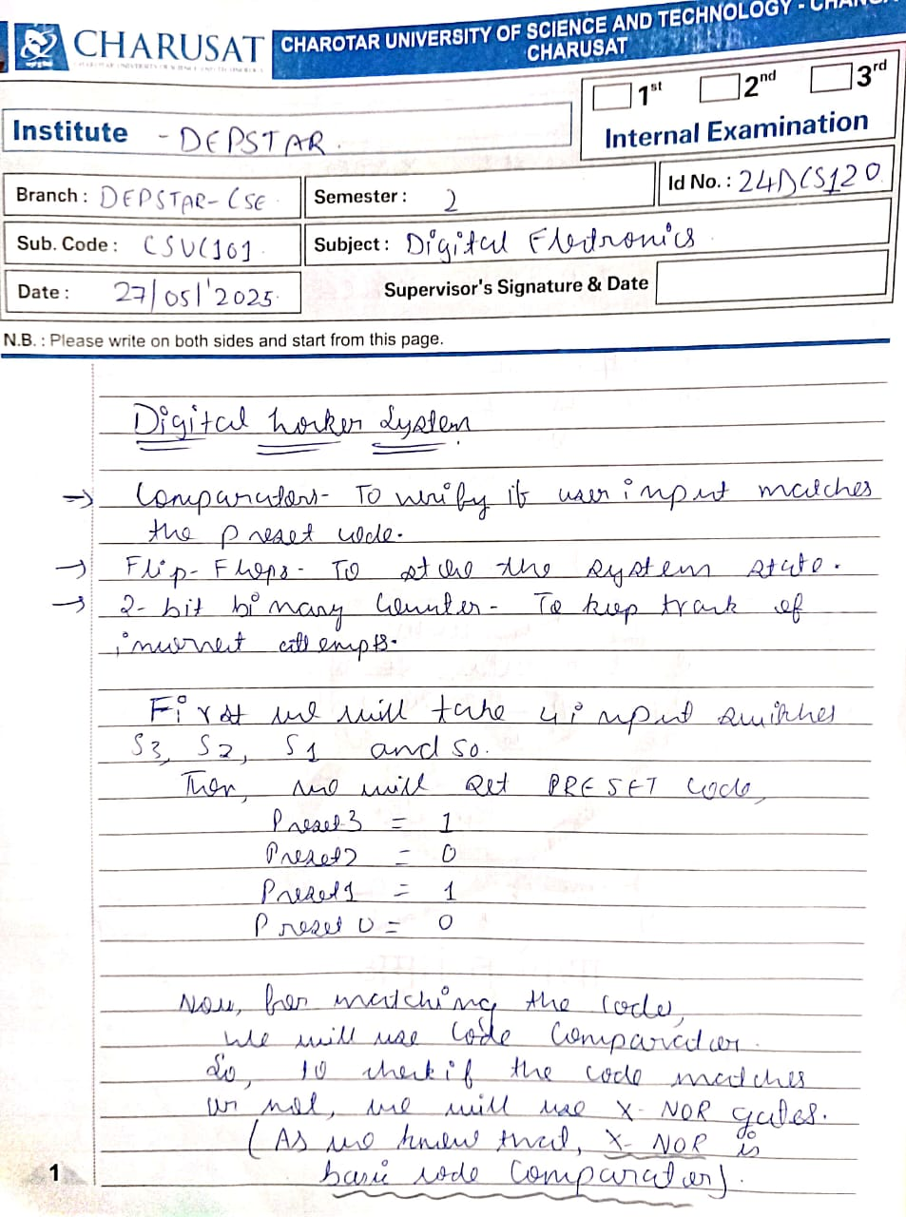

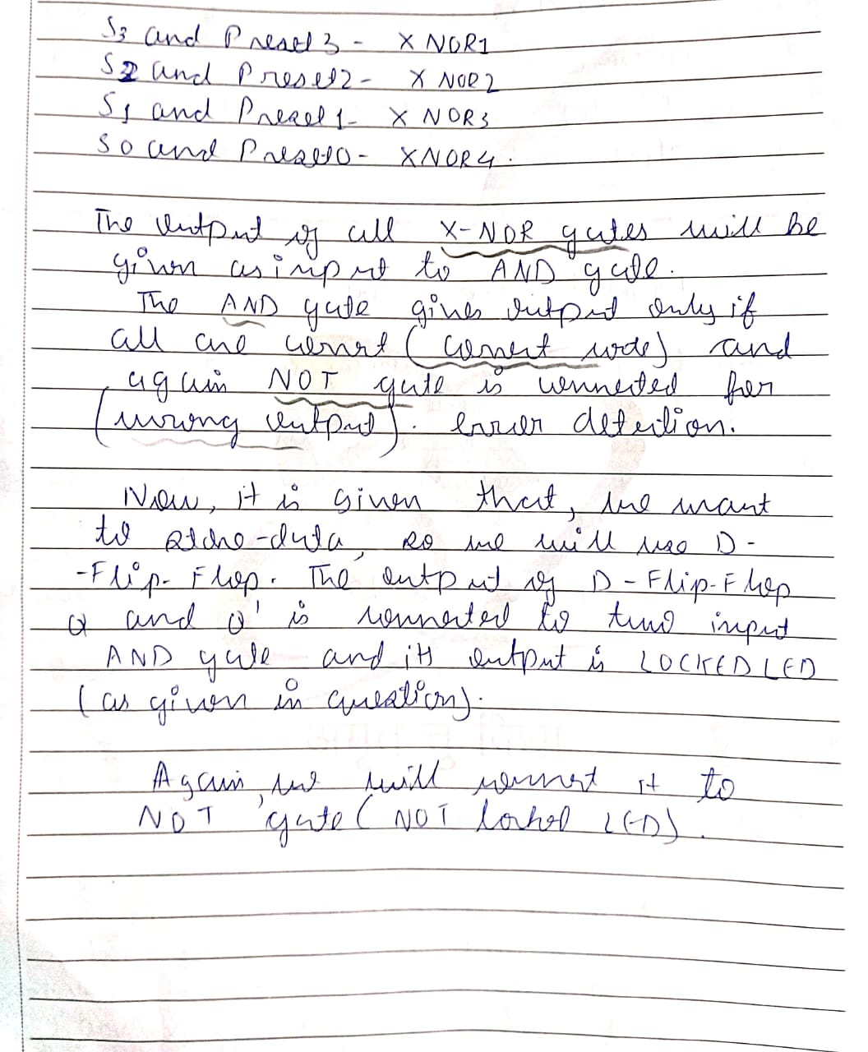

CIRCUIT SCREENSHOTS:
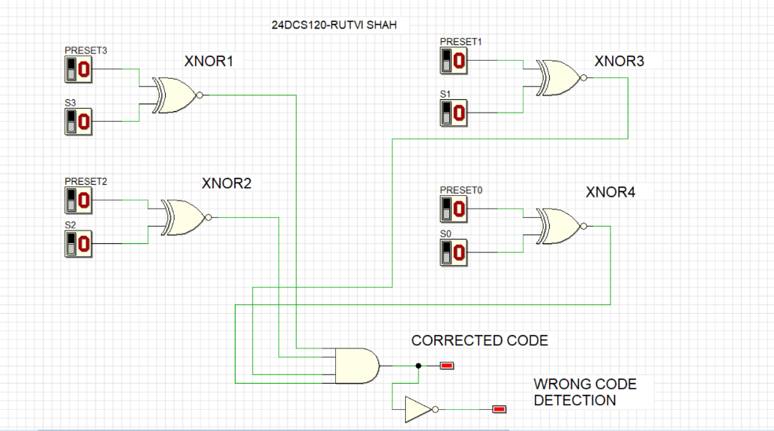
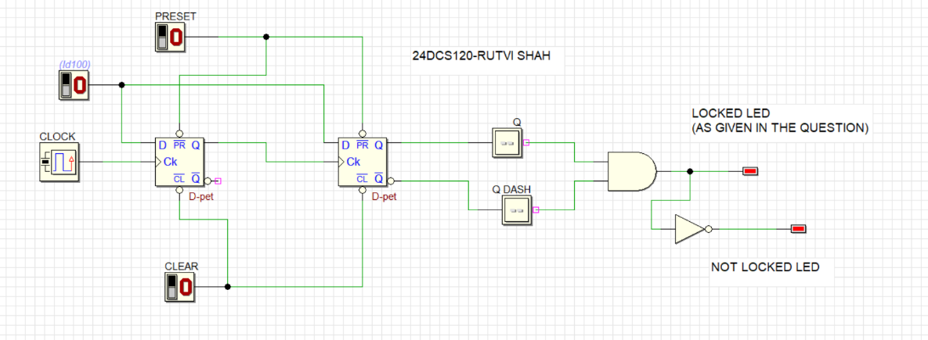

COMPLETE CIRCUIT IMPLEMENTATION
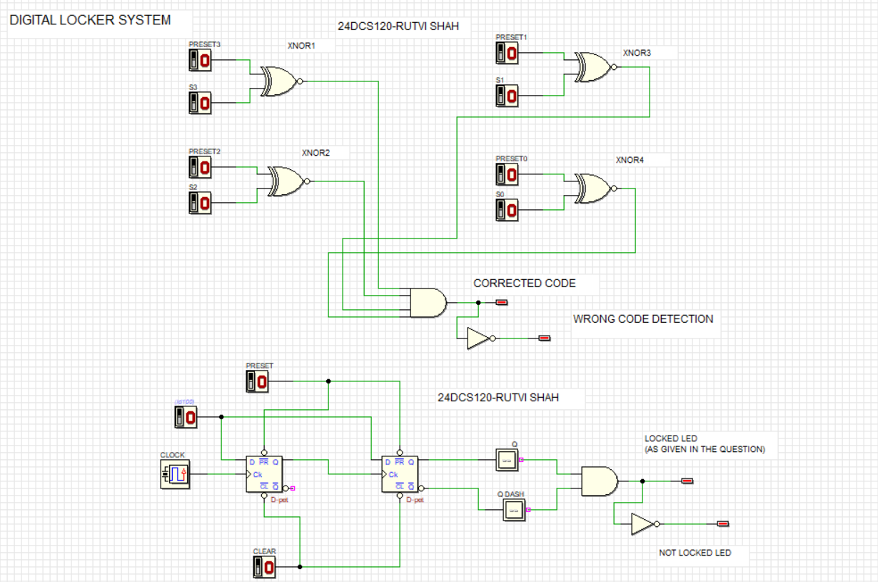
OUTPUT
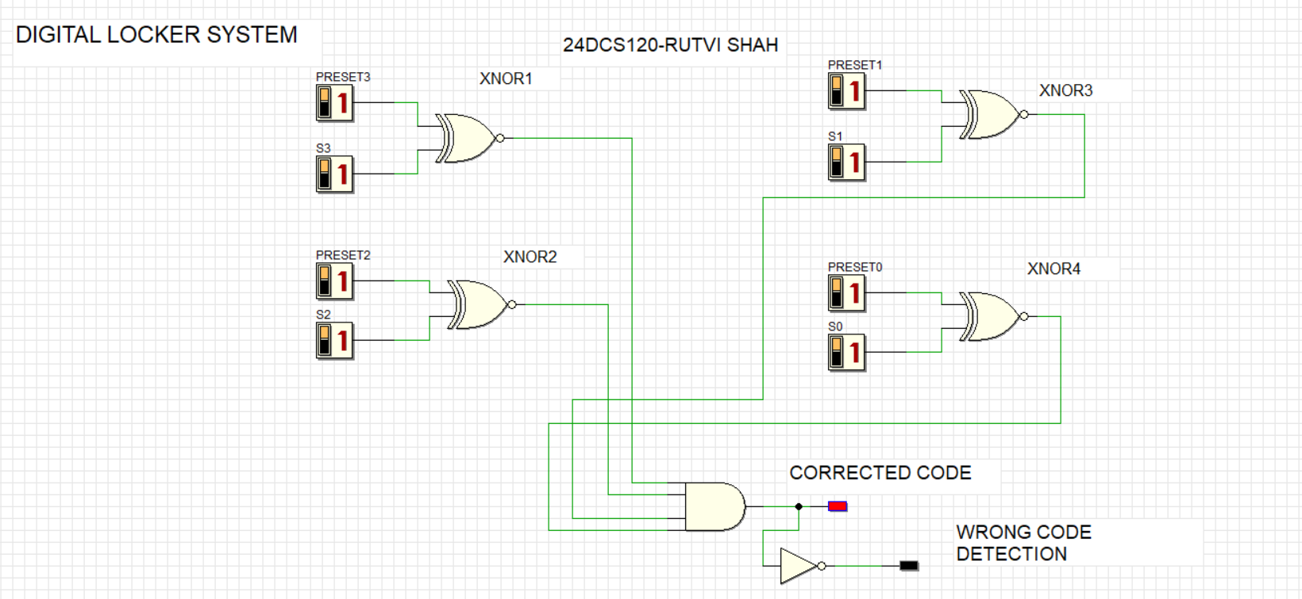
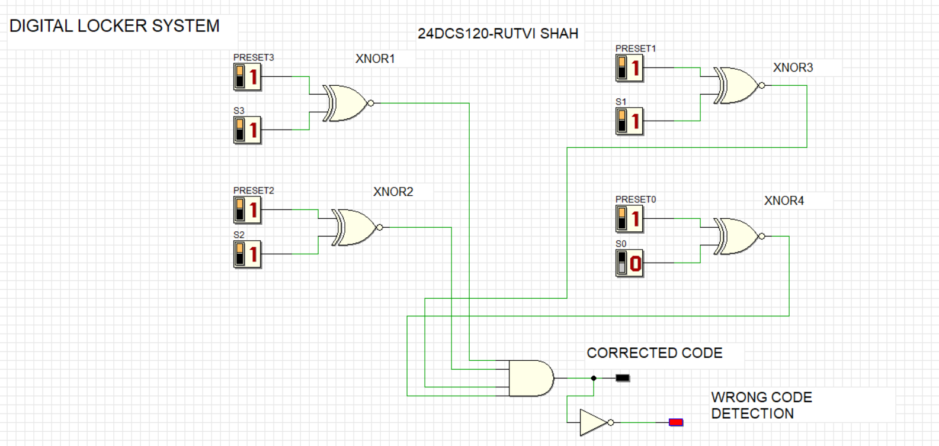
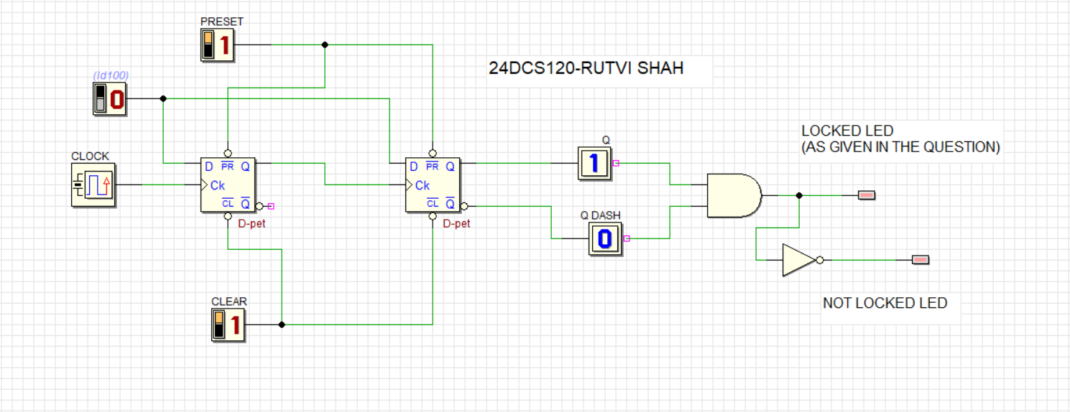

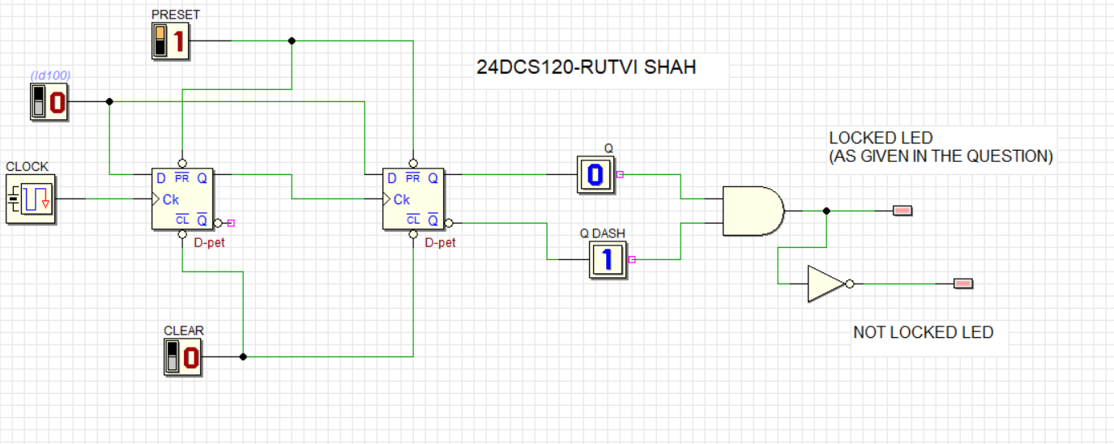

CONCLUSION
In Digital Locker System, we are using Comparators, Flip-Flops and Counters to first verify if user input matches the preset code, to store the data and to keep the track of incorrect attempts made by user using the Counters. Thus, in this way we can implement the Digital Locker System, also we can LOCKED LED if maximum of three attempts are made by the user.

