**PROG8170-23W-SEC3**

**Software Quality Assurance Tech**

**Assignment 1 – Defect Logging**

**Name:** Rutvik Dineshchandra Gandhi

**Student No.** : 8809972

**Created on-** 01/25/2023

* **Individual Screenshots:**

1. Showing Total Price = NaN

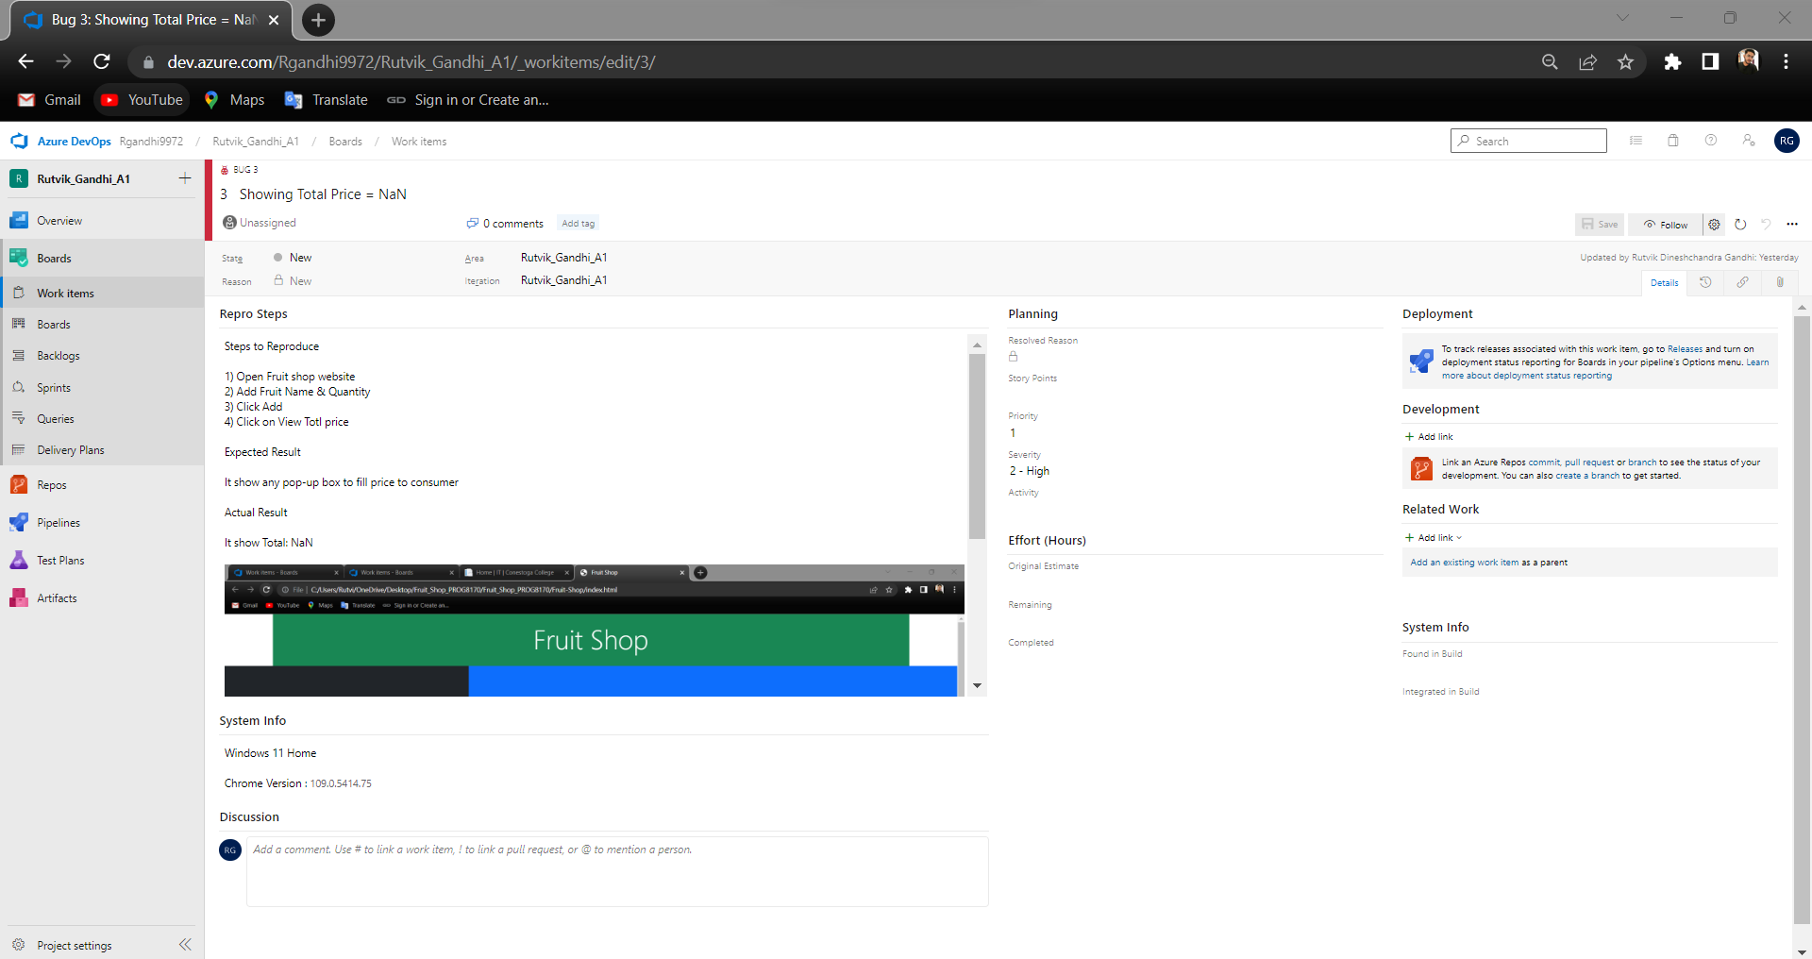

1. Fruit Name takes "Numbers"

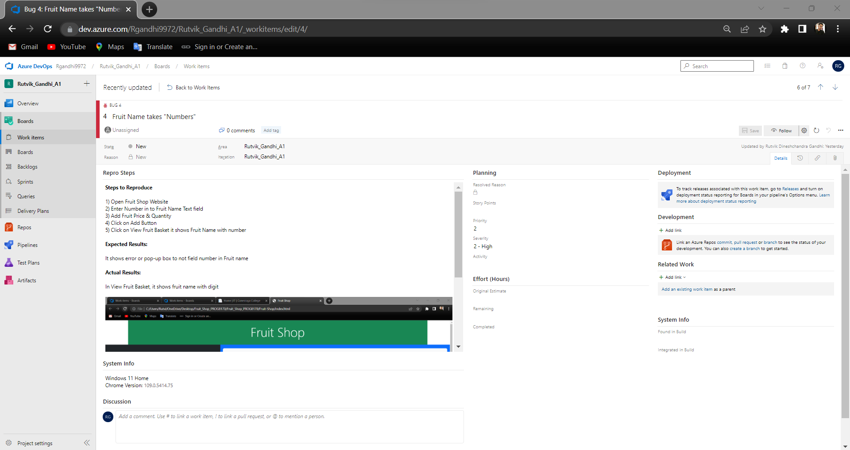

1. Clear list button not work

1. Fruit Price takes Negative Value

1. Design has low fidelity

1. Broken Code on Landing Website

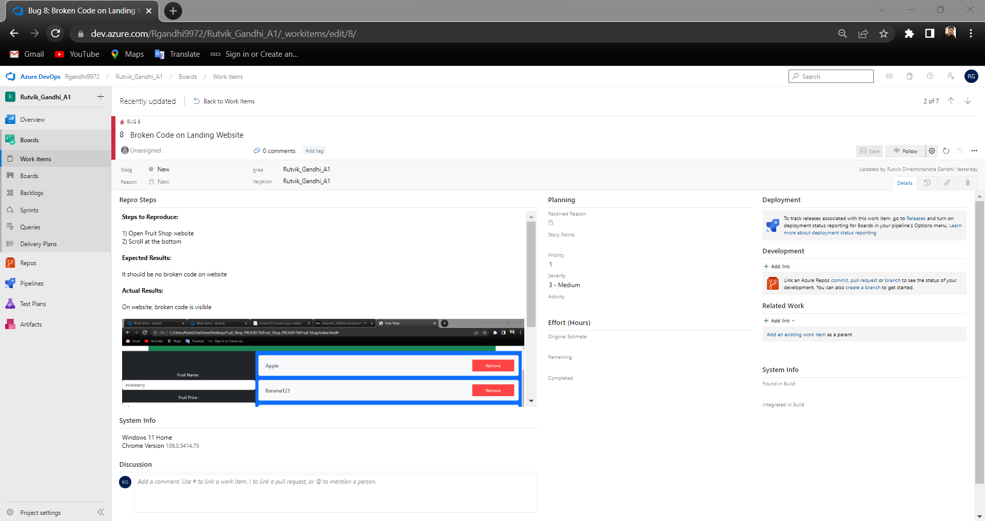

1. Limited Options to enter quantity of fruits

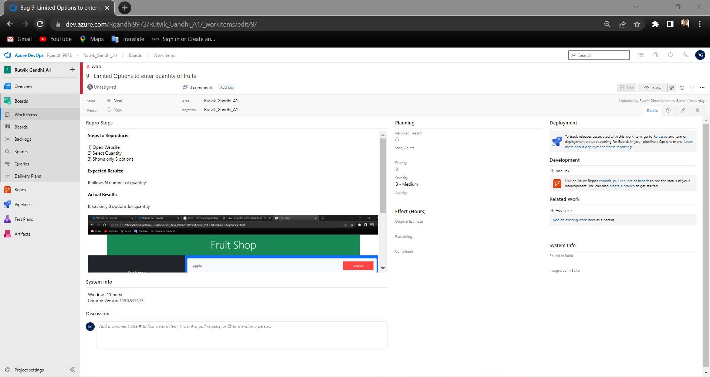

* **A query showing following fields (in order):**

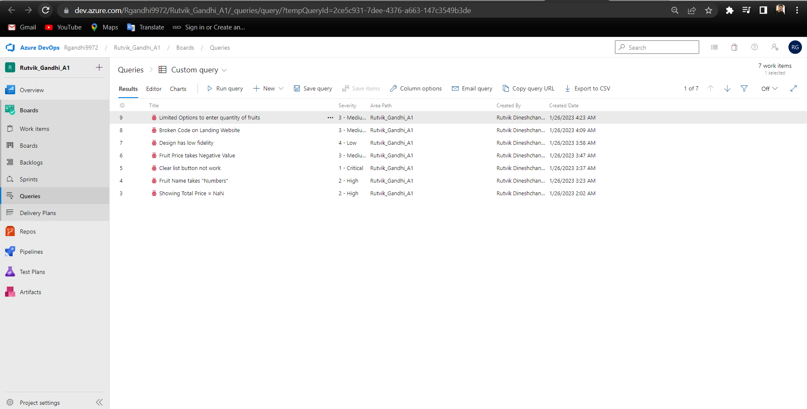

* **an overall view - chart of all the defects grouped by Severity**

* **Recommendations:**

I would advise against deploying the application in question until all issues have been fixed, as a QA tester. Before making an application available to the general public, it's crucial to make sure it works as planned and complies with all standards.

Prior to any further deployment, I would advise the development team to carefully examine and solve the problems found in the programme. It is crucial to make sure the programme is reliable for end users and operates as planned.

Regression testing would also be advantageous to make sure that the programme is stable after problem repairs and that the patches do not result in the introduction of any new bugs.