Assignment-2 (DAA)

* Name: KRISHNA PANDEY
* Roll No.: B110
* Admission No.: U20CS110
  1. Implement the above algorithms using the programming language of your choice.

I chose C++ to implement the above algorithms.

* 1. Provide the details of Hardware/Software you used to implement algorithms and to measure the time.

Hardware details is provided below and the IDE used by me is Visual Studio.

Device name LAPTOP-LEHQUDIU

Processor 11th Gen Intel(R) Core (TM) i5-1135G7 @ 2.40GHz 2.42 GHz

Installed RAM 8.00 GB (7.75 GB usable)

Device ID 2C14C1C1-1420-41A4-B7F5-0D78ADA245F8

Product ID 00327-36277-89595-AAOEM

System type 64-bit operating system, x64-based processor

Pen and touch No pen or touch input is available for this display

Edition Windows 10 Home Single Language

Version 21H1

Installed on ‎29-‎07-‎2021

OS build 19043.1526

Experience Windows Feature Experience Pack 120.2212.4170.0

* 1. Submit the code (complete programs).

Insertion Sort:

#include <bits/stdc++.h>

using namespace std; #include <time.h>

void swap(int *a, int *b)

{

int temp = *a;

*a = *b;

*b = temp;

}

void insertionSort(vector<int> &values, int n)

{

int i, j, key;

for (i = 1; i < n; i++)

{

key = values[i]; j = i - 1;

while (j >= 0 && values[j] > key)

{

values[j + 1] = values[j]; j = j - 1;

}

values[j + 1] = key;

}

}

int main()

{

string filename("File5.txt"); vector<int> values;

int number;

ifstream input_file(filename); if (!input_file.is_open())

{

cerr << "Could not open the file - '"

<< filename << "'" << endl; return EXIT_FAILURE;

}

int n = 0;

while (input_file >> number)

{

values.push_back(number); n++;

}

cout << n << endl;

//sort(values.begin(), values.end(), greater<int>());

//sort(values.begin(), values.end()); clock_t tStart = clock();

insertionSort(values, n); cout.precision(10);

cout << "Time taken by function: " << (double)(clock() - tStart) / CLOCKS_PER_SEC << " seconds" << endl;

cout << "The sorted array is : " << endl;

/*for (int i = 0; i < n; i++)

{

cout << values[i] << " ";

}*/

cout << endl; input_file.close();

return EXIT_SUCCESS;

}

* 1. Measure the average-case time (considering current data of six files) of insertion sort for all six files. Plot a graph.

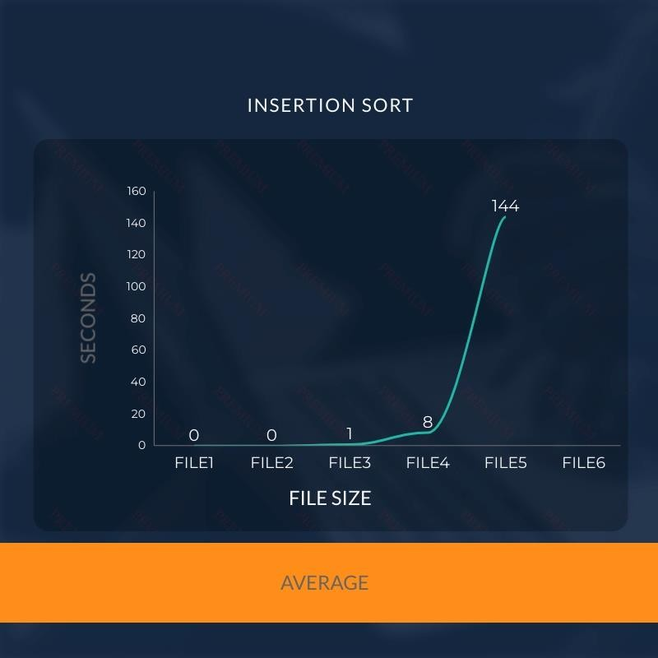

1.5 Measure the best-case time of insertion sort for all six files. Plot a graph.

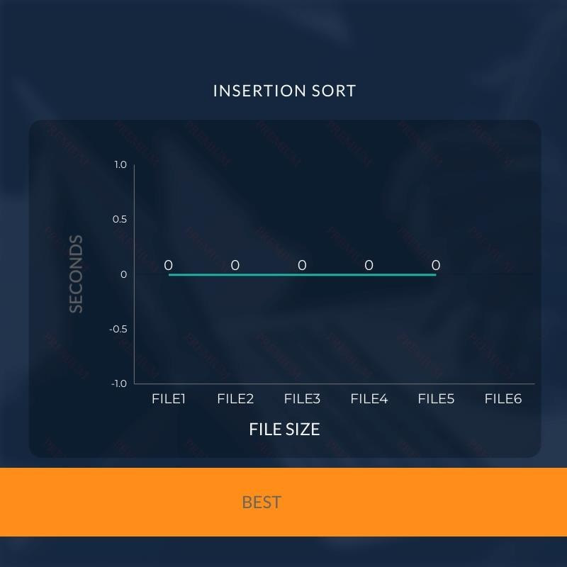

1.6. Measure the worst-case time of insertion sort for all six files. Plot a graph.

