# TUTORIAL 2 (DBMS)

U20CS110

Krishna Pandey

Consider the following two tables for reference to practice the SQL queries.

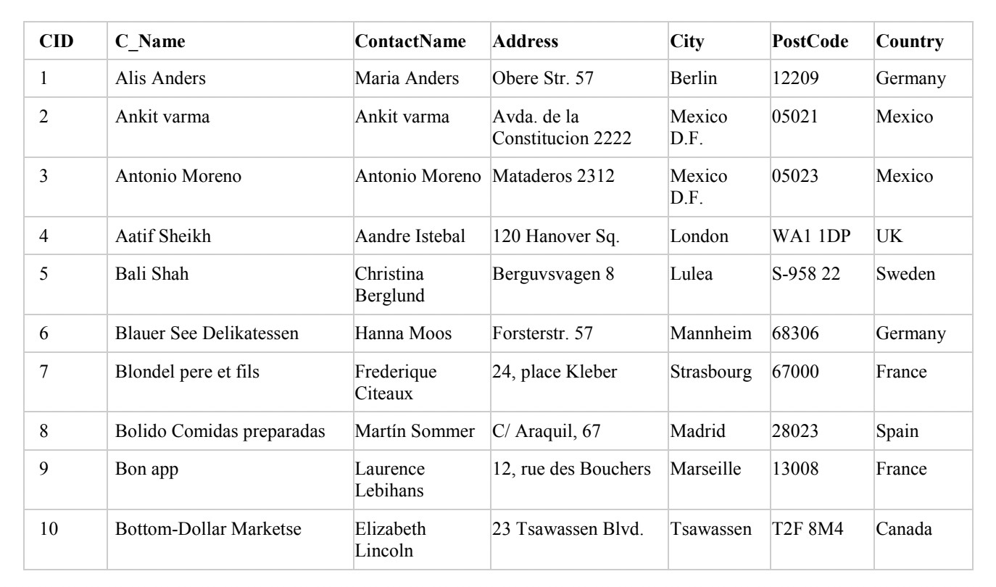

Table – CustomerDetails

Write SQL Queries for the following:

1. Create the table CustomerDetails (as shown above).

->CREATE TABLE CustomerDetails ( CID INT,

C_Name VARCHAR(30),

ContactName VARCHAR(30), Address VARCHAR(30), City VARCHAR(15), PostCode VARCHAR(10), Country VARCHAR(10)

);

1. Insert the values in the tables.

->INSERT INTO CustomerDetails VALUES(1,'Alis Anders','Maria Anders', 'Obere Str. 57','Berlin', '12209' ,'Germany');

INSERT INTO CustomerDetails VALUES(2, 'Ankit varma' ,'Ankit varma' ,'Avda. de la Constitucion 2222' , 'Mexico D.F.' , '05021' , 'Mexico');

INSERT INTO CustomerDetails VALUES(3, 'Antonio Moreno', 'Antonio Moreno', 'Mataderos 2312', 'Mexico D.F.', '05023', 'Mexico');

INSERT INTO CustomerDetails VALUES(4, 'Aatif Sheikh', 'Aandre Istebal', '120 Hanover Sq.' ,'London', 'WA1 1DP', 'UK');

INSERT INTO CustomerDetails VALUES(5, 'Bali Shah', 'Christina Berglund', 'Berguvsvagen 8' ,

'Lulea' ,'S-958 22', 'Sweden');

INSERT INTO CustomerDetails VALUES(6, 'Blauer See Delikatessen', 'Hanna Moos', 'Forsterstr. 57', 'Mannheim', '68306', 'Germany');

INSERT INTO CustomerDetails VALUES(7, 'Blondel pere et fils', 'Frederique Citeaux', '24, place Kleber', 'Strasbourg' ,'67000' ,'France'); INSERT INTO CustomerDetails VALUES(8, 'Bolido

Comidas preparadas', 'Martín Sommer', 'C/ Araquil, 67' ,'Madrid' ,'28023', 'Spain');

INSERT INTO CustomerDetails VALUES(9, 'Bon app', 'Laurence Lebihans', '12, rue des Bouchers', 'Marseille', '13008', 'France');

INSERT INTO CustomerDetails VALUES(10, 'Bottom- Dollar Marketse', 'Elizabeth Lincoln', '23 Tsawassen Blvd.' ,'Tsawassen' ,'T2F

8M4' ,'Canada');

SELECT * FROM CustomerDetails;

1. Write an SQL query to fetch CID and Address with a CustomerName that does NOT start with “B".

->SELECT CID,Address FROM CustomerDetails WHERE C_Name NOT LIKE 'B%';

1. Write an SQL query to fetch the Id and Name of customers’ city which starts with ‘Mar’.

->SELECT CID,C_Name FROM CustomerDetails WHERE City LIKE 'MAR%';

1. Write an SQL query to fetch all the ContactName which is same as C_Name.

->SELECT ContactNAME FROM CustomerDetails WHERE ContactName = C_NAME;

1. List C_name ends with ’S’.

->SELECT C_Name FROM CustomerDetails WHERE C_Name LIKE '%S';

1. Write an SQL query to find the CId and C_Name of the customers with a City containing the pattern

“XI".

->SELECT CID,C_Name FROM CustomerDetails WHERE City LIKE '%XI%';

1. Write an SQL query to fetch all customers with a City starting with "B" or "S", or “L".

->SELECT * FROM CustomerDetails WHERE City LIKE '[BSL]%';

1. Write an SQL query to fetch city and postalcode of customer having address ends with digits.

->SELECT City,PostCode FROM CustomerDetails WHERE Address LIKE '%[0-9]';

1. Write an SQL query to find the country of customers with a C_Name that starts with "A" and are at

least 3 characters in length.

->SELECT Country FROM CustomerDetails WHERE C_Name LIKE 'A %';

1. Write an SQL query to fetch CID and Address with a PostCode having 0 digit.

->SELECT CID,Address FROM CustomerDetails WHERE PostCode LIKE '%0%';

1. Write an SQL query to list all the cities of country name having length 2.

->SELECT City,Country FROM CustomerDetails WHERE Country LIKE " ";

1. Write an SQL query to list the length of all C_name.

->SELECT LENGTH(C_Name) AS "LENGTH OF CUSTOMER

NAMES" FROM CustomerDetails;

1. Write an SQL query to display the C_name country wise in ascending order country and c_name.

->SELECT C_Name,Country FROM CustomerDetails ORDER BY Country,C_Name ;

1. Write an SQL query to update all the character type data with UPPERCASE.

->SELECT UPPER(C_Name) AS "CUSTOMER" FROM

CustomerDetails;

SELECT UPPER(ContactName) AS "CONTACT NAMES" FROM

CustomerDetails;

SELECT UPPER(Address) AS "ADDRESS" FROM

CustomerDetails;

SELECT UPPER(City) AS "CITY" FROM CustomerDetails; SELECT UPPER(Country) AS "COUNTRY" FROM

CustomerDetails;