Practical – 2

Text Formatting in HTML

1. Write the HTML code to display the following output. Do not use table.

<!DOCTYPE html>

<html lang="en">

<head>

    <meta charset="UTF-8">

    <meta name="viewport" content="width=device-width, initial-scale=1.0">

    <title>P1</title>

</head>

<body>

    <H1>Text Formatting Tags</H1><br>

    <pre>HTML Tag                       Output</pre>

    <pre>Normal Text                    hello world</pre>

    <pre>&lt;B&gt;                      <b>Bold</b></pre>

    <pre>&lt;i&gt;                      <i>Italic</i></pre>

    <pre>&lt;U&gt;                      <u>underline</u></pre>

    <pre>&lt;em&gt;                     <em>Emphasis</em></pre>

    <pre>&lt;B&gt;                      <strong>STRONG</strong></pre>

    <pre>&lt;CITE&gt;                   <cite>Citation</cite></pre>

    <pre>&lt;strike&gt;                 <strike>strike through text</strike></pre>

    <pre>&lt;SUB&gt;                    a<sub>b</sub></pre>

    <pre>&lt;SUP&gt;                    a<sup>b</sup></pre>

    <pre>&lt;del&gt;                    <del>One</del></pre>

    <pre>&lt;INS&gt;                    <ins>Two</ins></pre>

    <pre>&lt;Big&gt;                    <Big>text in a big font</Big></pre>

    <pre>&lt;Small&gt;                  <small>text in a small font</small></pre>

</body>

</html>

**OUTPUT :**

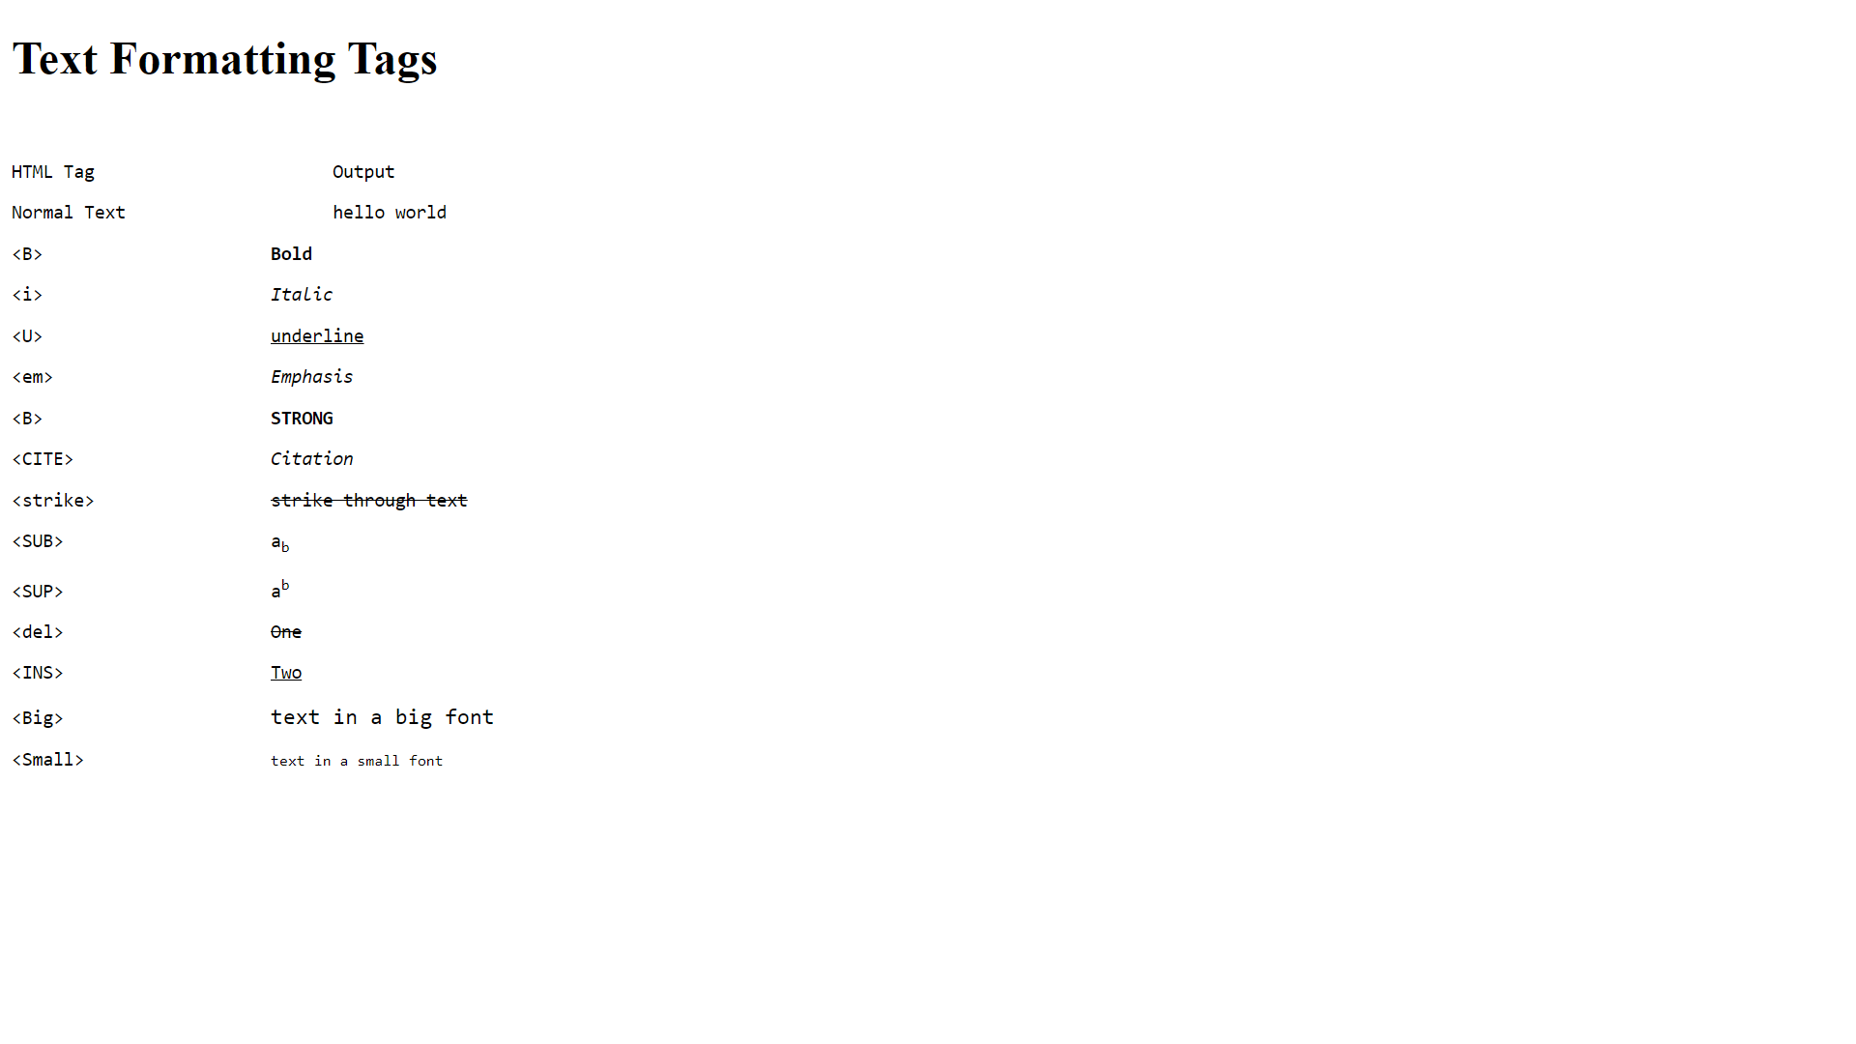

2. Write the HTML code to display the following output.

<!DOCTYPE html>

<html lang="en">

<head>

    <meta charset="UTF-8">

    <meta name="viewport" content="width=device-width, initial-scale=1.0">

    <title>P2</title>

</head>

<body>

    <center><h2>CLASS-X</h2></center>

    <center><h2>SUBJECT-BASICMATHEMATICS(241)</h2></center>

    <center><h2>SAMPLE QUESTION PAPER(2023-24)</h2></center>

    <pre><h1>TIME ALLOWED:3 HRS

    MAXIMUM MARKS:80</h1></pre>

    <ins><h3>General Instruction:</h3></ins>

    <ol>

        <li>This Question Paper has 5 section A,B,C,D,and E.</li>

        <li>Section A has 20 Multiple Choice Question(MCQs) carrying 1 mark each.</li>

        <li>Section B has 5 Short Answer-I(SA-I) type question carrying 2 marks

       each.</li>

        <li>Section C has 6 Short Answer-II(SA-II) type question carring 3 marks

       each.</li>

       <li>Section D has 4 Long Answer(LA) type question carring 5 marks each.</li>

       <li>Section E has 3 sourced based/Case Based/passage based/integrated units

        of<br>assessment(4 marks each)with sub-parts of the values of 1,1 and 2 marks each<br>

        respectively.</li>

        <li>All Question are compulsory.Hoewever,an internal choice in 2 Qs 2 marks, 2

        Qs<br>of 3 marks and 2 Question of 5 marks has been provided.An internal choice has<br>

        been provided in the 2 marks question of section E.</li>

        <li>Draw neat wherever required.Take &pi;=22/7 wherever required if not<br>

        stated.</li>

        <u align="center"><h2>SECTION A</h2></u>

    <ol>

        a=x<sup>3</sup>y<sup>2</sup> and b=xy<sup>3</sup>;x,y are prime<br>

        <li> If two positive integers a and b are written as

        numbers,then HCF(a,b)is:</li>

        <pre> a) xy b) xy<sup>2</sup> c) x<sup>3</sup>y<sup>3</sup>

        d) x<sup>2</sup>y<sup></sup></pre><br>

        <li> The LCM of smallest two-digit compoiste number and smallest composite

        number is:</li>

        <pre> a) 12 b) 4 c) 20 d) 44</pre>

    </ol>

</body>

</html>

**OUTPUT :**

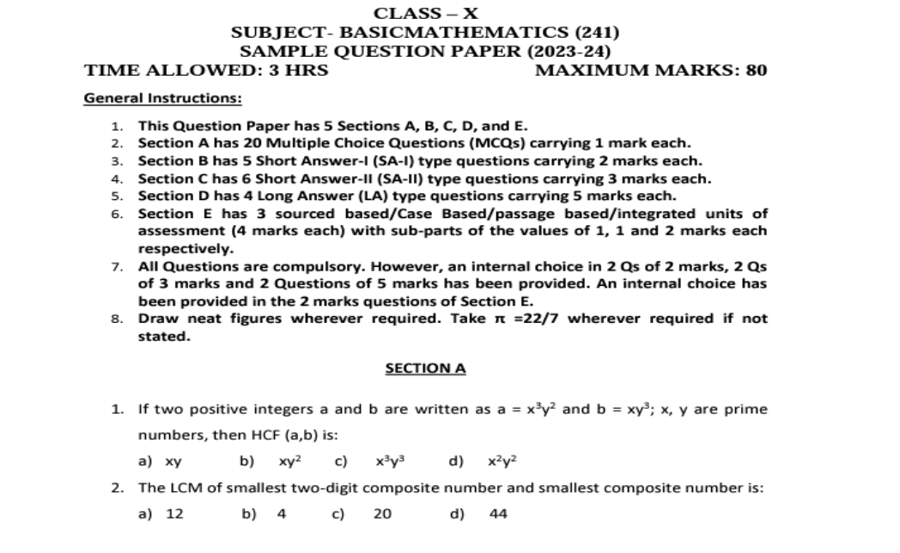

3. Write the HTML code to display your Resume.

<!DOCTYPE html>

<html lang="en">

<head>

    <meta charset="UTF-8">

    <meta name="viewport" content="width=device-width, initial-scale=1.0">

    <title>P3</title>

</head>

<body style="background-color:#73C6B6">

    <center><h1><u>RESUME</u></h1></center>

    <h2>TYPE YOUR NAME PLEASE</h2>

    <p align="right">cell:+00 0000000000<br>

        cell:+00 0000000000<br>

        <u>Email:name@gmail.com</u></p>

        <hr>

    <u><h4>Career Objective:</h4></u>

    <p>To process a career in a renowed frime with dedicated effects and to

        associate myself with an organization that gives me a chance to update my

        knowledge.</p>

         <u><h4>Educational Qualification:</h4></u>

         <ul>

         <li>Graduation <b>B.com(computer science)</b> under Osmania University

        from Sandeepani Degree college,Kamareddy-2009.</li>

         <li>Intermediate <b>C.E.C</b> under Board of Intermediate Education from

        Sandeepani Jr.College,Kamareddt-2006</li>

         <li><b>S.S.C</b> from Board Of Secondary Education, Triveni High

        School,Domalcoda-2004 </li>

         </ul>

         <u><h4>Computer Skills:</h4></u>

         <p>P.G.D.C.A(Post Graduate Diploma in Computer Application)<br>

         A.D.C.A(Advanced Diploma in Computer Application)<br>

         D.T.P(Desktop Publisher)<br>

         Operation System(XP,2000,98,and other)</p>

         <u><h4>Strengths:</h4></u>

         <p> Good Communication Skills.<br>

         Ready to take responsibility<br>

         Quick Learner and Good Interpersonal Skill.</p>

</body>

</html>

**OUTPUT :**

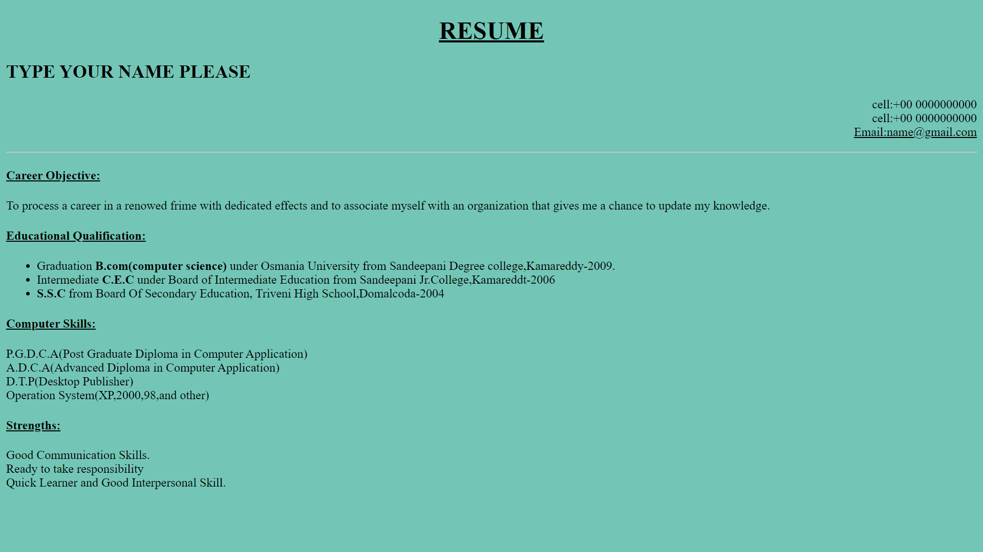

4. Print the squares of the numbers 1 - 20. Each number should be on a separate line, next to it the number 2 superscripted, an equal sign and the result. (Example: 102 = 100)

<!DOCTYPE html>

<html lang="en">

<head>

    <meta charset="UTF-8">

    <meta name="viewport" content="width=device-width, initial-scale=1.0">

    <title>P4</title>

</head>

<body>

    <h3>1<sup>2</sup>=1</h3>

    <h3>2<sup>2</sup>=4</h3>

    <h3>3<sup>2</sup>=9</h3>

    <h3>4<sup>2</sup>=16</h3>

    <h3>5<sup>2</sup>=25</h3>

    <h3>6<sup>2</sup>=36</h3>

    <h3>7<sup>2</sup>=49</h3>

    <h3>8<sup>2</sup>=64</h3>

    <h3>9<sup>2</sup>=81</h3>

    <h3>10<sup>2</sup>=100</h3>

    <h3>11<sup>2</sup>=121</h3>

    <h3>12<sup>2</sup>=144</h3>

    <h3>13<sup>2</sup>=169</h3>

    <h3>14<sup>2</sup>=196</h3>

    <h3>15<sup>2</sup>=225</h3>

    <h3>16<sup>2</sup>=256</h3>

    <h3>17<sup>2</sup>=289</h3>

    <h3>18<sup>2</sup>=324</h3>

    <h3>19<sup>2</sup>=361</h3>

    <h3>20<sup>2</sup>=400</h3>

</body>

</html>

**OUTPUT :**

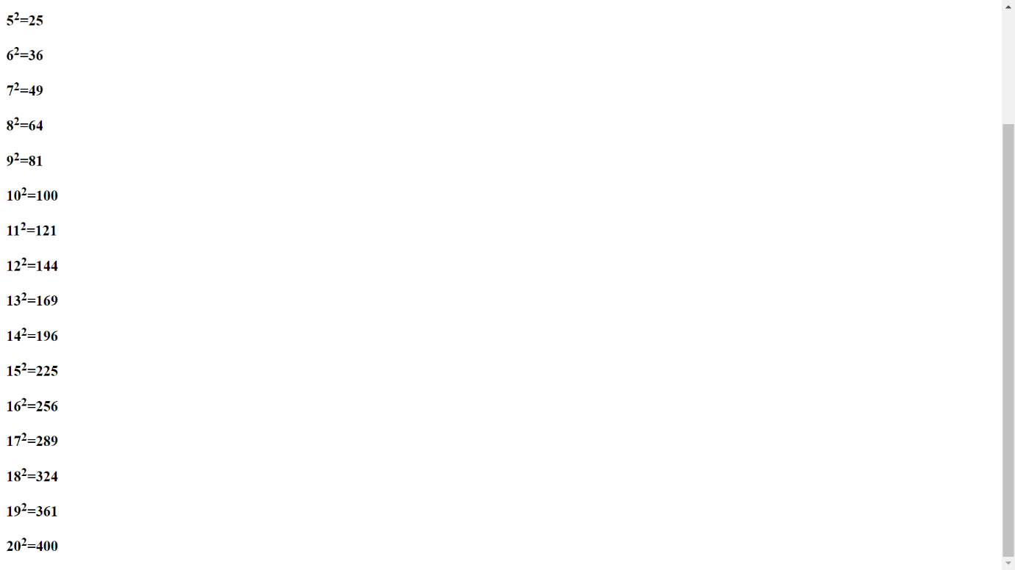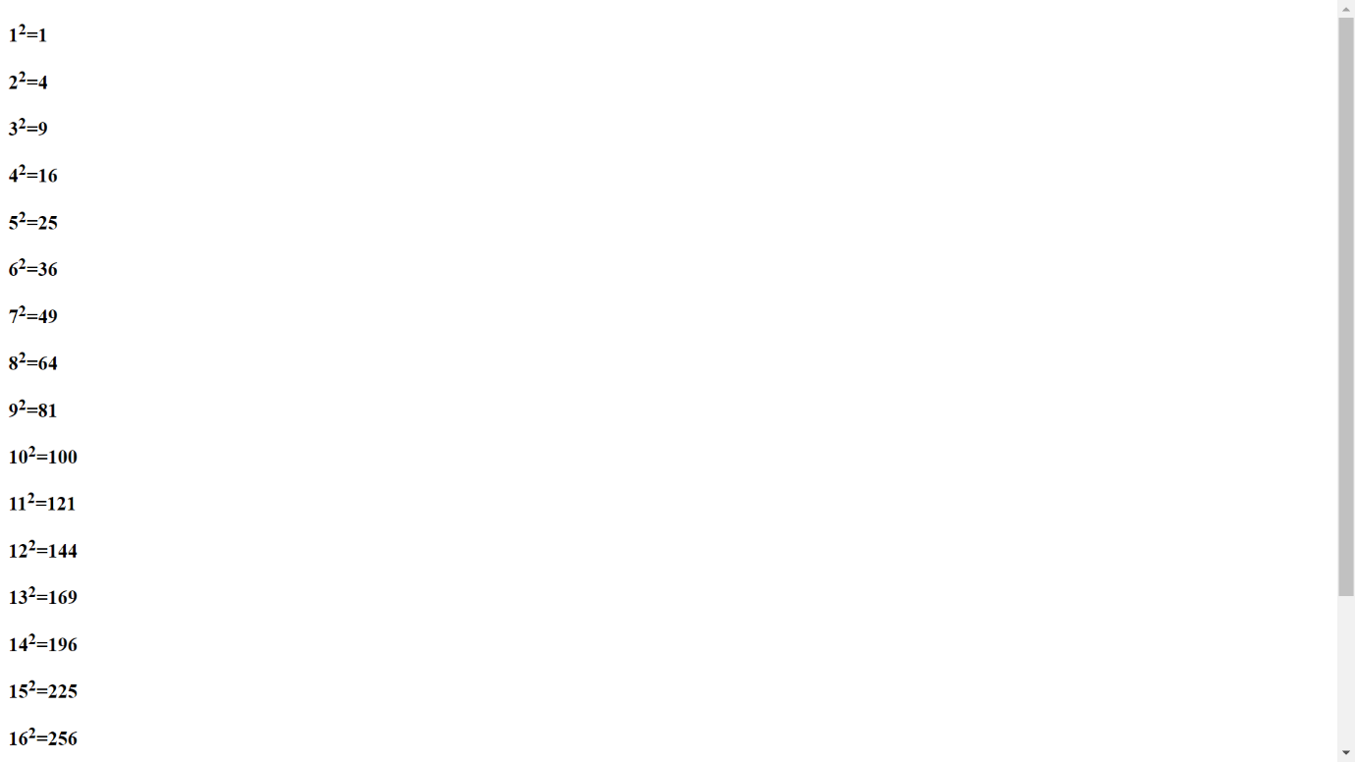

5. Write a HTML code to overriding text direction. (hint using bdo element with).

<!DOCTYPE html>

<html lang="en">

<head>

    <meta charset="UTF-8">

    <meta name="viewport" content="width=device-width, initial-scale=1.0">

    <title>P5</title>

</head>

<body>

    <p>Lorem ipsum dolor, sit amet consectetur adipisicing elit. Fuga, asperiores! <bdo dir="rtl">Hello DDU</bdo>Lorem ipsum dolor sit amet.</p>

</body>

</html>

**OUTPUT :**

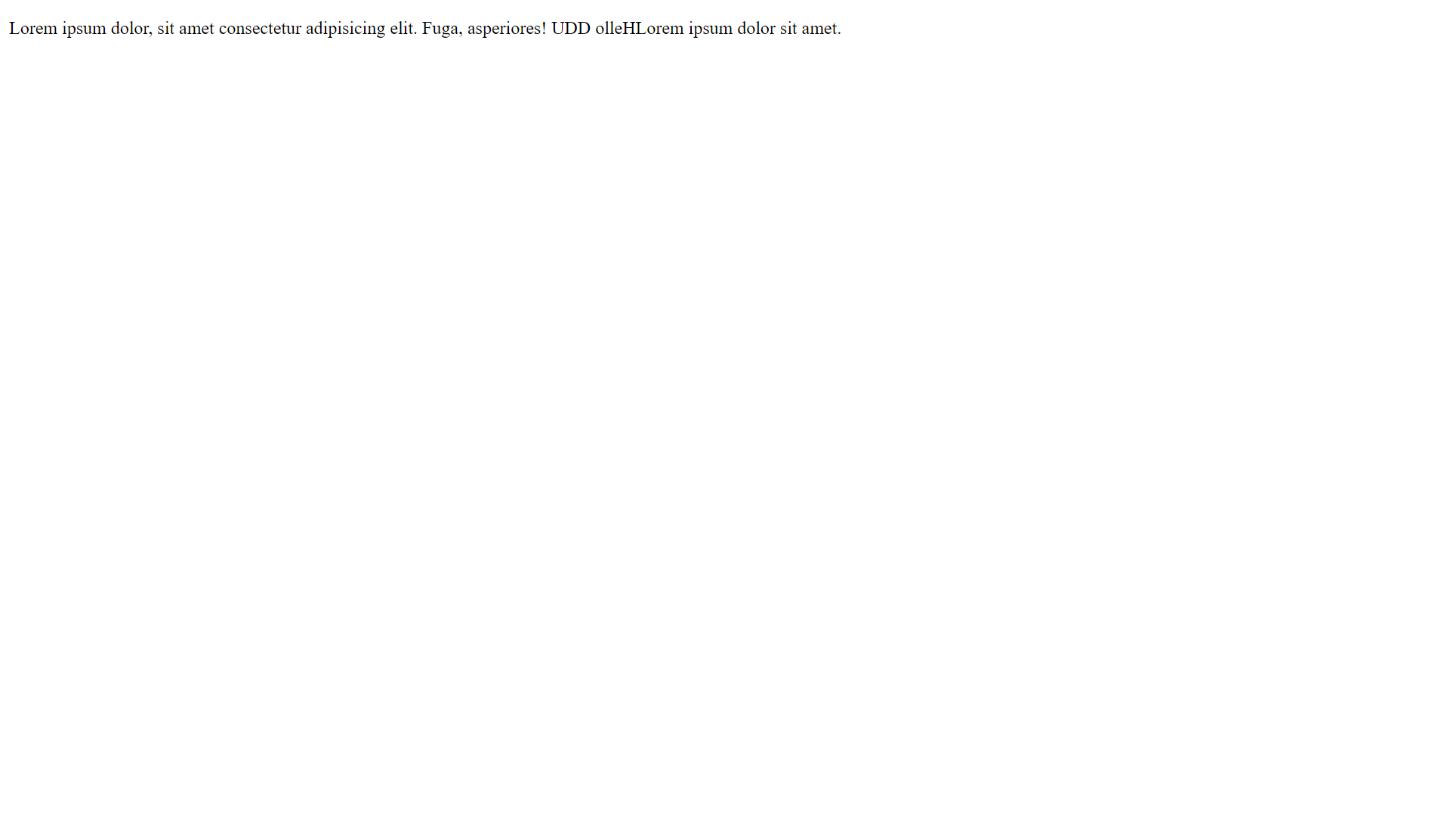

6. Write a HTML code to implement long and short quotation. (hint use <Q> and <BLOCKQUOTE>).

<!DOCTYPE html>

<html lang="en">

<head>

    <meta charset="UTF-8">

    <meta name="viewport" content="width=device-width, initial-scale=1.0">

    <title>P6</title>

</head>

<body>

    <H1>Hello DDU <Q>Hello Lorem ipsum dolor sit.</Q></H1>

    <H1>Hello DDU <Blockquote>Hello Lorem ipsum dolor sit amet.</Blockquote></H1>

</body>

</html>

**OUTPUT :**

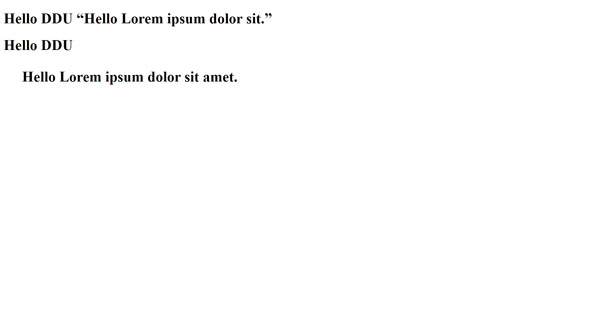

7. Write a HTML code to implement div and span tags. (hint <div> use

and <span>).

<!DOCTYPE html>

<html lang="en">

<head>

    <meta charset="UTF-8">

    <meta name="viewport" content="width=device-width, initial-scale=1.0">

    <title>P6</title>

</head>

<body>

    <H1>Hello DDU <div>Hello Lorem ipsum dolor sit.</div></H1>

    <H1>Hello DDU <span>Hello Lorem ipsum dolor sit amet.</span></H1>

</body>

</html>

**OUTPUT :**

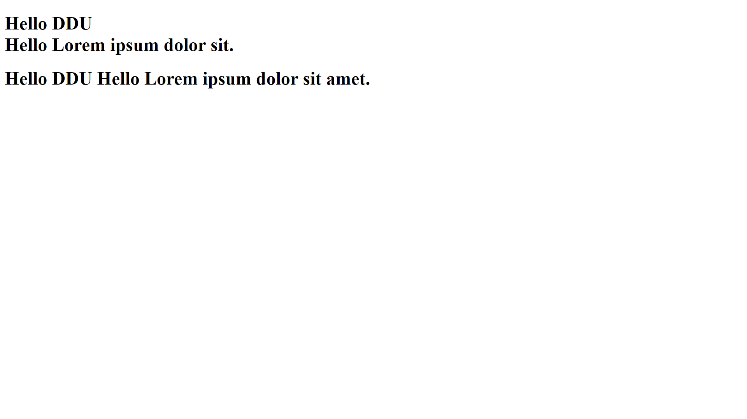

8. Write a HTML code to display the following output. (hint use <code>).

<!DOCTYPE html>

<html lang="en">

<head>

    <meta charset="UTF-8">

    <meta name="viewport" content="width=device-width, initial-scale=1.0">

    <title>P8</title>

</head>

<body>

    <h2>Following is the basic structure of HTML:</h2>

    <code>

        &lt;!DOCTYPE html&gt;

        &lt;Html&gt;

        &lt;head&gt;

        &lt;title&gt;

        &lt;/title&gt;

        &lt;/head&gt;

        &lt;body&gt;

        &lt;/body&gt;

        &lt;/Html&gt;

    </code>

</body>

</html>

**OUTPUT :**

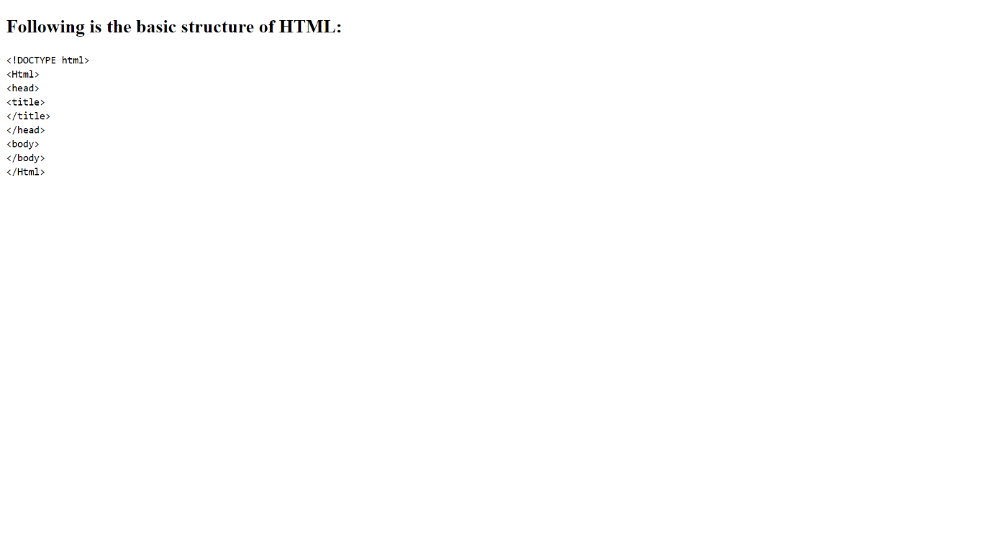

9. Create an HTML web page to implement various character entities in HTML. Implement at least 10 character entities (refer <https://tools.w3cub.com/html-entities>).

<!DOCTYPE html>

<html lang="en">

<head>

    <meta charset="UTF-8">

    <meta name="viewport" content="width=device-width, initial-scale=1.0">

    <title>P9</title>

</head>

<body>

    <H2>&#33;</H2>

    <h2>&#34;</h2>

    <h2>&#35;</h2>

    <h2>&#36;</h2>

    <h2>&#37;</h2>

    <h2>&#38;</h2>

    <h2>&#39;</h2>

    <h2>&#40;</h2>

    <h2>&#41;</h2>

    <h2>&#42;</h2>

    <h2>&#43;</h2>

    <h2>&#44;</h2>

</body>

</html>

**OUTPUT :**



10. How to insert a copyright symbol on a browser page ?

<!DOCTYPE html>

<html lang="en">

<head>

    <meta charset="UTF-8">

    <meta name="viewport" content="width=device-width, initial-scale=1.0">

    <title>p10</title>

</head>

<body>

    <H1>CopyRight Entities : &#169;</H1>

</body>

</html>

**OUTPUT :**

