Practical - 3

Implementing Image, Table and List in HTML

1. Write a script which display image using all its attributes [ scr, align width, height and alt].

<!DOCTYPE html>

<html lang="en">

<head>

    <meta charset="UTF-8">

    <meta name="viewport" content="width=device-width, initial-scale=1.0">

    <title>P1</title>

</head>

<body>

    <img

        src="2.png"

        align="center"

        width="300"

        height="200"

        alt="1.png"

    />

</body>

</html>

**OUTPUT :**

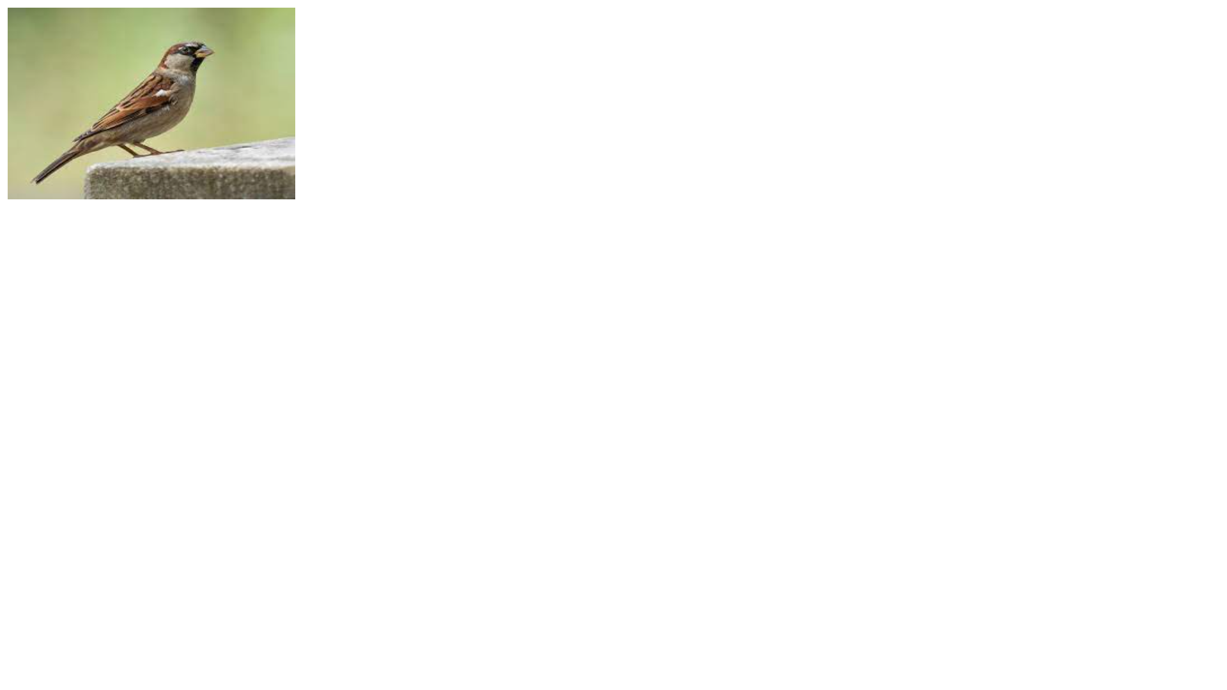

2. Write a script which display table using all its attributes [ tr, td, th, caption]

<!DOCTYPE html>

<html lang="en">

<head>

    <meta charset="UTF-8">

    <meta name="viewport" content="width=device-width, initial-scale=1.0">

    <title>P2</title>

</head>

<body>

    <table border="2px">

        <caption>Student Table Data</caption>

        <tr>

            <th>Roll no</th>

            <th>name</th>

        </tr>

        <tr>

            <td>001</td>

            <td>ABC</td>

        </tr>

        <tr>

            <td>002</td>

            <td>CDF</td>

        </tr>

        <tr>

            <td>003</td>

            <td>XYZ</td>

        </tr>

    </table>

</body>

</html>

**OUTPUT :**

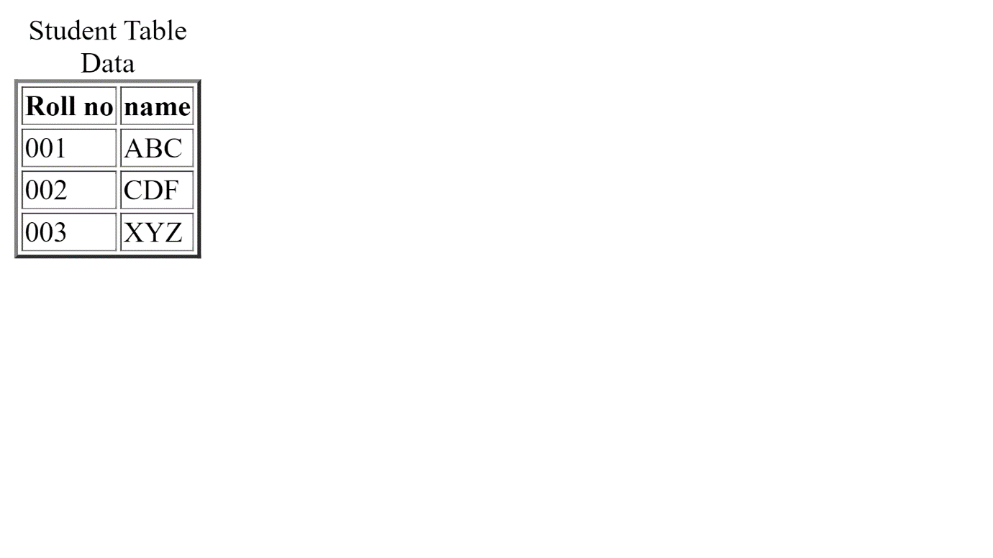

3. Create tables in HTML page that Uses Rowspan and Colspan as shown below

<!DOCTYPE html>

<html lang="en">

<head>

    <meta charset="UTF-8">

    <meta name="viewport" content="width=device-width, initial-scale=1.0">

    <title>P3</title>

    <style>

        tr, td{

            padding: 50px;

        }

    </style>

</head>

<body>

    <center><h1>HTML Table</h1></center>

    <center><table border="2px">

        <tr>

            <td colspan="2">cell1</td>

            <td>cell2</td>

            <td>cell3</td>

        </tr>

        <tr>

            <td rowspan="3">cell4</td>

            <td>cell5</td>

            <td>cell6</td>

            <td>cell7</td>

        </tr>

        <tr>

            <td colspan="3">cell8</td>

        </tr>

        <tr>

            <td>cell9</td>

            <td colspan="2">cell10</td>

        </tr>

    </table></center>

</body>

</html>

**Output:**

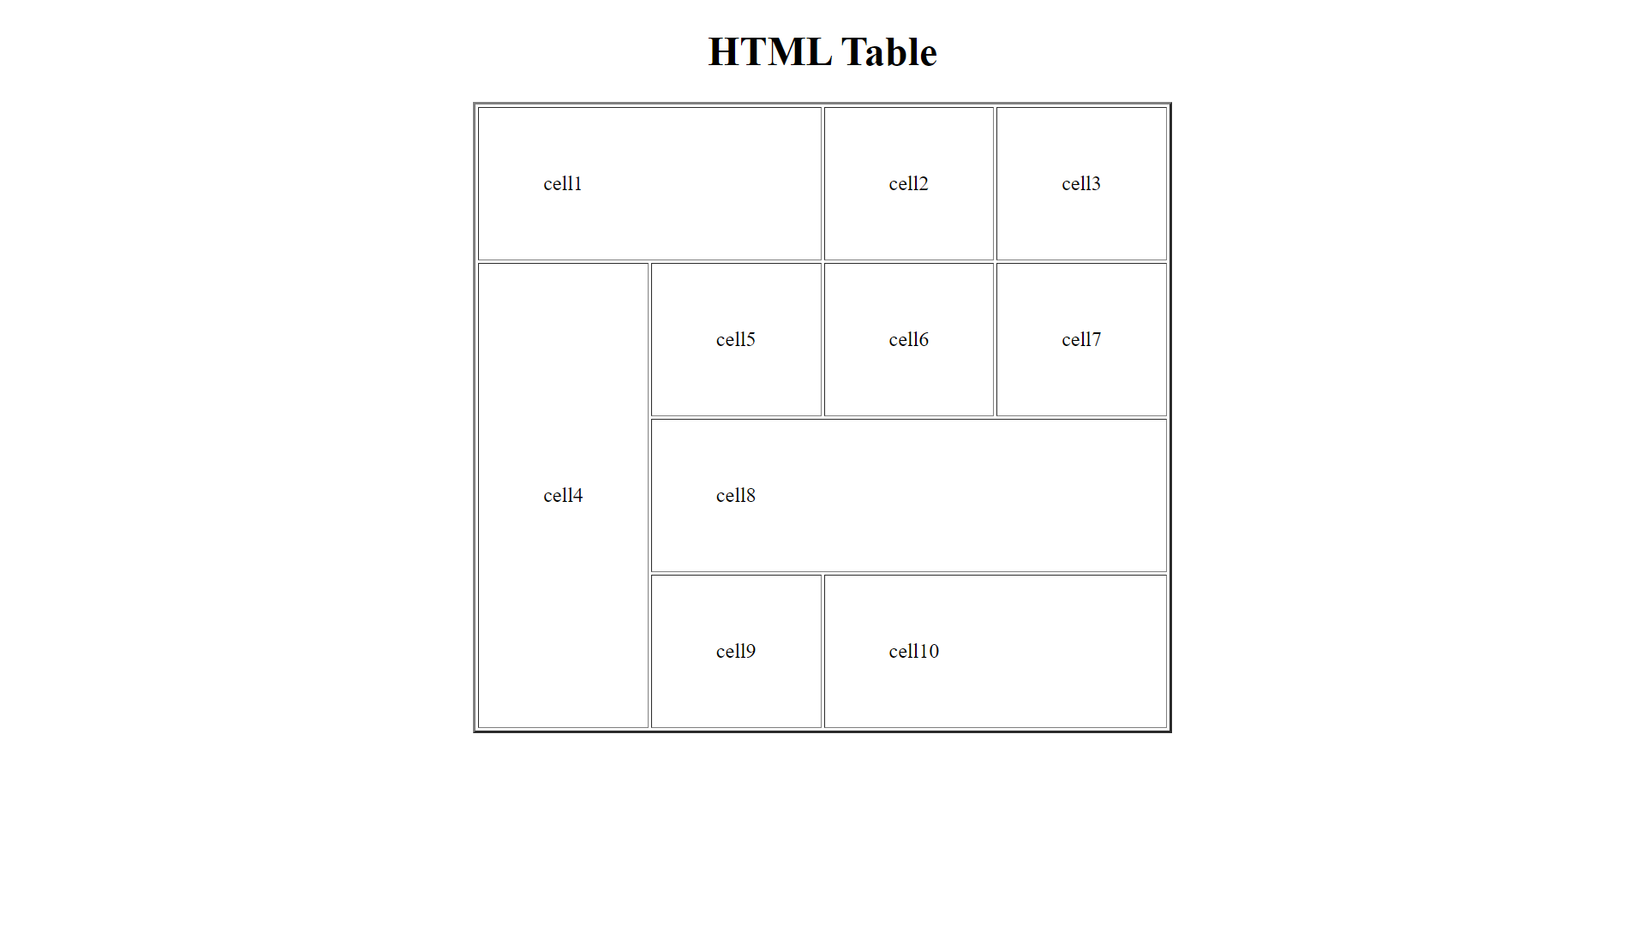

4. Create an HTML page to display the table as shown below. [use colgroup attribute]

<!DOCTYPE html>

<html lang="en">

<head>

    <meta charset="UTF-8">

    <meta name="viewport" content="width=device-width, initial-scale=1.0">

    <title>P4</title>

    <style>

        tr, td{

            padding: 20px;

        }

    </style>

</head>

<body>

    <center><h1>Example of Colgroup Tag</h1></center>

    <center>

        <table>

            <colgroup>

                <col style="background-color: green">

                <col span="2" style="background-color:red">

            </colgroup>

            <tr>

                <th>Sr.no</th>

                <th>Product</th>

                <th>Price</th>

            </tr>

            <tr>

                <td>1</td>

                <td>Rice</td>

                <td>85</td>

            </tr>

            <tr>

                <td>2</td>

                <td>Butter</td>

                <td>260</td>

            </tr>

            <tr>

                <td>3</td>

                <td>Mango</td>

                <td>125</td>

            </tr>

        </table>

    </center>

</body>

</html>

**Output:**

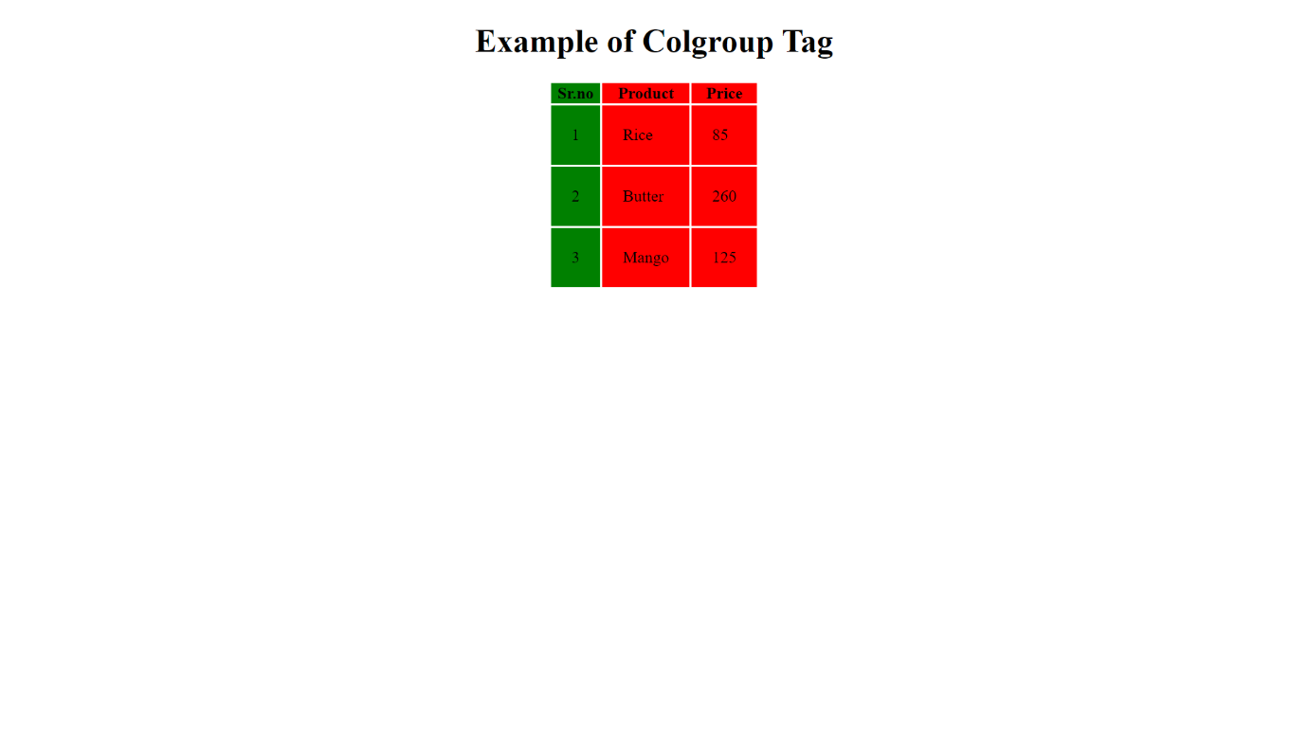

5. Create an HTML page to display the nested table as shown below [use border and border color attribute]

<!DOCTYPE html>

<html lang="en">

<head>

    <meta charset="UTF-8">

    <meta name="viewport" content="width=device-width, initial-scale=1.0">

    <title>P5</title>

    <style>

        tr, td{

            padding: 50px;

        }

        .b1{

            border-color: green;

        }

        .b2{

            border-color: blue;

        }

    </style>

</head>

<body>

    <center>

        <table border="5px" class="b1">

            <tr>

                <td>Table1</td>

                <td>

                    <table border="2px" class="b2">

                        <caption>Table1</caption>

                        <tr>

                            <td>Table2</td>

                            <td>Table2</td>

                        </tr>

                        <tr>

                            <td>Table2</td>

                            <td>Table2</td>

                        </tr>

                    </table>

                </td>

            </tr>

            <tr>

                <td>Table1</td>

                <td>Table1</td>

            </tr>

        </table>

    </center>

</body>

</html>

**Output:**

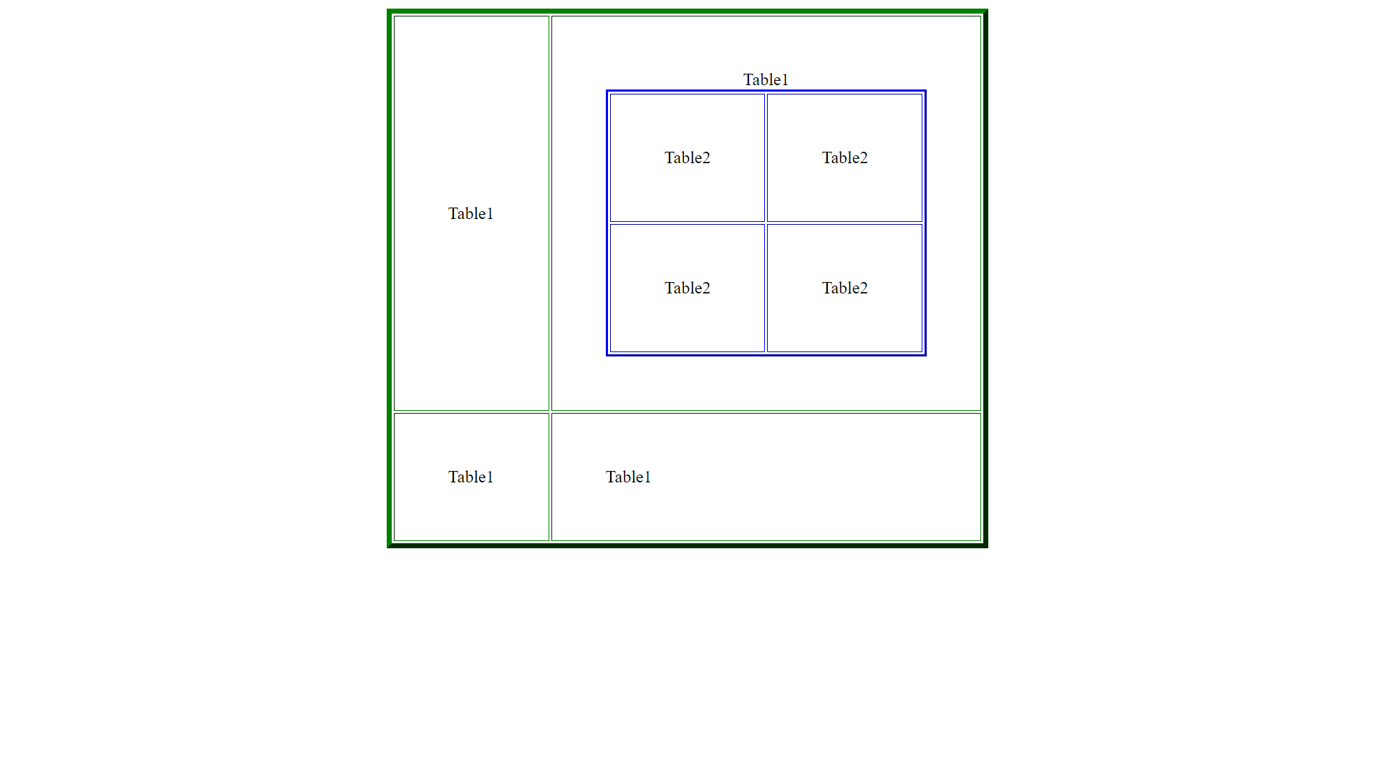

6. Create an HTML page to display unordered list as shown below

<!DOCTYPE html>

<html lang="en">

<head>

    <meta charset="UTF-8">

    <meta name="viewport" content="width=device-width, initial-scale=1.0">

    <title>P6</title>

</head>

<body>

    <h2>Hello Users!........</h2>

    <h2>The following list uses the Square mark in front of list items.</h2>

    <ul>

        <li type="Square">Cars</li>

        <li type="Square">bikes</li>

        <li type="Square">Aeroplanes</li>

        <li type="Square">ships</li>

    </ul>

    <h2>The following list uses the Circle mark in front of list items.</h2>

    <ul>

        <li type="Circle">BMW</li>

        <li type="Circle">Audi</li>

        <li type="Circle">Mercedes</li>

        <li type="Circle">Jaguar</li>

        <li type="Circle">Lamborghini</li>

    </ul>

    <h2>The following list uses the Disc mark in front of list items.</h2>

    <ul>

        <li type="Disc">Apache</li>

        <li type="Disc">KTM</li>

        <li type="Disc">R15</li>

        <li type="Disc">Ducati</li>

        <li type="Disc">Harley-Davidson</li>

    </ul>

</body>

</html>

**Output:**

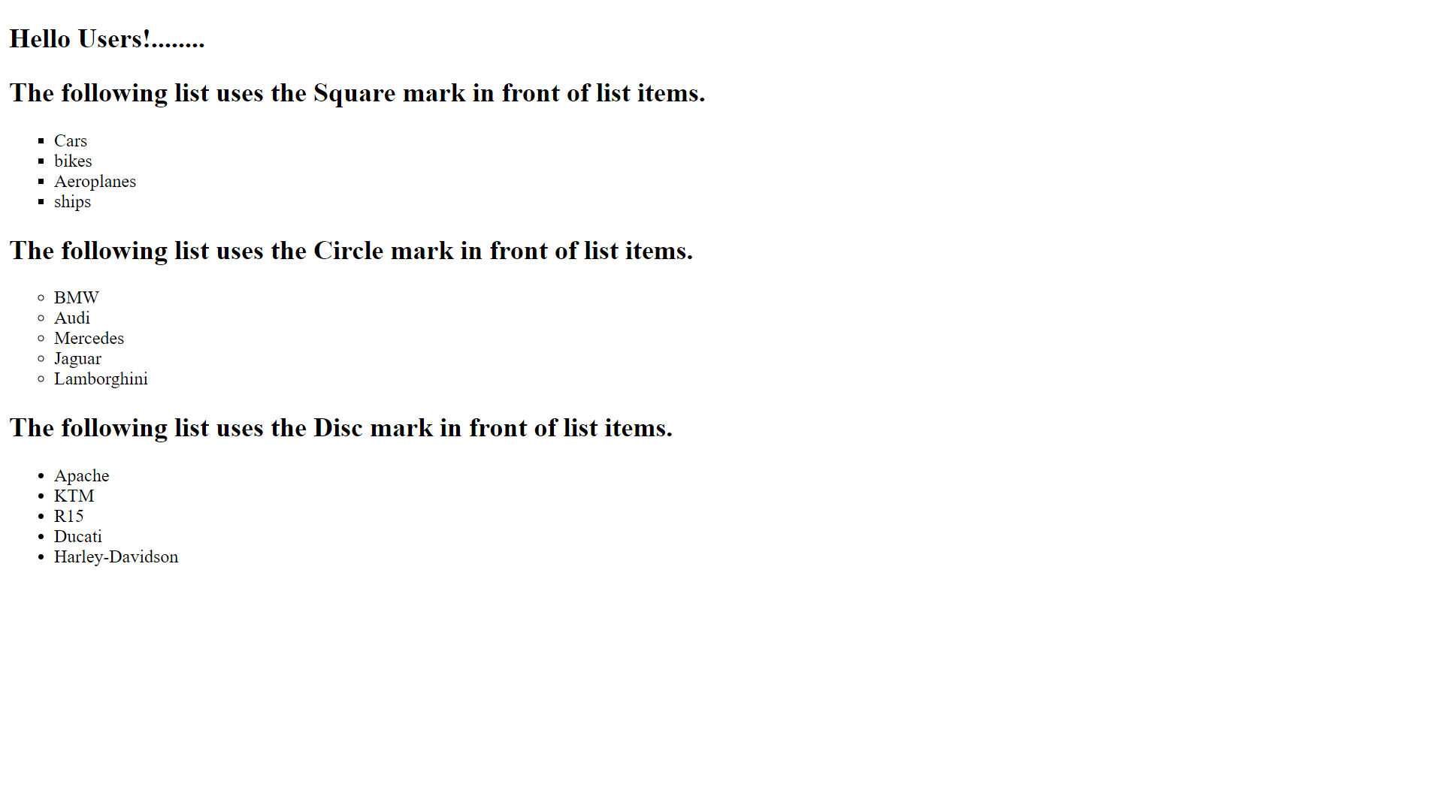

7. Create an HTML page to display ordered list as shown below

<!DOCTYPE html>

<html lang="en">

<head>

    <meta charset="UTF-8">

    <meta name="viewport" content="width=device-width, initial-scale=1.0">

    <title>P7</title>

</head>

<body>

    <h1>Welcome to YumYumCart</h1>

    <h2>YumYumCart Ice Cream Menu</h2>

    <h3>Ice Cream</h3>

    <ol>

        <li>Oreo ice cream</li>

        <li>Chocolate ice cream</li>

    </ol>

    <h3>Gelato</h3>

    <ol type="A">

        <li>Blueberry Gelato</li>

        <li>Apple Gelato</li>

    </ol>

    <h3>Sorbet</h3>

    <ol type="a">

        <li>Sweet chilly Sorbet</li>

        <li>Green apple Sorbet</li>

    </ol>

    <h3>Rolled ice Cream</h3>

    <ol type="I">

        <li>Black Rolled ice cream</li>

        <li>Coffee Rolled ice cream</li>

    </ol>

    <h3>Mochi</h3>

    <ol type="i">

        <li>Macha Mochi</li>

        <li>Mango Mochi</li>

    </ol>

</body>

</html>

**Output:**

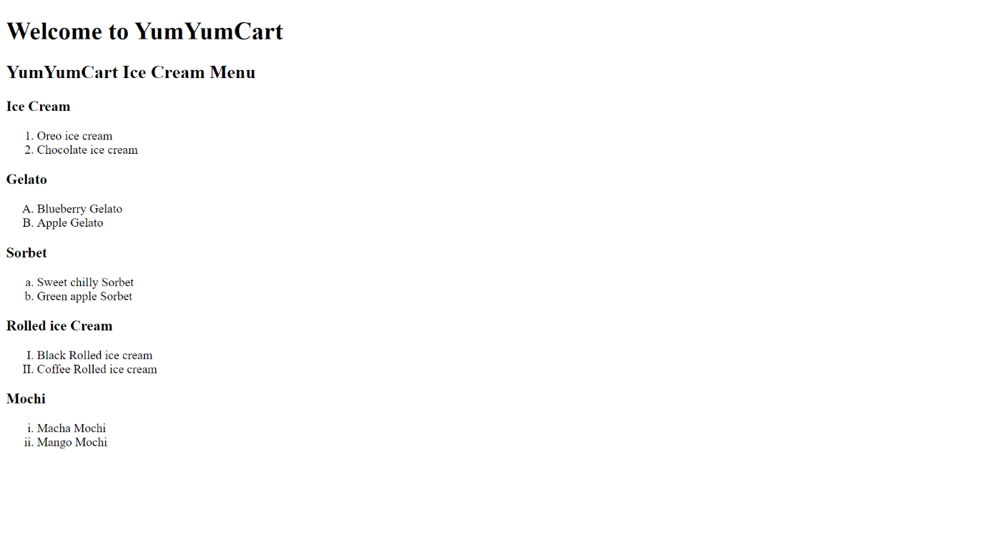

8. Create an HTML page to display definition list as shown below

<!DOCTYPE html>

<html>

<head>

    <title>P8</title>

</head>

<body>

    <dl>

        <dt>HTML</dt>

        <dd>is a HyperText Markup Language</dd>

        <dt>CSS</dt>

        <dd>is a programming language and platform.</dd>

        <dt>JavaScript</dt>

        <dd>is a scripting language</dd>

        <dt>SQL</dt>

        <dd>is a query language</dd>

    </dl>

</body>

</html>

**Output:**

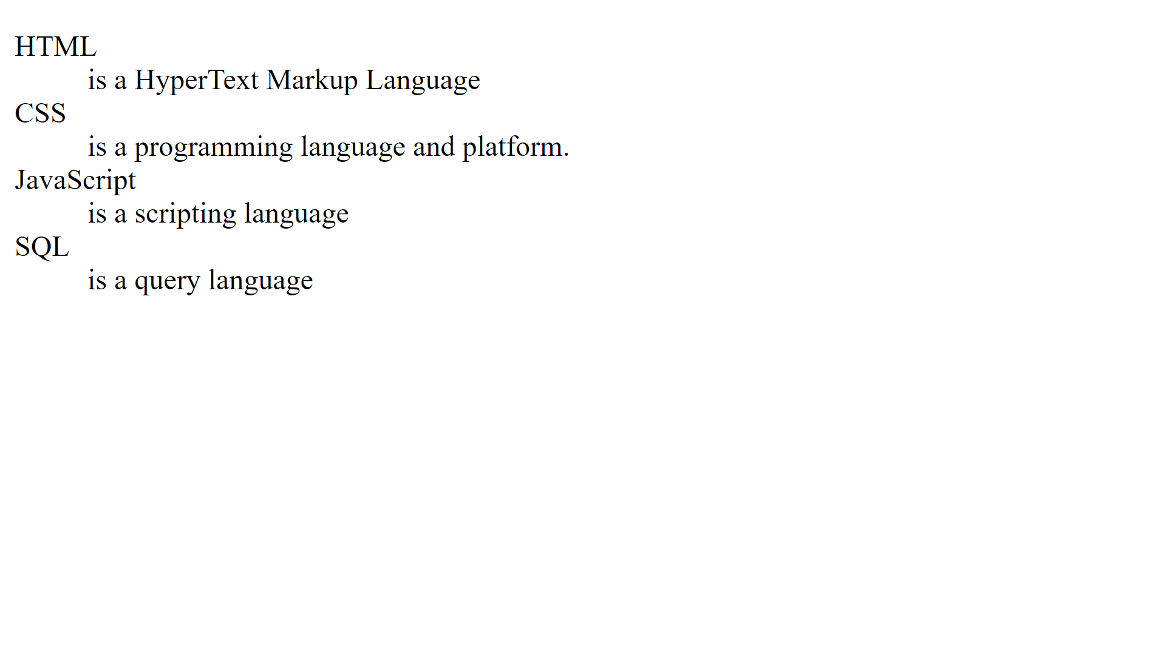

9. Create an HTML page to display nested unordered list as shown below

<!DOCTYPE html>

<html lang="en">

<head>

    <meta charset="UTF-8">

    <meta name="viewport" content="width=device-width, initial-scale=1.0">

    <title>P9</title>

</head>

<body>

    <h2>

    <ul>

        <li>Fruits</li>

        <ul>

            <li type="Circle">Mango</li>

            <li type="Circle">Orange</li>

        </ul>

        <li>Vegetables</li>

        <ul>

            <li type="Circle">Cabbage</li>

            <li type="Circle">Capsicum</li>

            <ul>

                <li type="Square">Green Capsicum</li>

                <li type="Square">Yellow Capsicum</li>

                <li type="Square">Red Capsicum</li>

            </ul>

        </ul>

    </ul></h2>

</body>

</html>

**Output:**

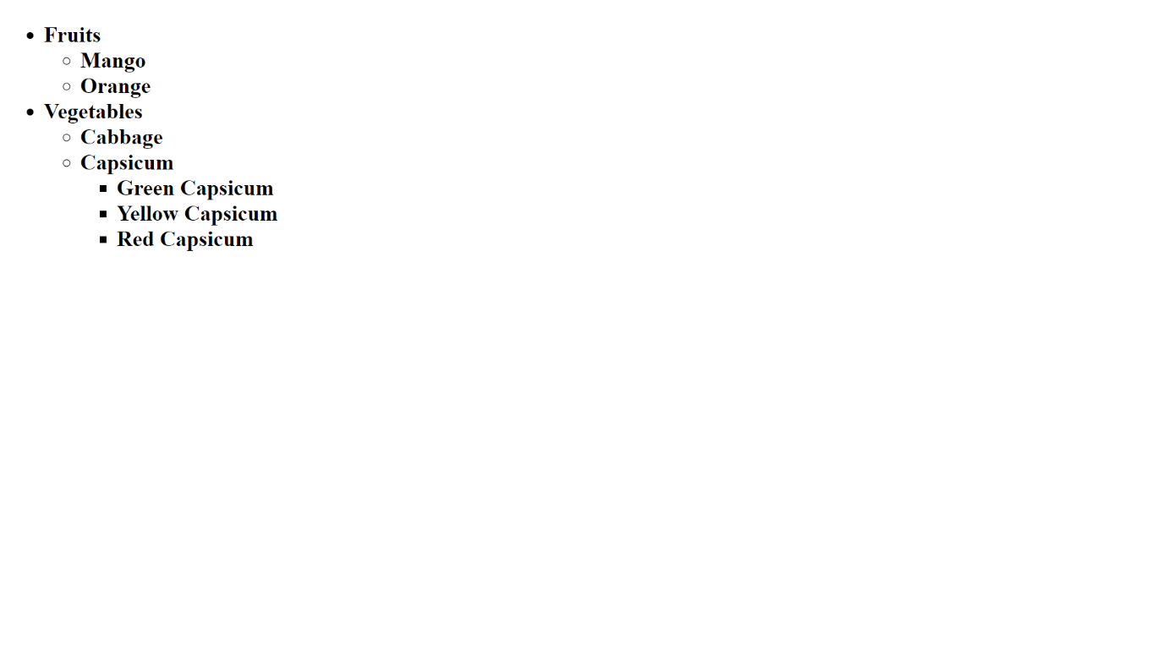

10. Create an HTML page to display nested ordered list as shown below

<!DOCTYPE html>

<html lang="en">

<head>

    <meta charset="UTF-8">

    <meta name="viewport" content="width=device-width, initial-scale=1.0">

    <title>P10</title>

</head>

<body>

    <h2><u><ol>

        <li>Unordered Lists</li>

        <li>Ordered List</li>

        <ol>

            <li>Changeing Numbering</li>

            <ol>

                <li>1.1.1 Creating a Countdown list</li>

                <li>1.1.2 Starting a List on a specific number</li>

                <li>1.1.3 Changeing the Numbering style</li>

            </ol>

        </ol>

        <li>Description Lists</li>

        <li>Nested Lists</li>

        <li>Using Lists for Menus</li>

        <ol>

            <li>Menus</li>

            <li>Lists</li>

        </ol>

        <li>Styeling Lists</li>

        <li>Closing Thoughts</li>

    </ol></u></h2>

</body>

</html>

**Output:**

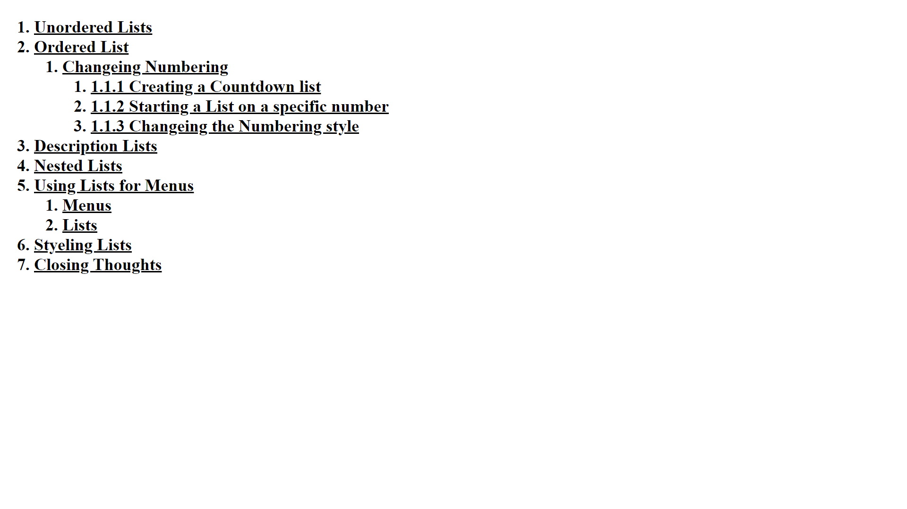

11. Create an HTML page to display ordered list as shown below

<!DOCTYPE html>

<html lang="en">

<head>

    <meta charset="UTF-8">

    <meta name="viewport" content="width=device-width, initial-scale=1.0">

    <title>P11</title>

</head>

<body>

    <h1>HTML5's Reverse Ordered Lists</h1>

    <p>(The list below is just a normal reversed list)</p>

    <h2><ol reversed>

        <li>List item one</li>

        <li>List item two</li>

        <li>List item three</li>

    </ol></h2>

    <p>(The list below has two nested lists: one reversed, one not)</p>

    <h2>

        <ol reversed>

            <li>List item one</li>

            <li>List item two</li>

            <ol reversed>

                <li>Nested one</li>

                <li>Nested two</li>

                <li>Nested three</li>

                <li>Nested four</li>

            </ol>

            <li>List item three</li>

            <li>List item four</li>

            <li>List item five</li>

            <ol>

                <li>Nested one</li>

                <li>Nested two</li>

                <li>Nested three</li>

                <li>Nested four</li>

            </ol>

            <li>List item six</li>

            <li>List item seven</li>

        </ol>

    </h2>

</body>

</html>

**Output:**

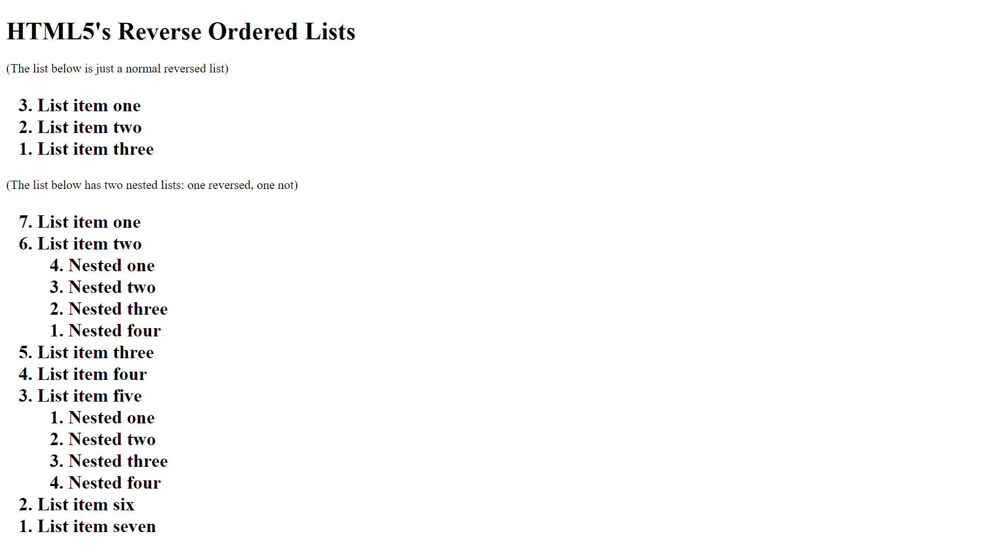

12. Create an HTML page to display images in table as shown below.

<!DOCTYPE html>

<html lang="en">

<head>

    <meta charset="UTF-8">

    <meta name="viewport" content="width=device-width, initial-scale=1.0">

    <title>12</title>

</head>

<body>

    <table border="2px">

        <tr>

            <th>Name</th>

            <th>Image</th>

            <th>Category</th>

        </tr>

        <tr>

            <td>Sparrow</td>

            <td><img src="2.png" height="100px" width="100px" alt="1.png"></td>

            <td>Bird</td>

        </tr>

        <tr>

            <td>Peacock</td>

            <td><img src="3.png" height="100px" width="100px" alt="1.png"></td>

            <td>Bird</td>

        </tr>

        <tr>

            <td>Rabbit</td>

            <td><img src="4.png" height="100px" width="100px" alt="1.png"></td>

            <td>Animal</td>

        </tr>

        <tr>

            <td>Cat</td>

            <td><img src="5.png" height="100px" width="100px" alt="1.png"></td>

            <td>Animal</td>

        </tr>

    </table>

</body>

</html>

**Output:**

