Practical - 10

Operators Function and Array in JavaScript

1. Write a javascript to test the following arithmetic[ +, -,\*,/,%] and comparison operators

[==, !=, >, <, >=, <=]

<!DOCTYPE html>

<html lang="en">

<head>

    <meta charset="UTF-8">

    <meta name="viewport" content="width=device-width, initial-scale=1.0">

    <title>Document</title>

</head>

<body>

    <script>

        let num1 = 10;

        let num2 = 5;

        document.write("<h3>Arithmetic Operators:</h3>");

        document.write("Addition : " + (num1 + num2) + "<br>");

        document.write("Subtraction : " + (num1 - num2) + "<br>");

        document.write("Multiplication : " + (num1 \* num2) + "<br>");

        document.write("Division : " + (num1 / num2) + "<br>");

        document.write("Modulus : " + (num1 % num2) + "<br>");

        let a = 10;

        let b = 5;

        document.write("<h3>Comparison Operators:</h3>");

        document.write("Equal : " + (a == b) + "<br>");

        document.write("Not Equal : " + (a != b) + "<br>");

        document.write("Greater Than : " + (a > b) + "<br>");

        document.write("Less Than : " + (a < b) + "<br>");

        document.write("Greater Than or Equal : " + (a >= b) + "<br>");

        document.write("Less Than or Equal : " + (a <= b) + "<br>");

    </script>

</body>

</html>

Output :

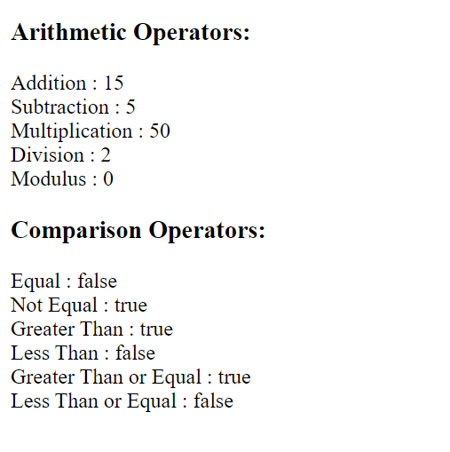

2. Write a function to reverse a given number.

<!DOCTYPE html>

<html lang="en">

<head>

    <meta charset="UTF-8">

    <meta name="viewport" content="width=device-width, initial-scale=1.0">

    <title>Document</title>

</head>

<body>

    <script>

        function reverseNum(n) {

            return parseInt(n.toString().split('').reverse().join(''), 10);

        }

        const num = 12345;

        const reversed = reverseNum(num);

        document.write("Original: " + num + "<br>");

        document.write("Reversed: " + revNum(num));

    </script>

</body>

</html>

Output :



3. Write a javascript to check global and local scope of a variable.

<!DOCTYPE html>

<html lang="en">

<head>

    <meta charset="UTF-8">

    <meta name="viewport" content="width=device-width, initial-scale=1.0">

    <title>Document</title>

</head>

<body>

    <script>

        var a = "Global";

        function checkScope() {

            var b = "Local";

            document.write("Inside function: " + b + "<br>");

            document.write("Inside function: " + a + "<br>");

        }

        document.write("Outside function: " + a + "<br>");

        // This line throw error.

        // document.write("Outside function: " + b + "<br>");

        checkScope();

    </script>

</body>

</html>

Output :

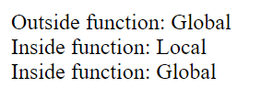

4. Write a recursive function to calculate factorial of a number.

<!DOCTYPE html>

<html lang="en">

<head>

    <meta charset="UTF-8">

    <meta name="viewport" content="width=device-width, initial-scale=1.0">

    <title>Document</title>

</head>

<body>

    <script>

        function f(n) {

            if (n === 0 || n === 1) return 1;

            else return n \* f(n - 1);

        }

        const num = 5;

        document.write(`Factorial of ${num} is: ${f(num)}`);

    </script>

</body>

</html>

Output :

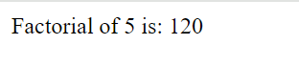

5. Write a JavaScript for passing a variable as a parameter to a function call, and another

that passes the return value of a function directly to the parameters of another function

[Hint perform multiplication of two numbers]

<!DOCTYPE html>

<html lang="en">

<head>

    <meta charset="UTF-8">

    <meta name="viewport" content="width=device-width, initial-scale=1.0">

    <title>Document</title>

</head>

<body>

    <script>

        function m(a, b) { return a \* b; }

        function s(x) { return x \* x; }

        const n1 = 3;

        const n2 = 4;

        document.write(`Multiplication result: ${m(n1, n2)}<br>`);

        const n3 = 5;

        document.write(`Squared multiplication result: ${s(m(n3, 2))}`);

    </script>

</body>

</html>

Output :

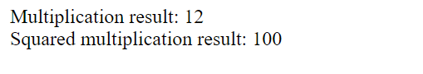

6. Write a javascript to add two numbers using form and textbox as shown below : [hint use

a=document.getElementById(id of textbox).value to refer the value inputted by user.

For display of result use document.getElementById(id of textbox).value = s]

<!DOCTYPE html>

<html lang="en">

<head>

    <meta charset="UTF-8">

    <meta name="viewport" content="width=device-width, initial-scale=1.0">

    <title>Document</title>

</head>

<body>

    <form id="f">

        <label for="n1">Num 1: </label>

        <input type="text" id="n1" name="n1" required><br>

        <label for="n2">Num 2: </label>

        <input type="text" id="n2" name="n2" required><br>

        <input type="button" value="Add" onclick="a()">

    </form>

    <input type="text" id="r" readonly>

    <script>

        function a() {

            var n1 = parseFloat(document.getElementById('n1').value);

            var n2 = parseFloat(document.getElementById('n2').value);

            var s = n1 + n2;

            document.write(`Result: ${s}`);

        }

    </script>

</body>

</html>

Output :

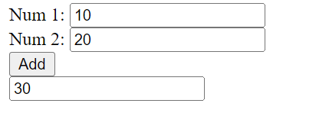

7. Write a javascript to print even numbers in a given array

<!DOCTYPE html>

<html lang="en">

<head>

    <meta charset="UTF-8">

    <meta name="viewport" content="width=device-width, initial-scale=1.0">

    <title>Document</title>

</head>

<body>

    <script>

        var numbers = [1, 2, 3, 4, 5, 6, 7, 8, 9, 10];

        for (const element of numbers) {

            if (element % 2 === 0) {

                document.write(element + '<br>');

            }

        }

    </script>

</body>

</html>

Output

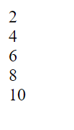

8. Write a Javascript to find the largest and smallest number in an array.

<!DOCTYPE html>

<html lang="en">

<head>

    <meta charset="UTF-8">

    <meta name="viewport" content="width=device-width, initial-scale=1.0">

    <title>Document</title>

</head>

<body>

    <script>

        var n = [5, 2, 8, 1, 7, 3, 9, 4, 6];

        var l = n[0];

        var s = n[0];

        for (var i = 1; i < n.length; i++) {

            if (n[i] > l) l = n[i];

            if (n[i] < s) s = n[i];

        }

        document.write("Largest: " + l + "<br>");

        document.write("Smallest: " + s);

    </script>

</body>

</html>

Output :

