Practical - 4

Implementing Link and Form in HTML

1. Design a simple webpage about your college. Create another webpage named address.html containing the college address. Give links from college page to address.htm.

<!DOCTYPE html>

<html>

<head>

    <title>My College</title>

</head>

<body>

    <ul>

        <li><a href="p4p1.html">Home</a></li>

        <li><a href="p4p1add.html">Address</a></li>

    </ul>

    <h2>About Our College</h2>

    <p>Welcome to our college. We are committed to providing quality education and a nurturing environment for our students.</p>

    <p>Explore the beautiful campus and discover our dedicated faculty and staff.</p>

</body>

</html>

<!DOCTYPE html>

<html>

<head>

    <title>College Address</title>

</head>

<body>

    <h1>College Address</h1>

    <ul>

        <li><a href="p4p1.html">Home</a></li>

        <li><a href="p4p1add.html">Address</a></li>

    </ul>

    <h2>College Address</h2>

    <p>College Road, Near to vaniyavad,Nadiad</p>

</body>

</html>

**Output :**

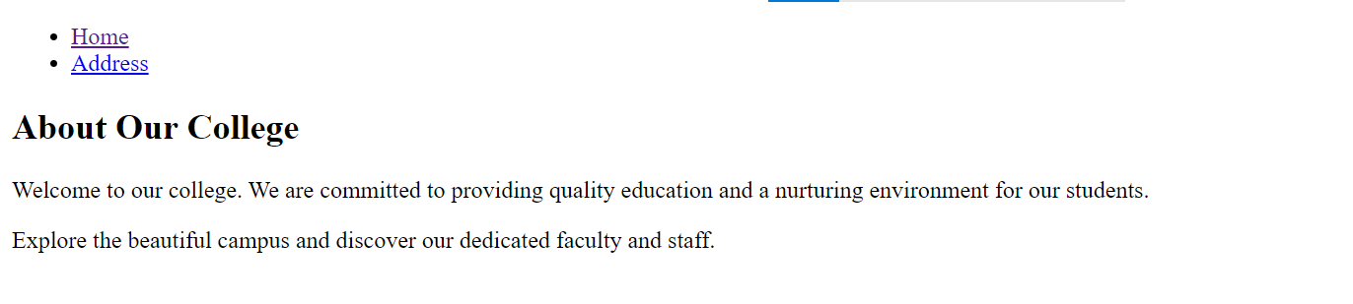

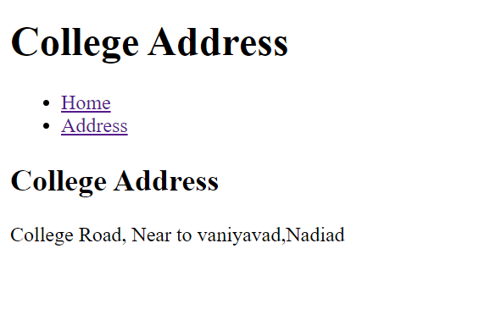

1. Design an attractive webpage about India. Provide details about the Indian freedom movement at the bottom of the webpage. Also create another webpage containing the list of states in India, named „states.html‟. Create two links in the main webpage – one to link to the bottom of the webpage where details about freedom movement is given and another to the webpage „states.html‟.

<!DOCTYPE html>

<html lang="en">

<head>

    <meta charset="UTF-8">

    <meta name="viewport" content="width=device-width, initial-scale=1.0">

    <title>P2</title>

</head>

<body>

    <a href="#freedom-movement">Freedom Movement</a>

    <a href="p4p2state.html">States of India</a>

    <h2>About us : India</h2>

    <p>India, with its rich history and diverse culture, is a land of endless wonders. Explore its beauty, heritage, and more.</p>

    <h2 id="freedom-movement">Indian Freedom Movement</h2>

    <p>

        The Indian freedom movement was a significant part of India's history, marked by the struggles, sacrifices, and determination of countless individuals who fought for India's independence from British colonial rule. It spanned several decades and culminated in India gaining independence on August 15, 1947.

    </p>

</body>

</html>

<!DOCTYPE html>

<html lang="en">

<head>

    <meta charset="UTF-8">

    <meta name="viewport" content="width=device-width, initial-scale=1.0">

    <title>P2State</title>

</head>

<body>

    <h1>States of India</h1>

    <ul>

        <li>Andhra Pradesh</li>

        <li>Arunachal Pradesh</li>

        <li>Assam</li>

        <li>Bihar</li>

        <li>Chhattisgarh</li>

        <li>Goa</li>

        <li>Gujarat</li>

        <li>Himachal Pradesh</li>

        <li>Jharkhand</li>

        <li>Karnataka</li>

        <li>Kerala</li>

        <li>Madhya Pradesh</li>

        <li>Maharashtra</li>

        <li>Manipur</li>

        <li>Meghalaya</li>

        <li>Mizoram</li>

        <li>Nagaland</li>

        <li>Odisha</li>

        <li>Punjab</li>

        <li>Rajasthan</li>

        <li>Sikkim</li>

        <li>Tamil Nadu</li>

        <li>Telangana</li>

        <li>Tripura</li>

        <li>Uttar Pradesh</li>

        <li>Uttarakhand</li>

        <li>West Bengal</li>

        <li>Haryana</li>

    </ul>

</body>

</html>

**Output :**

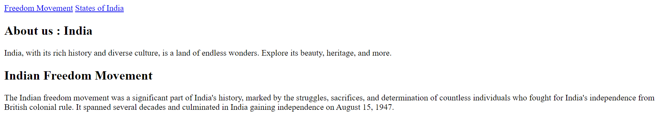

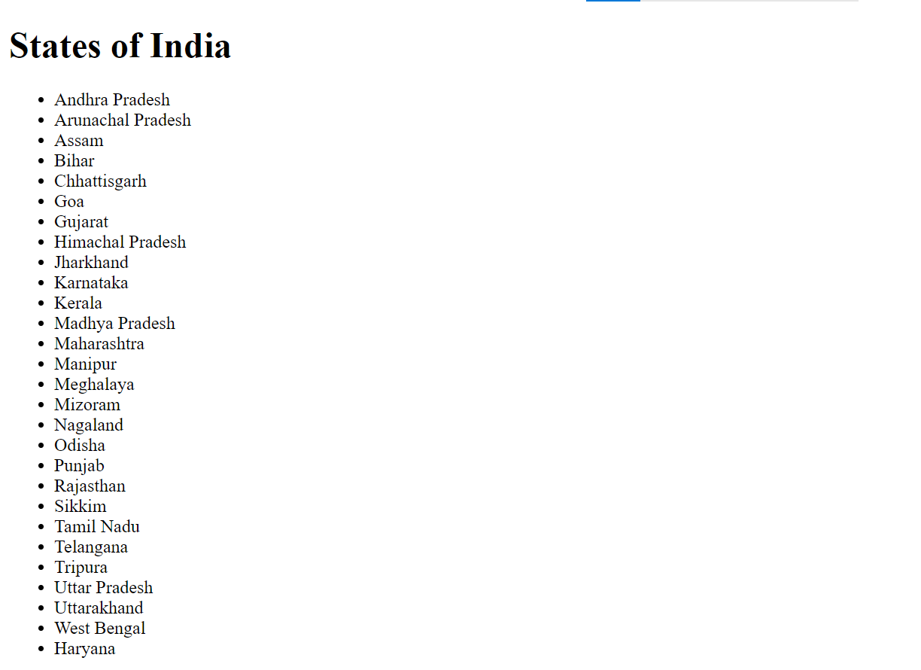

1. Create a HTML webpage about my family using hyperlink. On first page you have following link as shown below :

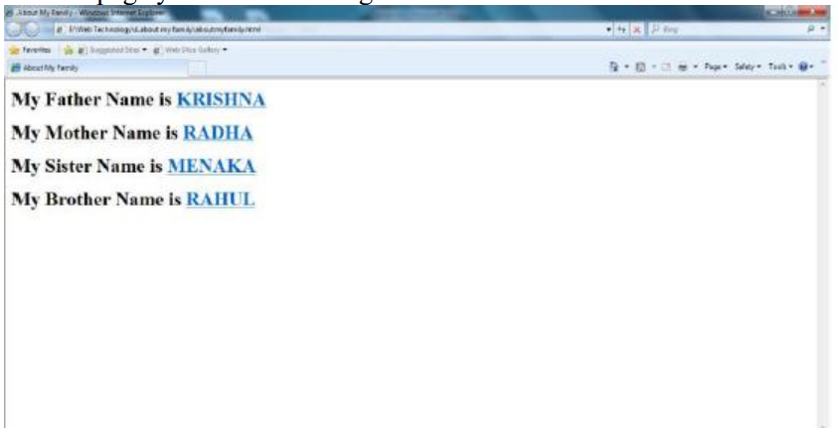

Now create father.html, mother.html, sister.html and brother.html. Each of these page would have image of family member with one line showing your family member‟s quality. For example “He is my father, a philospher and my mentor”. When the appropiate link is clicked the corresponding family member page whould be open.

<!DOCTYPE html>

<html lang="en">

<head>

    <meta charset="UTF-8">

    <meta name="viewport" content="width=device-width, initial-scale=1.0">

    <title>P4</title>

</head>

<body>

    <ul>

        <li>My Father Name is<a href="p4p3f.html">JagdishBhai</a></li>

        <li>My Mother Name is<a href="p4p3m.html">AshaBen</a></li>

        <li>My Sister Name is<a href="p4p3s.html">Nirali</a></li>

        <li>My Brother Name is<a href="p4p3b.html">Vivek</a></li>

    </ul>

</body>

</html>

<!DOCTYPE html>

<html lang="en">

<head>

    <meta charset="UTF-8">

    <meta name="viewport" content="width=device-width, initial-scale=1.0">

    <title>Brother</title>

</head>

<body>

    <h1>My Brother</h1>

    <img src="b.jpg" alt="Brother">

    <p>He is my brother, a fun-loving and reliable companion.</p>

    <a href="p4p3.html">Back to Family</a>

</body>

</html>

<!DOCTYPE html>

<html lang="en">

<head>

    <meta charset="UTF-8">

    <meta name="viewport" content="width=device-width, initial-scale=1.0">

    <title>Father</title>

</head>

<body>

    <h1>My Father</h1>

    <img src="f.jpg" alt="Father">

    <p>He is my father, a philosopher and my mentor.</p>

    <a href="p4p3.html">Back to Family</a>

</body>

</html>

<!DOCTYPE html>

<html lang="en">

<head>

    <meta charset="UTF-8">

    <meta name="viewport" content="width=device-width, initial-scale=1.0">

    <title>Mother</title>

</head>

<body>

    <h1>My Mother</h1>

    <img src="m.jpg" alt="Mother">

    <p>She is my mother, a caring and nurturing soul.</p>

    <a href="p4p3.html">Back to Family</a>

</body>

</html>

<!DOCTYPE html>

<html lang="en">

<head>

    <meta charset="UTF-8">

    <meta name="viewport" content="width=device-width, initial-scale=1.0">

    <title>Sister</title>

</head>

<body>

    <h1>My Sister</h1>

    <img src="s.jpg" alt="Sister">

    <p>She is my sister, a wonderful and supportive sibling.</p>

    <a href="p4p3.html">Back to Family</a>

</body>

</html>

**Output :**

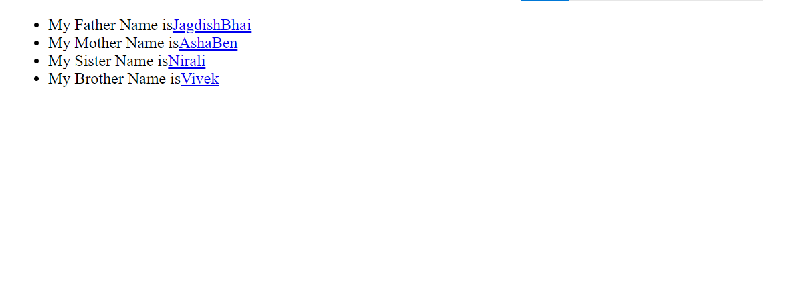

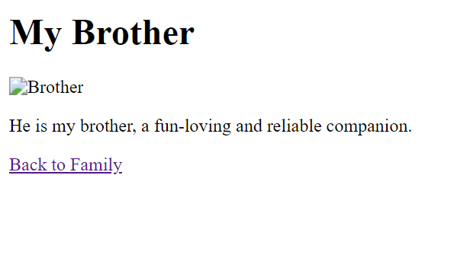

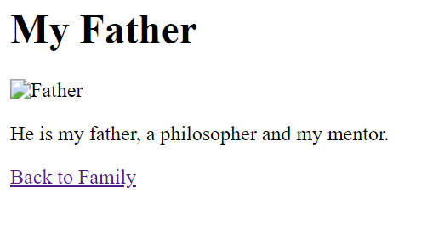

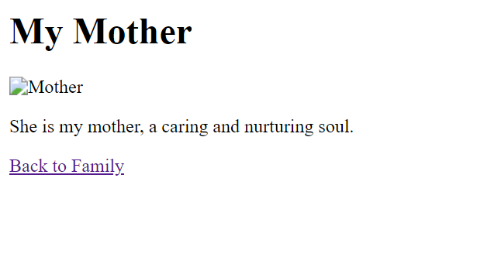

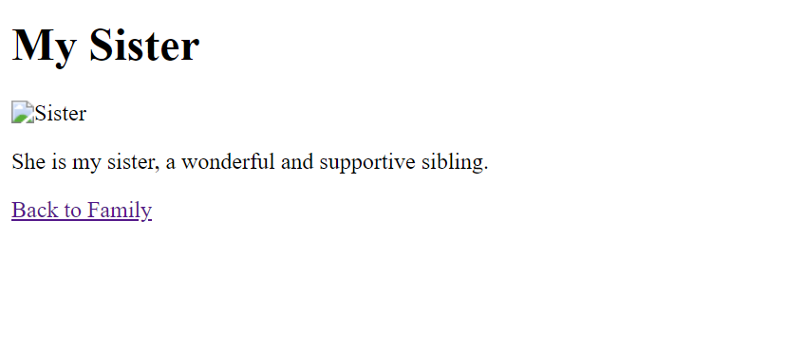

1. Create a web page with an appropriate image towards the left hand side of the page, when user clicks on the image another web page should open.

<!DOCTYPE html>

<html lang="en">

<head>

    <meta charset="UTF-8">

    <meta name="viewport" content="width=device-width, initial-scale=1.0">

    <title>P4</title>

</head>

<body>

    <p>Click the image to open a new page:</p>

    <a href="p4p4new.html"><img src="2.png" alt="Clickable Image" id="clickable-image"></a>

</body>

</html>

<!DOCTYPE html>

<html lang="en">

<head>

    <meta charset="UTF-8">

    <meta name="viewport" content="width=device-width, initial-scale=1.0">

    <title>New page</title>

</head>

<body>

    <h1>New Page</h1>

    <p>This is the content of the new page.</p>

    <p><a href="p4p4.html">Back to Main Page</a></p>

</body>

</html>

Output :

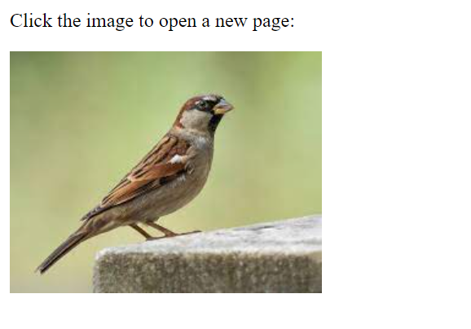

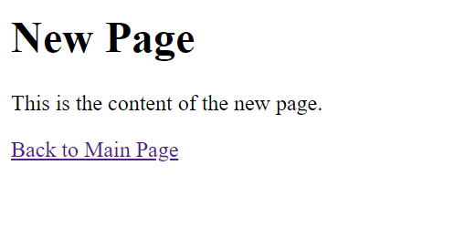

1. Write a HTML program for demonstrating Hyperlinks. Navigation within the page.

<!DOCTYPE html>

<html lang="en">

<head>

    <meta charset="UTF-8">

    <meta name="viewport" content="width=device-width, initial-scale=1.0">

    <title>P5</title>

</head>

<body>

    <ul>

        <li><a href="#main">Main Part</a></li>

        <li><a href="#about">About</a></li>

        <li><a href="#content">Contact</a></li>

    </ul>

    <h2 id="section1">Section 1</h2>

    <p>This is Section 1.</p>

    <p><a href="#main">Jump to Section 2</a></p>

    <h2 id="section2">Section 2</h2>

    <p>This is Section 2.</p>

    <p><a href="#about">Jump to Section 3</a></p>

    <h2 id="section3">Section 3</h2>

    <p>This is Section 3.</p>

    <p><a href="#content">Back to Section 1</a></p>

</body>

</html>

Output :

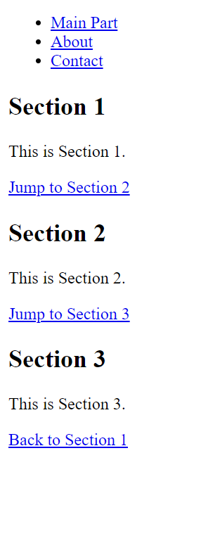

1. Write a HTML program to demonstrate all target attribute of tag.[ for example target : _self, _blank, _top, _parent, iframe]

<!DOCTYPE html>

<html lang="en">

<head>

    <meta charset="UTF-8">

    <meta name="viewport" content="width=device-width, initial-scale=1.0">

    <title>P6</title>

</head>

<body>

    <a href="https://www.google.com" target="_self">_self - Current Tab/Window</a><br>

    <a href="https://www.instagram.com" target="_top">_top - Top-level Browsing Context</a><br>

    <a href="https://www.flutterdev.com" target="_parent">_parent - Parent Browsing Context</a>

    <a href="https://www.linkdin.com" target="_blank">_blank - New Tab/Window</a><br>

    <iframe src="https://www.facebook.com"></iframe>

</body>

</html>

Output :

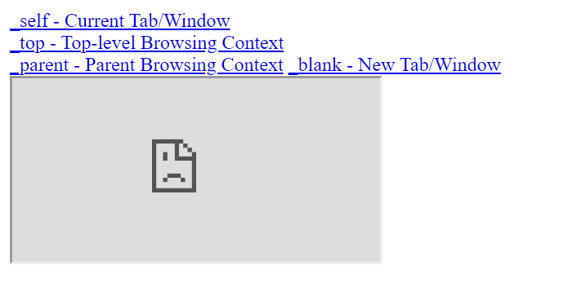

7. Create a web page for internal links; when the user clicks on different links on the web page it should go to the appropriate locations/sections in the same page. [Hint:

1. First give name for the each section of the page by using name attribute of the tag (i.e )

2. To provide link for the sections use href=”#name of section” in tag.

3. The ouput is shown below:

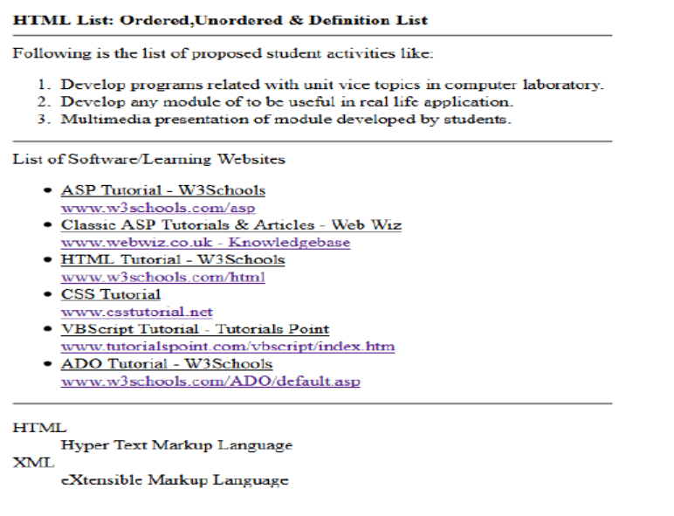

<!DOCTYPE html>

<html lang="en">

<head>

    <meta charset="UTF-8">

    <meta name="viewport" content="width=device-width, initial-scale=1.0">

    <title>Document</title>

</head>

<body>

    <h1>HTML List: Ordered,Unordered & Definition List</h1>

    <hr>

    Following is the list of proposed student activities like:

    <ol>

        <li>Develop programs related with unit vice topic in computer laboratory.</li>

        <li>Develop any module of to be useful in real life application.</li>

        <li>Multimedia presentation of module developed by students.</li>

    </ol>

    <hr>

    List of Software/Learning Websites

    <ul>

        <li>ASP Tutorial - W3Schools <br>

        <a href="#w3school">www.w3schools.com/asp</a>

        </li>

        <li>Classic ASP Tutorials & Articles - Web Wiz <br>

        <a href="#webwiz">www.w3schools.com/asp</a>

        </li>

        <li>HTML Tutorial - W3Schools<br>

        <a href="#html">www.w3schools.com/html</a>

        </li>

        <li>CSS Tutorials <br>

        <a href="#css">www.csstutorial.net</a>

        </li>

        <li>VBScript Tutorial - Tutorials Point<br>

        <a href="#vb">www.tutorials.com/vbscript/index.htm</a>

        </li>

        <li>ADO Tutorial - W3Schools <br>

        <a href="#ado">www.w3schools.com/ADO/default.asp</a>

        </li>

    </ul>

    <hr>

    <dl>

        <dt>HTML</dt>

        <dd>is a markup language</dd>

        <dt>XML</dt>

        <dd>eXtensible Markup Language</dd>

    </dl>

    <hr>

    <a id="w3school">

    <b><h4>Classic ASP Tutorials and Articles</h4></b>

    <p>So you want to learn Classic ASP, well hopefully you will find some of the tutorials and

    articles in this section of Web Wiz knowledgebase that you will find useful.</p>

    <p>Classic ASP Tutorials, Articles, and Applications</p>

    <pre>Creating Your First ASP Page

    Tutorial is for ASP newbies and shows how to create your first ASP page.

    Part 1: Connecting to an Access Database (Guestbook Pt.1)

    How to connect to an Access Database and display the contents in a web page.

    Part 2: Adding Data to an Access Database (Guestbook Pt.2)

    How to add new data to an Access Database through a web page form.

    Part 3: Deleting Data from an Access Database (Guestbook Pt.3)

    How to delete data from an Access Database from a web page.

    Part 4: Updating Data in an Access Database (Guestbook Pt.4)

    How to update data in an Access Database from through a web page form.</pre>

    </a>

    <br><br><br><br><br><br><br><br><br>

    <a id="webwiz">

    <pre><b><h4>The ASP Technology</h4></b>

        ASP and ASP.NET are server side technologies.

        Both technologies enable computer code to be executed by an Internet server.

        When a browser requests an ASP or ASP.NET file, the ASP engine reads the file, executes any code in the file, and returns the result to the browser.

            Classic ASP - Active Server Pages

            ASP (aka Classic ASP) was introduced in 1998 as Microsoft's first server side scripting language.

            Classic ASP pages have the file extension .asp and are normally written in VBScript.

        <b>ASP.NET</b>

            ASP.NET was released in 2002 as a successor to Classic ASP.

            ASP.NET pages have the extension .aspx and are normally written in C# (C sharp).

            ASP.NET 4.6 is the latest official version of ASP.NET.

            ASP.NET 5 was expected to be an important redesign of ASP.NET.

            However, the development of ASP.NET 5 was stopped in favor of ASP.NET Core.

        <b><h3>ASP.NET Web Pages</h3></b>

        ASP.NET Web Pages is an SPA application model (Single Page Application).

        The SPA model is quite similar to PHP and Classic ASP.

        ASP.NET Web Pages is being merged into the new ASP.NET Core.</pre>

    <br><br><br><br><br><br><br><br><br>

    <a id="html">

    <pre><b><h4>What is HTML?</h4></b>

        HTML stands for Hyper Text Markup Language

        HTML is the standard markup language for creating Web pages

        HTML describes the structure of a Web page

        HTML consists of a series of elements

        HTML elements tell the browser how to display the content

        HTML elements label pieces of content such as "this is a heading", "this is a paragraph", "this is a link", etc.

        What is an HTML Element?

        An HTML element is defined by a start tag, some content, and an end tag </pre>

    <br><br><br><br><br><br><br><br><br>

    <a id="css">

    <pre><b><h4>CSS Tutorial</h4></b>

        CSS is an acronym for Cascading Style Sheet and it was created by HÃƒÂ¥kon Wium Lie in 1996 for

        the web developers to change the layout, colors, and fonts of their websites.

        CSS is a style sheet or presentational language that is used to layout, format, and

        style documents that are written in HTML to make them look beautiful. CSS is generally used with

        HTML to change the style of web pages and user interfaces. You can use CSS to change the color,

        backgrounds, borders, paddings, margins, fonts, icons, position and various other properties of

        HTML elements in a web document.

        This tutorial covers all the versions of CSS including CSS1, CSS2 and CSS3, and gives a complete

        understanding of CSS, starting from its basics to advanced concepts. This tutorial will teach you

        about CSS Box Model, Selectors, The cascade, Color, Sizing Units, Layout, Flexbox, Grid,

        Pseudo-elements and Pseudo-classes, Borders, Shadows, Focus, Functions, Gradients, Animations,

        Filters, Lists, Transitions, Overflow, Backgrounds, Text and typography. </pre>

    </a>

    <br><br><br><br><br><br><br><br><br>

    <a id="vb">

        <pre><b><h4>VBScript</h4></b>

        VBScript stands for Visual Basic Scripting that forms a subset of Visual Basic for Applications (VBA).

        VBA is a product of Microsoft which is included NOT only in other Microsoft products such as MS Project

        and MS Office but also in Third Party tools such as AUTO CAD.

        Features of VBScript

            VBScript is a lightweight scripting language, which has a lightning fast interpreter.

            VBScript, for the most part, is case insensitive. It has a very simple syntax, easy to learn and to implement.

            Unlike C++ or Java, VBScript is an object-based scripting language and NOT an Object-Oriented Programming language.

            It uses Component Object Model (COM) in order to access the elements of the environment in which it is executing.

        VBscript – Version History and Uses

            VBScript was introduced by Microsoft way back in 1996 and its first version was 1.0. The current stable version of VBScript is 5.8, which is available as part of IE8 or Windows 7.

            The VBScript usage areas are aplenty and not restricted to the below list.

            VBScript is used as a scripting language in one of the popular Automation testing tools – Quick Test

            Professional abbreviated as QTP

            VBScript is used for Client side scripting in Microsoft Internet Explorer.</pre>

</a>

<br><br><br><br><br><br><br><br><br>

<a id="ado">

<pre><b><h4>ADO</h4></b>

What you should already know Before you continue you should have a basic understanding of the following:

HTML

ASP

SQL

<b><h4>What is ADO?</h4></b>

ADO is a Microsoft technology

ADO stands for ActiveX Data Objects

ADO is a Microsoft Active-X component

ADO is automatically installed with Microsoft IIS

ADO is a programming interface to access data in a database

Accessing a Database from an ASP Page

<b><h4>The common way to access a database from inside an ASP page is to:</h4></b>

Create an ADO connection to a database

Open the database connection

Create an ADO recordset

Open the recordset

Extract the data you need from the recordset

Close the recordset

Close the connection</pre>

</a>

</body>

</html>

Output :

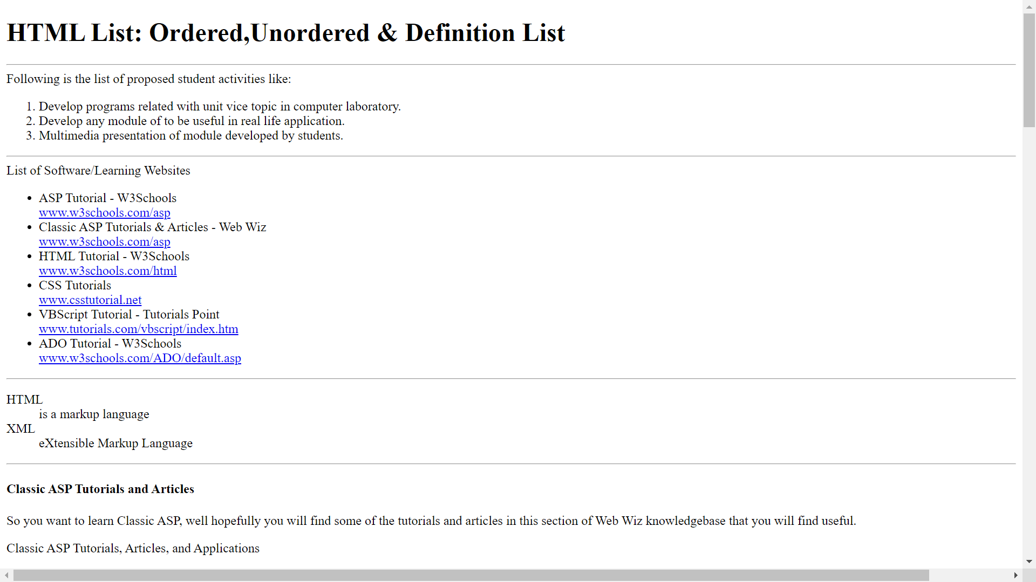

8. Consider that your school is hosting an inter-school IT fair. Design a form webpage that contains a form for accepting registrations. The form page should contain facility to enter school name, user name, password and a mobile phone number. It should also contain buttons for saving and clearing data entered.

<!DOCTYPE html>

<html lang="en">

<head>

    <meta charset="UTF-8">

    <meta name="viewport" content="width=device-width, initial-scale=1.0">

    <title>P8</title>

</head>

<body>

    <h1>Inter-School IT Fair Registration</h1>

    <form action="" method="post">

        <label for="schoolName">School Name:</label>

        <input type="text" id="schoolName" name="schoolName" required><br><br>

        <label for="userName">User Name:</label>

        <input type="text" id="userName" name="userName" required><br><br>

        <label for="password">Password:</label>

        <input type="password" id="password" name="password" required><br><br>

        <label for="phoneNumber">Mobile Phone Number:</label>

        <input type="tel" id="phoneNumber" name="phoneNumber" required><br><br>

        <input type="submit" value="Save">

        <input type="reset" value="Clear">

    </form>

</body>

</html>

Output :

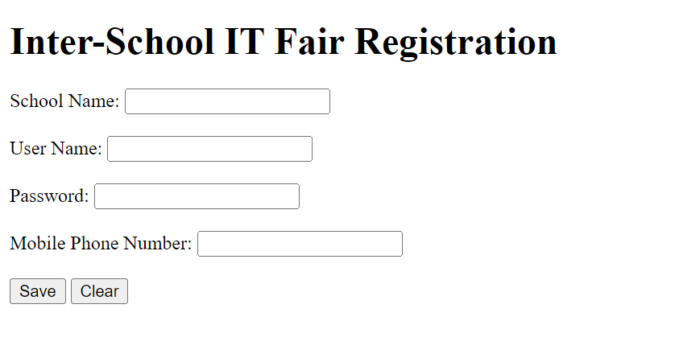

9. Create Registration Form shown as below

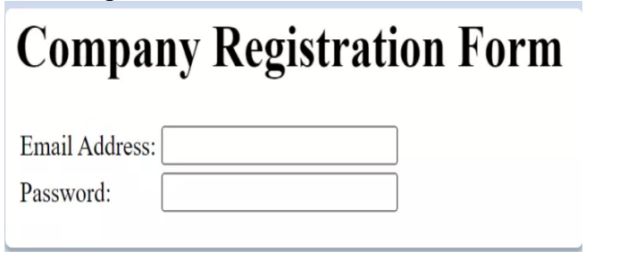

<!DOCTYPE html>

<html lang="en">

<head>

    <meta charset="UTF-8">

    <meta name="viewport" content="width=device-width, initial-scale=1.0">

    <title>P9</title>

</head>

<body>

    <h1>Company Registration Form</h1>

    <form action="" method="post">

        <label for="email">Email Address:</label>

        <input type="email" id="email" name="email" required><br><br>

        <label for="password">Password:</label>

        <input type="password" id="password" name="password" required><br><br>

        <input type="submit" value="Register">

    </form>

</body>

</html>

Output :

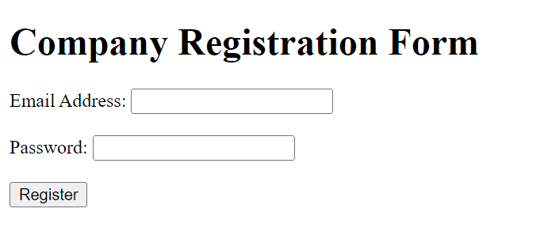

10. Create Employee Registration Form as shown below

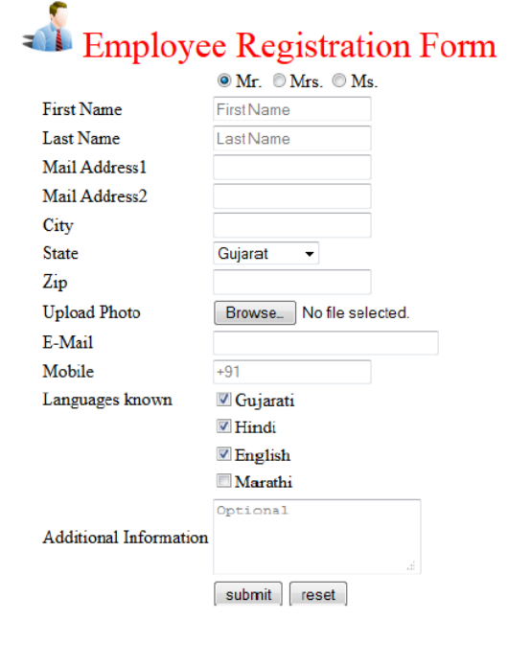

<!DOCTYPE html>

<html lang="en">

<head>

    <meta charset="UTF-8">

    <meta name="viewport" content="width=device-width, initial-scale=1.0">

    <title>Document</title>

</head>

<body>

    <table>

        <tr>

            <td><img src="person.jpg" height="100" width="100"></td>

            <td><h1 style="color: red;">Employee Registration Form</h1></td>

        </tr>

        </table>

        <table>

        <tr>

            <td> </td>

            <td><input type="radio" name="g1" value="mr">MR.

                <input type="radio" name="g1" value="mrs">Mrs.

                <input type="radio" name="g1" value="ms">Ms.</td>

        </tr>

        <tr>

            <td>First Name</td>

            <td><input type="text" placeholder="First Name"></td>

        </tr>

        <tr>

            <td>Last Name</td>

            <td><input type="text" placeholder="Last Name"></td>

        </tr>

        <tr>

            <td>Mail Address1</td>

            <td><input type="email"></td>

        </tr>

        <tr>

            <td>Mail Address2</td>

            <td><input type="email"></td>

        </tr>

        <tr>

            <td>City</td>

            <td><input type="text"></td>

        </tr>

        <tr>

            <td>State</td>

            <td><select>

                <option value="gujarat">Gujarat</option>

                <option value="maharashtra">Maharashtra</option>

                <option value="Assam">Assam</option>

                <option value="Punjab">Punjab</option>

            </select></td>

        </tr>

        <tr>

            <td>Zip</td>

            <td><input type="number"></td>

        </tr>

        <tr>

            <td>Upload Photo</td>

            <td><input type="file"></td>

        </tr>

        <tr>

            <td>Mail</td>

            <td><input type="email"></td>

        </tr>

        <tr>

            <td>Mobile</td>

            <td><input type="tel" placeholder="+91"></td>

        </tr>

        <tr>

            <td>Language Known</td>

            <td><input type="checkbox" name="chk1">Gujarati<br>

                <input type="checkbox" name="chk1">Hindi<br>

                <input type="checkbox" name="chk1">English<br>

                <input type="checkbox" name="chk1">Marathi

            </td>

        </tr>

        <tr>

            <td>Additional Information</td>

            <td><textarea placeholder="optional" rows="5"></textarea></td>

        </tr>

        <tr>

            <td></td>

            <td><input type="submit" value="Submit">

                <input type="reset" value="Reset"></td>

        </tr>

    </table>

</body>

</html>

Output :

