Practical - 5

Working with Multimedia in HTML

1. Design a simple webpage to whose output is shown below:



<!DOCTYPE html>

<html lang="en">

<head>

    <meta charset="UTF-8">

    <meta http-equiv="X-UA-Compatible" content="IE=edge">

    <meta name="viewport" content="width=device-width, initial-scale=1.0">

    <title>p1.html</title>

</head>

<body>

    <canvas id="myCanvas" height="500" width="500">

    </canvas>

    <script>

    const canvas = document.getElementById("myCanvas");

    const ctx = canvas.getContext("2d");

    ctx.beginPath();

    ctx.arc(120, 120, 50, 0, 2 * Math.PI);

    ctx.fillStyle ="#F5B23D ";

    ctx.fill();

    ctx.beginPath();

    ctx.rect(20, 30, 100, 100);

    ctx.fillStyle ="#73A1A6";

    ctx.fill();

</script>

</body>

</html>

**Output :**



1. Design a simple webpage to whose output is shown below:

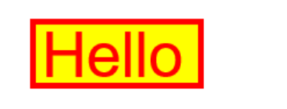

<!DOCTYPE html>

<html lang="en">

<head>

    <meta charset="UTF-8">

    <meta http-equiv="X-UA-Compatible" content="IE=edge">

    <meta name="viewport" content="width=device-width, initial-scale=1.0">

    <title>P2.html</title>

</head>

<body>

    <canvas id="myCanvas" height="80" width="200" style="border:2px solid red; background-color: #F8E608     ;">

    </canvas>

    <script>

    const canvas = document.getElementById("myCanvas");

    const ctx = canvas.getContext("2d");

    ctx.fillStyle =" #F80F08 ";

    ctx.font = "30px Arial";

    ctx.fillText("Hello World", 10, 50);

    ctx.fill();

</script>

</body>

</html>

**Output :**

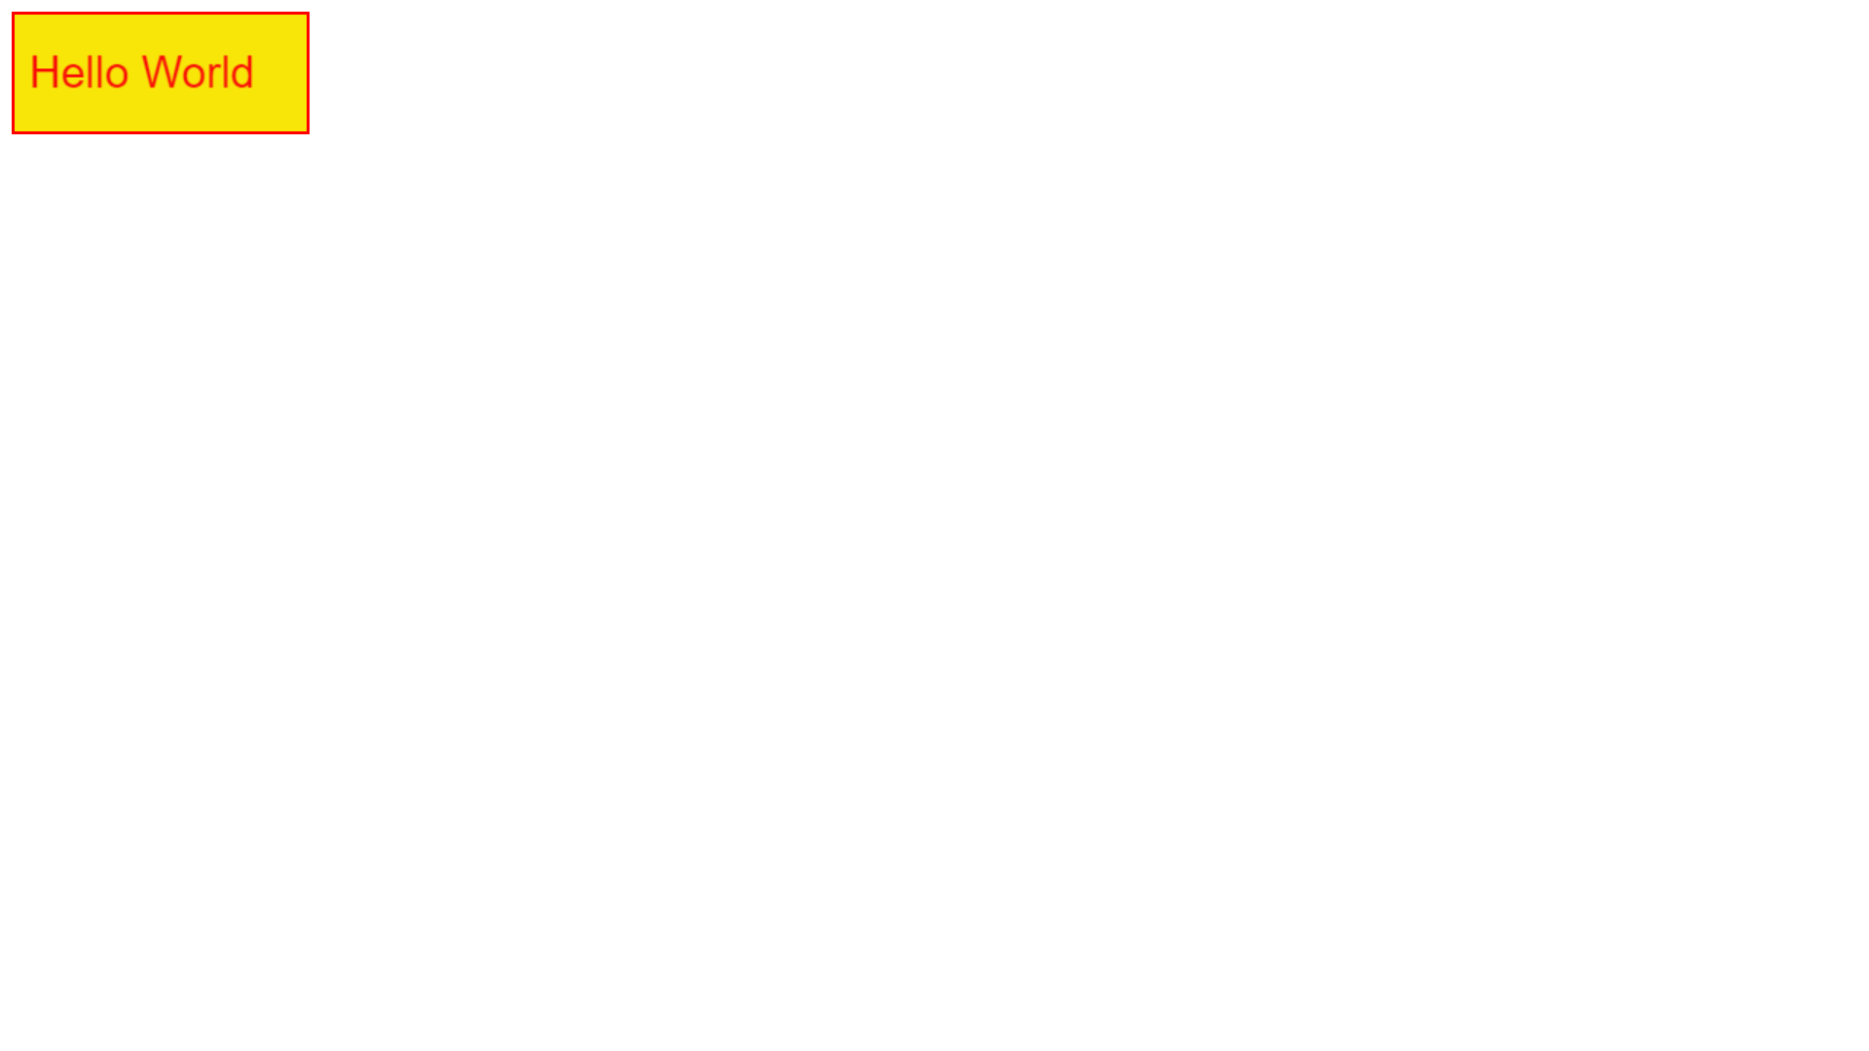

3. Let us take the same 200x200 pixel canvas. Draw a red rectangle and a green circle within the rectangle.

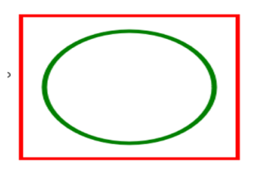

<!DOCTYPE html>

<html lang="en">

<head>

    <meta charset="UTF-8">

    <meta http-equiv="X-UA-Compatible" content="IE=edge">

    <meta name="viewport" content="width=device-width, initial-scale=1.0">

    <title>p3.html</title>

</head>

<body>

    <canvas id="myCanvas" width="200" height="200" style="border:2px solid #F80F08; "">

    </canvas>

    <script>

        var c = document.getElementById("myCanvas");

        var ctx = c.getContext("2d");

        ctx.beginPath();

        ctx.arc(100, 100, 80, 0, 2 * Math.PI);

        ctx.strokeStyle="#3D9E05 ";

        ctx.lineWidth = 5;

        ctx.stroke();

        </script>

</body>

</html>

**Output :**

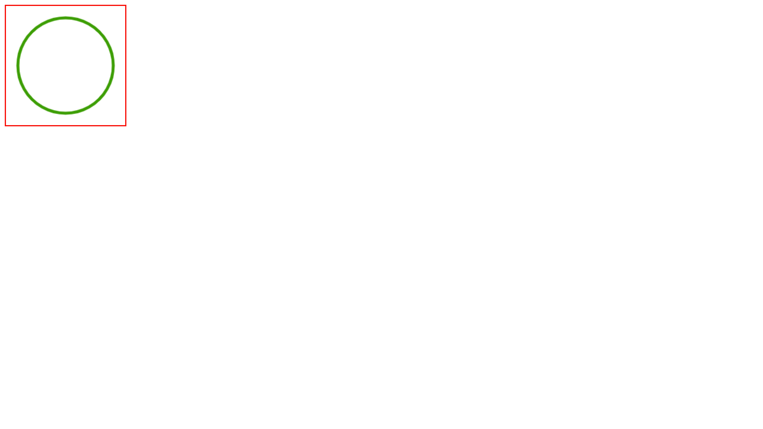

4. Design a simple webpage to whose output is shown below:

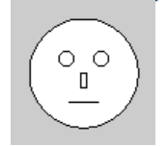

<!DOCTYPE html>

<html lang="en">

<head>

    <meta charset="UTF-8">

    <meta http-equiv="X-UA-Compatible" content="IE=edge">

    <meta name="viewport" content="width=device-width, initial-scale=1.0">

    <title>p4.html</title>

</head>

<body>

    <canvas id="myCanvas" width="200" height="200" style="border:2px solid #000000; background-color: gray;"">

    </canvas>

    <script>

        var c = document.getElementById("myCanvas");

        var ctx = c.getContext("2d");

        ctx.beginPath();

        ctx.arc(100, 100, 80, 0, 2 * Math.PI);

        ctx.strokeStyle="#000000";

        ctx.fillStyle="#FFFFFF";

        ctx.fill();

        ctx.stroke();

        ctx.beginPath();

        ctx.arc(70, 80, 20, 0, 2 * Math.PI);

        ctx.strokeStyle="#000000 ";

        ctx.stroke();

        ctx.beginPath();

        ctx.arc(130, 80, 20, 0, 2 * Math.PI);

        ctx.strokeStyle="#000000 ";

        ctx.stroke();

        ctx.beginPath();

        ctx.rect(95, 110, 10, 20);

        ctx.strokeStyle="#000000 ";

        ctx.stroke()

        ctx.beginPath();

        ctx.moveTo(65,150);

        ctx.lineTo(135, 150);

        ctx.stroke()

        </script>

</body>

</html>

**Output :**

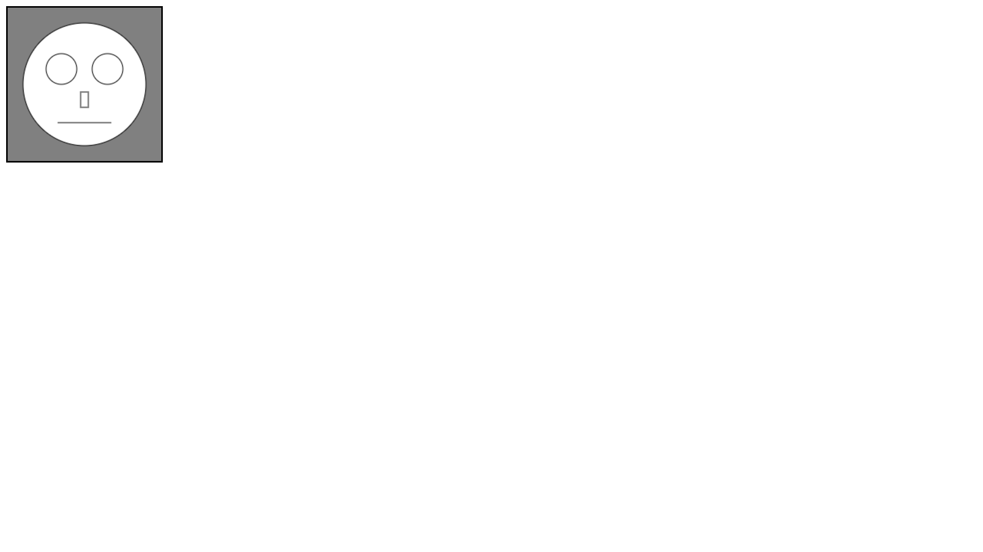

5. Design a simple webpage to whose output is shown below:

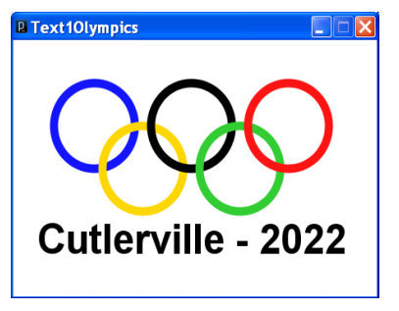

<!DOCTYPE html>

<html lang="en">

<head>

    <meta charset="UTF-8">

    <meta http-equiv="X-UA-Compatible" content="IE=edge">

    <meta name="viewport" content="width=device-width, initial-scale=1.0">

    <title>p5.html</title>

</head>

<body>

    <canvas id="myCanvas" width="500" height="300" style="border:2px solid #000000; "">

    </canvas>

    <script>

        var c = document.getElementById("myCanvas");

        var ctx = c.getContext("2d");

        ctx.beginPath();

        ctx.arc(100, 80, 50, 0, 2 * Math.PI);

        ctx.strokeStyle="#052A9E";

        ctx.lineWidth = 8;

        ctx.stroke();

        ctx.beginPath();

        ctx.arc(220, 80, 50, 0, 2 * Math.PI);

        ctx.strokeStyle="#000000 ";

        ctx.lineWidth = 8;

        ctx.stroke();

        ctx.beginPath();

        ctx.arc(340, 80, 50, 0, 2 * Math.PI);

        ctx.strokeStyle="#F50B0B";

        ctx.lineWidth = 8;

        ctx.stroke();

        ctx.beginPath();

        ctx.arc(160, 130, 50, 0, 2 * Math.PI);

        ctx.strokeStyle="#F5EE0B";

        ctx.lineWidth = 8;

        ctx.stroke();

        ctx.beginPath();

        ctx.arc(280, 130, 50, 0, 2 * Math.PI);

        ctx.strokeStyle="#1DF50B";

        ctx.lineWidth = 8;

        ctx.stroke();

        ctx.fillStyle =" #000000 ";

    ctx.font = "bold 40px Arial";

    ctx.fillText("Cutlerville - 2022", 100, 260);

        </script>

</body>

</html>

**Output :**

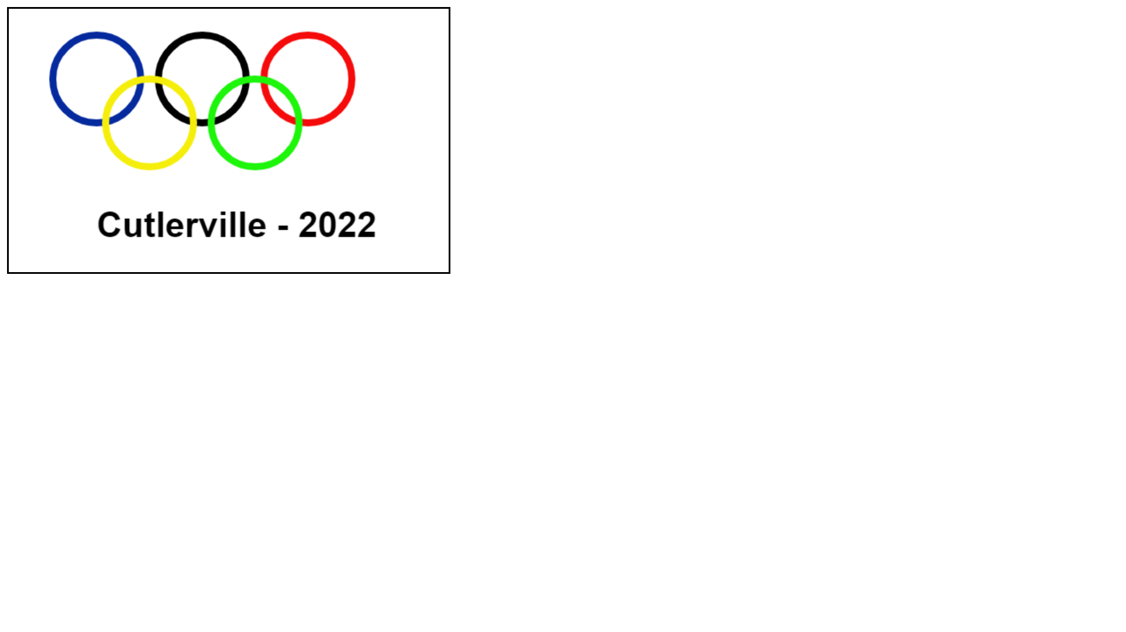

6. To create a web page which includes a map and display the related information when a hot spot is clicked in the map. [Hint three places New Delhi, Calcutta and TamilNadu ]

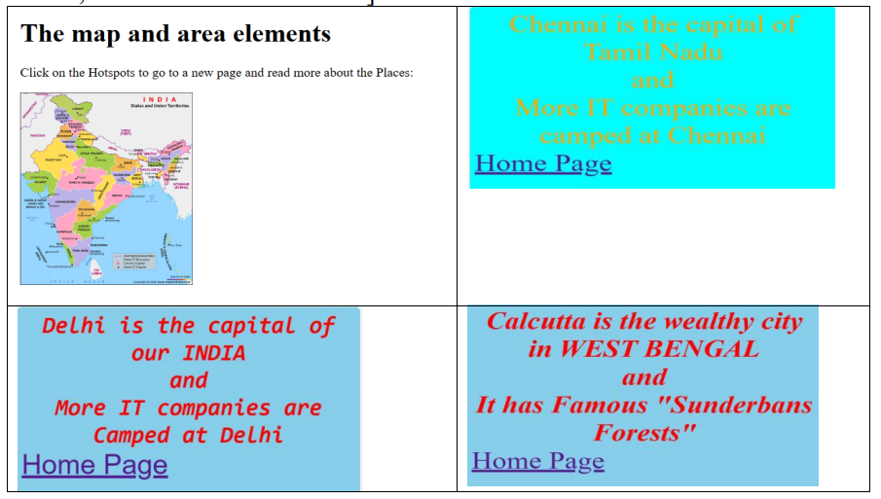

<!DOCTYPE html>

<html lang="en">

<head>

    <meta charset="UTF-8">

    <meta http-equiv="X-UA-Compatible" content="IE=edge">

    <meta name="viewport" content="width=device-width, initial-scale=1.0">

    <title>p6.html</title>

</head>

<body>

    <h1>The map and area elements</h1>

    <p>Click on the Hotspots to go to a new page and read more about the places:</p>

    <img src="india.jpg" alt="india" usemap="#indiamap">

    <map name="indiamap">

        <area shap="rect" coords="249,263,285,278" href="delhi.html">

        <area shap="rect" coords="336,723,389,731" href="chennai.html">

        <area shap="rect" coords="529,440,564,456" href="culcutta.html">

</body>

</html>

<!DOCTYPE html>

<html lang="en">

<head>

    <meta charset="UTF-8">

    <meta http-equiv="X-UA-Compatible" content="IE=edge">

    <meta name="viewport" content="width=device-width, initial-scale=1.0">

    <title>chennai.html</title>

</head>

<body style="background-color:#0BF5DC; color:rgb(180, 180, 24);"">

    <h3>Chennai is the capital of</h3>

    <h3><b>Tamil Nadu</b> and</h3>

    <h3>More <b>IT</b>Companies are campedd at Chennai</h3>

    <a href="p6.html">Home Page</a>

</body>

</html>

<!DOCTYPE html>

<html lang="en">

<head>

    <meta charset="UTF-8">

    <meta http-equiv="X-UA-Compatible" content="IE=edge">

    <meta name="viewport" content="width=device-width, initial-scale=1.0">

    <title>culcutta.html</title>

</head>

<body style="background-color:powderblue; color:red;">

    <h3>Calcutta is the wealthy city<br>

     in <b>WEST BENGAL</b><br>

    and<br>

    It has Famous "Sunderbans Forests"</h3>

    <a href="p6.html">Home Page</a>

</body>

</html>

<!DOCTYPE html>

<html lang="en">

<head>

    <meta charset="UTF-8">

    <meta http-equiv="X-UA-Compatible" content="IE=edge">

    <meta name="viewport" content="width=device-width, initial-scale=1.0">

    <title>delhi.html</title>

</head>

<body style="background-color:powderblue; color:red;">

    <h3>Delhi is the capital of our <b>INDIA</b> and </h3>

    <h3>More <b>IT</b>Companies are camed at Delhi</h3>

    <a href="p6.html">Home Page</a>

</body>

</html>

Output :

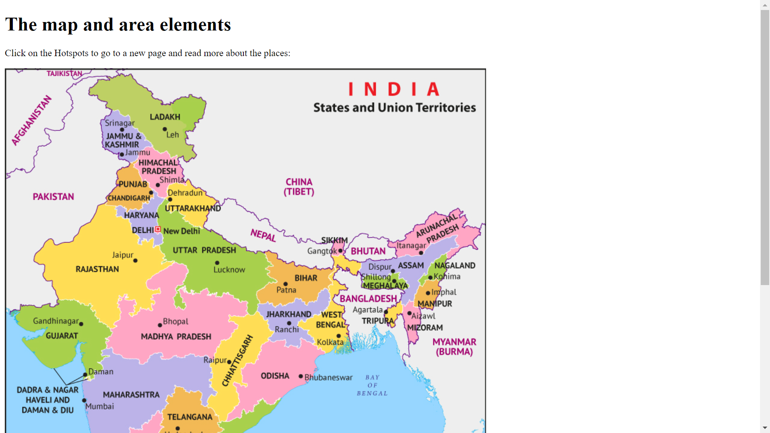

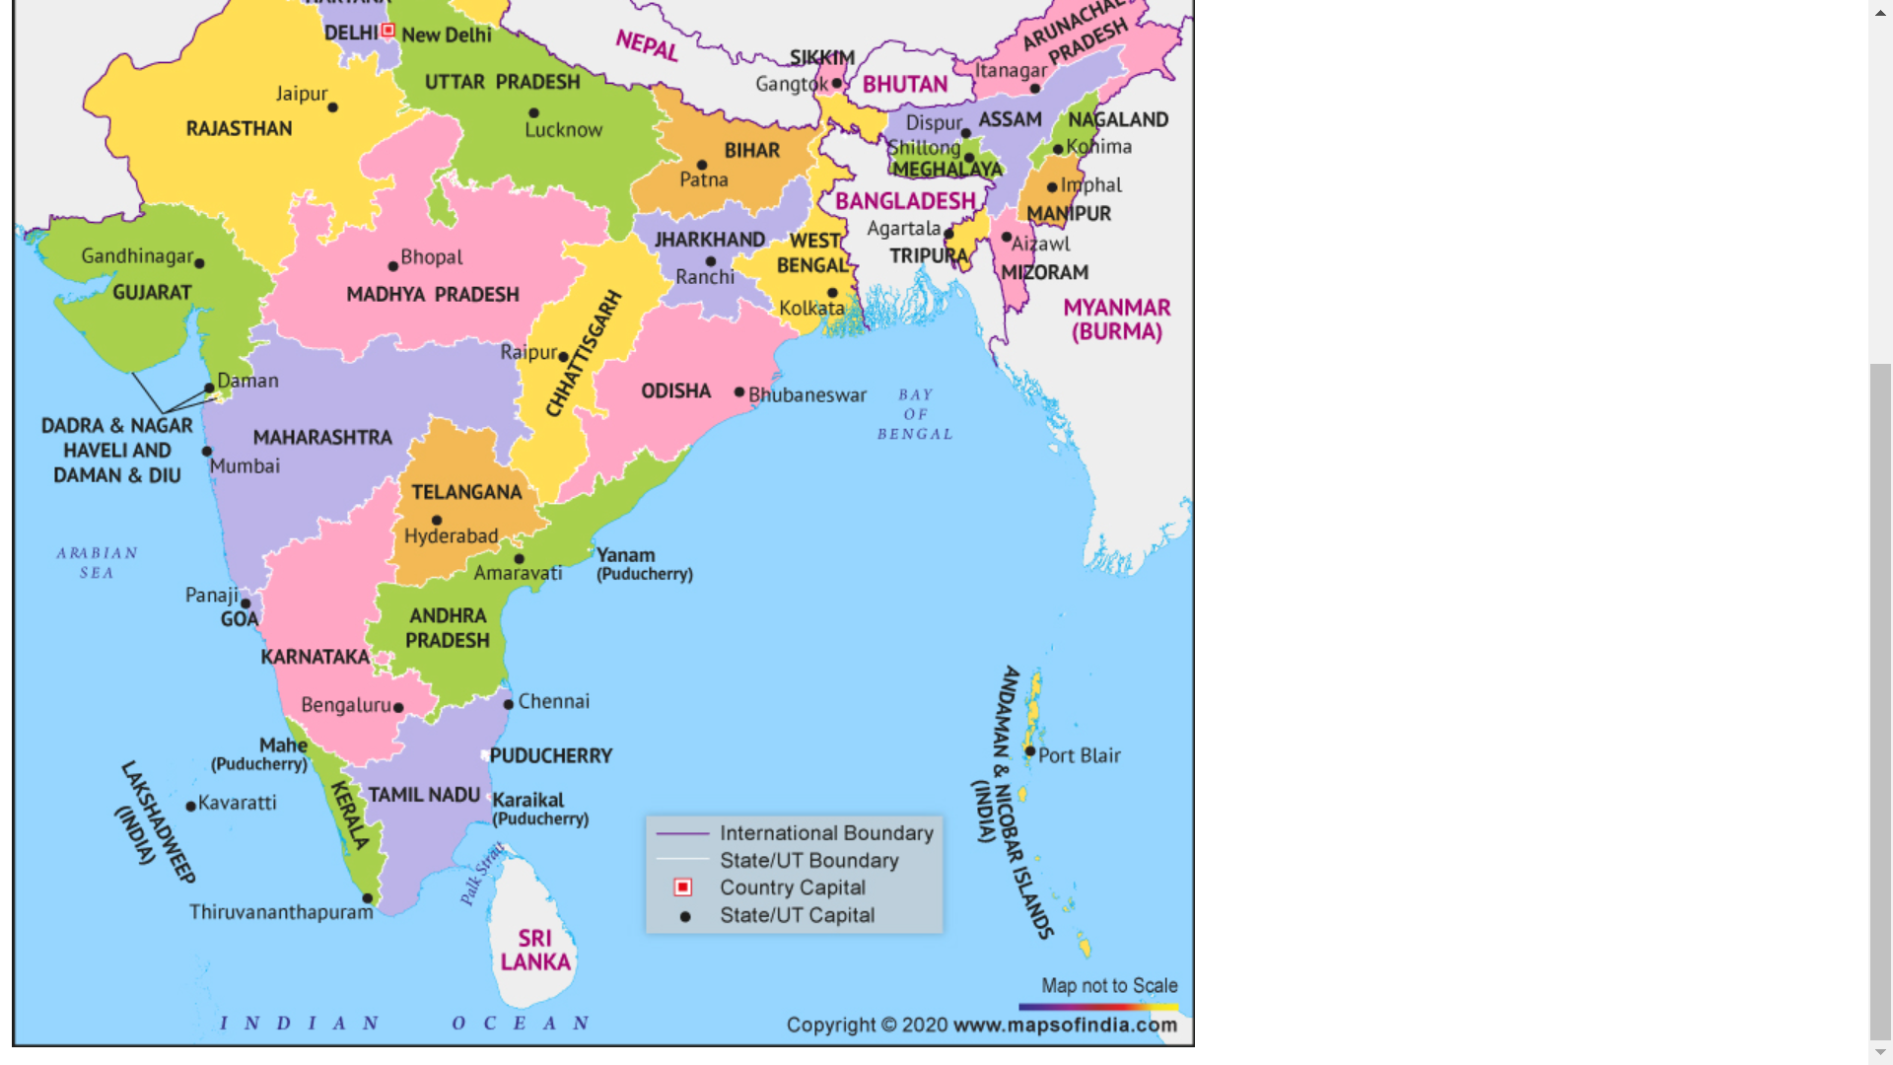



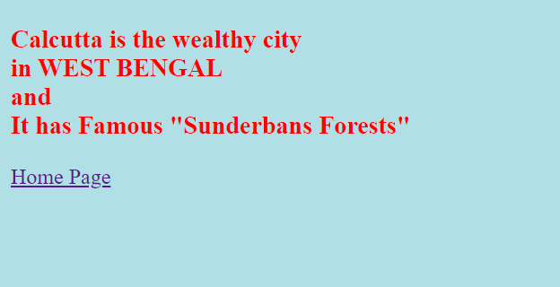



7. Design a webpage whose output is shown below. When user click the shape then another page should be open showing the corresponding figure which was clicked.

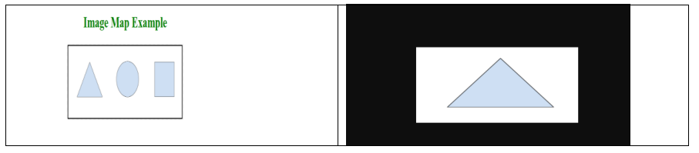

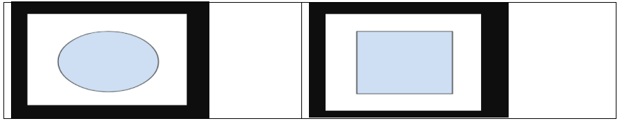

<!DOCTYPE html>

<html lang="en">

<head>

    <meta charset="UTF-8">

    <meta http-equiv="X-UA-Compatible" content="IE=edge">

    <meta name="viewport" content="width=device-width, initial-scale=1.0">

    <title>p7.html</title>

</head>

<body style="color:green;" align="center">

    <h1>Image Map Example</h1>

    <img src="area11.png" usemap="#area">

    <map name="area">

        <area shap="rect" coords="170,188,167,223" href="triangle.html">

        <area shap="rect" coords="453,163,448,207" href="circle.html">

        <area shap="rect" coords="731,155,729,191" href="square.html">

</body>

</html>

<!DOCTYPE html>

<html lang="en">

<head>

    <meta charset="UTF-8">

    <meta http-equiv="X-UA-Compatible" content="IE=edge">

    <meta name="viewport" content="width=device-width, initial-scale=1.0">

    <title>circle.html</title>

</head>

<body style="background-color:black;" align="center">

    <img src="area3.png"  usemap="#area">

</body>

</html>

<!DOCTYPE html>

<html lang="en">

<head>

    <meta charset="UTF-8">

    <meta http-equiv="X-UA-Compatible" content="IE=edge">

    <meta name="viewport" content="width=device-width, initial-scale=1.0">

    <title>suare.html</title>

</head>

<body style="background-color:black;" align="center">

    <img src="area4.png"  usemap="#area">

</body>

</html>

<!DOCTYPE html>

<html lang="en">

<head>

    <meta charset="UTF-8">

    <meta http-equiv="X-UA-Compatible" content="IE=edge">

    <meta name="viewport" content="width=device-width, initial-scale=1.0">

    <title>triangle.html</title>

</head>

<body style="background-color:black;" align="center">

    <img src="area2.png"  usemap="#area">

</body>

</html>

Output :

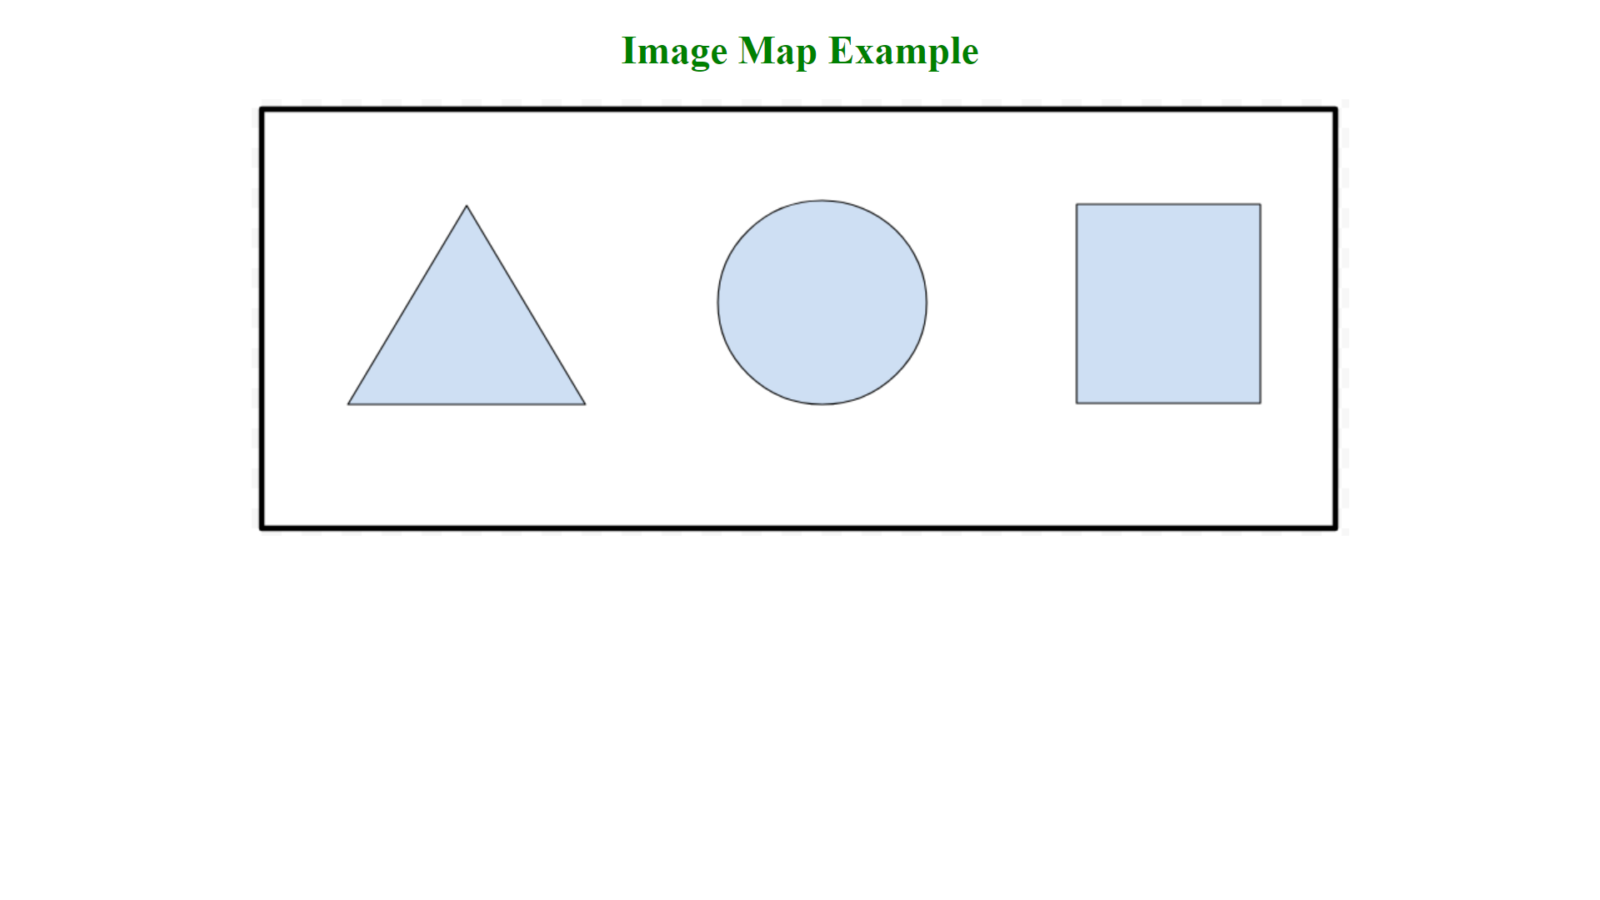

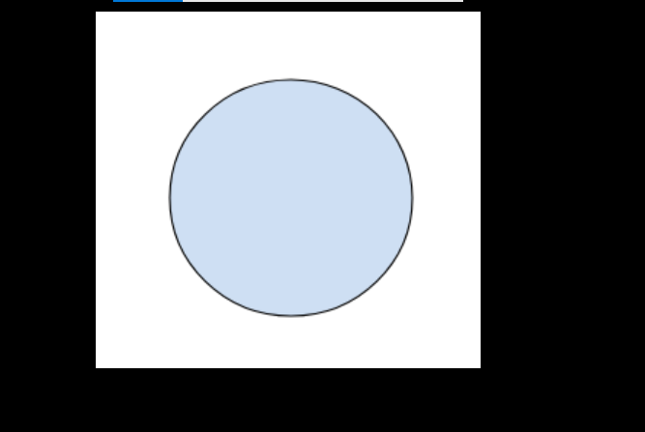

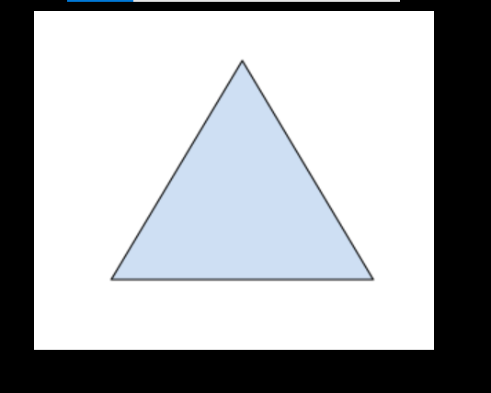

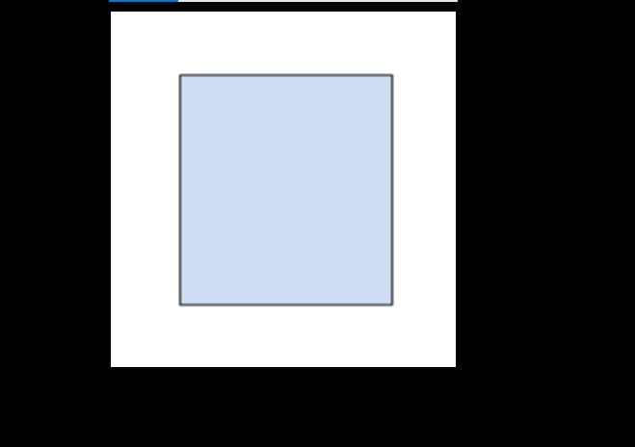

8. Design a web page has two logical section – the first one only uses the figure markup element and the second uses both figure as well as figcaption.

<!DOCTYPE html>

<html lang="en">

<head>

    <meta charset="UTF-8">

    <meta http-equiv="X-UA-Compatible" content="IE=edge">

    <meta name="viewport" content="width=device-width, initial-scale=1.0">

    <title>p8.html</title>

</head>

<body>

    <figure>

    <img src="c.jpg" height="200" width="200">

    <hr>

        <img src="c.jpg" height="200" width="200">

        <figcaption><h3>helllooo!!!! i am kittttyyyyy...</h3></figcaption>

      </figure>

</body>

</html>

Output :

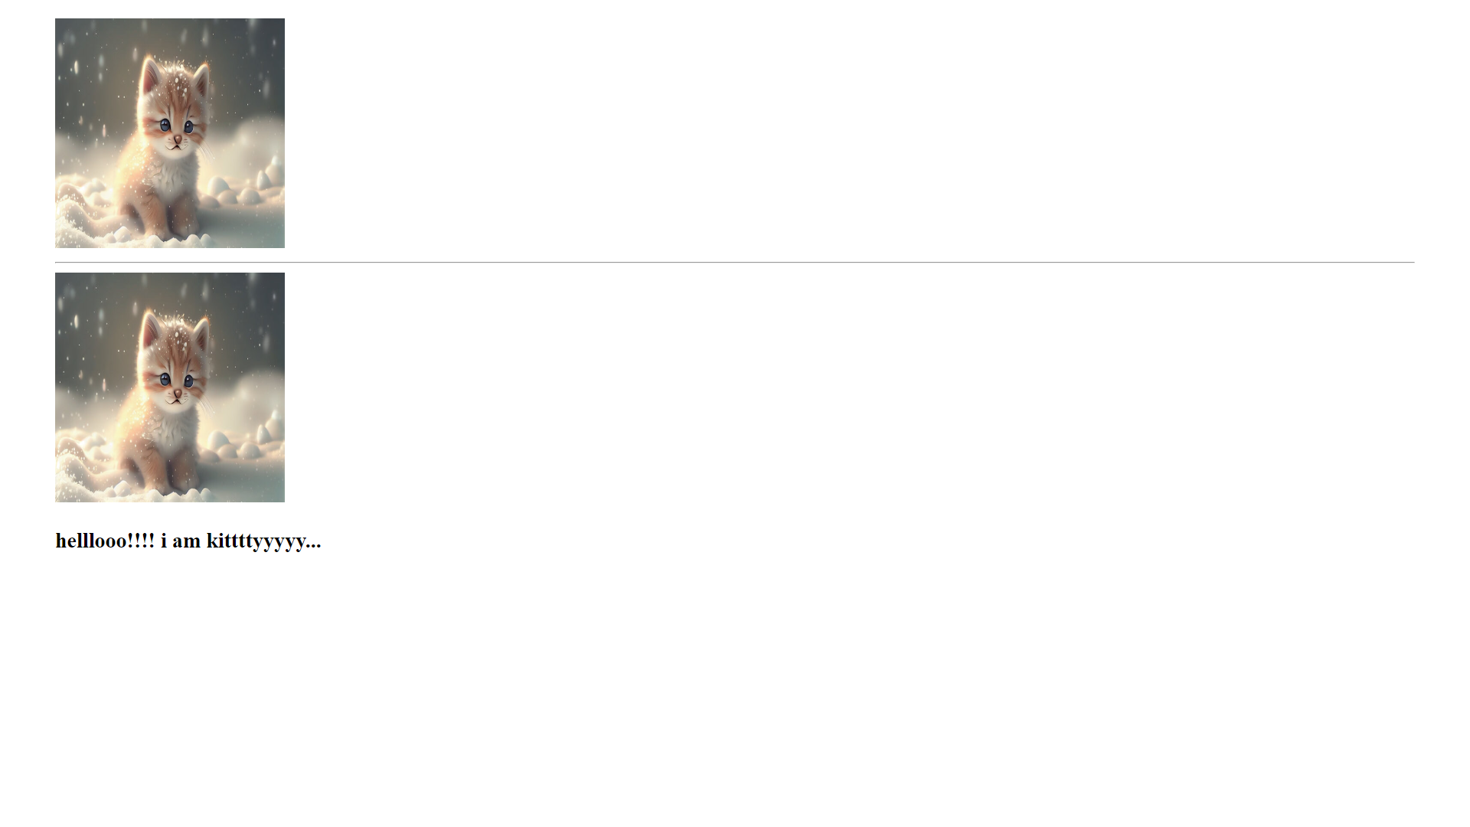

9. Design a webpage to implement audio and video.

<!DOCTYPE html>

<html lang="en">

<head>

    <meta charset="UTF-8">

    <meta http-equiv="X-UA-Compatible" content="IE=edge">

    <meta name="viewport" content="width=device-width, initial-scale=1.0">

    <title>p9.html</title>

</head>

<body align="center">

    <h1>Audio Clip</h1>

    <audio controls>

        <source src="meri maa.mp3" type="audio/mpeg">

      </audio>

    <h1>Video Clip</h1>

      <video width="320" height="240" controls>

        <source src="birds.mp4" type="video/mp4">

      </video>

</body>

</html>

Output :

