Practical - 7

Introduction to css

1. Create a webpage which displays "Hello World" with font size 20 pixels, bold format, in "Times New Roman" font and green in color using inline CSS, internal/embedded CSS and external CSS.

<!DOCTYPE html>

<html lang="en">

<head>

    <meta charset="UTF-8">

    <meta name="viewport" content="width=device-width, initial-scale=1.0">

    <title>P1</title>

    <style>

        p {

            font-size: 20px;

            font-weight: bold;

            font-family: 'Times New Roman', serif;

            color: green;

        }

    </style>

</head>

<body>

    <p>Hello World</p>

</body>

</html>

Output :



1. Create a webpage which implements CSS for the following appearance.

• For h1 background-color: green

• For p background-color: red

• For div background-color: gray

• For Body set Background image

<!DOCTYPE html>

<html lang="en">

<head>

    <meta charset="UTF-8">

    <meta name="viewport" content="width=device-width, initial-scale=1.0">

    <title>P2</title>

    <style>

        h1 {

            background-color: green;

        }

        p {

            background-color: red;

        }

        div {

            background-color: gray;

        }

        body {

            background-image: url('2.png');

            background-size: cover;

            background-repeat: no-repeat;

        }

    </style>

</head>

<body>

    <h1>This is h1 Tag.</h1>

    <p>This is P Tag.</p>

    <div>This is div Tag.</div>

</body>

</html>

Output :

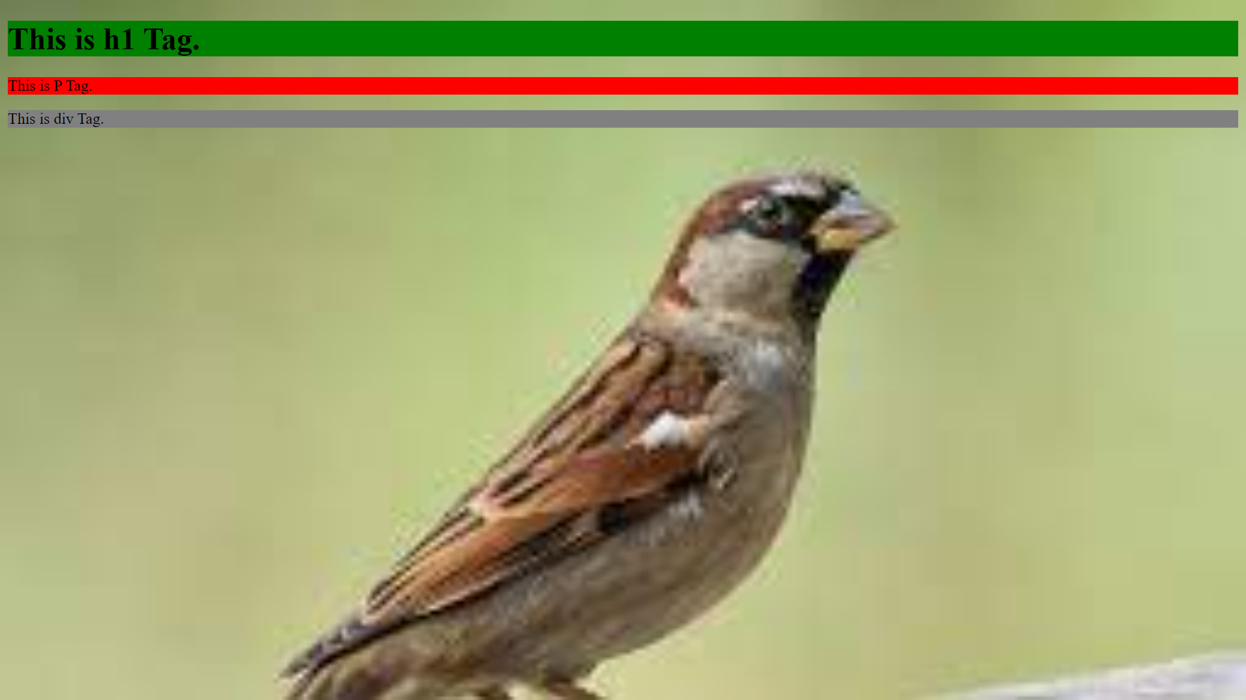

1. Create a webpage which implements CSS to set different font type, color and size for H1 to H6.

<!DOCTYPE html>

<html lang="en">

<head>

    <meta charset="UTF-8">

    <meta name="viewport" content="width=device-width, initial-scale=1.0">

    <title>P3</title>

    <style>

        h1 {

            font-family: Arial, sans-serif;

            color: black;

            font-size: 40px;

        }

        h2 {

            font-family: 'Times New Roman', serif;

            color: firebrick;

            font-size: 35px;

        }

        h3 {

            font-family: 'Courier New', monospace;

            color: saddlebrown;

            font-size: 30px;

        }

        h4 {

            font-family: 'Trebuchet MS', sans-serif;

            color: wheat;

            font-size: 25px;

        }

        h5 {

            font-family: 'Georgia', serif;

            color: aqua;

            font-size: 20px;

        }

        h6 {

            font-family: 'Lucida Console', monospace;

            color: rosybrown;

            font-size: 15px;

        }

    </style>

</head>

<body>

    <h1>H1</h1>

    <h2>H2</h2>

    <h3>H3</h3>

    <h4>H4</h4>

    <h5>H5</h5>

    <h6>H6</h6>

</body>

</html>

**Output :**

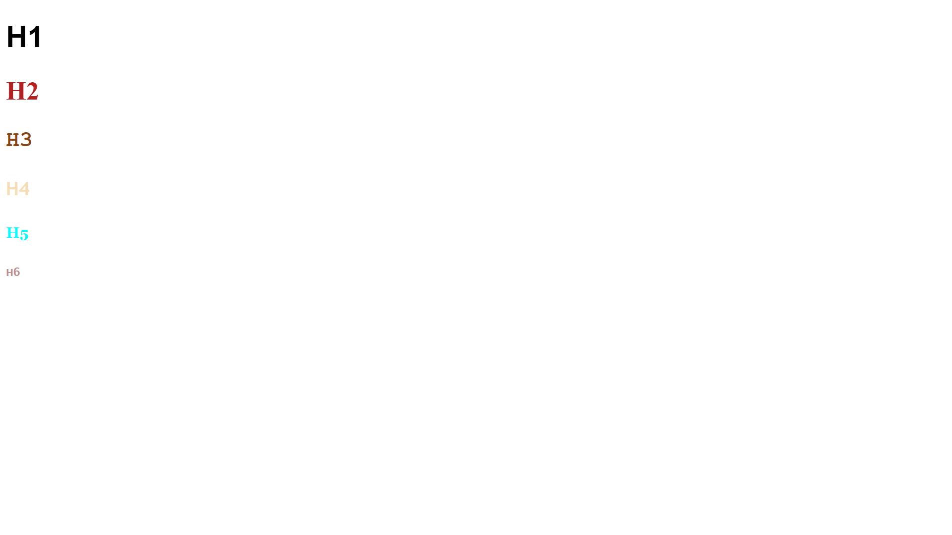

1. Create a webpage which implements different selectors.

<!DOCTYPE html>

<html lang="en">

<head>

    <meta charset="UTF-8">

    <meta name="viewport" content="width=device-width, initial-scale=1.0">

    <title>P4</title>

    <style>

        p {

            color: blue;

        }

        .special-text {

            font-weight: bold;

            color: red;

        }

        #unique-paragraph {

            background-color: yellow;

        }

        ul li {

            list-style-type: square;

        }

        h2 + p {

            font-style: italic;

        }

        a[href*="example"] {

            text-decoration: underline;

        }

    </style>

</head>

<body>

    <p>This is a simple paragraph.</p>

    <p class="special-text">This paragraph has a special class.</p>

    <p id="unique-paragraph">This paragraph has a unique ID.</p>

    <ul>

        <li>Item 1</li>

        <li>Item 2</li>

    </ul>

    <h2>Heading 2</h2>

    <p>This paragraph is an adjacent sibling of Heading 2.</p>

    <a href="google.com">Link 1</a>

    <a href="google.com">Link 2</a>

</body>

</html>

**Output :**

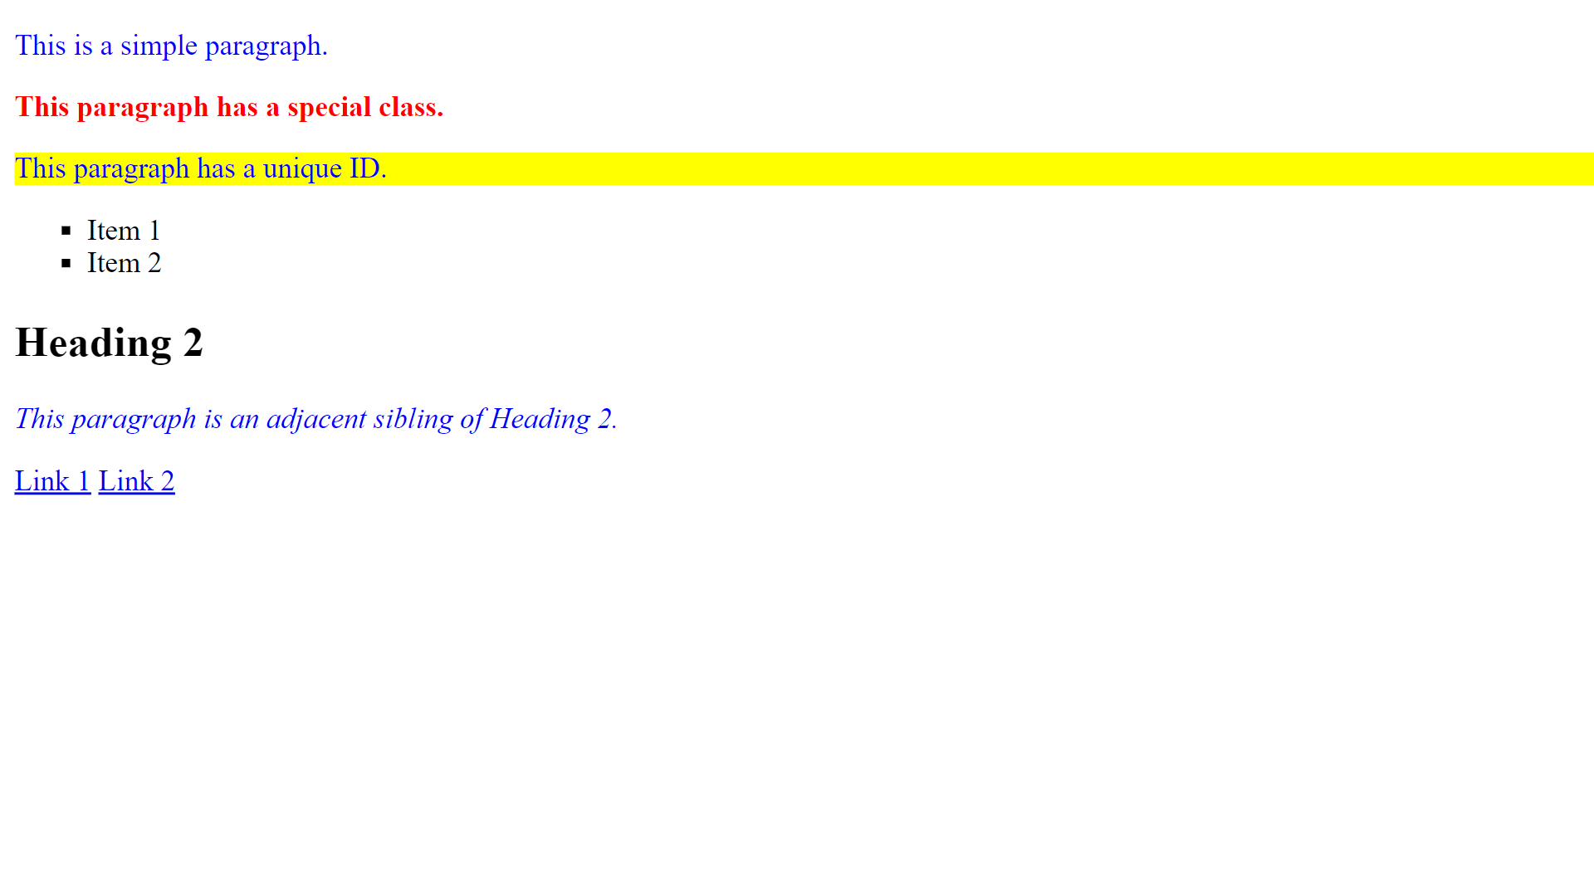

1. Create a webpage which implements different types of borders.

<!DOCTYPE html>

<html lang="en">

<head>

    <meta charset="UTF-8">

    <meta name="viewport" content="width=device-width, initial-scale=1.0">

    <title>P5</title>

    <style>

        .container {

            text-align: center;

            margin: 20px;

        }

        .border-examples {

            display: inline-block;

            width: 100px;

            height: 100px;

            margin: 10px;

            padding: 10px;

            text-align: center;

            font-weight: bold;

        }

        .solid-border {

            border: 2px solid #3498db;

        }

        .dashed-border {

            border: 2px dashed #e74c3c;

        }

        .double-border {

            border: 4px double #27ae60;

        }

        .groove-border {

            border: 4px groove #f39c12;

        }

        .ridge-border {

            border: 4px ridge #9b59b6;

        }

        .inset-border {

            border: 4px inset #2ecc71;

        }

        .outset-border {

            border: 4px outset #34495e;

        }

    </style>

</head>

<body>

    <div class="container">

        <div class="border-examples solid-border">Solid</div>

        <div class="border-examples dashed-border">Dashed</div>

        <div class="border-examples double-border">Double</div>

        <div class="border-examples groove-border">Groove</div>

        <div class="border-examples ridge-border">Ridge</div>

        <div class="border-examples inset-border">Inset</div>

        <div class="border-examples outset-border">Outset</div>

    </div>

</body>

</html>

**Output :**

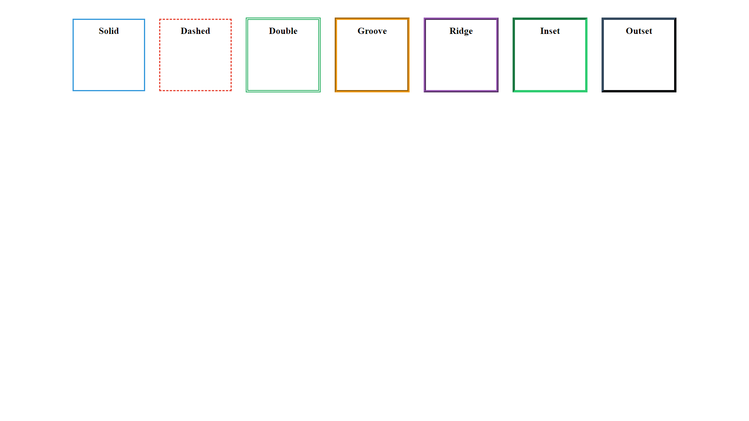

1. Create a webpage which implements different CSS text property.

<!DOCTYPE html>

<html lang="en">

<head>

    <meta charset="UTF-8">

    <meta name="viewport" content="width=device-width, initial-scale=1.0">

    <title>P6</title>

    <style>

        .text-color {

            color: #3498db;

        }

        .text-align-left {

            text-align: left;

        }

        .text-align-center {

            text-align: center;

        }

        .text-align-right {

            text-align: right;

        }

        .text-align-justify {

            text-align: justify;

        }

        .text-underline {

            text-decoration: underline;

        }

        .text-overline {

            text-decoration: overline;

        }

        .text-line-through {

            text-decoration: line-through;

        }

        .text-uppercase {

            text-transform: uppercase;

        }

        .text-lowercase {

            text-transform: lowercase;

        }

        .text-capitalize {

            text-transform: capitalize;

        }

        .letter-spacing {

            letter-spacing: 3px;

        }

    </style>

</head>

<body>

    <p class="text-color">Text Color</p>

    <p class="text-align-left">Text Alignment: Left</p>

    <p class="text-align-center">Text Alignment: Center</p>

    <p class="text-align-right">Text Alignment: Right</p>

    <p class="text-align-justify">Text Alignment: Justify</p>

    <p class="text-underline">Text Underline</p>

    <p class="text-overline">Text Overline</p>

    <p class="text-line-through">Text Line-Through</p>

    <p class="text-uppercase">Text Uppercase</p>

    <p class="text-lowercase">Text Lowercase</p>

    <p class="text-capitalize">Text Capitalize</p>

    <p class="letter-spacing">Letter Spacing</p>

</body>

</html>

**Output :**

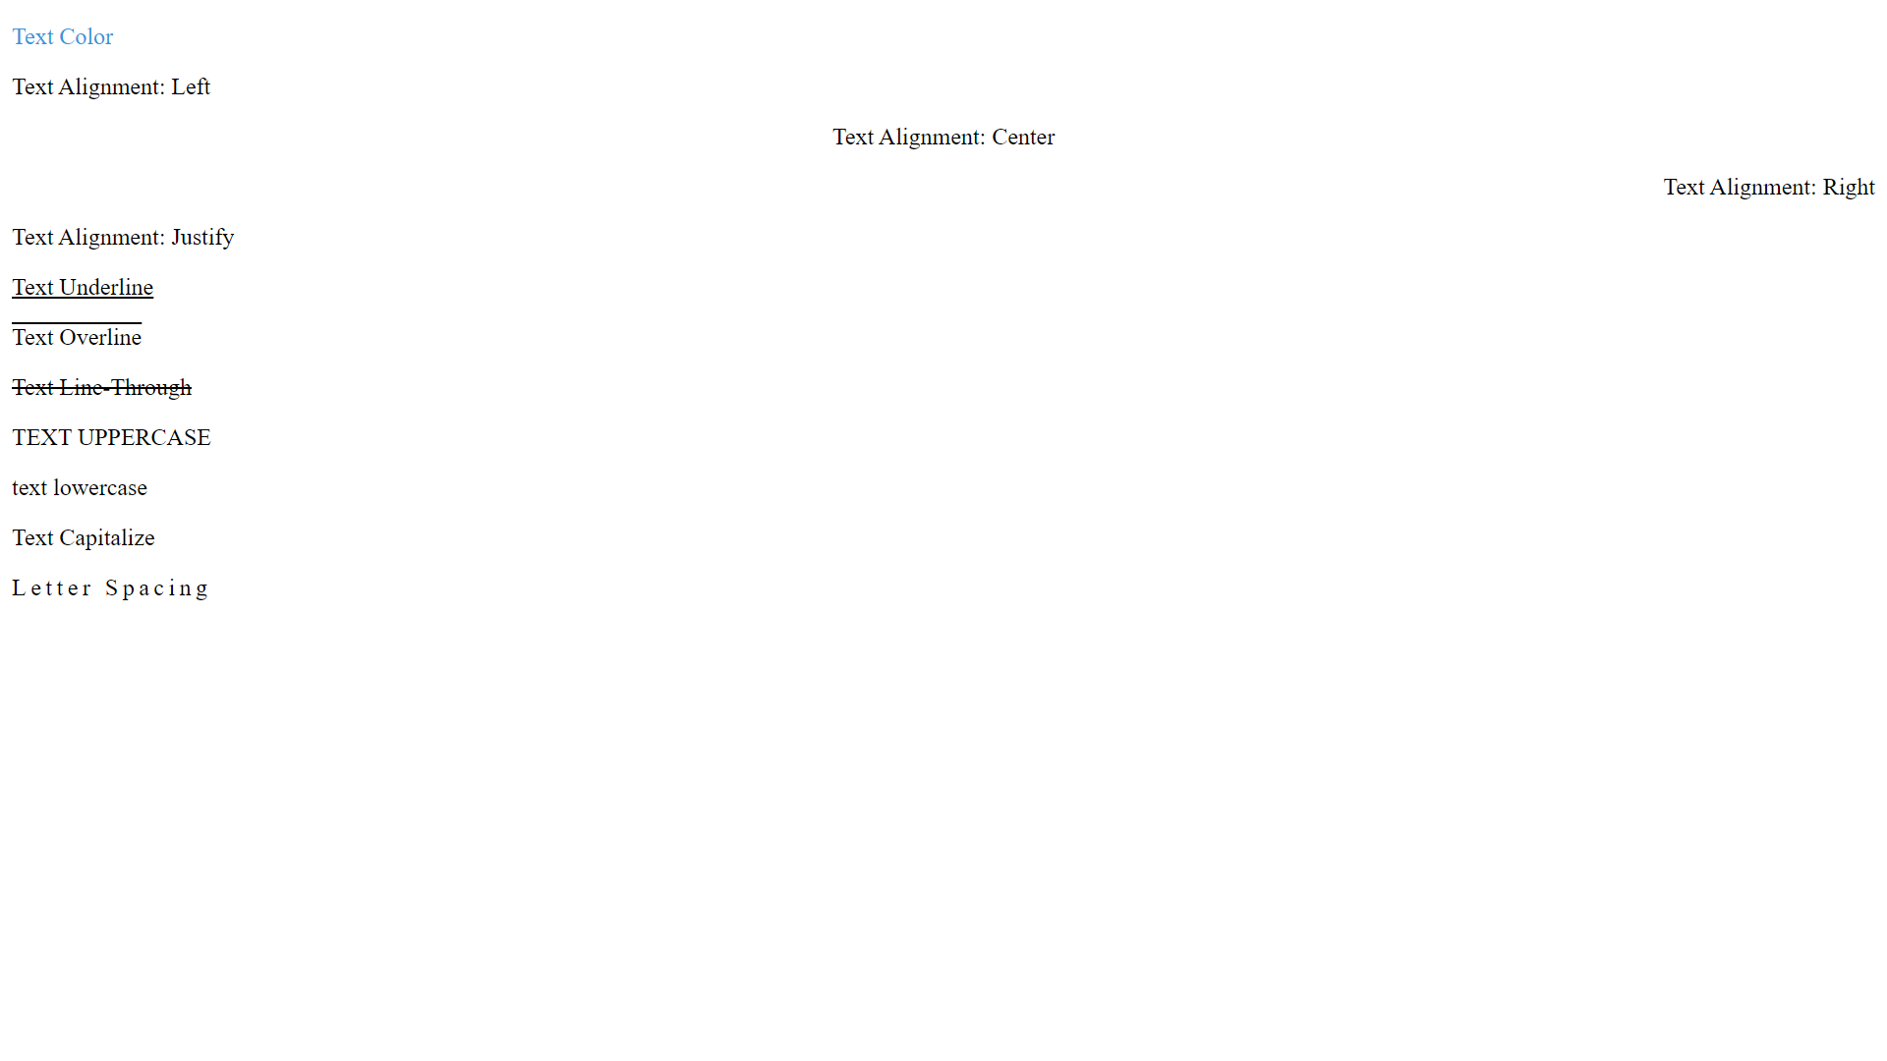

1. Create a webpage which generate zebra stripe table. [Hint: Use the nth-child() selector and add background-color of your choice to all odd (or even) table rows/columns. Apply on tr or td elements]

<!DOCTYPE html>

<html lang="en">

<head>

    <meta charset="UTF-8">

    <meta name="viewport" content="width=device-width, initial-scale=1.0">

    <title>P7</title>

    <style>

        table {

            border-collapse: collapse;

            width: 100%;

        }

        th, td {

            border: 1px solid #dddddd;

            text-align: left;

            padding: 8px;

        }

        tr:nth-child(odd) {

            background-color: #f2f2f2;

        }

    </style>

</head>

<body>

    <table>

        <thead>

            <tr>

                <th>Header 1</th>

                <th>Header 2</th>

                <th>Header 3</th>

            </tr>

        </thead>

        <tbody>

            <tr>

                <td>Row 1, Column 1</td>

                <td>Row 1, Column 2</td>

                <td>Row 1, Column 3</td>

            </tr>

            <tr>

                <td>Row 2, Column 1</td>

                <td>Row 2, Column 2</td>

                <td>Row 2, Column 3</td>

            </tr>

            <tr>

                <td>Row 3, Column 1</td>

                <td>Row 3, Column 2</td>

                <td>Row 3, Column 3</td>

            </tr>

        </tbody>

    </table>

</body>

</html>

**Output :**

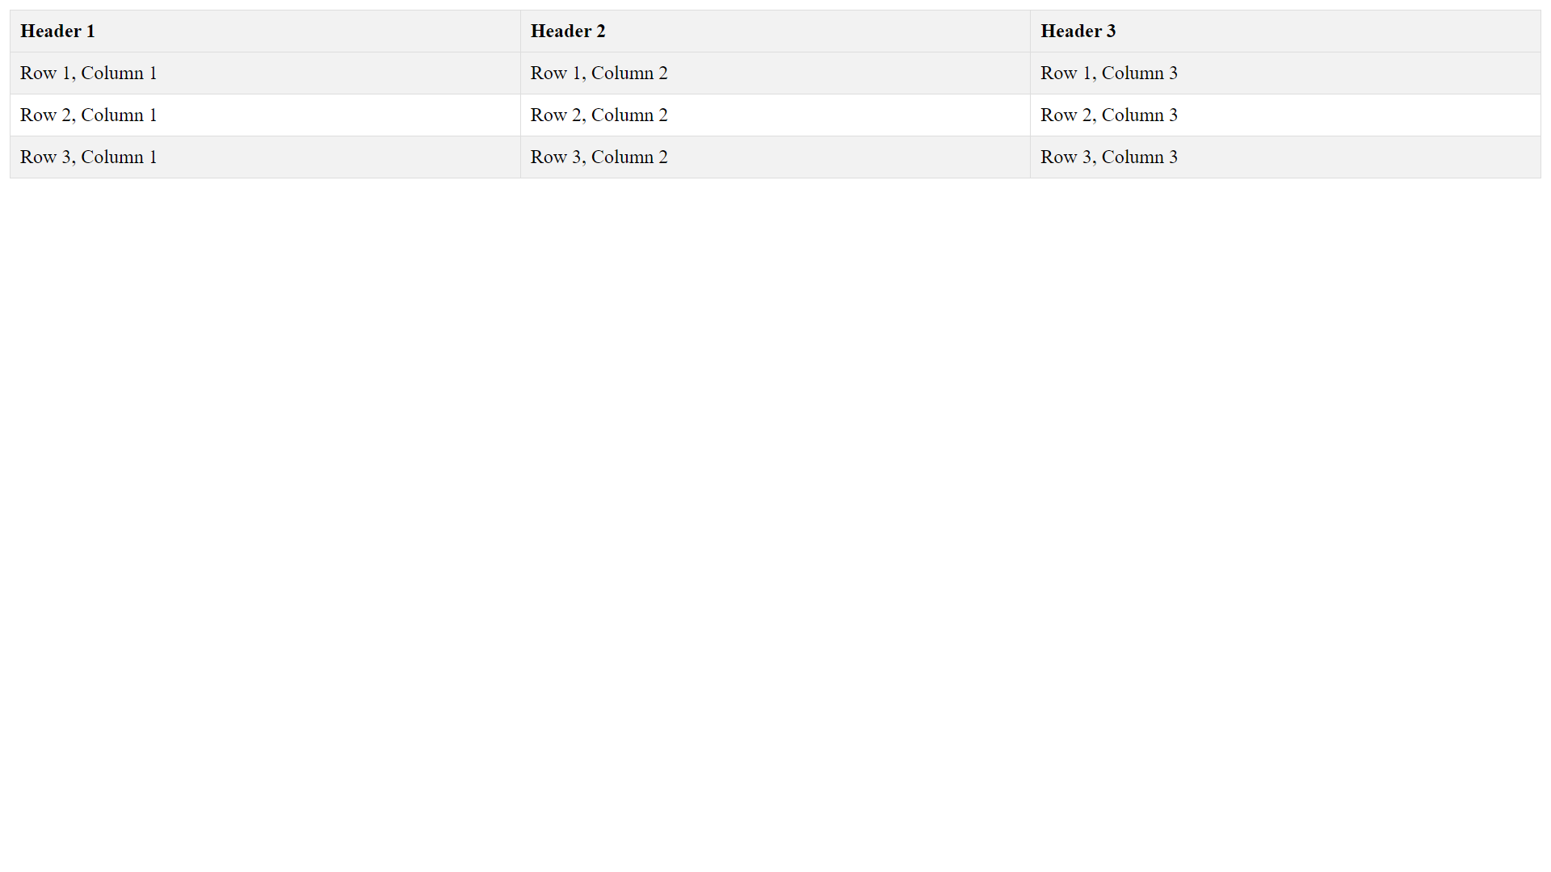

1. Create a webpage which implements following pseudo-classes and pseudo-elements. [ Syntax: selector: pseudo-class{ property: value; } ]

<!DOCTYPE html>

<html lang="en">

<head>

    <meta charset="UTF-8">

    <meta name="viewport" content="width=device-width, initial-scale=1.0">

    <title>P8</title>

    <style>

        a:hover {

            color: red;

        }

        p:first-child {

            font-weight: bold;

        }

        p:last-child {

            text-decoration: underline;

        }

        li:nth-child(odd) {

            background-color: #f2f2f2;

        }

        li:nth-child(even) {

            background-color: #ddd;

        }

        h1::before {

            content: "Before Text - ";

            color: blue;

        }

        h2::after {

            content: " - After Text";

            color: green;

        }

        p::first-line {

            font-size: 24px;

        }

        p::first-letter {

            font-size: 36px;

            font-weight: bold;

        }

    </style>

</head>

<body>

    <h1>This is a heading with a pseudo-element</h1>

    <h2>This is another heading with a pseudo-element</h2>

    <p>This is the first paragraph. It's the first child of its parent.</p>

    <p>This is the second paragraph. It's not the first child.</p>

    <ul>

        <li>Item 1</li>

        <li>Item 2</li>

        <li>Item 3</li>

    </ul>

    <a href="#">Hover over me</a>

</body>

</html>

**Output :**

