Practical - 9

Introduction to JavaScript

1. Write an HTML which contains Java Script in the head section, which calculates

percentage from the five subject marks. Display all five subject marks and

percentage on the web page.

Hint:

<SCRIPT type="text/javascript">

document.write("Welcome to the World of JavaScript

<BR/>");

document.write("In this example we have used the

JavaScript in the HEAD element.");

</SCRIPT>

<!DOCTYPE html>

<html lang="en">

<head>

    <meta charset="UTF-8">

    <meta name="viewport" content="width=device-width, initial-scale=1.0">

    <title>Document</title>

    <SCRIPT type="text/javascript">

        var s1 = parseInt(prompt("Enter 1st no : "));

        var s2 = parseInt(prompt("Enter 2nd no : "));

        var s3 = parseInt(prompt("Enter 3rd no : "));

        var s4 = parseInt(prompt("Enter 4th no : "));

        var s5 = parseInt(prompt("Enter 5th no : "));

        var per = (s1 + s2 + s3 + s4 + s5)/5;

        document.write("Sub1 : "+s1 + "<br>");

        document.write("Sub2 : "+s2+ "<br>");

        document.write("Sub3 : "+s3+ "<br>");

        document.write("Sub4 : "+s4+ "<br>");

        document.write("Sub5 : "+s5+ "<br>");

        document.write("Percentage : "+per);

        document.write("<br>Welcome to the World of JavaScript <BR/>");

        document.write("In this example we have used the JavaScript in the HEAD element.");

    </SCRIPT>

</head>

<body>

</body>

</html>

Output :

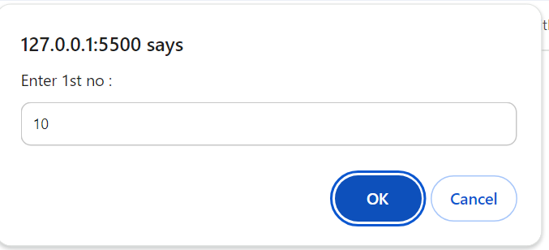

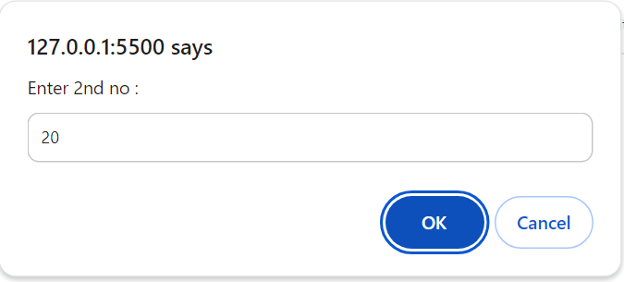

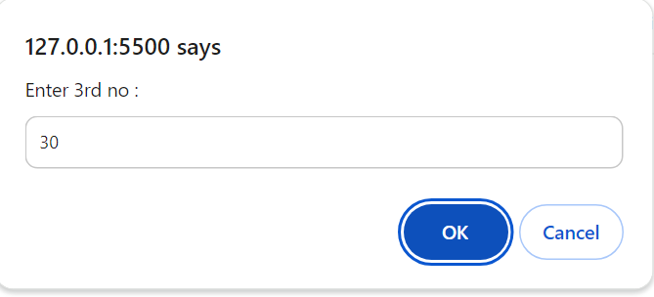

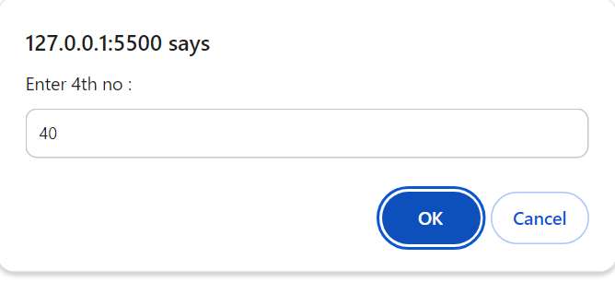

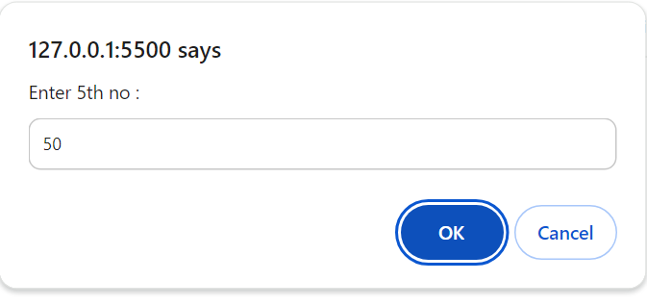

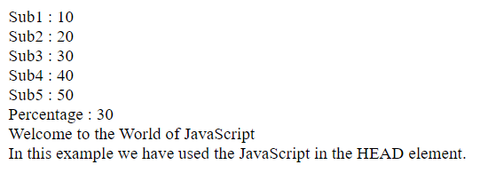

2. Write a Java Script which displays all the even numbers from 1 to 100.

hint syntax of for loop :

for(initialize ; condition ; increment) { ... }

example :for(x=0;x<10;x++) { // Code Here }

<!DOCTYPE html>

<html lang="en">

<head>

    <meta charset="UTF-8">

    <meta name="viewport" content="width=device-width, initial-scale=1.0">

    <title>Document</title>

</head>

<body>

    <script>

        var x;

        for(x=0;x<=100;x++){

            document.write("<br>"+x);

            x = x + 1;

        }

    </script>

</body>

</html>

Output :





3. Write a Java Script to check whether the number is prime or not.

<!DOCTYPE html>

<html lang="en">

<head>

    <meta charset="UTF-8">

    <meta name="viewport" content="width=device-width, initial-scale=1.0">

    <title>Document</title>

</head>

<body>

    <script>

        var x;

        var pr=0;

        var s1 = parseInt(prompt("Enter any no : "));

        for(x=1;x<=s1;x++){

            if(s1%x==0){

                pr++;

            }

        }

    if(pr==2){

            document.write("Not Prime");

        }else{

            document.write("Prime");

        }

    </script>

</body>

</html>

Output :

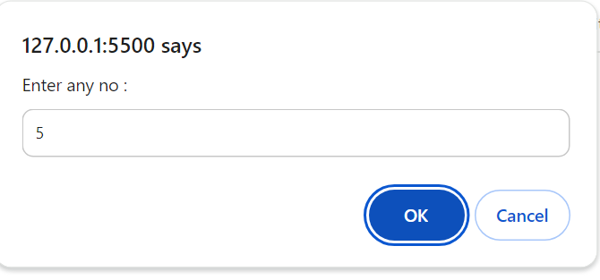



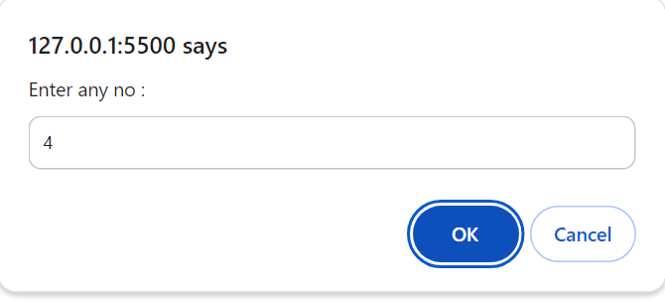



4. Write a Java Script to check whether the last digit of threenumbers is same or not.

<!DOCTYPE html>

<html lang="en">

<head>

    <meta charset="UTF-8">

    <meta name="viewport" content="width=device-width, initial-scale=1.0">

    <title>Document</title>

</head>

<body>

    <script>

        var s1 = parseInt(prompt("Enter 1st no : "));

        var s2 = parseInt(prompt("Enter 2nd no : "));

        var s3 = parseInt(prompt("Enter 3rd no : "));

        var r1 = s1%10;

        var r2 = s2%10;

        var r3 = s3%10;

        // document.write("1 : " + r1 + " " + r2 + " " + r3);

        if(r1==r2 && r2 == r3){

            document.write("no is same");

        }else{

            document.write("no is not same");

        }

    </script>

</body>

</html>

Output :

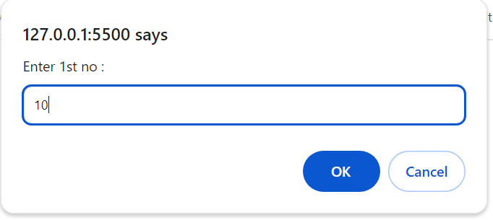

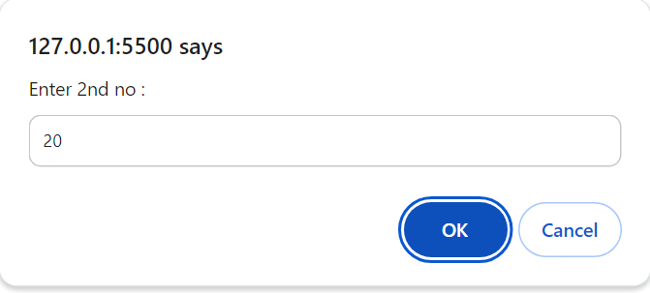

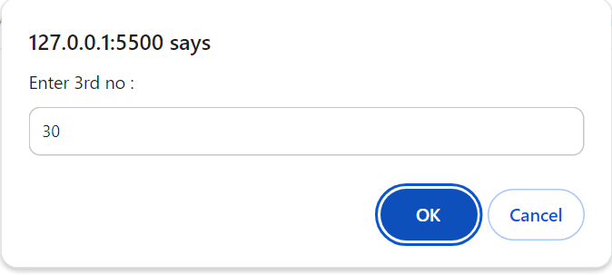



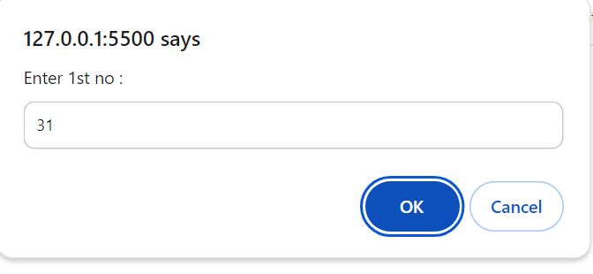

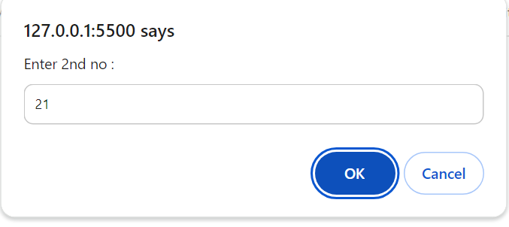

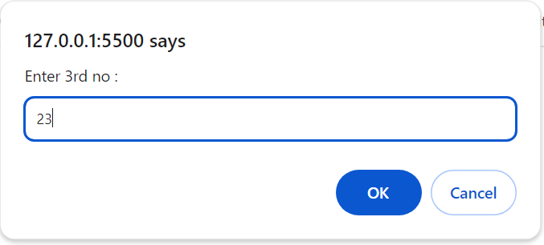



5. Write a Java Script which takes username and password using prompt box. If the

username and password are “Admin” then it will display “Successful Login”

message in the alert box otherwise it will display “Username and Password are

not matched” message in the alert box.

Hint:

<SCRIPT type="text/javascript">

var name= prompt( "Please enter your name: " );

if (name==null || name=="") name = " visitor ";

{

document.write ("Hi " + name + ", Welcome to

JavaScript");

}

</SCRIPT>

<SCRIPT type="text/javascript">

alert( "Hello, I am an alert box." );

</SCRIPT>

<!DOCTYPE html>

<html lang="en">

<head>

    <meta charset="UTF-8">

    <meta name="viewport" content="width=device-width, initial-scale=1.0">

    <title>Document</title>

</head>

<body>

    <script>

        var unmae = prompt("Enter Username : ");

        var pass = prompt("Enter Password : ");

        if(unmae == "Admin" && pass == "Admin"){

            document.write("Sucessfull Login");

        }else{

            alert("Username and Password are not matched");

        }

    </script>

</body>

</html>

Output :

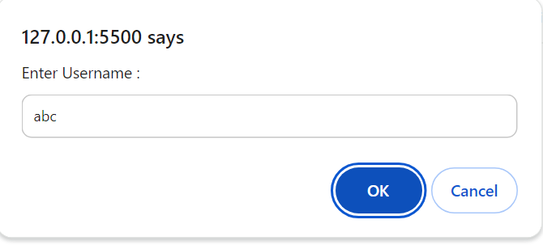

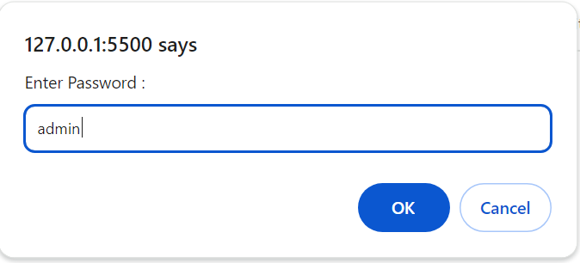

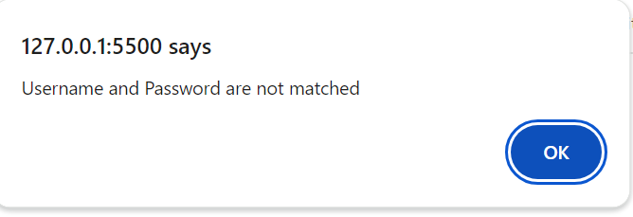

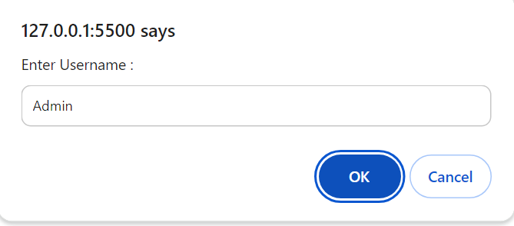

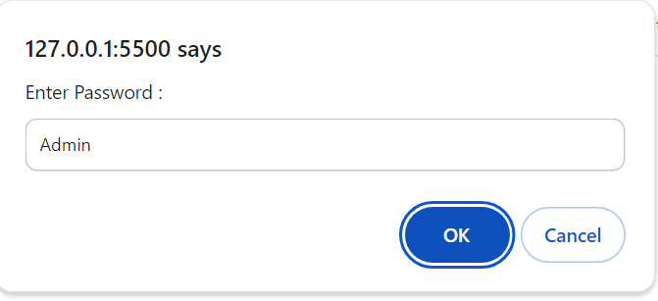



6. Write a Java Script which contains functions to calculate area of circle, rectangle

and triangle. Write a switch case to call above functions and take choice number

from the user using prompt box.

Hint:

function total(a,b,c)

{

var sum = a+b+c;

document.write("total="+sum);

}

document.write("The sum is calculated by passing

arguments to the function<BR/>");

total(4,5,6);

<SCRIPT type="text/javascript">

var letter="I";

switch(letter)

{

default:document.write("consonant");

break;

case "A":document.write("A is a vowel");

break;

case "E":document.write("E is a vowel");

}

document.write("<BR/>Thank You!");

</SCRIPT>

<!DOCTYPE html>

<html lang="en">

<head>

    <meta charset="UTF-8">

    <meta name="viewport" content="width=device-width, initial-scale=1.0">

    <title>Document</title>

</head>

<body>

    <script>

        var ch;

        ch = prompt("Enter choice (c,r,t)");

        switch(ch){

            case "c":

                var s1 = parseInt(prompt("Enter r no : "));

                document.write("Circle : "+(s1\*3.14\*3.14));

                break;

            case "r":

                var s21 = parseInt(prompt("Enter h no : "));

                var s22 = parseInt(prompt("Enter b no : "));

                document.write("Reactangle : "+(0.5\*s21\*s22));

                break;

            case "t":

                var s31 = parseInt(prompt("Enter l no : "));

                var s32 = parseInt(prompt("Enter b no : "));

                document.write("Triangle : "+(s31\*s32));

                break;

            default:

                alert("Enter Proper no");

        }

    </script>

</body>

</html>

Output :

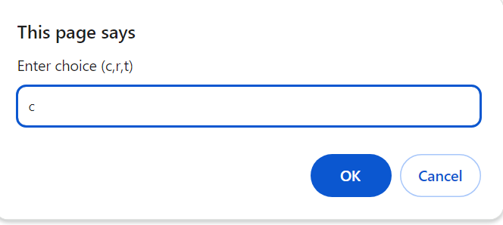

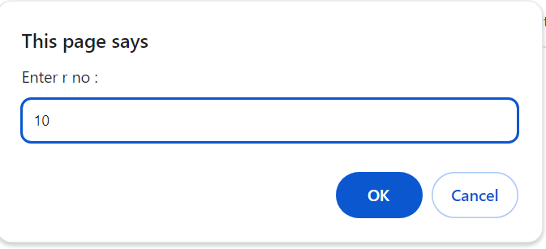



7. Create login form. When user clicks on login button it will display following

messages.

a. If password is empty “Please enter Password”

b. If username is empty “Please enter Username”

c. If both username and password are „Admin‟ then “Login successful”

d. If both username and password are not matched then “Login unsuccessful”

e. If username is not „Admin‟ then “Enter correct Username”

f. If password is not „Admin‟ then “Enter correct Password”

hint:

<html>

<body>

<input type=“text” id=“myText”>

</body>

</html>

code snippet

<script>

function myFunction()

{

var txt = document.getElementById(“myText”);

alert(txt.value);

}

</script>

<!DOCTYPE html>

<html lang="en">

<head>

    <meta charset="UTF-8">

    <meta name="viewport" content="width=device-width, initial-scale=1.0">

    <title>Document</title>

</head>

<body>

    <script>

        var unmae = prompt("Enter Username : ");

        var pass = prompt("Enter Password : ");

        if(unmae == null){

            alert("Please enter Username");

        }else if(pass == null){

            alert("Please enter Password");

        }else if(unmae == "Admin" && pass == "Admin"){

            document.write("Login successful");

        }else if(unmae != "Admin"){

            alert("Enter correct Username");

        }else if(pass != "Admin"){

            alert("Enter correct Password");

        }else{

            document.write("Login unsuccessful");

        }

    </script>

</body>

</html>

Output :

