Architecture

Restaurant Rating Prediction

|  |  |
| --- | --- |
| Written By | Rutvik Savaliya |
| Document Version | 0.3 |
| Last Revised Date | 26 – Jan -2022 |

**Document Control**

**Change Record:**

|  |  |  |  |
| --- | --- | --- | --- |
| **Version** | **Date** | **Author** | **Comments** |
| 0.1 | 24 – Jan -  2022 | Rutvik Savaliya | Introduction & Architecture defined |
| 0.2 | 25 – Jan -  2022 | Rutvik savaliya | Architecture & Architecture Description appended and updated |
| 0.3 | 26 – Jan -  2022 | Rutvik Savaliya | Unit Test Cases defined and appended |
|  |  |  |  |
|  |  |  |  |
|  |  |  |  |

**Approval Status:**

|  |  |  |  |  |
| --- | --- | --- | --- | --- |
| **Version** | **Review Date** | **Reviewed By** | **Approved By** | **Comments** |
|  |  |  |  |  |

Contents

1. Introduction 1

1.1. What is Low-Level design document? 1

1.2. Scope 1

2. Architecture 2

3. Architecture Description 3

3.1. Data Description 3

3.2. Data Transformation 3

3.3. Data Pre-processing 3

3.4. Model Building 4

3.5. Data from User 4

3.6. Data Validation 4

3.7. Deployment 4

4. Unit Test Cases 5

# Introduction

## What is Low-Level design document?

The goal of LLD or a low-level design document (LLDD) is to give the internal logical design of the actual program code for Restaurant Rating Prediction System. LLD describes the class diagrams with the methods and relations between classes and program specs. It describes the modules so that the programmer can directly code the program from the document.

## Scope

Low-level design (LLD) is a component-level design process that follows a step-by- step [refinement p](https://en.wikipedia.org/wiki/Refinement_(computing))rocess. This process can be used for designing data structures, required software architecture, source code and ultimately, performance algorithms. Overall, the data organization may be defined during requirement analysis and then refined during data design work

# Architecture

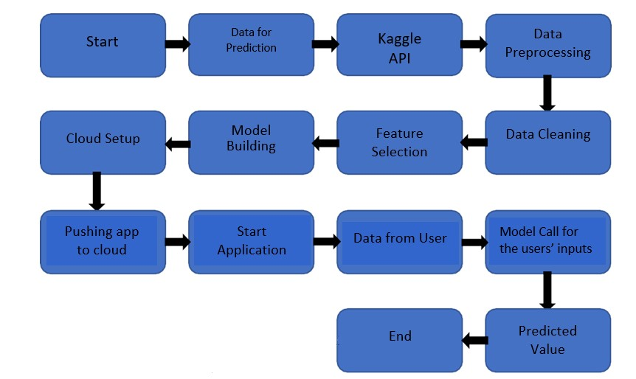

# Architecture Description

## Data Description

Zomato Bangalore Restaurant dataset is a large publicly available restaurant dataset. This dataset contains information of each restaurant’s reviews and ratings of the customer. This dataset contains 150000+ data of the customer ratings and review.

## Data Transformation

In the Transformation Process, we will clean, wrangle the data and pre-process the raw data.

## Data Pre-processing

In Data Pre-processing steps, we could use are Null value handling, Imbalanced data set handling, Handling columns with standard deviation zero or below a threshold, etc.

## Model Building

After we get the clean data, we will find the best model for the data. As the target variable is continuous, we use regression type of algorithms. We used various types of regression algorithms and select the model with the best score.

## Data from User

Here we will collect data from user such as restaurant location, dishes, cuisines, restaurant type, rate, online ordering facilities etc.

## Data Validation

Here Data Validation will be done, given by the user

## Deployment

We will be deploying the model to Heroku.

This is a workflow diagram for the Restaurant Rating Prediction.

# Unit Test Cases

|  |  |  |
| --- | --- | --- |
| **Test Case Description** | **Pre-Requisite** | **Expected Result** |
| Verify whether the Application URL is  accessible to the user | 1. Application URL should be defined | Application URL should be accessible to the user |
| Verify whether the Application loads completely for the user when the URL is accessed | 1. Application  URL is accessible 2. Application is deployed | The Application should load completely for the user when the URL is accessed |
| Verify whether user is able to see input fields | 1. Application is accessible 2. User is signed up to the application 3. User is logged in to the application | User should be able to see input |
| Verify whether user is able to edit all input fields | 1. Application is accessible 2. User is signed up to the application 3. User is logged   in to the application | User should be able to edit all input fields |
| Verify whether user gets Submit button to submit the inputs | 1. Application is accessible 2. User is signed up to the application 3. User is logged   in to the application | User should get Submit button to submit the inputs |
| Verify whether user is presented  with ratings results on clicking submit | 1. Application is accessible 2. User is signed up to the application 3. User is logged in to the application | User should be presented with ratings results on clicking submit |