**Practical-8:**

**Consider the following schema for a LibraryDatabase:**

**BOOK (Book_id, Title, Publisher_Name, Pub_Year)**

**BOOK_AUTHORS (Book_id, Author_Name)**

**PUBLISHER (Name, Address, Phone)**

**BOOK_COPIES**

**(Book_id, Branch_id, No-of_Copies)**

**BOOK_LENDING (Book_id, Branch_id, Card_No, Date_Out, Due_Date)**

**LIBRARY_BRANCH (Branch_id, Branch_Name, Address)**

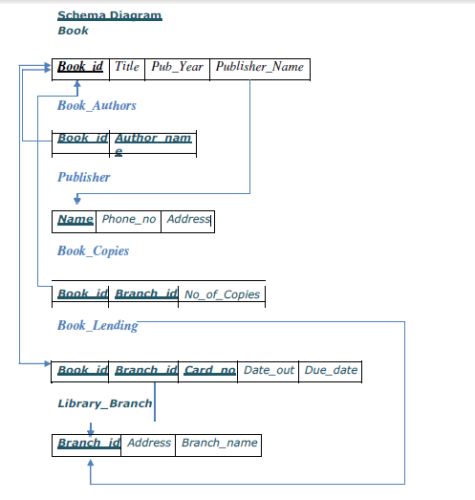

**Table Creation**

CREATE TABLE PUBLISHER (NAME VARCHAR (20) PRIMARY KEY, PHONE INT, ADDRESS VARCHAR (20));

CREATE TABLE BOOK (BOOK_ID INT PRIMARY KEY,TITLE VARCHAR(20), PUB_YEAR VARCHAR (20), PUBLISHER_NAME VARCHAR(20) REFERENCES PUBLISHER (NAME) ON DELETE CASCADE);

CREATE TABLE BOOK_AUTHORS (AUTHOR_NAME VARCHAR (20), BOOK_ID INT REFERENCES BOOK (BOOK_ID) ON DELETE CASCADE,

PRIMARY KEY (BOOK_ID, AUTHOR_NAME));

CREATE TABLE LIBRARY_BRANCH (BRANCH_ID INT PRIMARY KEY, BRANCH_NAME VARCHAR(50), ADDRESS VARCHAR2 (50));

CREATE TABLE BOOK_COPIES(NO_OF_COPIES INT,BOOK_ID INT REFERENCES BOOK (BOOK_ID) ON DELETE CASCADE,BRANCH_ID INT REFERENCES LIBRARY_BRANCH (BRANCH_ID) ON DELETE CASCADE, PRIMARY KEY (BOOK_ID, BRANCH_ID));

CREATE TABLE CARD (CARD_NO INT PRIMARY KEY);

CREATE TABLE BOOK_LENDING (DATE_OUT DATE, DUE_DATE DATE,

BOOK_ID REFERENCES BOOK (BOOK_ID) ON DELETE CASCADE,

BRANCH_ID REFERENCES LIBRARY_BRANCH (BRANCH_ID) ON DELETE

CASCADE, CARD_NO INT REFERENCES CARD (CARD_NO) ON DELETE CASCADE,PRIMARY KEY (BOOK_ID, BRANCH_ID, CARD_NO));

**Insertion of Values to Tables:**

INSERT INTO PUBLISHER VALUES (EMCGRAW-HILL‘, 9989076587, EBANGALORE‘);

INSERT INTO PUBLISHER VALUES (EPEARSON‘, 9889076565, ENEWDELHI‘);

INSERT INTO PUBLISHER VALUES (ERANDOM HOUSE‘, 7455679345, EHYDRABAD‘); INSERT

INTO PUBLISHER VALUES (EHACHETTE LIVRE‘, 8970862340, ECHENAI‘);

INSERTINTOPUBLISHERVALUES(EGRUPOPLANETA‘,7756120238,EBANGALORE‘);

INSERT INTO BOOK VALUES (1,‘DBMS‘,‘JAN-2017‘, EMCGRAW-HILL‘); INSERT INTO

BOOK VALUES (2,‘ADBMS‘,‘JUN-2016‘, EMCGRAW-HILL‘); INSERT INTO BOOK

VALUES (3,‘CN‘,‘SEP-2016‘, EPEARSON‘);

INSERT INTO BOOK VALUES (4,‘CG‘,‘SEP-2015‘, EGRUPO PLANETA‘); INSERT

INTO BOOK VALUES (5,‘OS‘,‘MAY-2016‘, EPEARSON‘);

INSERT INTO BOOK_AUTHORS VALUES (‘NAVATHE‘, 1); INSERT INTO

BOOK_AUTHORS VALUES (‘NAVATHE‘, 2); INSERT INTO

BOOK_AUTHORS VALUES (‘TANENBAUM‘, 3); INSERT INTO

BOOK_AUTHORS VALUES (‘EDWARD ANGEL‘, 4); INSERT INTO

BOOK_AUTHORS VALUES (‘GALVIN‘, 5);

INSERT INTO LIBRARY_BRANCH VALUES (10,‘RR NAGAR‘,‘BANGALORE‘); INSERT

INTO LIBRARY_BRANCH VALUES (11,‘RNSIT‘,‘BANGALORE‘);

INSERT INTO LIBRARY_BRANCH VALUES (12,‘RAJAJI NAGAR‘, ‘BANGALORE‘); INSERT INTO

LIBRARY_BRANCH VALUES (13,‘NITTE‘,‘MANGALORE‘);

INSERT INTO LIBRARY_BRANCH VALUES (14,‘MANIPAL‘,‘UDUPI‘);

INSERT INTO BOOK_COPIES VALUES (10, 1, 10);

INSERT INTO BOOK_COPIES VALUES (5, 1,11);

INSERT INTO BOOK_COPIES VALUES (2, 2,12);

INSERT INTO BOOK_COPIES VALUES (5, 2,13);

INSERT INTO BOOK_COPIES VALUES (7, 3,14);

INSERT INTO BOOK_COPIES VALUES (1, 5,10);

INSERT INTO BOOK_COPIES VALUES (3, 4,11);

INSERT INTO CARD VALUES (100);

INSERT INTO CARD VALUES (101);

INSERT INTO CARD VALUES (102);

INSERT INTO CARD VALUES (103);

INSERT INTO CARD VALUES (104);

INSERT INTO BOOK_LENDING VALUES (‘01-JAN-17‘,‘01-JUN-17‘, 1, 10, 101);

INSERT INTO BOOK_LENDING VALUES (‘11-JAN-17‘,‘11-MAR-17‘, 3, 14, 101);

INSERT INTO BOOK_LENDING VALUES (‘21-FEB-17‘,‘21-APR-17‘, 2, 13, 101);

INSERT INTO BOOK_LENDING VALUES (‘15-MAR-17‘,‘15-JUL-17‘, 4, 11, 101);

INSERT INTO BOOK_LENDING VALUES (‘12-APR-17‘,‘12-MAY-17‘, 1, 11, 104);

SELECT * FROM PUBLISHER;

**Write SQL queries to**

**1.** Retrieve details of all books in the library – id, title, name of publisher, authors, number

of copies in each branch,etc.

**2.** Get the particulars of borrowers who have borrowed more than 3 books, but from Jan

2017 to Jun2017

**3.** Delete a book in BOOK table. Update the contents of other tables to reflect this data

manipulationoperation.

**4.** Partition the BOOK table based on year of publication. Demonstrate its working with a

simplequery.

**5.** Create a view of all books and its number of copies that are currently available in the

Library.