ZAT Asset Management Project Flow and Purpose
Simple explanation of the backend, asset lifecycle, RBAC security, and main workflows

This document explains your ZAT Asset Management backend in simple English. It describes what the project does, why it exists, how the main modules work together, and how RBAC security controls every important action.
The project is built to answer five practical business questions: what assets does the company have, where are they, who is using them, what condition are they in, and who is allowed to view or change them.

1 Project Purpose
The ZAT Asset Management project is a backend system for tracking and controlling company assets from the time they are created or purchased until they are returned, audited, maintained, transferred, or disposed.
It is not only an asset list. It is a controlled workflow system. It stores asset data, connects assets to employees and locations, records asset history, manages approvals, and protects every action with role based access control.
- Keep a central record of company assets.
- Know which employee, branch, department, or company location is connected to an asset.
- Handle requests, approvals, allocation, return, transfer, maintenance, audit, and disposal.
- Stop users from seeing or changing data they are not allowed to access.
- Record important changes so the company can later review what happened.

2 One Line Project Flow
User logs in -> Backend checks role and permissions -> User performs allowed asset action -> Service applies company/branch/department scope -> Database stores result -> History and audit records are updated

3 Complete High Level Flow
Step | What happens | Why it matters
1. Login | User enters email and password. Backend authenticates the user. | Only real users can access the system.
2. Token creation | Backend returns an access token and refresh token. | The frontend can call APIs securely without sending the password again.
3. Permission loading | Backend loads the user's effective permissions from role permissions and user-specific overrides. | The system knows exactly what the user can do.
4. API request | Frontend calls an endpoint such as create asset, allocate asset, or approve request. | All work happens through controlled backend APIs.
5. Authorization check | Backend checks if the user has the required permission. | Unauthorized actions return 403 Forbidden.
6. Scope check | Backend checks company, branch, department, or own-user boundaries. | A user cannot access another company's data.
7. Business action | Service layer performs the requested action. | The real asset workflow is executed safely.
8. Database update | Entities are saved or updated in PostgreSQL. | The system keeps permanent records.
9. History/audit | Asset history or security audit records are written when needed. | The company can trace important actions later.

4 Main Modules

Module Summary
Module | What it does | Example
Authentication | Logs users in and issues tokens. | User receives access token and refresh token.
RBAC | Controls who can do each action. | Only a user with Asset.Role.Create can create a role.
Company / Branch / Department | Stores organizational structure. | Assets can belong to a company, branch, and department.
Employee / User | Stores people who use or manage assets. | An employee can request an asset.
Asset Master | Stores main asset records. | Laptop, monitor, vehicle, software license.
Asset Request | Handles request and approval workflow. | Employee requests a laptop.
Asset Allocation | Assigns assets to employees. | Laptop allocated to employee A.
Asset Return | Handles return of allocated assets. | Employee returns a laptop.
Asset Transfer | Moves assets between owners or locations. | Asset moves from Branch A to Branch B.
Maintenance | Tracks repair and preventive maintenance. | Schedule service for equipment.
Warranty / AMC / Insurance | Tracks support contracts and coverage. | Warranty expiry report.
Audit | Checks physical assets against system records. | Scan QR code during branch audit.
Disposal | Handles end-of-life asset removal. | Old damaged asset is approved for disposal.
Dashboard / Reports | Shows summaries and reporting data. | Company-wide asset count or valuation.

5 Asset Lifecycle

Asset Lifecycle Diagram
Create asset -> Store company/branch/department -> Allocate to employee -> Track usage and location -> Maintain or repair -> Transfer or return -> Audit -> Dispose or archive

This lifecycle means the system follows the asset from beginning to end. Every major stage has its own module and permissions. The asset history module helps record important changes, so the company can later understand what happened to the asset.

Asset Lifecycle Details
Step | What happens | Why it matters
1. Create asset | Admin or Asset Manager enters asset information. | The asset becomes part of the company record.
2. Assign location | Asset is connected to company, branch, and department. | Reports and scope checks can filter correctly.
3. Allocate asset | Asset is assigned to an employee or owner. | The company knows who is responsible for it.
4. Acknowledge | Employee confirms the asset allocation when required. | The handover is confirmed.
5. Track | Asset tracking, QR/barcode, and history show where the asset is. | Lost or moved assets are easier to find.
6. Maintain | Maintenance, warranty, AMC, and insurance modules manage service details. | The asset stays usable and covered.
7. Return or transfer | Asset may come back from an employee or move to another branch. | Ownership and location stay current.
8. Audit | Audit run checks whether physical assets match the system. | Data quality and compliance improve.
9. Dispose | Damaged or retired assets go through disposal approval. | Assets are removed with control and record keeping.

6 Asset Request Workflow

Request Flow Diagram
Employee creates request -> Request is sent -> Department Head approves -> Asset Manager or IT approves -> Request is fulfilled -> Asset is allocated -> Employee acknowledges

The request workflow is useful when an employee needs an asset but should not directly create or allocate it. The employee requests, managers approve, and the asset team fulfills the request.
- Employee can create a request for an asset.
- Department Head can approve only requests from their own department.
- Asset Manager or IT can approve and fulfill operational requests.
- Asset allocation connects the approved request to a real asset.
- History and status changes help users track the request progress.

7 RBAC Security
RBAC means Role Based Access Control. It decides what a user can do. A user has one primary role. That role has permissions. A user can also have personal permission overrides that grant or deny one permission only for that user.

RBAC Permission Flow
User -> Primary role -> Role permissions -> User overrides -> Effective permissions -> API allowed or blocked

RBAC Components
Component | Meaning | Simple example
User | The logged-in person. | An employee named Ali.
Role | The user's main job type. | Employee, Asset Manager, Admin.
Permission | One allowed action. | Asset.Asset_Master.Create.
Role Permission | Permission inherited from the role. | Asset Manager can allocate assets.
GRANT override | Extra permission for one user. | One employee can export a report.
DENY override | Remove permission for one user. | One manager cannot approve disposal.
Effective permissions | Final allowed permissions after role plus overrides. | Used by backend to allow or block APIs.

The effective permission formula is simple: role permissions plus GRANT overrides minus DENY overrides. DENY wins if there is a conflict.

8 Built In Roles

Role Meaning
Role | Typical purpose | Typical access
Admin | Full company administration and security control. | Can manage users, roles, permissions, organization, and high risk actions.
Asset Manager | Day-to-day asset operations. | Can create, allocate, transfer, maintain, audit, and fulfill asset work.
Department Head | Department approval and visibility. | Can approve department requests and see department-level information.
Employee | Self-service user. | Can create requests, view own assets, acknowledge allocation, and request returns.
Custom Role | Company-specific role created by Admin. | Can contain selected permissions from the catalog.

9 Data Scope
Permission alone is not enough. The system must also check data scope. A user may have permission to view assets, but they still should not see another company's assets.

Scope Flow
API request -> Current user -> Company scope -> Branch scope -> Department scope -> Own-user scope -> Filtered data

Scope Rules
Scope | Meaning | Example
Company | User can access data from their own company. | Company A user cannot see Company B assets.
Branch | Branch-limited users access branch data only. | Branch 1 user cannot manage Branch 2 asset.
Department | Department Head manages own department workflows. | Head of IT approves IT department requests only.
Own | Employee can access only their own records. | Employee sees own allocations and requests.

10 Login and Token Flow

Authentication Flow
Login request -> Password checked -> User details loaded -> Effective permissions loaded -> JWT access token created -> Refresh token created -> Frontend stores session

The access token is short-lived and contains identity information like user id, company id, branch id, department id, role id, and permissions. The refresh token lets the frontend ask for a new access token without asking the user to log in again.

11 Database Purpose

Important Tables
Table | Purpose
users / employees | Stores user and employee identity.
roles | Stores built-in and custom roles.
permissions | Stores the permission catalog using Asset.Module.Action.
role_permissions | Connects roles to permissions.
user_permission_overrides | Stores GRANT or DENY exceptions for one user.
refresh_tokens | Stores refresh token records for session rotation.
security_audit_log | Stores role and permission security changes.
assets | Stores main asset records.
asset_history | Stores important asset activity history.
asset_requests | Stores employee asset request workflow.
allocations / returns / transfers | Stores asset movement and ownership changes.

The RBAC migrations are important because they align the database with the new role, permission, override, refresh token, and audit model. The migration order should be followed before using the system in production.

12 Main API Behavior

What Happens When an API Is Called
Step | What happens | Why it matters
1. Authentication filter | Checks the JWT token from the Authorization header. | Rejects missing or invalid users with 401.
2. Spring Security | Checks endpoint-level permission rules. | Rejects forbidden actions with 403.
3. Controller | Receives the request and passes it to service layer. | Keeps API input and response clean.
4. Service | Runs business logic and scope validation. | Protects important rules beyond simple permission checks.
5. Repository | Reads or writes database records. | Keeps data permanent.
6. Response | Returns success result or error. | Frontend can update the screen.

13 Example Scenarios

Simple Examples
Scenario | System behavior
Employee requests a laptop | Employee creates request. Department Head approves. Asset Manager fulfills. Asset is allocated.
Asset Manager creates an asset | Backend checks Asset.Asset_Master.Create. If allowed, asset is saved.
Department Head approves request | Backend checks permission and same-department rule.
Admin gives one user report export | System stores a GRANT override for that user only.
Admin removes one risky permission from a user | System stores a DENY override for that user only.
User tries another company asset | Scope check blocks access even if the user has a view permission.
Old asset is disposed | Disposal starts, approval is recorded, completion closes the workflow.

14 Current Technical Status
- The backend compiles successfully.
- The Maven test suite passes with 76 tests, 0 failures, and 0 errors.
- The RBAC structure is aligned with the design: roles, permissions, role permissions, user overrides, effective permissions, JWT, refresh tokens, and audit support exist.
- Protected business controllers now have backend permission checks.
- The real database still needs RBAC migrations applied in the documented order before production use.

15 Simple Final Summary
Your project is a secure backend system for managing company assets. It tracks assets from creation to allocation, return, transfer, maintenance, audit, and disposal. It protects actions with RBAC, keeps users inside their company and department boundaries, and records important asset and security changes.
In very simple words: this project helps a company know what assets it owns, where they are, who has them, what happened to them, and who is allowed to do each action.

16 Visual Diagrams
The diagrams below show the complete project flow in a simple visual form. They match the explanation in the earlier sections and can be used when explaining the backend to another developer or stakeholder.

High Level Project Purpose
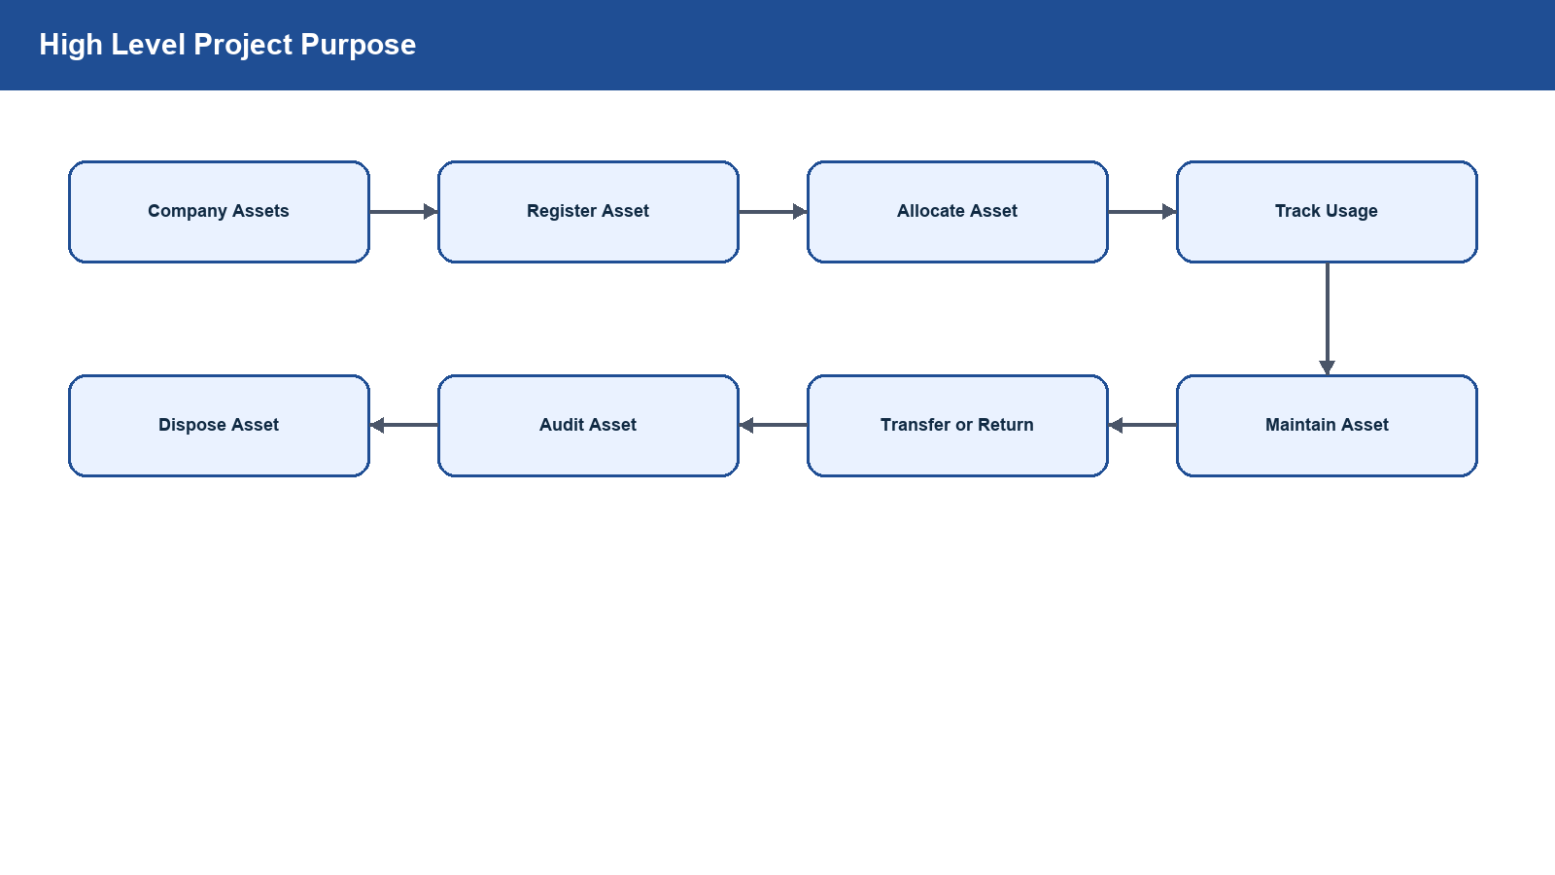

Main Backend Flow
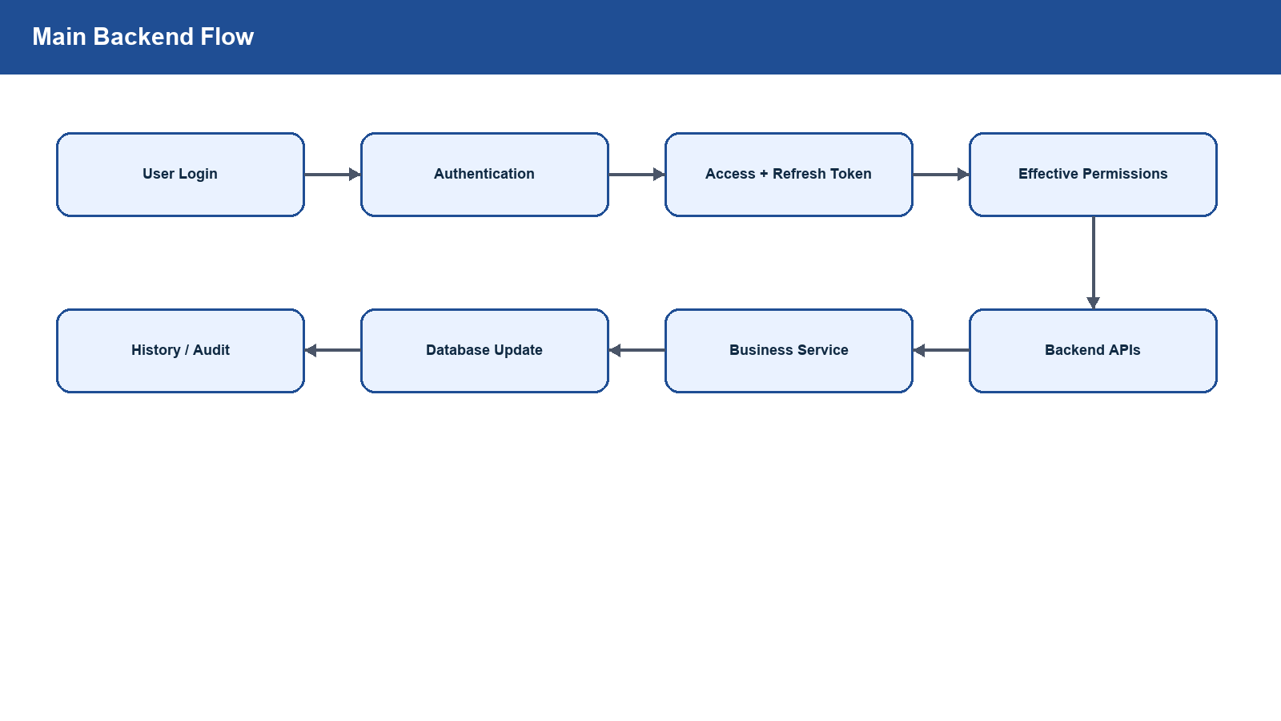

RBAC Security Flow
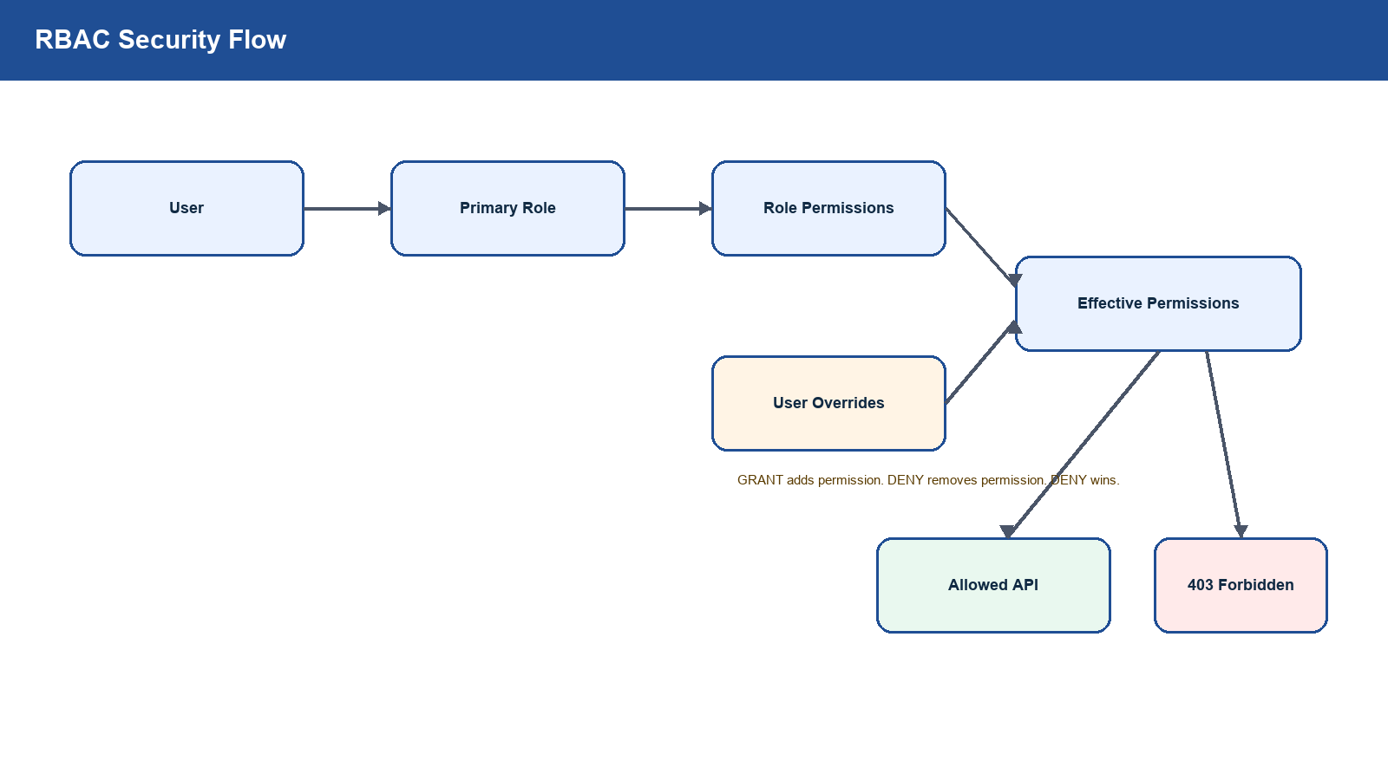

Asset Lifecycle
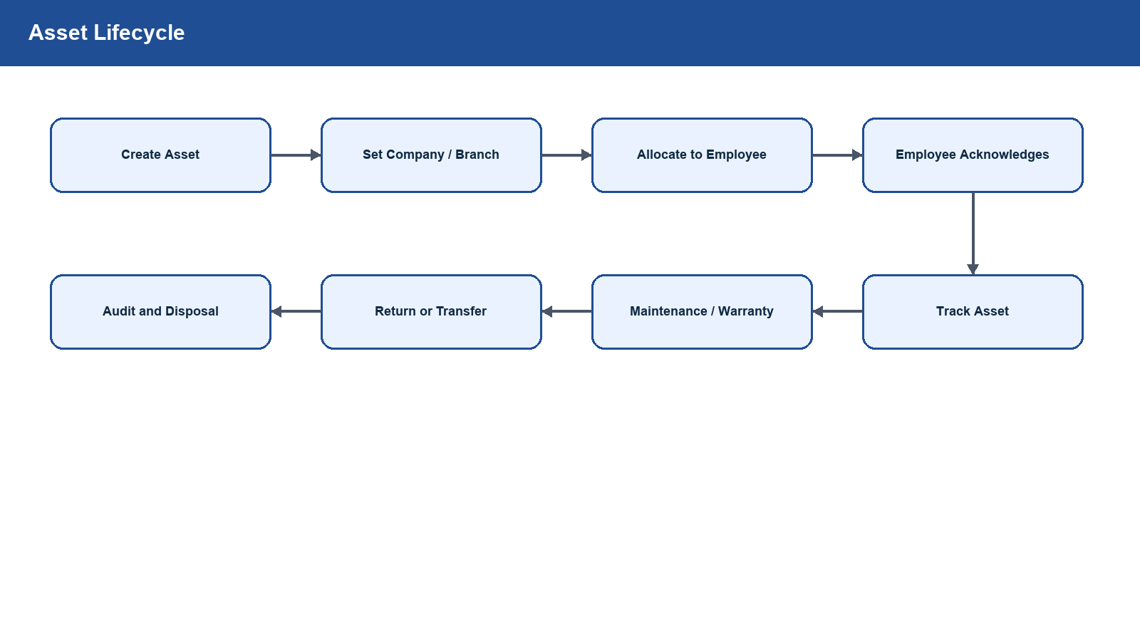

Asset Request Workflow
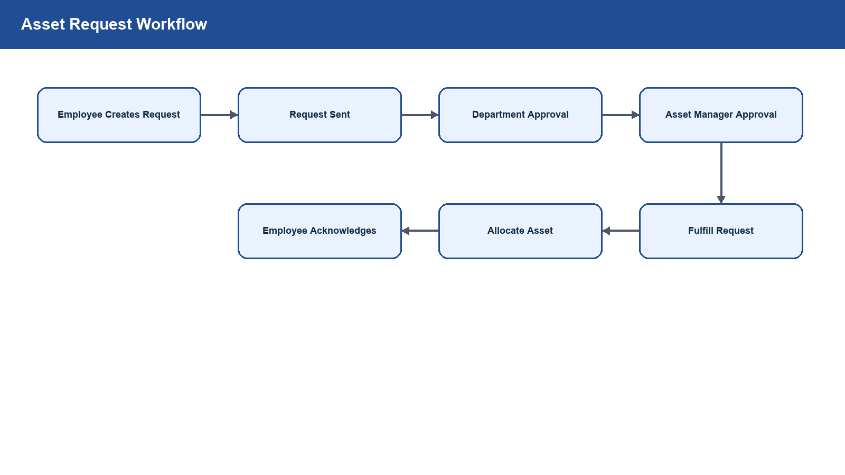

Data Scope Flow
