SQL
Assignment - 1

--------------------------------------------------------------------------------------------------------------------------
Assignment 1 : Simple SQL Query with a single table with where clause
--------------------------------------------------------------------------------------------------------------------------
Northwind database
Sample table :Products
-ProductID
-ProductName
-SupplierID
-CategoryID
-QuantityPerUnit
-UnitPrice
-UnitsInStock
-UnitsOnOrder
-ReorderLevel
-Discontinued

1. Write a query to get a Product list (id, name, unit price) where current products cost
less than $20.
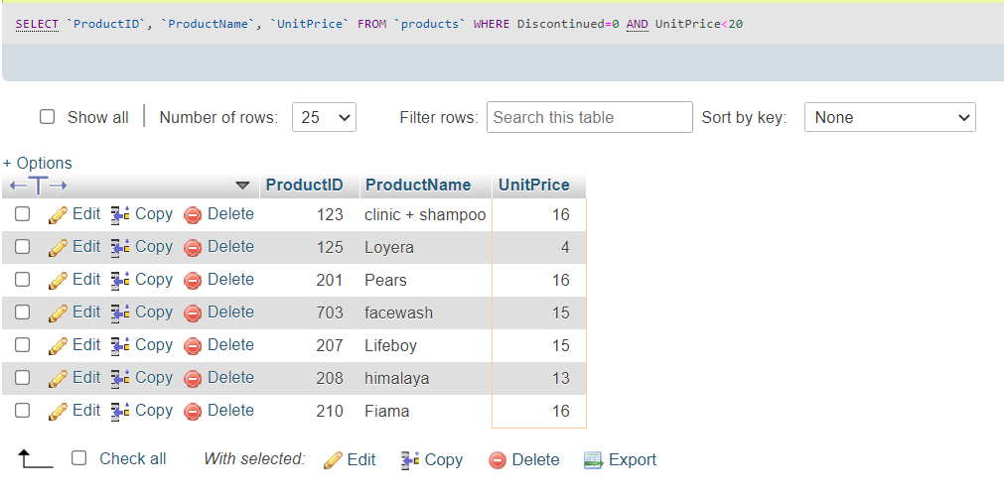
2. Write a query to get Product list (id, name, unit price) where products cost between
$15 and $25

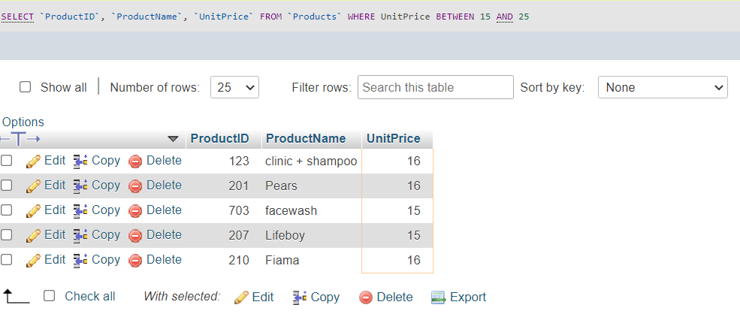

3. Write a query to get Product list (name, unit price) of above average price.

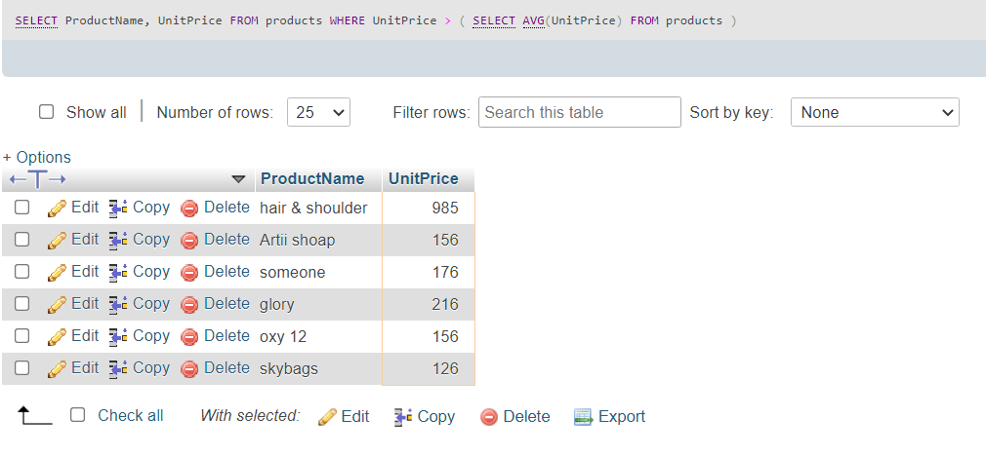

4. Write a query to get Product list (name, unit price) of ten most expensive products

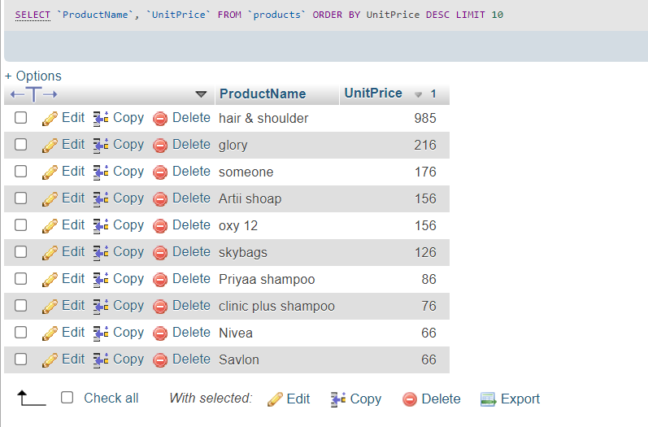

5. Write a query to count current and discontinued products

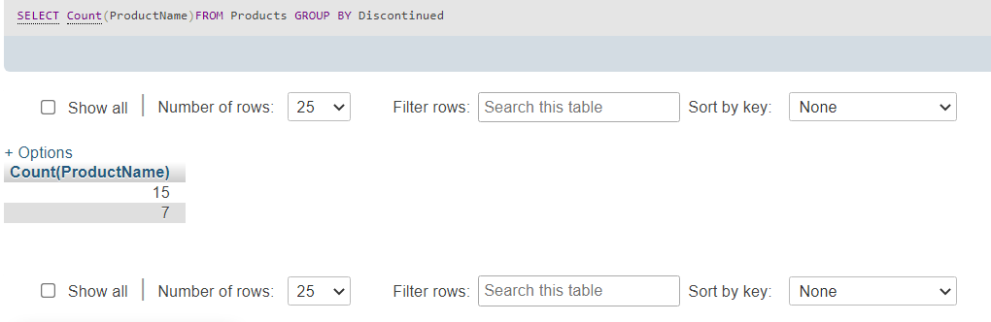

6. Write a query to get Product list (name, units on order , units in stock) of stock is less
than the quantity on order

