SQL

Assignment-3

--------------------------------------------------------------------------------------------------------------------------
Assignment 3 : Retrieve data using Group By clause
--------------------------------------------------------------------------------------------------------------------------
Sample table1:Department

-dept_id

-dept_name

Sample table2: Employee

-emp_id

-dept_id

-mngr_id

-emp_name

-salary

1. write a SQL query to find Employees who have the biggest salary in their Department

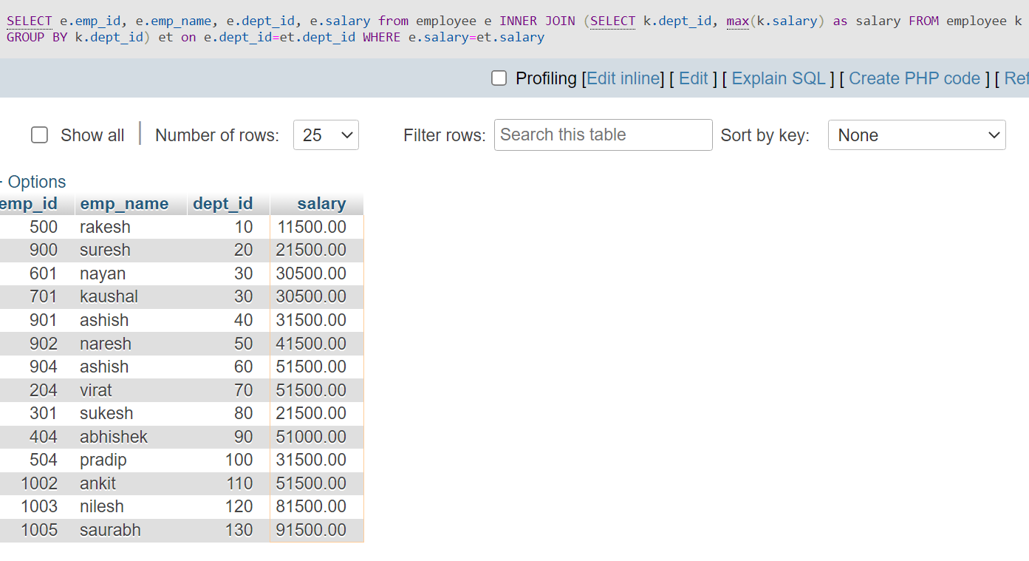
2. write a SQL query to find Departments that have less than 3 people in it

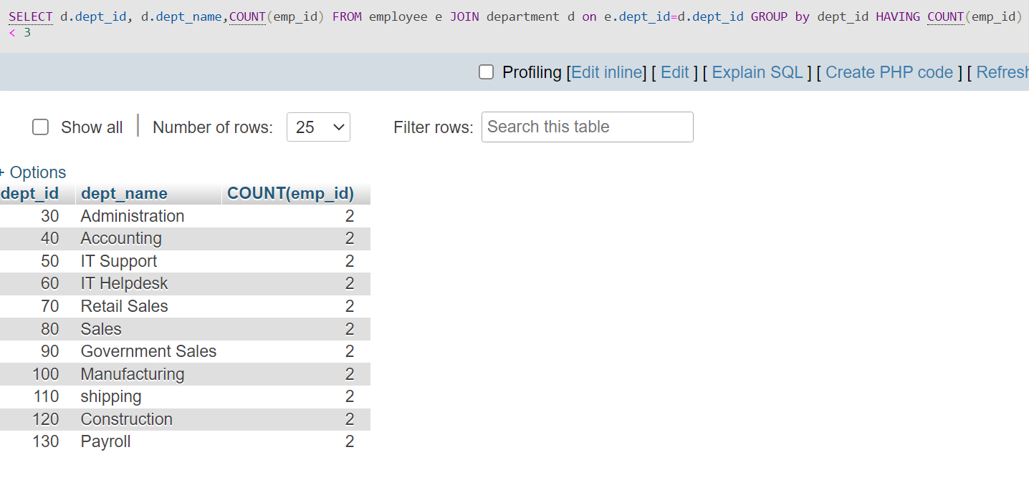

3. write a SQL query to find All Department along with the number of people there

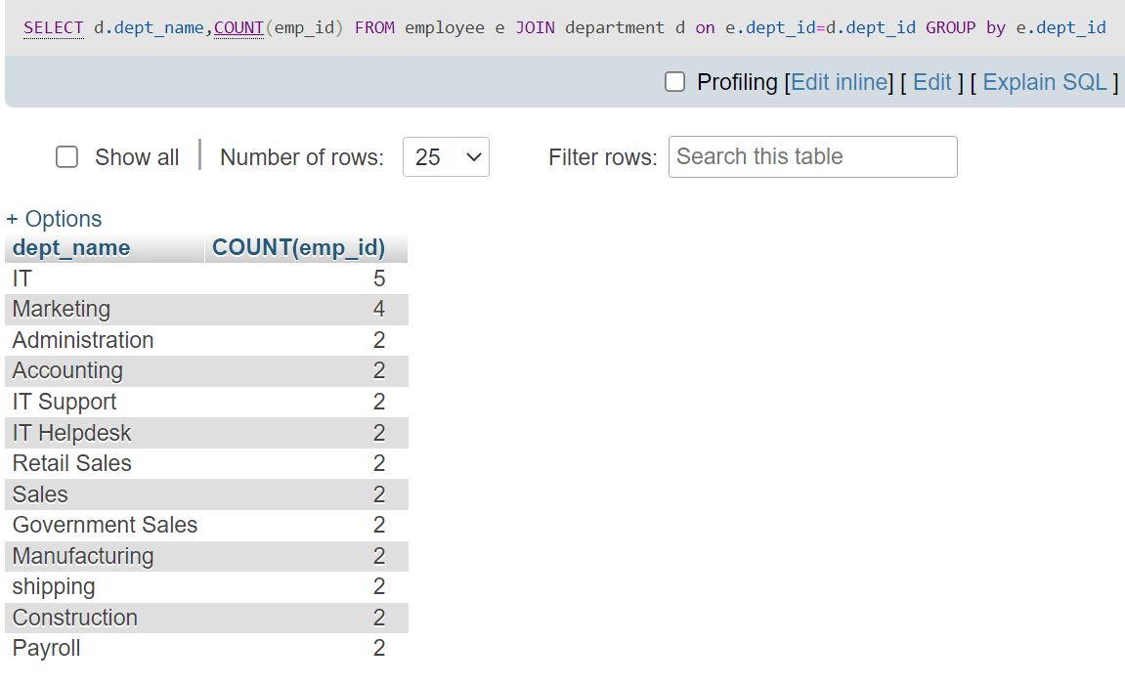

4. write a SQL query to find All Department along with the total salary there

