Assignment-4
SQL

1. Brife Description on stored procedure.
=>
A stored procedure is a prepared SQL code that you can save, so the code can be reused over and over again.
So if you have an SQL query that you write over and over again, save it as a stored procedure, and then just call it to execute it.
You can also pass parameters to a stored procedure, so that the stored procedure can act based on the parameter value(s) that is passed.
Example :
CREATE PROCEDURE SelectAllCustomers
AS
SELECT * FROM Customers
GO;
To exec:
EXEC SelectAllCustomers;

2. Explain ACID properties.
=>

Atomicity:
By this, we mean that either the entire transaction takes place at once or doesn’t happen at all. There is no midway i.e. transactions do not occur partially. Each transaction is considered as one unit and either runs to completion or is not executed at all. It involves the following two operations.
—Abort: If a transaction aborts, changes made to the database are not visible.
—Commit: If a transaction commits, changes made are visible.
Atomicity is also known as the ‘All or nothing rule’.

Consistency:

This means that integrity constraints must be maintained so that the database is consistent before and after the transaction. It refers to the correctness of a database. Referring to the example above,
The total amount before and after the transaction must be maintained.
Total before T occurs =500 + 200 = 700.
Total after T occurs = 400 + 300 = 700.
Therefore, the database is Consistent. Inconsistency occurs in caseT1completes butT2fails. As a result, T is incomplete.

Isolation:
This property ensures that multiple transactions can occur concurrently without leading to the inconsistency of the database state. Transactions occur independently without interference. Changes occurring in a particular transaction will not be visible to any other transaction until that particular change in that transaction is written to memory or has been committed. This property ensures that the execution of transactions concurrently will result in a state that is equivalent to a state achieved these were executed serially in some order.
Let X= 500,Y = 500.
Consider two transactions T and T.

Durability:

This property ensures that once the transaction has completed execution, the updates and modifications to the database are stored in and written to disk and they persist even if a system failure occurs. These updates now become permanent and are stored in non-volatile memory. The effects of the transaction, thus, are never lost.

3. Explain offset in limit query with example.
The following example uses both LIMIT & OFFSET clauses to return five rows starting from the 4th row:
SELECT
employee_id, first_name, last_name
FROM
employees
ORDER BY first_name
LIMIT 5 OFFSET 3;
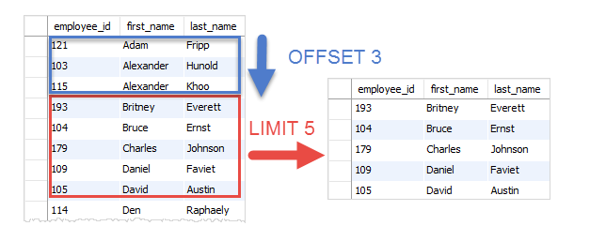

4.Left Join and Right Join with example.

=>

LEFT JOIN
This join returns all the rows of the table on the left side of the join and matches rows for the table on the right side of the join. For the rows for which there is no matching row on the right side, the result-set will contain null. LEFT JOIN is also known as LEFT OUTER JOIN.

Syntax:
SELECT table1.column1,table1.column2,table2.column1,....
FROM table1
LEFT JOIN table2
ON table1.matching_column = table2.matching_column;

table1: First table.
table2: Second table
matching_column: Column common to both the tables.

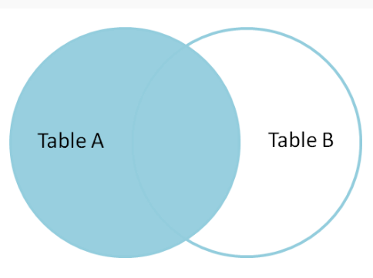
RIGHT JOIN

RIGHT JOIN is similar to LEFT JOIN. This join returns all the rows of the table on the right side of the join and matching rows for the table on the left side of the join. For the rows for which there is no matching row on the left side, the result-set will contain null. RIGHT JOIN is also known as RIGHT OUTER JOIN.

Syntax:
SELECT table1.column1,table1.column2,table2.column1,....
FROM table1
RIGHT JOIN table2
ON table1.matching_column = table2.matching_column;

table1: First table.
table2: Second table
matching_column: Column common to both the tables.
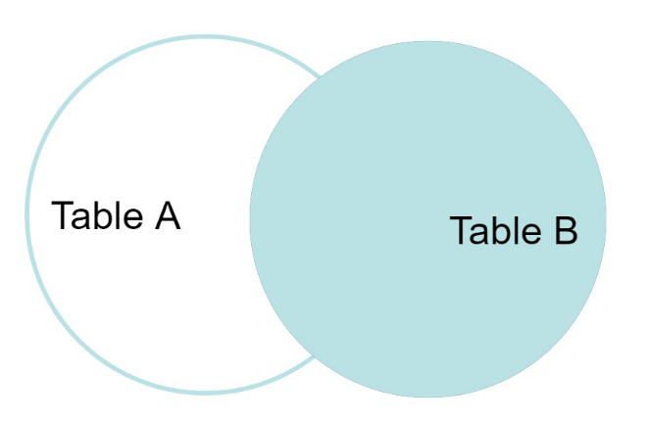

5. Explain Group by
The GROUP BY Statement in SQL is used to arrange identical data into groups with the help of some functions. i.e if a particular column has same values in different rows then it will arrange these rows in a group. Important Points:
- GROUP BY clause is used with the SELECT statement.
- In the query, GROUP BY clause is placed after the WHERE clause.
- In the query, GROUP BY clause is placed before ORDER BY clause if used any.
- In the query , Group BY clause is placed before Having clause .
- Place condition in the having clause

syntax:
SELECT column1, function_name(column2)
FROM table_name
WHERE condition
GROUP BY column1, column2
ORDER BY column1, column2;

function_name: Name of the function used for example, SUM(), AVG().
table_name: Name of the table.
condition: Condition used.

6. Logical operators in mySQL.
SQL logical operators are used to test for the truth of the condition. A logical operator like the Comparison operator returns a boolean value of TRUE, FALSE, or UNKNOWN.

Given below is the list of logical operators available in SQL.
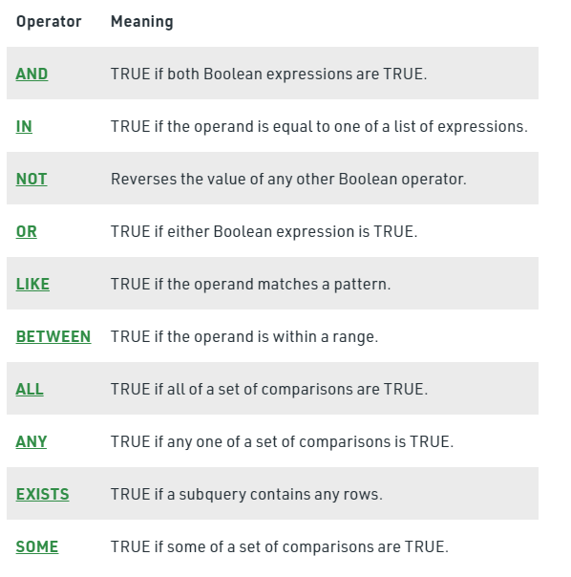

7.Data types in mySQL
1. Binary Datatypes :
There are four subtypes of this datatype which are given below :
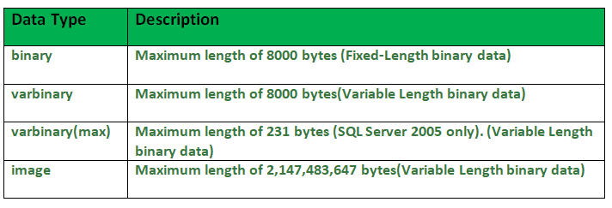
2. Exact Numeric Datatype :
There are nine subtypes which are given below in the table. The table contains the range of data in a particular type.
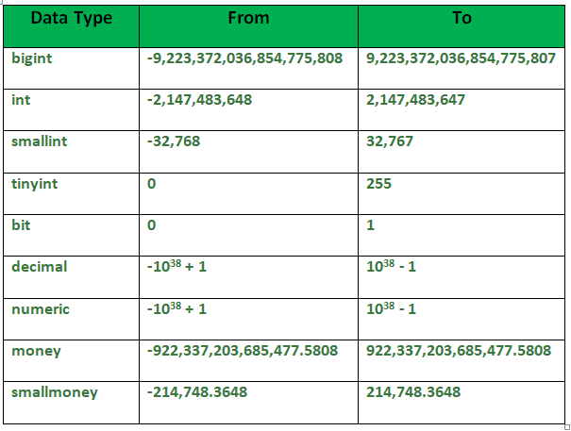
3. Approximate Numeric Datatype :
The subtypes of this datatype are given in the table with the range.
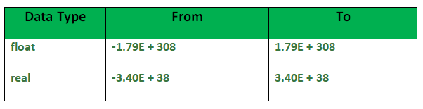

4. Character String Datatype :
The subtypes are given in below table –
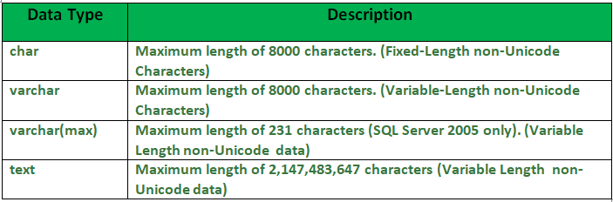
5. Unicode Character String Datatype :
The details are given in below table –
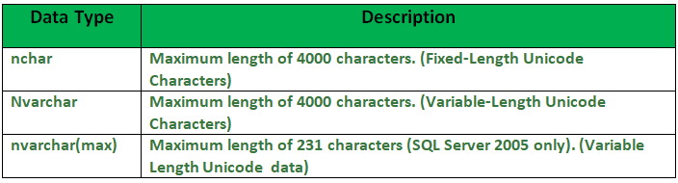

6. Date and Time Datatype :
The details are given in below table.
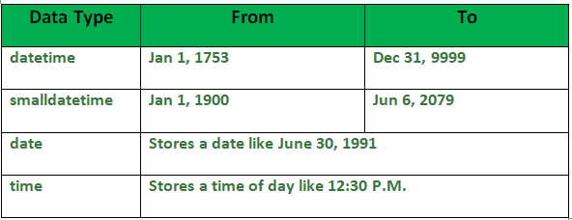

8.Float and double, Where to use them.
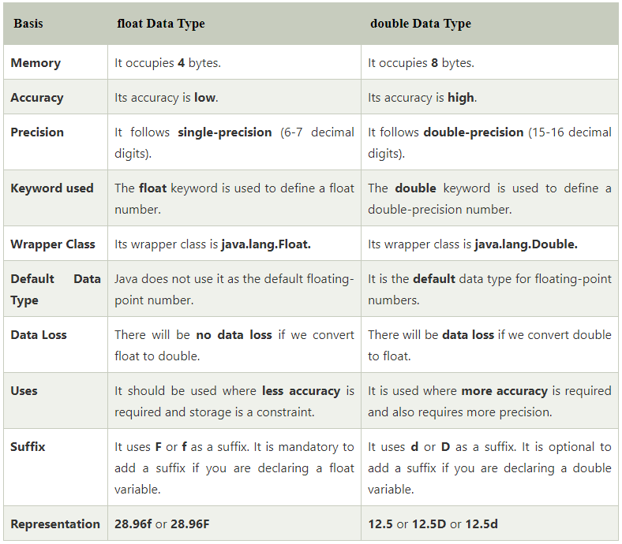
double is more precise than float. So, if a more precise and accurate result is required use double. Another reason to use double is that if the number is not fitting in the range offered by the float then use double. We should use float if we have memory constraint because it occupies half-space than double.
9.Functions in mySQL
Aggregate functions:
These functions are used to do operations from the values of the column and a single value is returned.
  - AVG()
  - COUNT()
  - FIRST()
  - LAST()
  - MAX()
  - MIN()
  - SUM()

Scalar functions:
These functions are based on user input, these too returns single value.
  - UCASE()
  - LCASE()
  - MID()
  - LEN()
  - ROUND()
  - NOW()
  - FORMAT()

AVG(): It returns the average value after calculating from values in a numeric column.
COUNT(): It is used to count the number of rows returned in a SELECT statement. It can’t be used in MS ACCESS.
FIRST(): The FIRST() function returns the first value of the selected column.

LAST(): The LAST() function returns the last value of the selected column. It can be used only in MS ACCESS.
MAX(): The MAX() function returns the maximum value of the selected column.
MIN(): The MIN() function returns the minimum value of the selected column.
SUM(): The SUM() function returns the sum of all the values of the selected column.
UCASE(): It converts the value of a field to uppercase.
LCASE(): It converts the value of a field to lowercase.
MID(): The MID() function extracts texts from the text field.
LEN(): The LEN() function returns the length of the value in a text field.
ROUND(): The ROUND() function is used to round a numeric field to the number of decimals specified.NOTE: Many database systems have adopted the IEEE 754 standard for arithmetic operations, which says that when any numeric .5 is rounded it results to the nearest even integer i.e, 5.5 and 6.5 both gets rounded off to 6.
NOW(): The NOW() function returns the current system date and time.
FORMAT(): The FORMAT() function is used to format how a field is to be displayed

10. Having clause.

In MySQL, the HAVING clause is used to apply a filter on the result of GROUP BY based on the specified condition. The conditions are Boolean type i.e. use of logical operators(AND, OR). This clause was included in SQL as the WHERE keyword failed when we use it with aggregate expressions. Having is a very generally used clause in SQL. Similar to WHERE it helps to apply conditions, but HAVING works with groups. If you wish to filter a group, the HAVING clause comes into action.
Some important points:
- Having clause is used to filter data according to the conditions provided.
- Having clause is generally used in reports of large data.
- Having clause is only used with the SELECT clause.
- The expression in the syntax can only have constants.
- In the query, ORDER BY is to be placed after the HAVING clause, if any.
- HAVING Clause implements in column operation.
- Having clause is generally used after GROUP BY.
- The GROUP BY clause is used to arrange required data into groups.

11. Difference between innoDB and myisam:
