Jenkins Freestyle Job – Branch Based Deployment to Apache HTTPD

Objective:
To create a GitHub repository with three branches and create three Jenkins Freestyle Job that deploys branch-specific code to Apache HTTPD web server.

Branch Structure:
- 2025Q1
- 2025Q2
- 2025Q3
Each branch contains different index.html content.

Step 1: Create GitHub Repository
1. Login to GitHub
2. Create a new repository named: branch-deploy-httpd
3. Clone repository:

Step 2: Create Branches
- 2025Q1
- 2025Q2
- 2025Q3

Step 3: Push index.html
- Push separate index.html in all branches with branch name message in file.
Step 4: Install Apache HTTPD
- Start httpd.

Creating 3 separate jobs for each branch code deployment.
- Create Jenkins Freestyle Job for 2025Q1 branch.
-- Jenkins Dashboard → New Item
-- Job Name: 2025Q1-job
-- Select Freestyle Project
-- configure git repository.
-- add branch name
-- Add Build steps:
--execute shell
-- rm -rf /var/www/html/*
-- cp /mnt/2025Q1-job/index.html /var/www/html/
-- Apply --> Save
-- Build Job
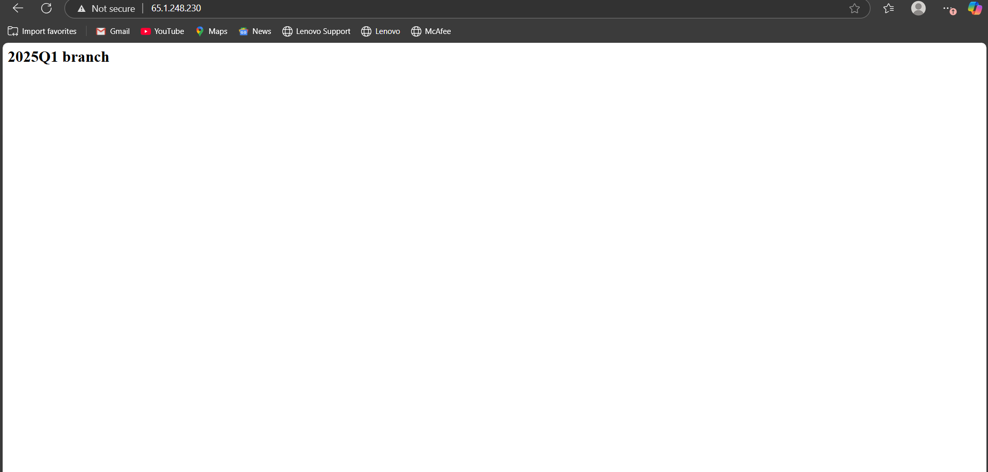

- Create Jenkins Freestyle Job for 2025Q2 branch.
-- Jenkins Dashboard → New Item
-- Job Name: 2025Q2-job
-- Select Freestyle Project
-- configure git repository.
-- add branch name
-- Add Build steps:
--execute shell
-- rm -rf /var/www/html/*
-- cp /mnt/2025Q2-job/index.html /var/www/html/
-- Apply --> Save
-- Build Job

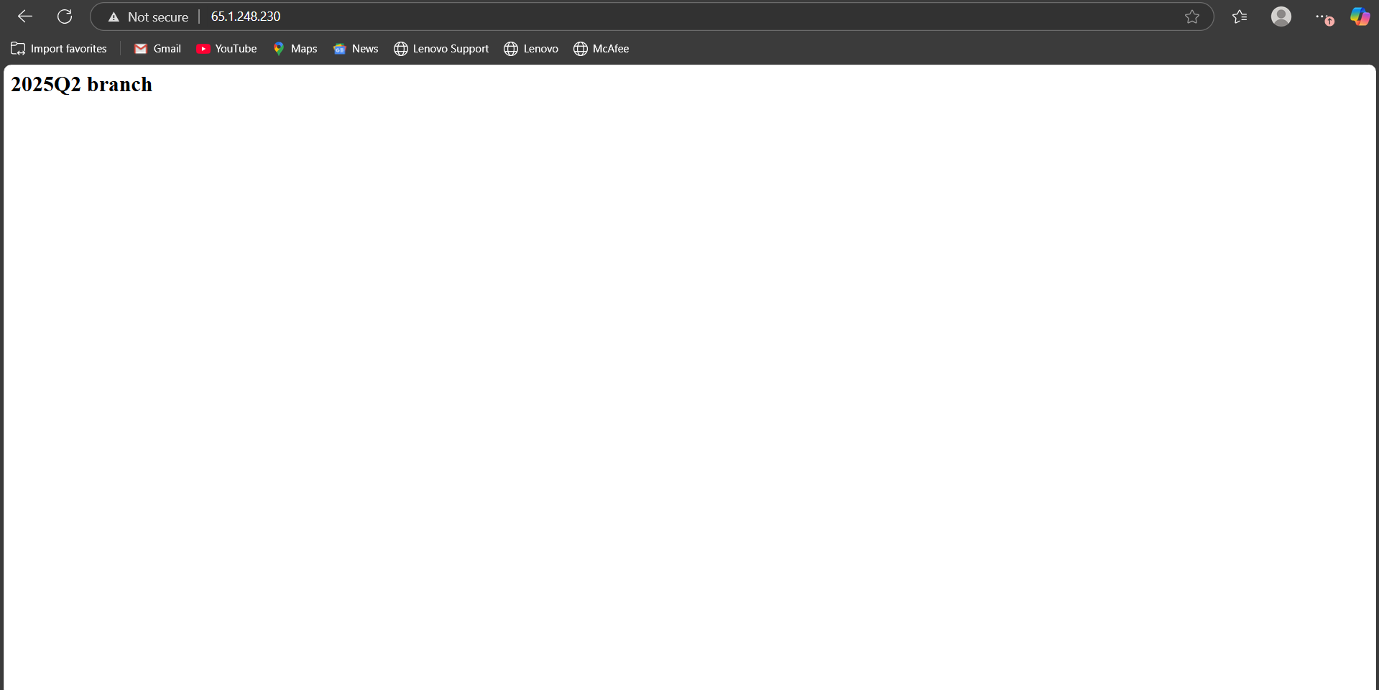

- Create Jenkins Freestyle Job for 2025Q3 branch.
-- Jenkins Dashboard → New Item
-- Job Name: 2025Q3-job
-- Select Freestyle Project
-- configure git repository.
-- add branch name
-- Add Build steps:
--execute shell
-- rm -rf /var/www/html/*
-- cp /mnt/2025Q3-job/index.html /var/www/html/
-- Apply --> Save
-- Build Job
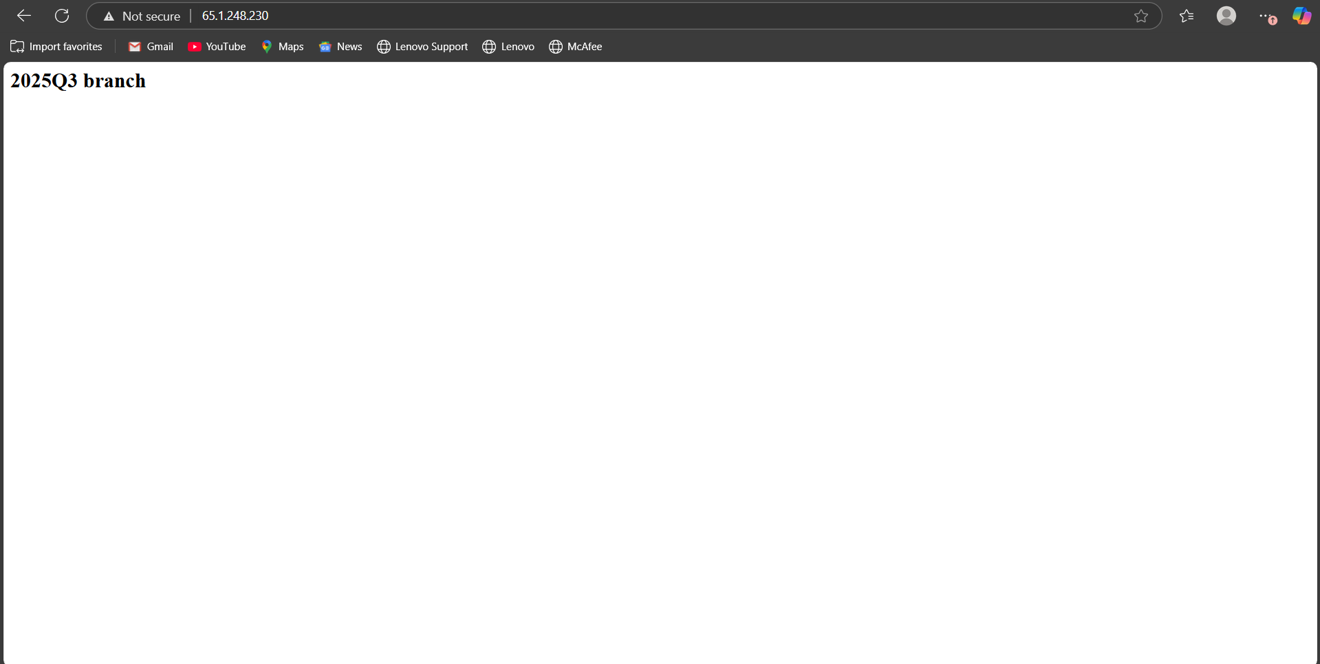

Conclusion:
This assignment demonstrates branch-specific deployment using Jenkins Freestyle job and Apache HTTPD.

