task 1: Sequential Builds using Freestyle Project

Step 1: Create First Freestyle Job-A
- Click on New Item
- Enter job name: Job-A
- Select Freestyle project
- Configure Build Step
- Go to Build section
- Select Execute shell
- Add command:
-sleep 10
- Save the job

Step 2: Create Second Freestyle Job-B
- Click New Item
- Enter job name: Job-B
- Select Freestyle project
- Configure Build Step
- Go to Build section
- Select Execute shell
- Add command:
-sleep 10
- Save the job

Step 3: Create Third Freestyle Job-c
- Click New Item
- Enter job name: Job-c
- Select Freestyle project
- Configure Build Step
- Go to Build section
- Select Execute shell
- Add command:
-sleep 10
- Save the job

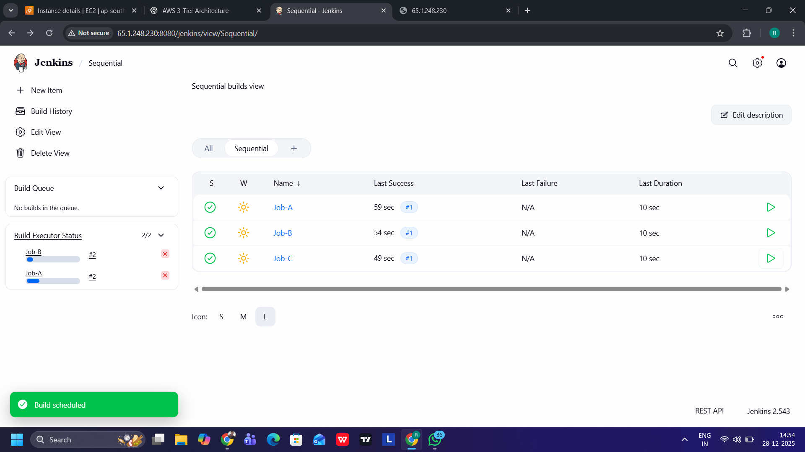

Summary:
Build each job using the build now then you can see each job will run sequentially a complete their build process.

