Task 2: Parallel Builds using Freestyle Project

Step 1: Create Three Freestyle Jobs
- Job-1
- Job-2
- Job-3

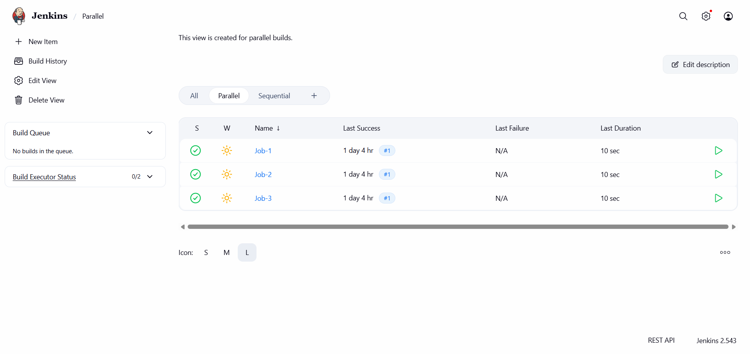

Step 2: Configure Build Steps
- Add Execute shell in both jobs:
sleep 10

Step 3: Configure Job-1
- In Build section
- Select: Build other projects
- Projects to build:
Job-2
- Check: Trigger builds in parallel

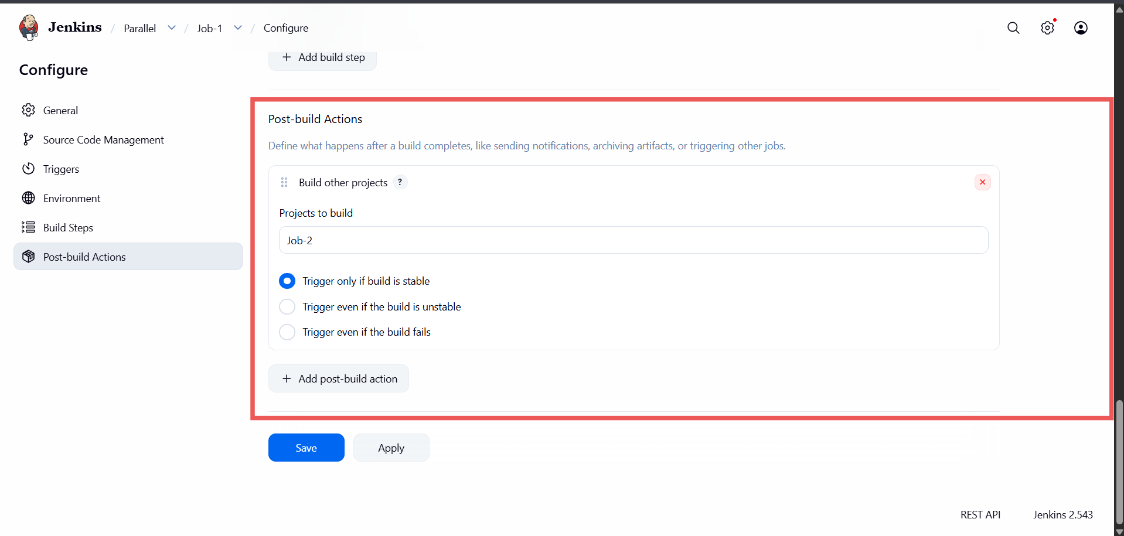

Step 4: Configure Job-2
- In Build section
- Select: Build other projects
- Projects to build:
- Job-3
- Check: Trigger builds in parallel
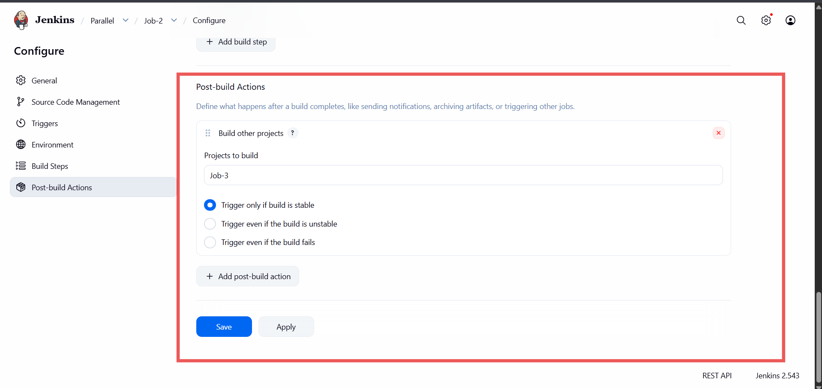

Step 5: Save and Build
- Trigger job-1
- Both jobs run in parallel.

Summary:
In this jenkins parallel jobs first job build process is completed then it will automatically trigger second job and second job build process is completed it will trigger third job.

