Assignment: Deploy index.html using Jenkins Freestyle Job and httpd.
In this assignment manually install and configure an HTTPD server on a Linux instance, create an index.html file, and deploy it using a Jenkins Freestyle job. Also the next step in the assignment is update the file and redeploying it through Jenkins.
-For the jenkins job run on your server you need java installation on your server.

Step 1: Install HTTP Server on Linux Instance
Login to the Linux instance and install Apache HTTP server manually using the following command:
yum install httpd -y

Step 2: Start and Enable HTTPD Service
Start the Apache service and enable it to run on system startup:
systemctl start httpd
systemctl enable httpd

Step 3: Create index.html File in /mnt Directory
In /mnt directory and create an index.html file manually and add some code into that file for test.

Step 4: Create Jenkins Freestyle Job for Deployment
- Open Jenkins Dashboard and click on New Item.
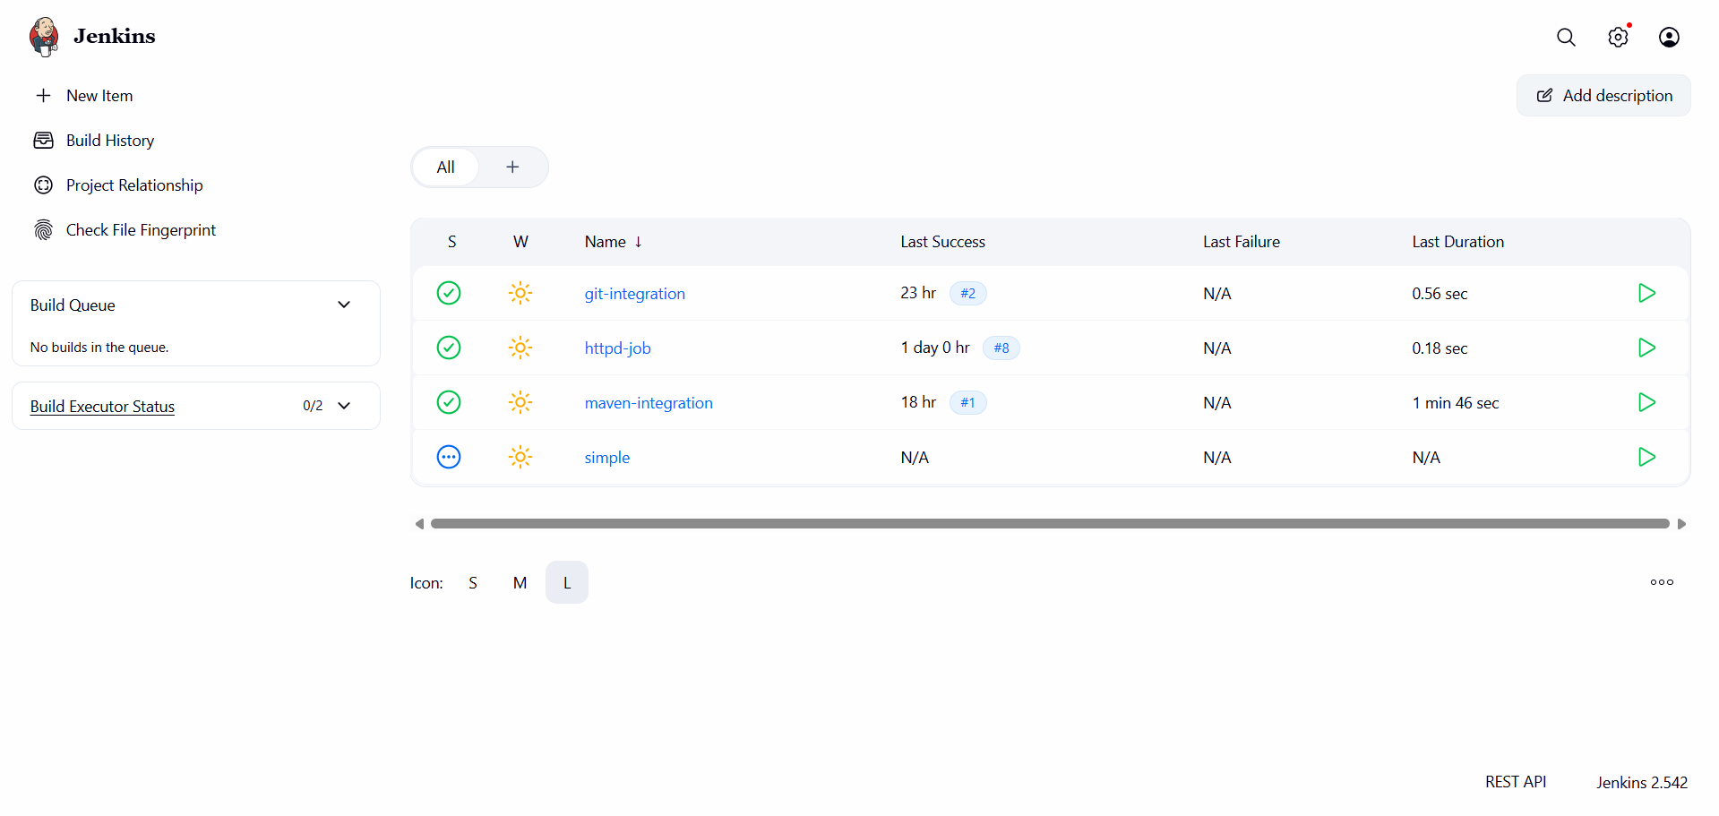
- Enter job name and select Freestyle project.
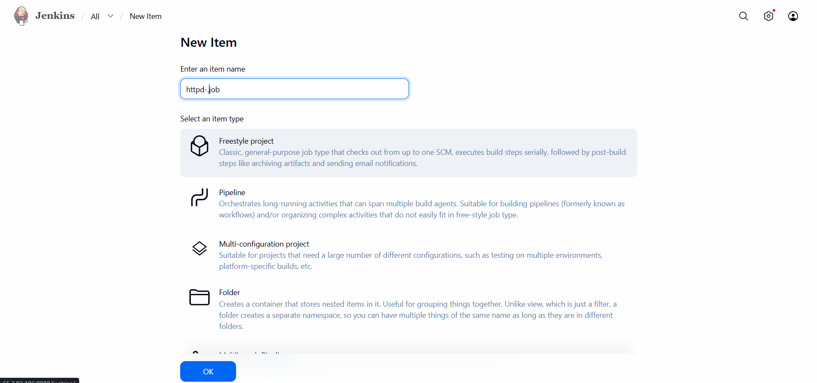
3. Configure the build step as Execute Shell.
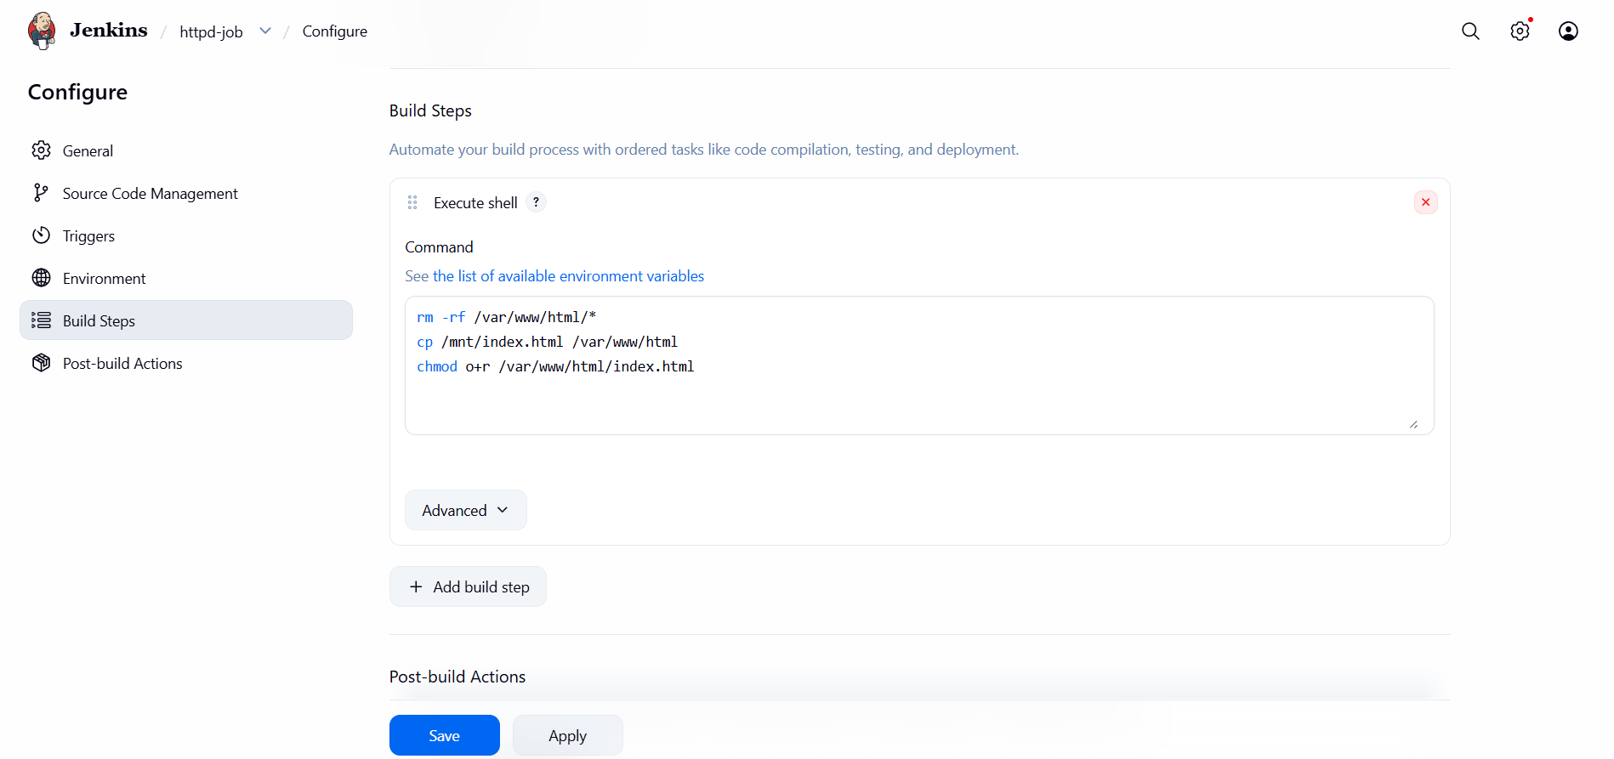

Build Step Commands
rm -rf /var/www/html/index.html
cp /mnt/index.html /var/www/html/index.html
chmod o+r /var/www/html/index.html
Apply and Save Job.

Step 5: Build and Verify Deployment
In the Jenkins job click on Build Now.
Open a browser and access the application using the server public IP address.
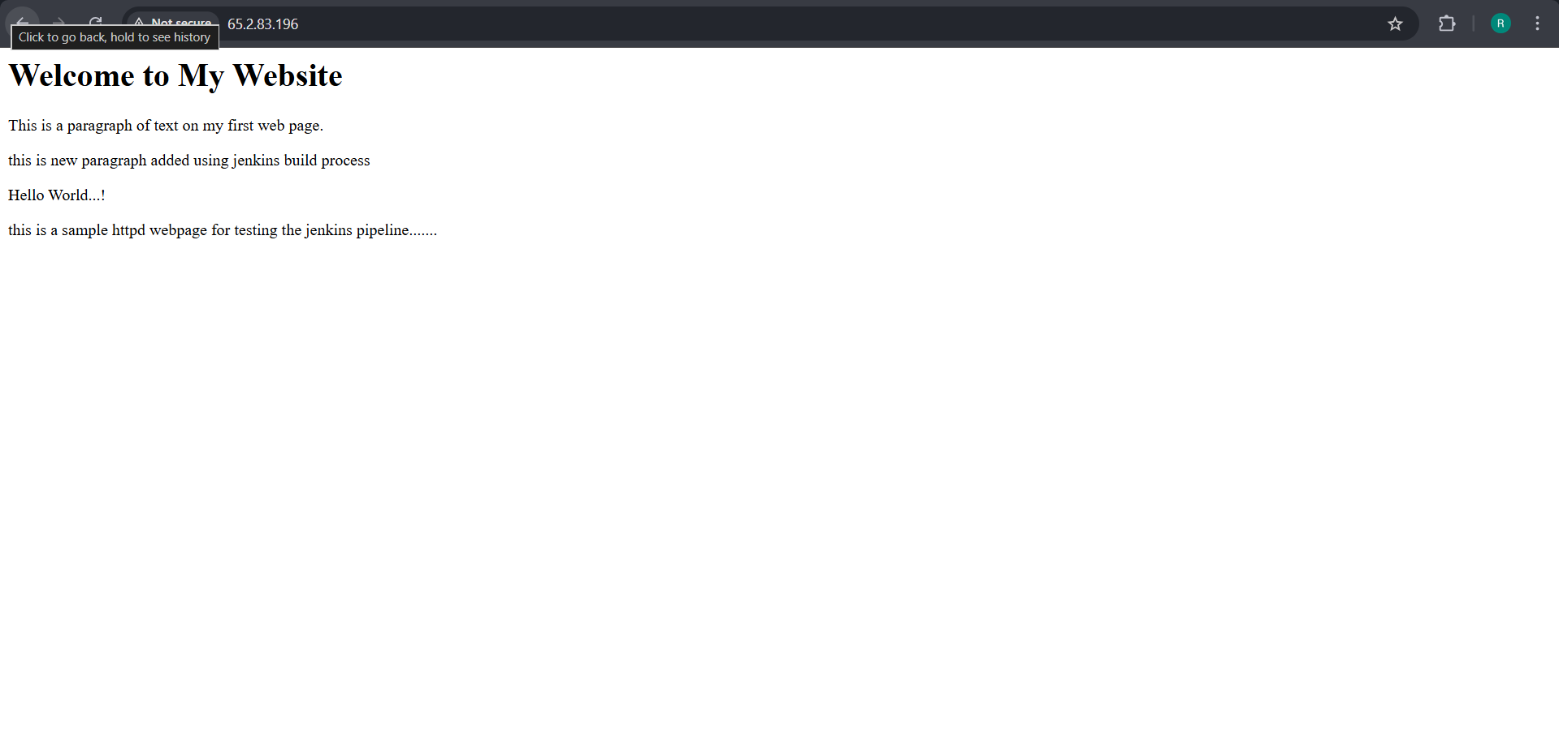

Step 6: Update index.html and Rebuild Job
Update the index.html file manually in /mnt directory.
Save the file.
Rebuild the Jenkins job.
Refresh the browser to verify that webpage.

Conclusion
This assignment successfully demonstrates manual installation of Apache, deployment of a web page using Jenkins Freestyle job, and redeployment after updating the file.

