Jenkins Parameterized Job – Tool Installation Assignment

Objective:
Create a Jenkins parameterized freestyle job that allows the user to select a tool (Java, Git, Maven, Tomcat) at build time.
The job should check whether the selected tool is installed on the Jenkins server.
If the tool is not installed, it should be installed automatically.

Step 1: Create Jenkins Freestyle Job
1. Login to Jenkins Dashboard
2. Click on New Item
3. Enter Job Name: Parameterized-Job
4. Select Freestyle Project
5. Click OK

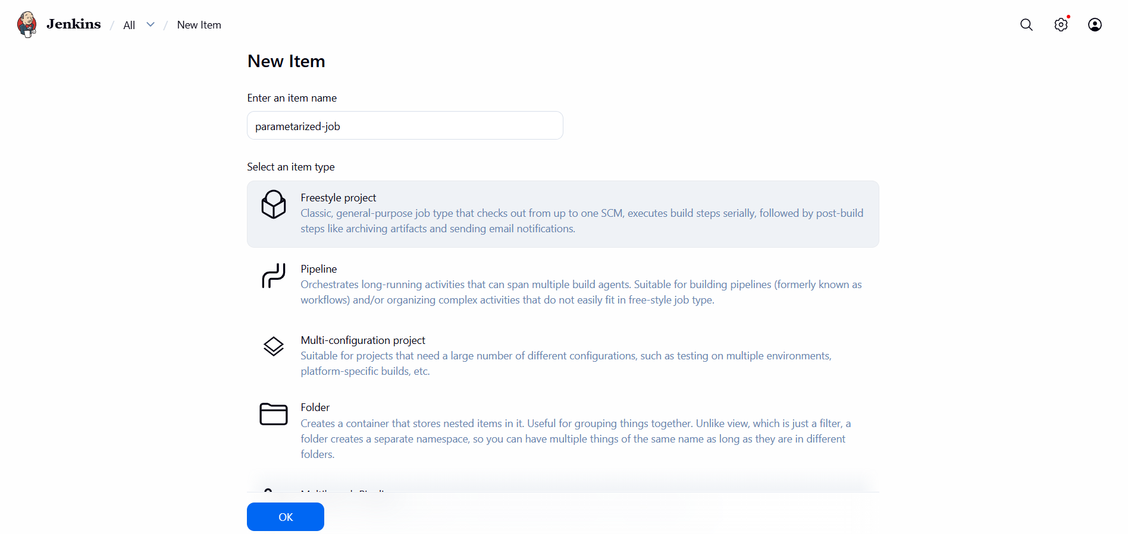

Step 2: Configure Parameters
1. Go to General section
2. Enable “This project is parameterized”
3. Add Choice Parameter
- Name: tools
- Choices:
Java
Git
maven
tomcat
- Description: Select the tool to install or verify

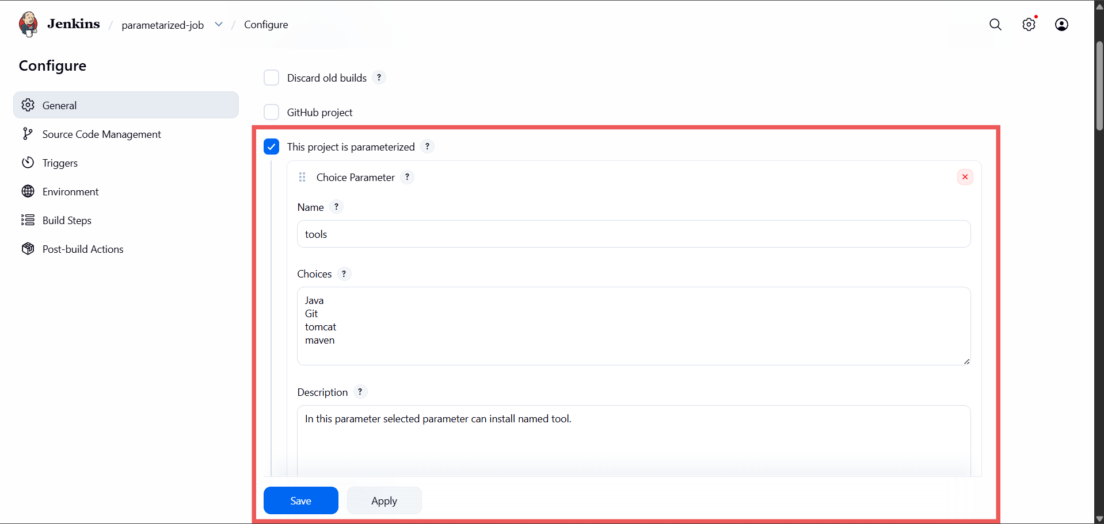

Step 3: Add Build Step (Execute Shell)
Add the following shell script:
#!/bin/bash

if [[ "$tools" == "Java" ]]
then
java --version
if [ $? -eq 0 ]
then
echo "java already installed"
else
dnf install java -y
echo "Java installed sucessfully"
fi

elif [[ "$tools" == "Git" ]]
then
git --version
if [ $? -eq 0 ]
then
echo "Git already installed."
else
dnf install git -y
echo "git installed successfully."
fi

elif [[ "$tools" == "tomcat" ]]
then
if ls $tools /mnt>/dev/null
then
echo "tomcat already installed"
else
mkdir /mnt/tomcat
cd /mnt/tomcat
wget https://dlcdn.apache.org/tomcat/tomcat-10/v10.1.50/bin/apache-tomcat-10.1.50.zip
unzip apache-tomcat-10.1.50.zip
rm -rf apache-tomcat-10.1.50.zip
echo "Tomcat installed successfully."
fi

elif [[ "$tools" == "maven" ]]
then
mvn --version
if [ $? -eq 0 ]
then
echo "Maven already installed"
else
mkdir /mnt/maven
cd /mnt/maven
wget https://dlcdn.apache.org/maven/maven-3/3.9.12/binaries/apache-maven-3.9.12-bin.zip
unzip apache-maven-3.9.12-bin.zip
rm -rf apache-maven-3.9.12-bin.zip
echo 'export PATH="/mnt/maven/apache-maven-3.9.12/bin:$PATH"' >> ~/.bashrc
echo "maven Installed successfully."
fi

else
echo "Wrong parameter"
fi

Step 4: Build with Parameters
1. Click Save
2. Click Build with Parameters
3. Select a tool from the dropdown
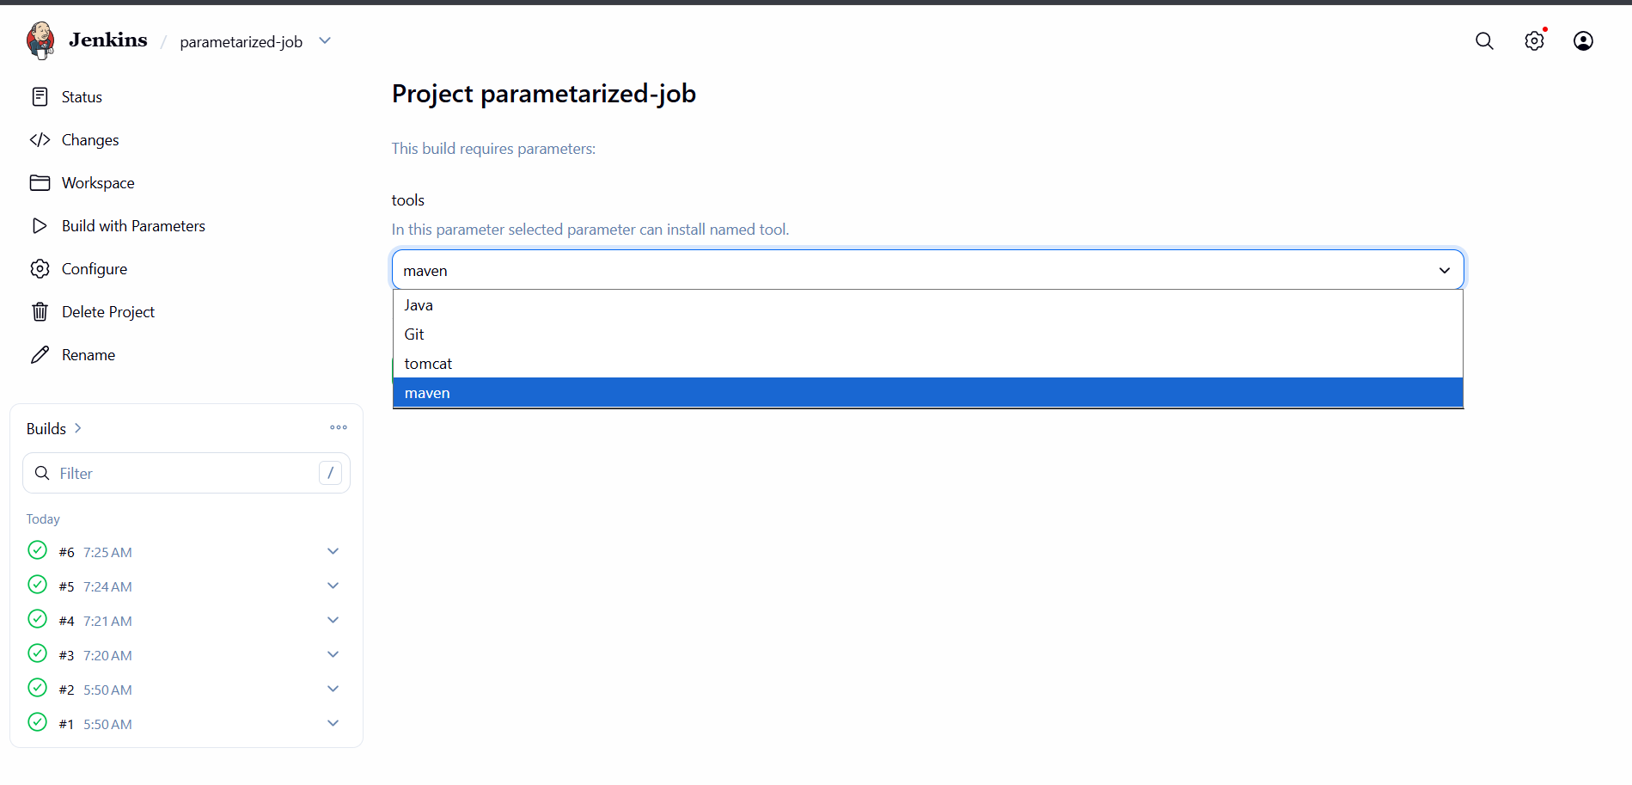

4. Click Build
5. Verify output in Console Output

Conclusion:
This assignment demonstrates how to use Jenkins parameterized jobs to automate tool verification and installation.
It improves efficiency by reducing manual setup and ensures required tools are always available.

