Task 4: Poll SCM using jenkins freestyle.

Step 1: Create Freestyle Job
- Job name: poll-scm-job
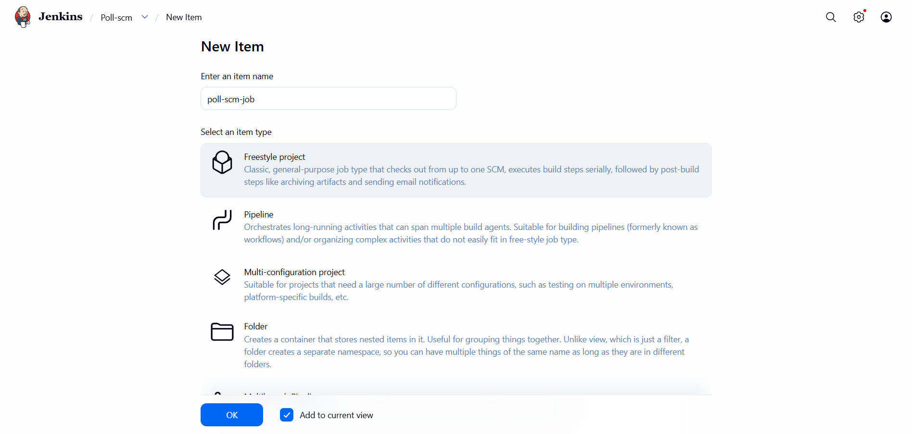

Step 2: Configure Git Repository
- Add Git repository URL
- Configure credentials if required
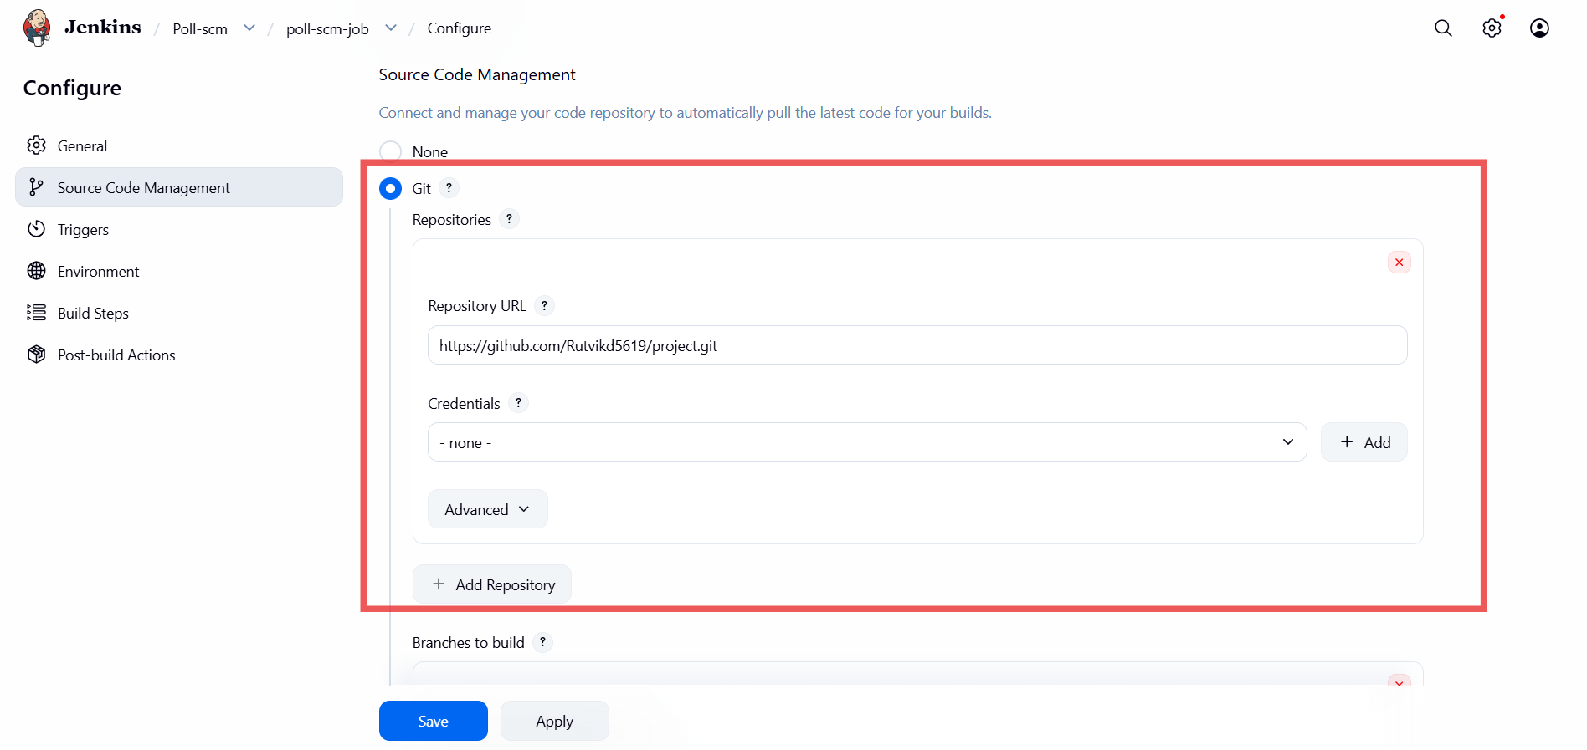

Step 3: Configure Poll SCM
- In Build Triggers
- Select: Poll SCM
- Enter cron:
H/2 * * * *
(This checks repository every 2 minutes)
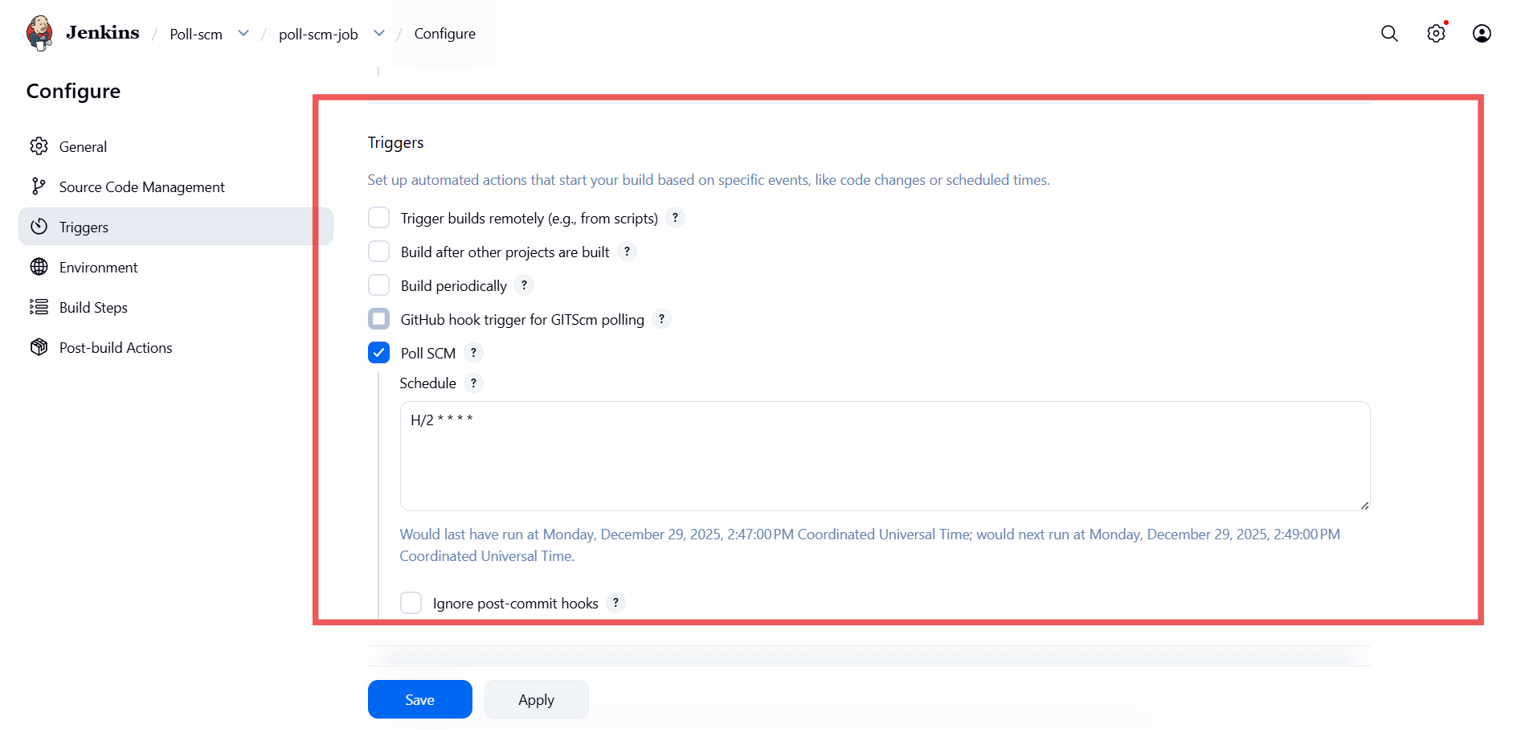

Step 4: Add Build Step
- Execute shell:
echo "SCM change detected"
- Save job

Step 5: Make Code Change
- Commit and push changes to Git repository
- Jenkins will automatically trigger build

Summary:
In this jenkins job it will check change detected in the git repository on every five minute if any change in the git repo it will clone repo and change is not detected it will not clone repo.

