Jenkins Assignment: Deploy index.html Using SCP
Objective:
Create a Jenkins pipeline that clones a Git repository and deploys the index.html file to multiple Linux servers running Apache httpd using the SCP command.

Prerequisites
1. Jenkins installed and running
2. Git installed on Jenkins server
3. Apache httpd installed on target Linux servers
4. SSH key-based authentication configured between Jenkins and target servers

Step 1: Prepare Target Servers
1. Install Apache httpd:
sudo yum install httpd -y
2. Start and enable httpd:
sudo systemctl start httpd
sudo systemctl enable httpd

Step 2: Configure SSH Access
1. Generate SSH key pair on Jenkins server:
2. first manually run scp command on jenkins master:
3. copy file manually on other servers.

Step 3: Prepare Git Repository
1. Create a Git repository
2. Add index.html file
3. Add Jenkinsfile in the repository root

Step 4: Create Jenkins Pipeline Job
- Open Jenkins Dashboard
2. Click New Item
3. Select Pipeline
4. Configure Git repository URL
5. Use Jenkinsfile from SCM
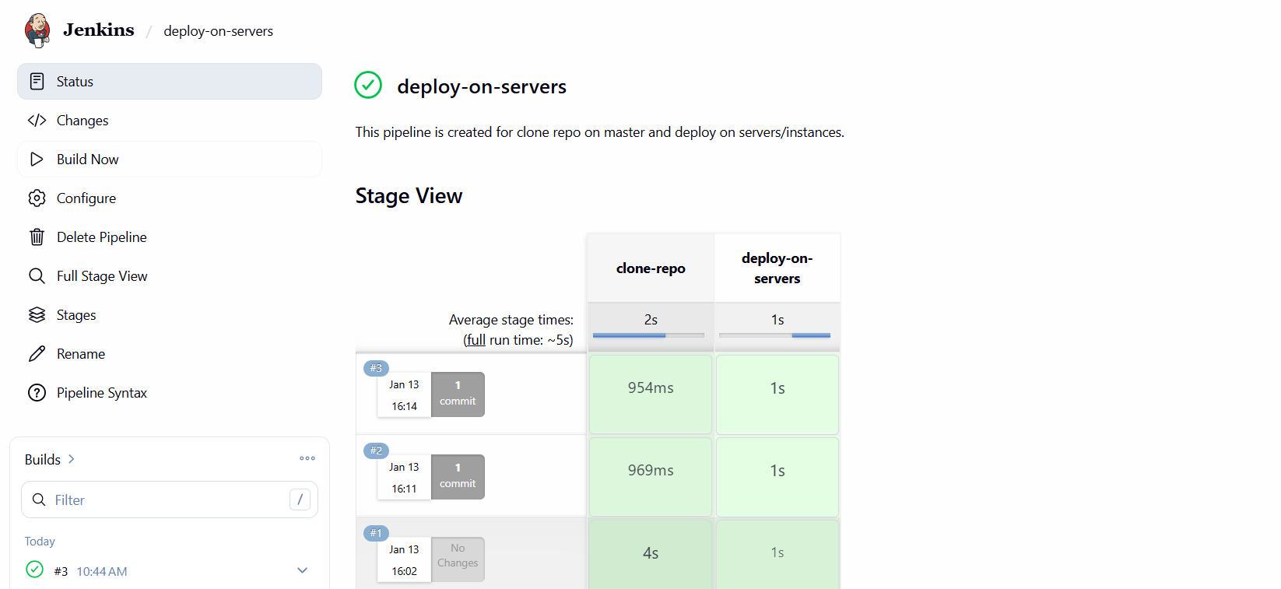

Step 5: Pipeline Execution Flow
1. Jenkins clones the Git repository
2. Jenkins accesses index.html from workspace
3. Jenkins copies index.html to each target server using SCP
4. Apache httpd is restarted on each server

Step 6: Verification
- Open browser
2. Access server public IP or DNS
3. Confirm index.html is displayed correctly


Update file and build again:


Conclusion
This pipeline automates the deployment of a static web page to multiple Linux servers. It demonstrates basic CI/CD concepts such as source control integration, automation, and remote deployment using Jenkins.

