Task 3: Periodic Build using Jenkins freestyle

Step 1: Create Freestyle Job
- Job name: periodic-build-job

Step 2: Configure Build Trigger
- Go to Build Triggers
- Select: Build periodically
- Enter cron schedule:
H/5 * * * *
(This runs the job every 5 minutes)

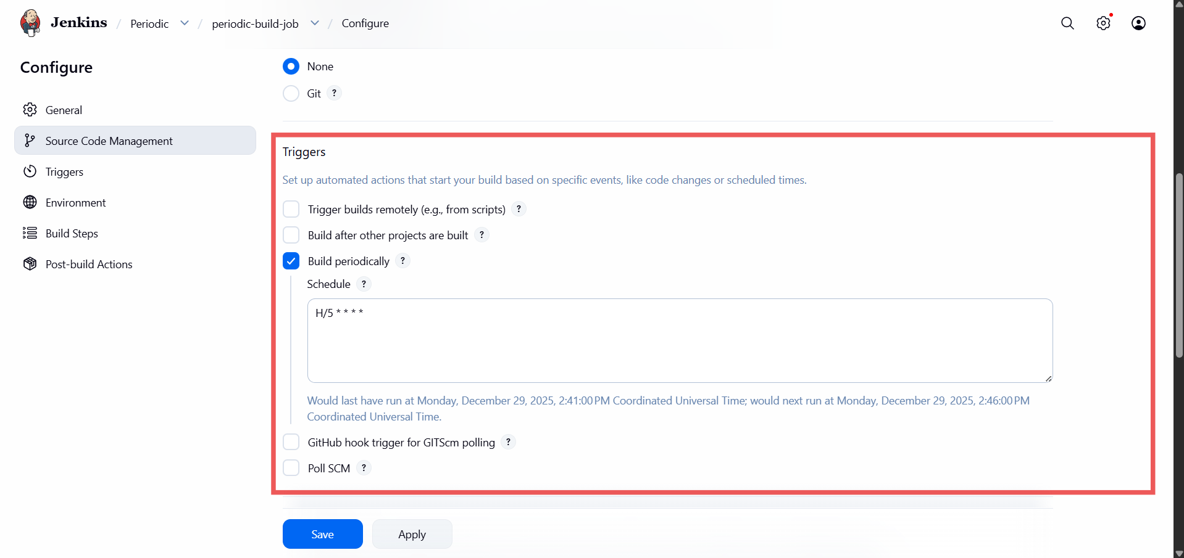

Step 3: Add Build Step
- Execute shell:
date

- Save the job

Summary:
In this job it will automatically runs in every five minutes add print the date on the terminal.

