Assignment: Jenkins Freestyle Pipeline with Maven & Tomcat
To manually install Apache Tomcat and Maven. Build and deploy a Java application using a Jenkins Freestyle job.
-For the jenkins job run on your server you need java and git installation on your server.

Step 1. Install Tomcat Server:
- Download from Apache Tomcat official site
- on linux server use command like:
----$ wget <tomcat-zip-file-url>

Step 2. Install Maven :
- Download from Apache Maven official site
- on linux server use command like:
---$ wget <maven-zip-file-url>
- configure Maven environment variables.

Step 3. Create a Freestyle Pipeline in Jenkins
- create job → name → freestyle
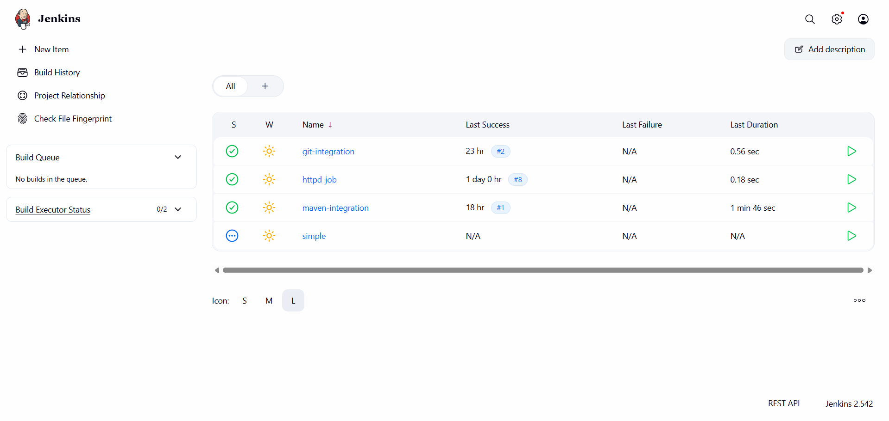

- Configure Source Code Management with Git
- Provide repo URL and also add credentials.

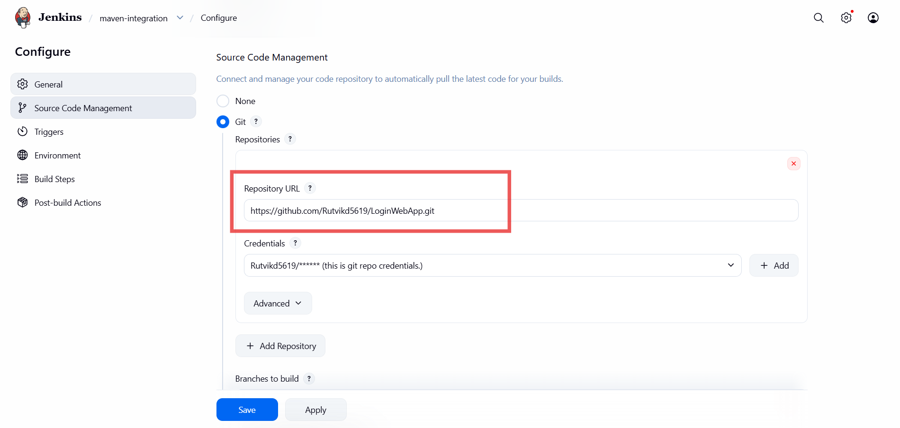

- add maven configuration.
- Add build step: Invoke top-level Maven targets
- select maven version
- Goals: clean package
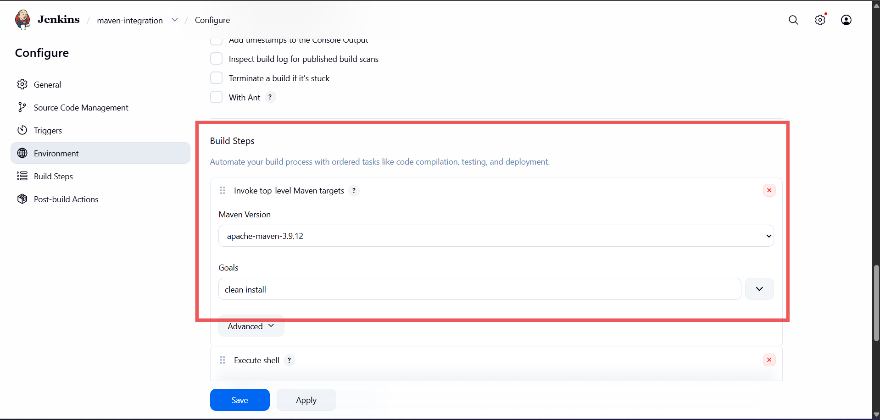
* Deploy package in Tomcat webapps dir →
- Add post-build step: Execute shell
- Command: cp /root/.jenkins/workspace/maven-integration/target/LoginWebApp.war /mnt/tomcat/apache-tomcat-10.1.50/webapps
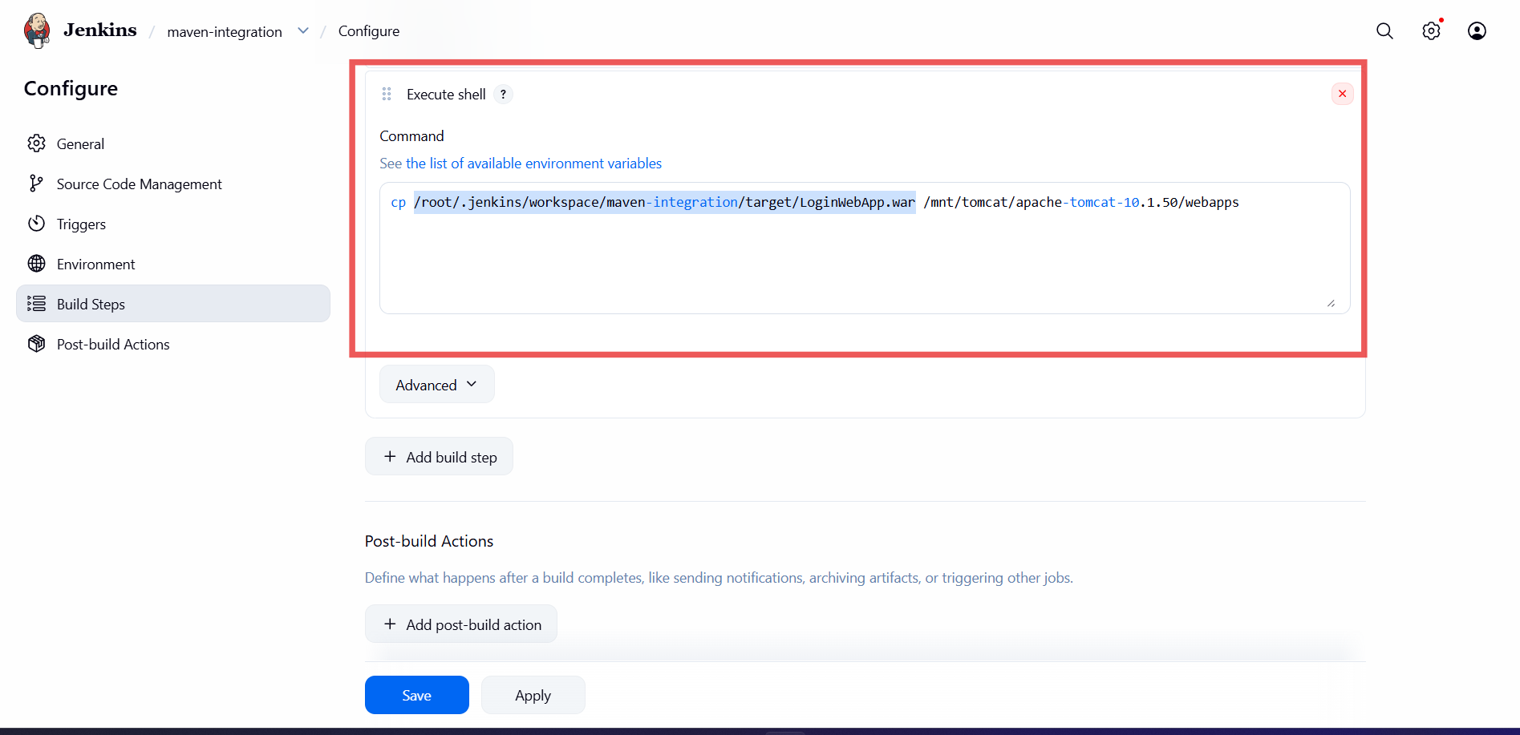

Apply And Save

Click ‘Build Now’

Step 4. Check Application on browser
- Open a browser and access the application using the server public IP address, port number and package name.
