Take-Home Assignment: The Untested API
Rutvik | September 30, 2026 | Node.js, Express, Jest, Supertest
1. Overview
For this assignment, I was asked to explore an untested Task Manager API, write a test suite to reach at least 80% coverage, document any bugs I found, fix a bug, and build a new endpoint for assigning tasks. Here is a walkthrough of what I did over the two days.
2. Getting Familiar with the Code
Before writing tests, I read through the files in src/ to understand how the API works:
• app.js: Sets up the Express app, body parsing, and routes under /tasks.
• routes/tasks.js: Defines the endpoints for listing, creating, updating, deleting, and completing tasks, plus a stats route.
• services/taskService.js: Stores tasks in a simple in-memory array and handles the CRUD logic.
• utils/validators.js: Checks incoming data for titles, statuses, priorities, and dates.
One small detail I noticed while reading: The README mentioned status values like "pending", but the validator code in validators.js only allows "todo", "in_progress", and "done". I made sure my tests used the values from validators.js so they would test against what the code actually supports.
3. Writing the Tests (Day 1)
I added two test files under tests/:
• taskService.test.js: Unit tests for each service function directly.
• tasks.routes.test.js: Integration tests using Supertest to check real HTTP responses, status codes, and error handling for bad inputs.
Because tasks are stored in memory, I added a beforeEach hook calling taskService._reset() in both test files so each test starts fresh without leftover data from earlier tests.
4. Bugs Found While Testing
Running the tests against the original code helped identify three bugs:
1. Status filter matches substrings instead of exact words
In taskService.js (line 9), getByStatus uses .includes(). Filtering by "do" returns both "todo" and "done" tasks instead of nothing. It needs an exact check (===).
2. Pagination skips the first page
In taskService.js (line 12), offset is calculated as page * limit. Since page numbers start at 1, page 1 with limit 10 produces an offset of 10, skipping the first 10 tasks. Changing it to (page - 1) * limit fixes the calculation.
3. Completing a task resets its priority
In taskService.js (line 69), completeTask hardcodes priority: "medium". If a high-priority task is completed, its priority gets changed to medium. Removing that line keeps the original priority intact.
5. Fixing the Bugs (Day 2)
The assignment suggested picking one bug to fix. I started with the pagination bug because having the first page work properly felt most important for users browsing a list of tasks. Updating line 12 in taskService.js to (page - 1) * limit got all pagination tests passing.
Because the other two bugs were also quick one-line fixes, I went ahead and fixed them as well so the test suite would run completely clean without any red errors.
6. Adding the Assign Endpoint (Day 2)
I added the new endpoint PATCH /tasks/:id/assign to let users assign a task to someone:
• Validation: In validators.js, I checked that assignee is provided and not just empty spaces. If it is blank, the API returns a 400 Bad Request error.
• Reassigning: If a task is already assigned, calling this endpoint updates the assignee to the new name.
• 404: If the task ID does not exist, it returns a 404 Not Found.
• Tests: I added 9 tests covering valid assignment, reassigning, missing names, empty strings, and bad IDs.
7. Test Results & Screenshots
Here are the screenshots from running npm run coverage in the terminal:
Step 1: After fixing pagination and adding the feature
At this point, 44 tests were passing and 4 tests were failing on the other two bugs we had documented:
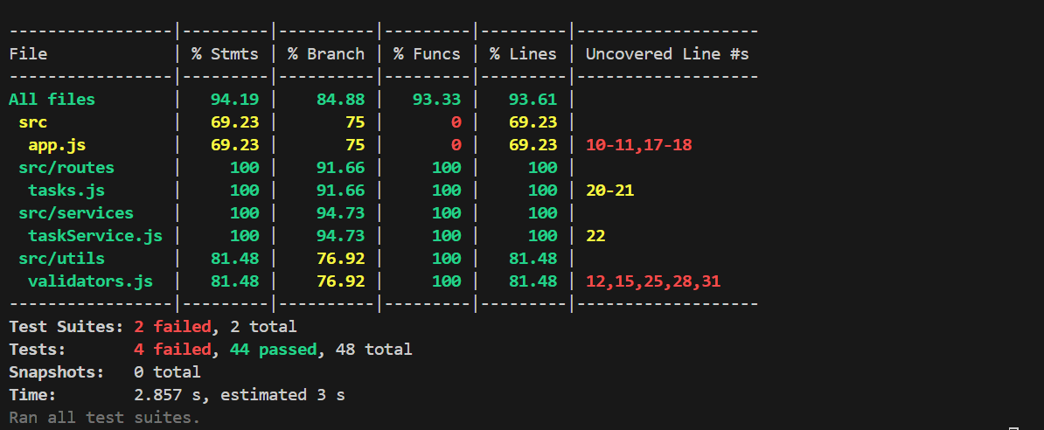
Figure 1: Test run with pagination fixed and assign feature added.
Step 2: After fixing all three bugs
All 48 tests now pass cleanly with 93.61% line coverage:
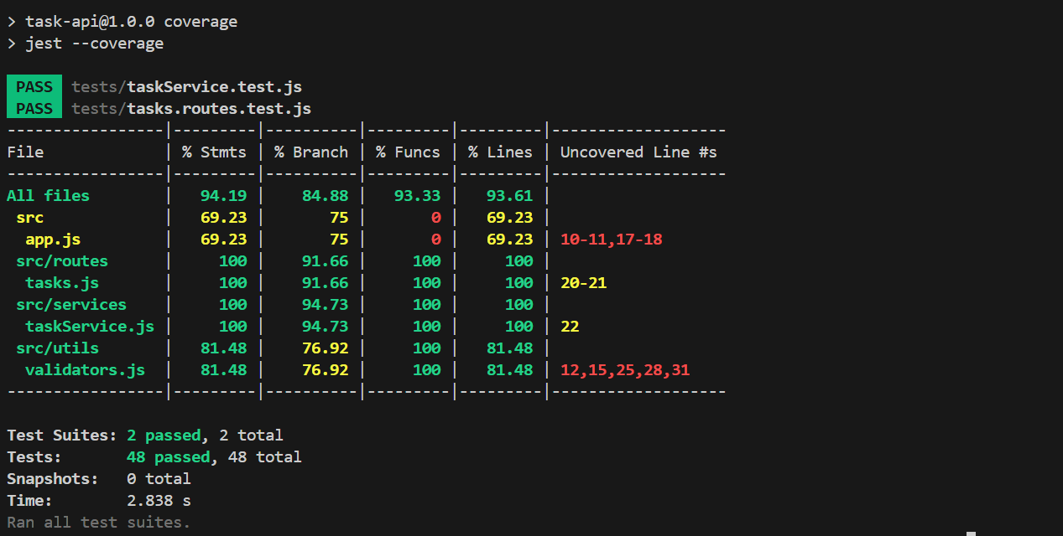
Figure 2: Final test run — all 48 tests passing.

8. Questions and Next Steps
What I would test next with more time:
• Testing simultaneous requests to see how the in-memory array handles concurrent updates or deletes.
• Edge cases around dates and timezones to ensure overdue counts stay accurate across different regions.
Surprises:
• The status mismatch between the README ("pending") and the code ("todo").
• completeTask setting priority back to "medium" upon completion.
Questions for the team before production:
• Database: What database should we move to so tasks persist when the server restarts?
• Auth: Do we need user login and permissions to control who can edit or reassign tasks?
• Deletion: Should deleting a task be permanent, or should we keep soft deletes for recovery?

