|  |  |
| --- | --- |
| Anti-Lock braking system Name: Rutvij Joshi ID: 2005502 |  |
|  |  |

Contents

Name: Rutvij Joshi ID: 2005502 1

Introduction 3

Mathematical Model 3

Vehicle Model 3

Wheel Model 4

Wheel Slip 4

Friction Coefficient 4

Controller 5

Model Parameters 6

Simulation Results 6

List of Figures

Figure 1: Various forces acting on vehicle during braking. 3

Figure 2: Forces acting on wheel. 4

Figure 3: Friction coefficient stability zone. 4

Figure 4: Controller design in Simulink. 5

Figure 5: Braking torque without ABS 6

Figure 6: Braking torque with ABS 6

Figure 8: Wheel slip with ABS 7

List of Tables

Table 1: Model parameters 6

## Introduction

Antilock braking system (ABS) prevent brakes from locking during braking. During sever braking situation or on slippery roadways when driver presses the break to hard the wheels approach lockup, the ABS takes over here. The ABS modulate braking torque applied on wheels independent of the pedal force to bring the wheel speed back to the optimal level.

It allows driver to control the car easier, even on roads with low adhesion, such as wet, snowy, muddy roads. ABS system takes vehicle speed and wheel speed as input to find slip ratio and with the help of controller it modulates braking torque to prevent wheel from lockup.

## Mathematical Model

### Vehicle Model

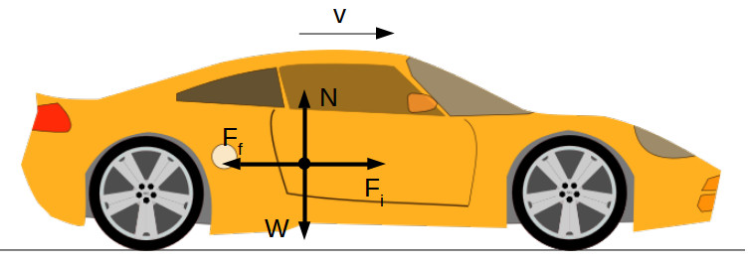

Figure 1: Various forces acting on vehicle during braking.

For horizontal direction:

$Ff=Fi$

Ff = Friction force between wheel and ground.

Fi = Inertia of vehicle.

For vertical direction:

$N=W$

N = Normal force.

W = Vehicle weight.

Friction force is given as:

$Ff=µ.N$

The vehicle’s weight is:

$W=m.g$

Therefore, $Ff=µ.m.g$

m = Total vehicle mass.

g = Gravitational acceleration.

Inertial force on vehicle is:

$Fi=m.a=m(\frac{dv}{dt})$

$\frac{dVv}{dt}=(µ.m.g)/m$

### Wheel Model

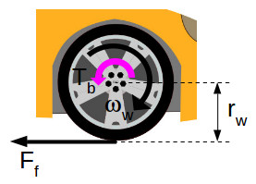

Figure 2: Forces acting on wheel.

During braking when driver applies braking torque (Tb) to the wheels. The friction force Ff applies an opposite torque on wheel.

Wheel acceleration can be given by:

$$\frac{dWw}{dt}=(Tb-Ff.rw)/Jw$$

Wheel speed can be obtained by integrating above equation.

### Wheel Slip

Wheel slip(s) is given by:

$s=1-(\frac{Ww}{Wv})$

This function is implemented by MATLAB function block.

Wv is equivalent angular speed of car, and it is given by:

$Wv=Vv/rw$

### Friction Coefficient

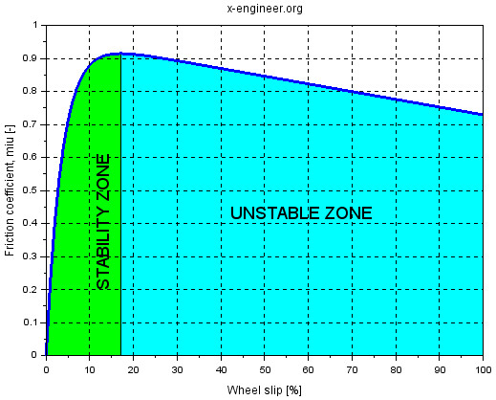

Figure 3: Friction coefficient stability zone.

Above graph shows the relation between friction coefficient and wheel slip (s). We can observe that at around 20% slip ratio friction coefficient is maximum. Hence, ABS system will try to keep slip ratio at 20% to avoid lockup.

The fiction coefficient can be given as:

$$µ=A.(B.(1-e^{-Cs}-D.s)$$

This equation is implemented using MATLAB function block.

s = Slip

A, B, C, D = Value depends on type of road.

### Controller

We set target slip of 0.2. A slip error is calculated by subtracting actual slip from target slip. To avoid action of controller at low-speed actual slip is only used when vehicle speed is higher than minimum speed (Vmin).

Depending on the error controller will output:

* 1, if s>0
* 0, if s==0
* -1, if s<0

The hydraulic system is modeled using first order transfer function, with the amplification factor K and time constant T.

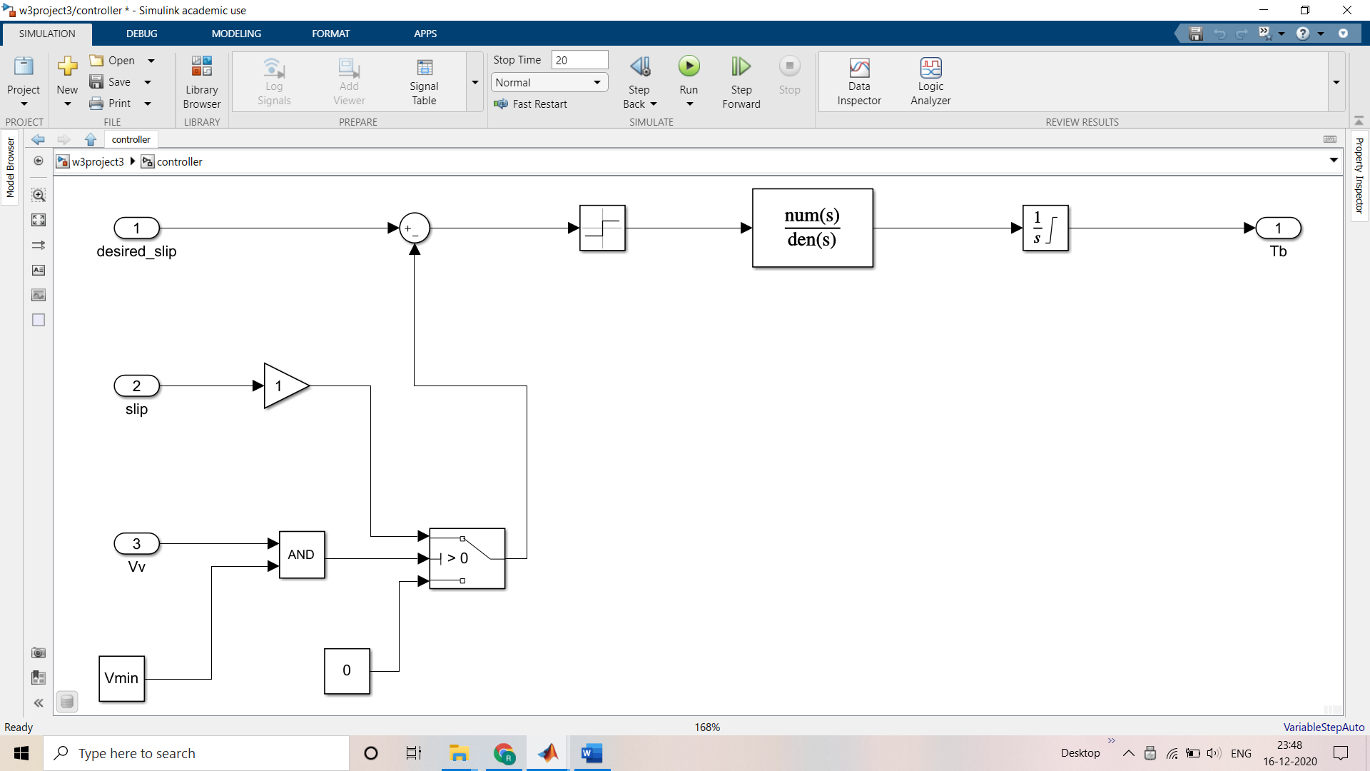

Figure 4: Controller design in Simulink.

## Model Parameters

|  |  |  |
| --- | --- | --- |
| Symbol | Description | Value |
| m | Vehicle mass | 1200 |
| J | Wheel inertia | 0.01 |
| rw | Wheel radius | 0.28 |
| Vmin | Minimum vehicle speed to activate slip controller | 1.4 |
| V0 | Initial vehicle speed | 28 |
| K | Hydraulic system amplification factor | 1000 |
| T | Hydraulic system time constant | 0.01 |
| Tbmax | Maximum braking torque | 2000 |

Table 1: Model parameters

## Simulation Results

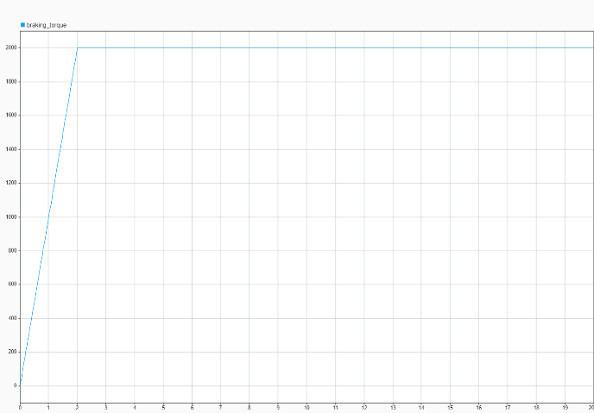Simulation is run for 20 sec and results are stored in data inspector.

Figure 5: Braking torque without ABS

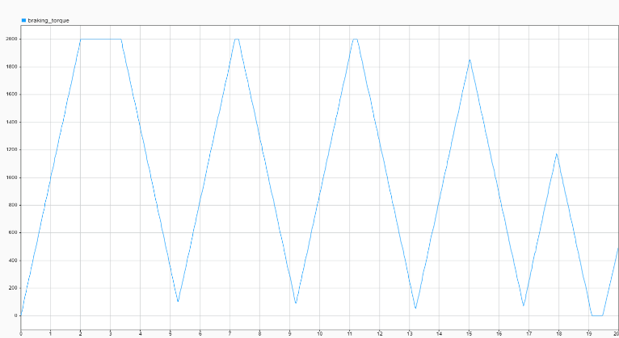

Figure 6: Braking torque with ABS

When ABS in disabled braking torque ramps up to maximum value and causes slip. When ABS is active braking torque is modulated to maintain optimal slip ratio.

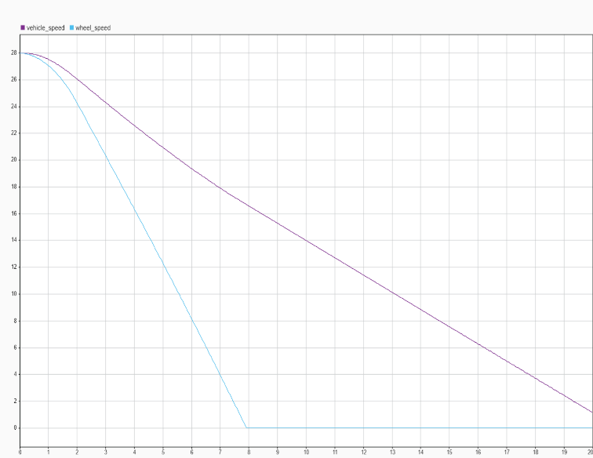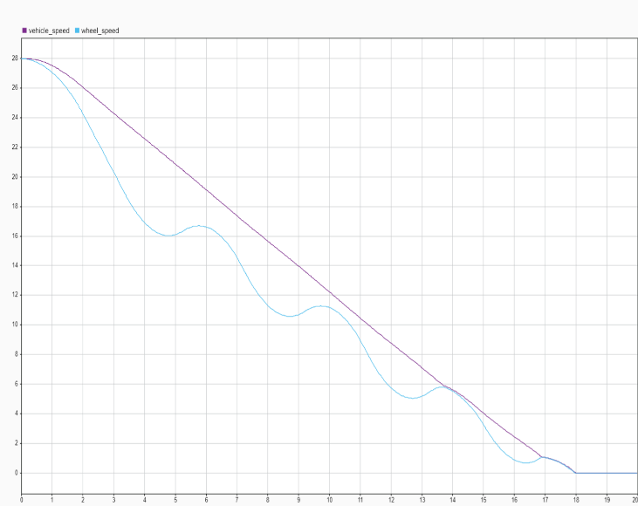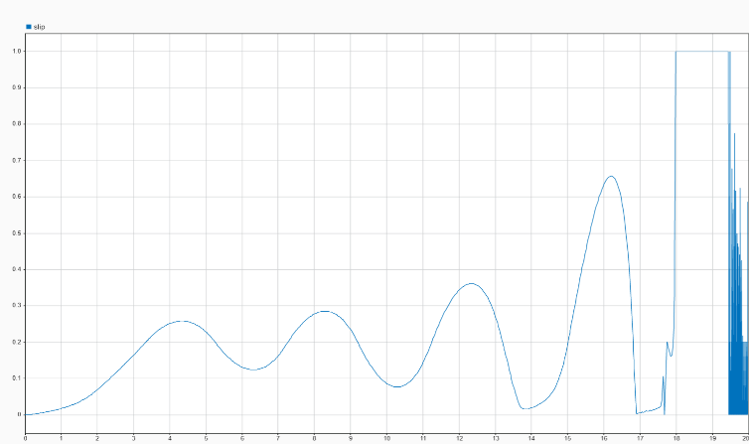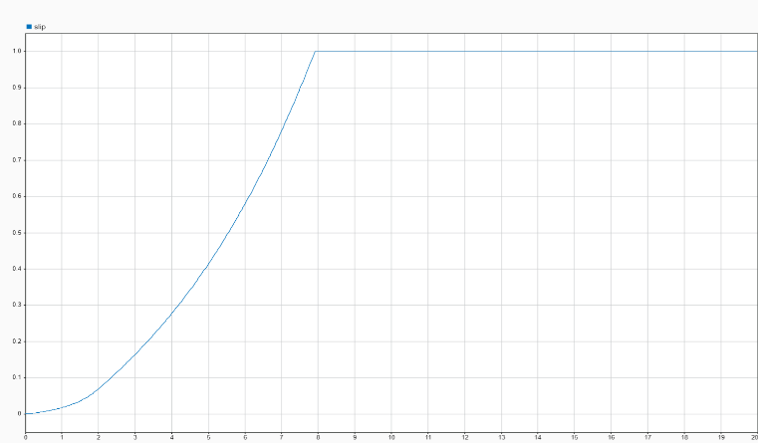When the ABS system is deactivated wheel slip climbs to 1 (wheel lock) as torque increases. When ABS system is activated slip is controlled by controlling braking torque.

Figure 10: Wheel speed and vehicle speed with ABS.

Figure 8: Wheel slip with ABS

Figure 8: Wheel slip without ABS

Figure 9: Wheel speed and vehicle speed without ABS.

When ABS is deactivated wheel locks before coming to complete halt. With ABS active wheel is prevented from locking thus reducing slip.