Dart Programming for Flutter
LAB 1

This document contains screenshots of all program outputs from Dart Programming Lab 1, demonstrating the implementation of 20 questions.
> the last question (20) is in handwritten answers, it doesn’t need codes.

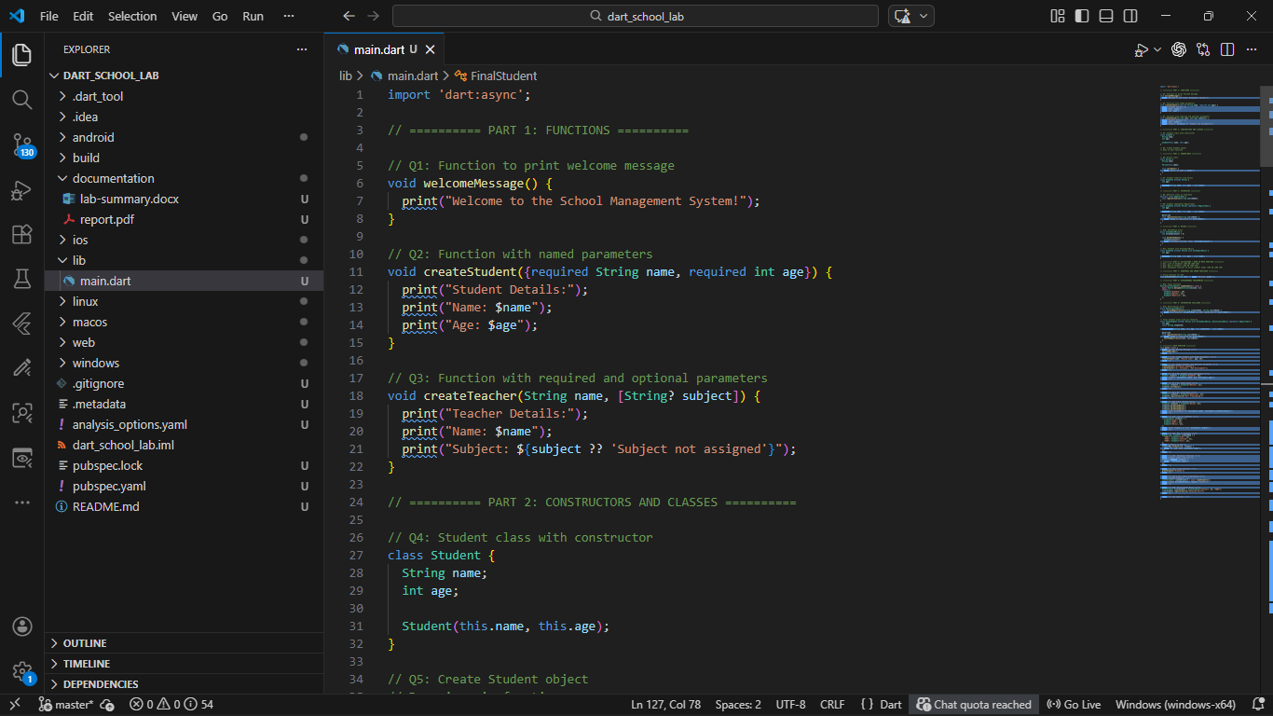
Figure 1: main.dart code file that implements all questions (single file)

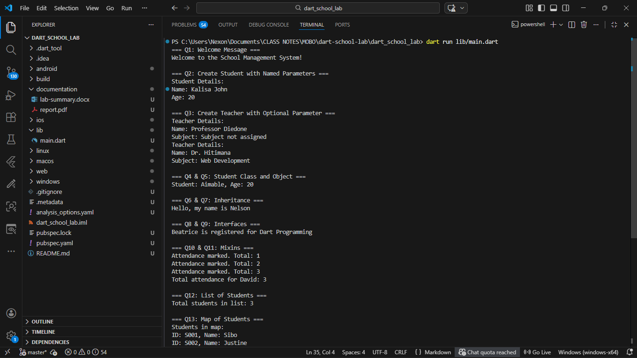
Figure 2: Output results for questions 1 to 12

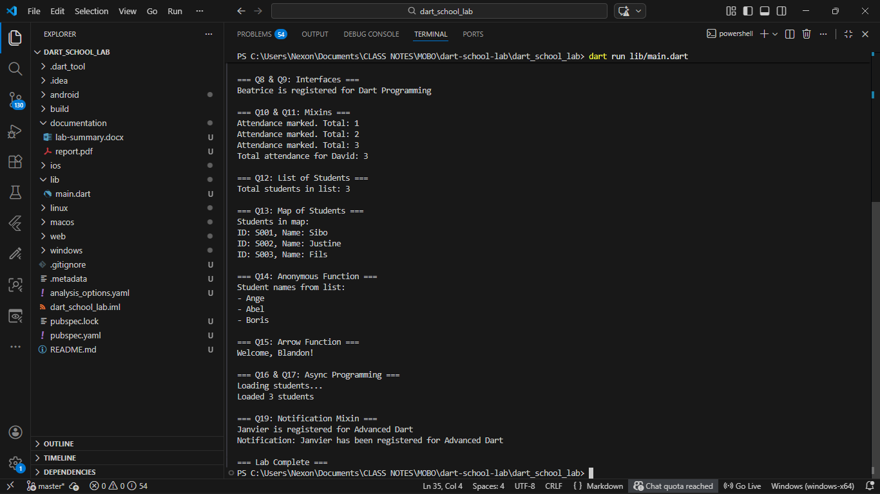
Figure 3: Output results for questions 13 to 19

