Jenkins assignment -3

Name : Rutwija Unde

Launching 2 machine.

In machine 1 : install java,tomcat,maven,Jenkins

In machine 2: install java,tomcat

Installing maven :

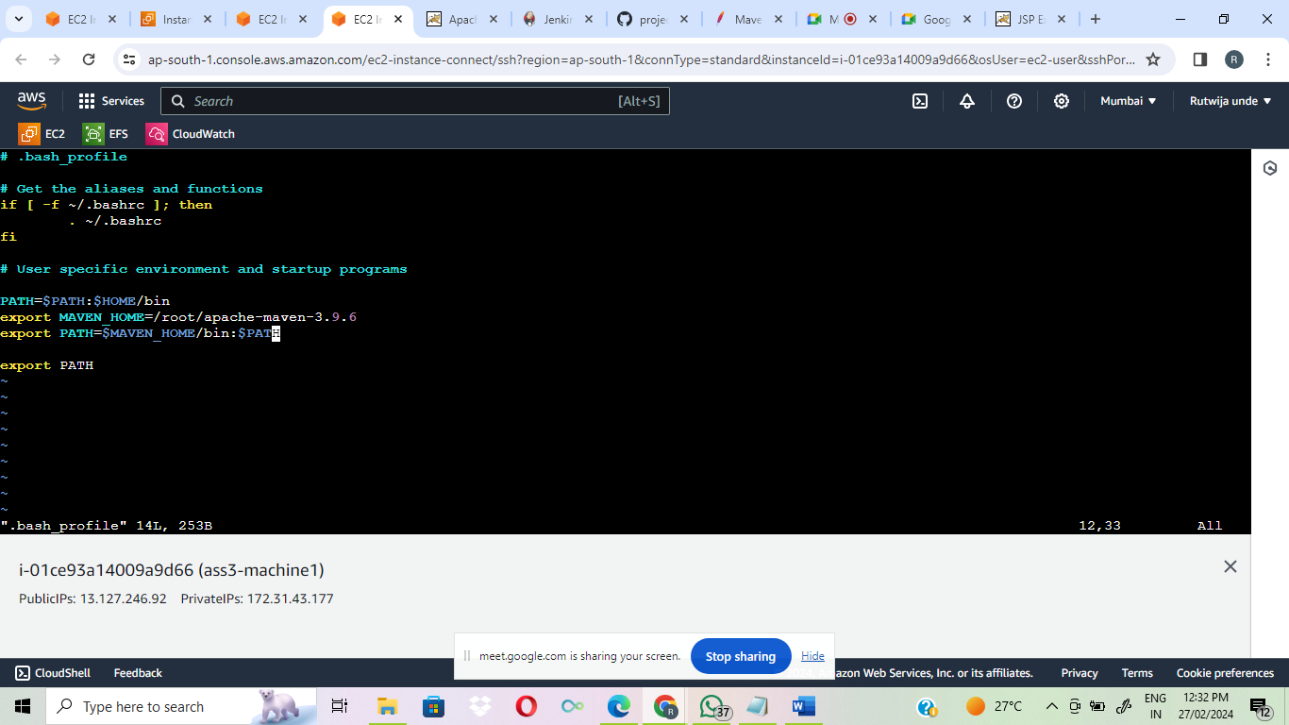

Create job configuration:

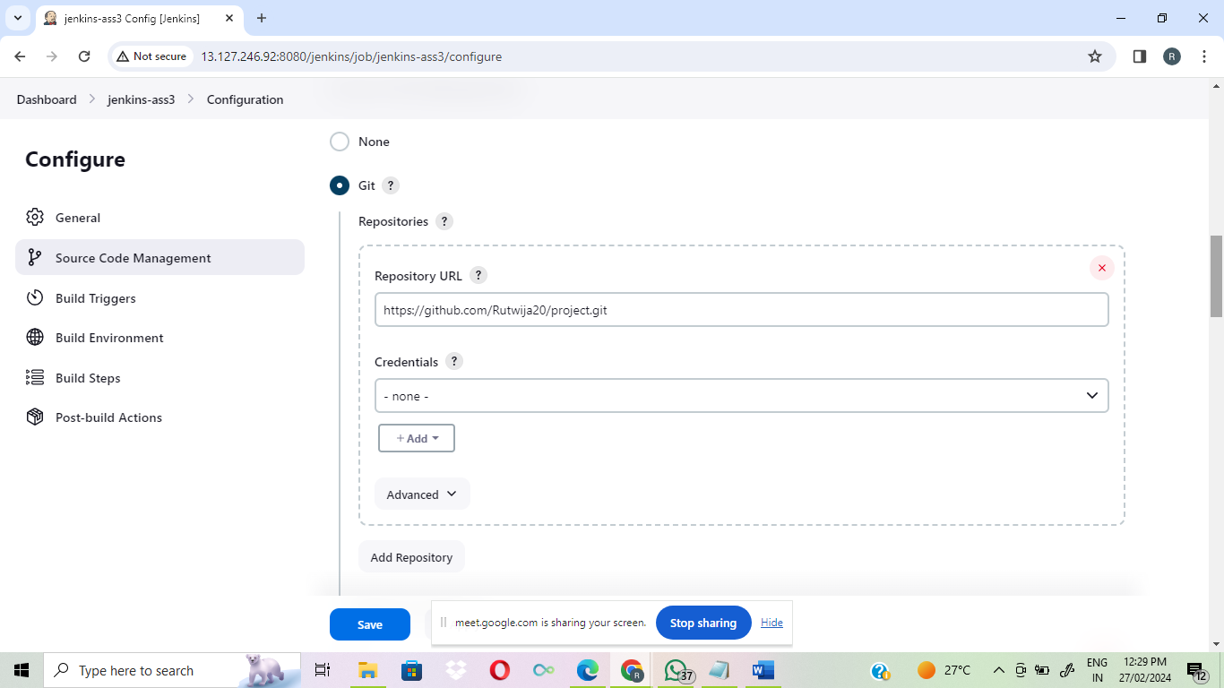

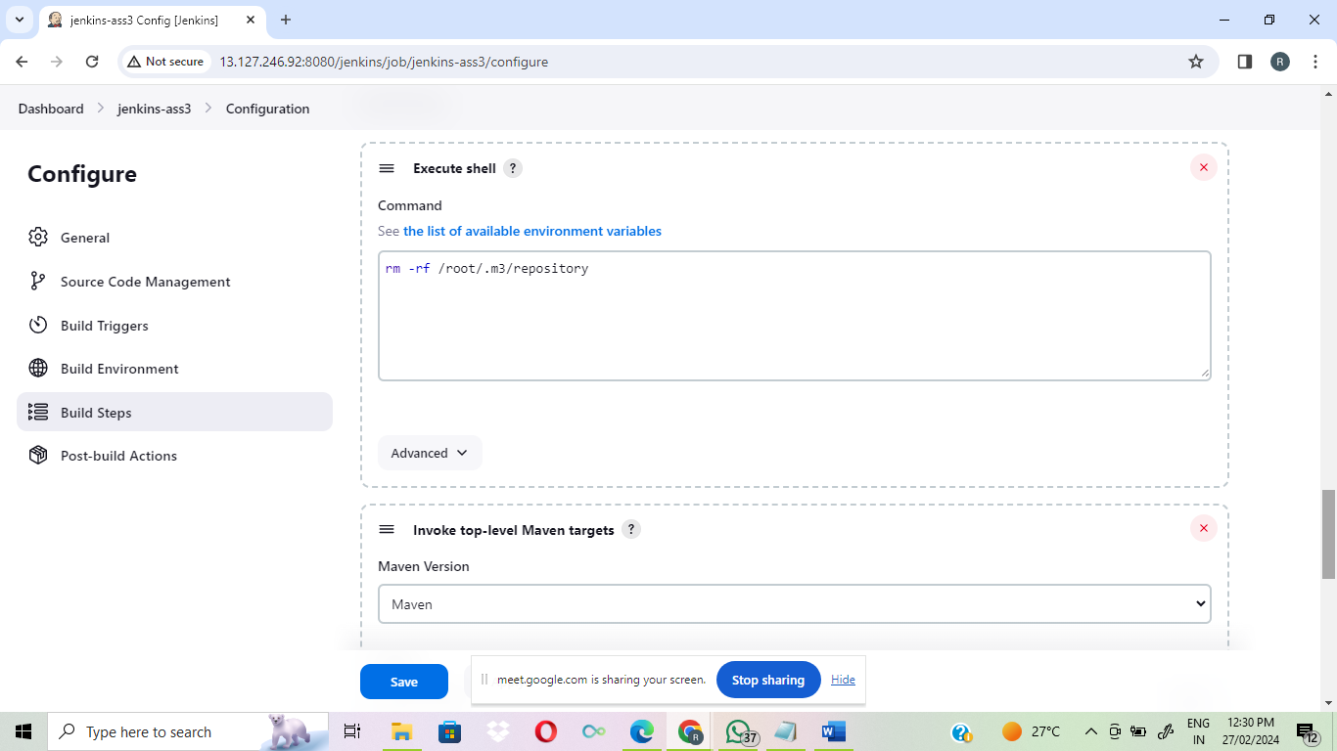

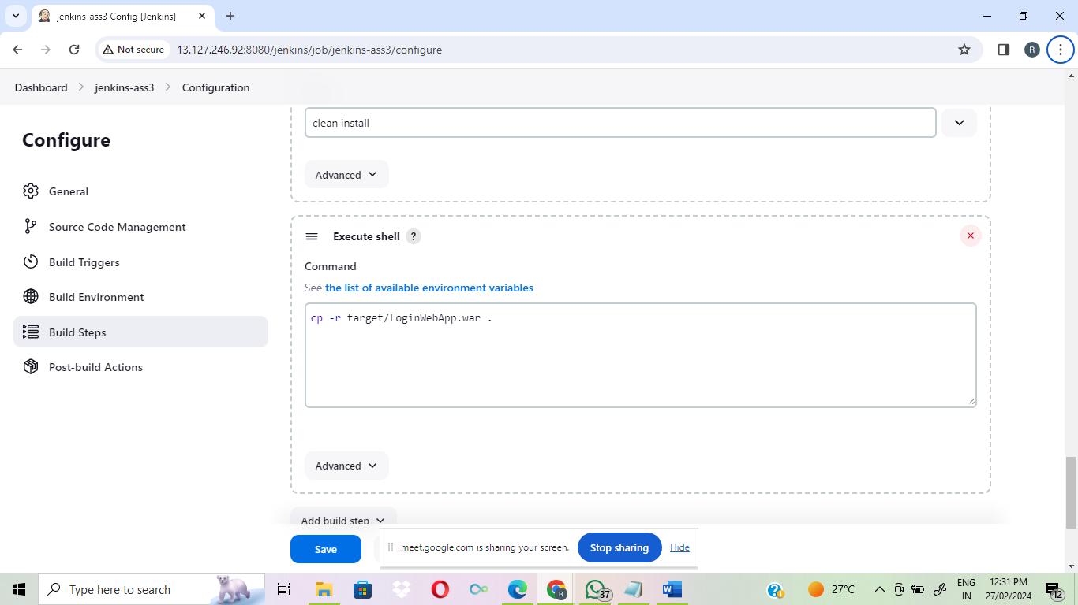

War file deploy on machine 1:

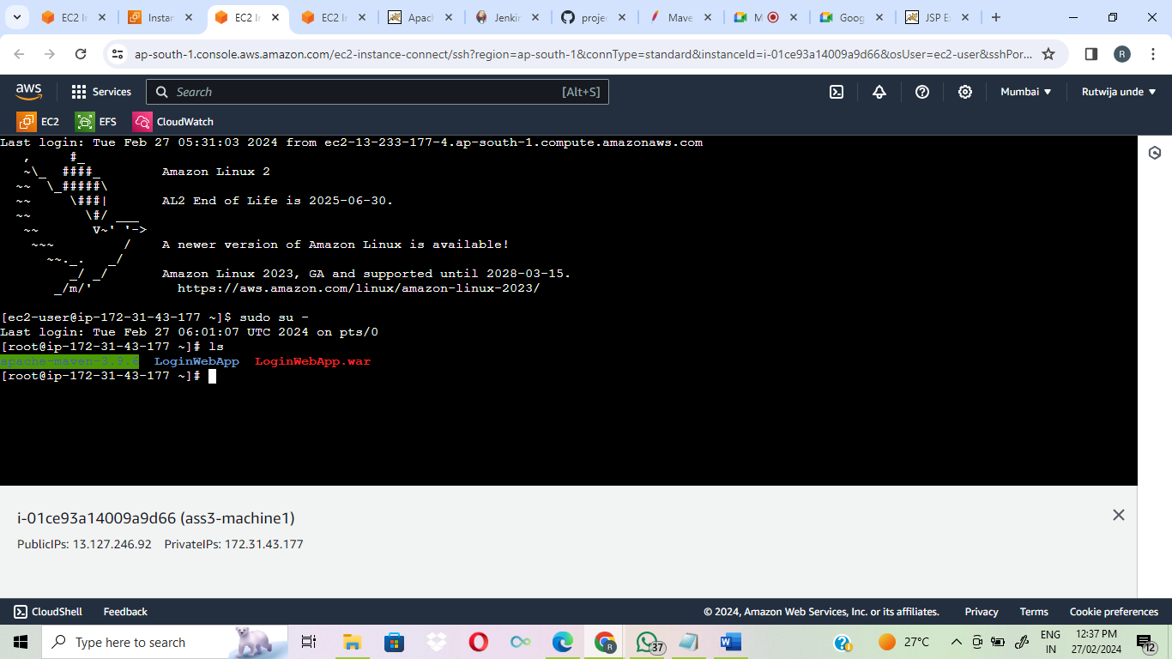

With help of EFS ,sharing war file from machine1 to machine2

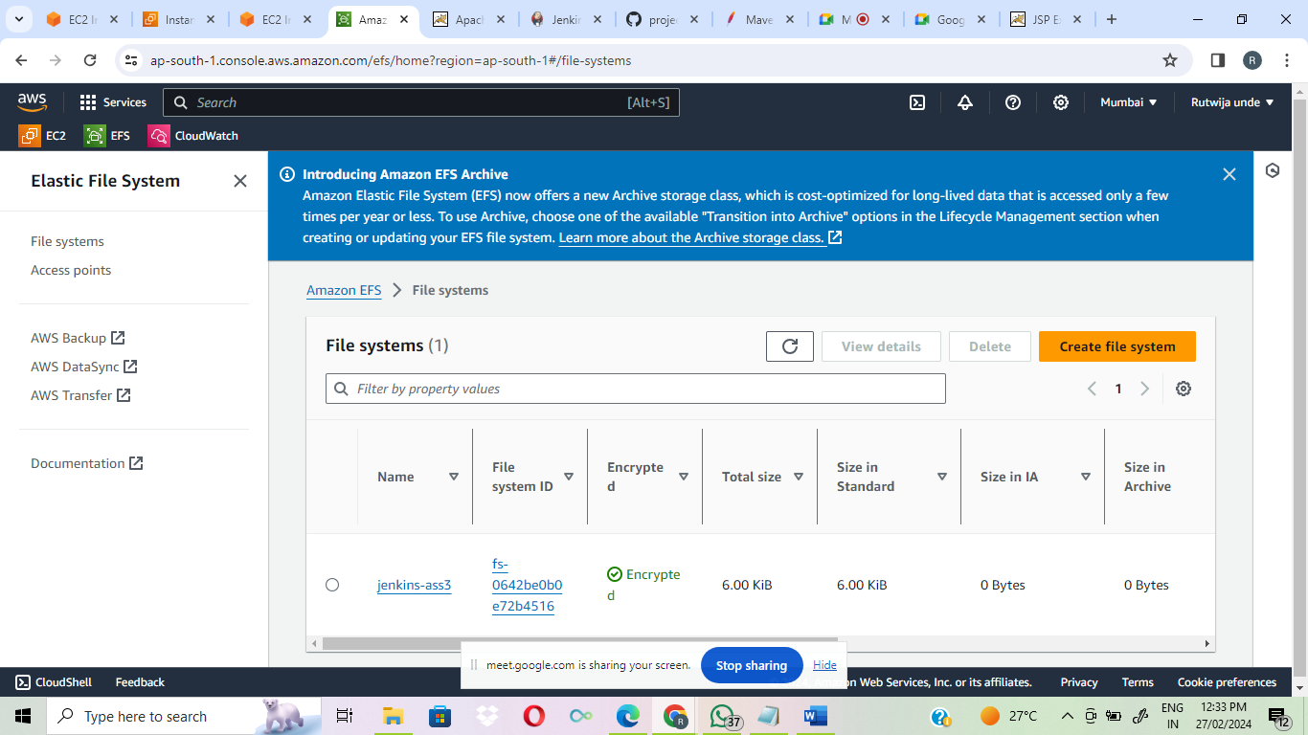

2nd machine has war file,deploying in tomcat of 2nd machine

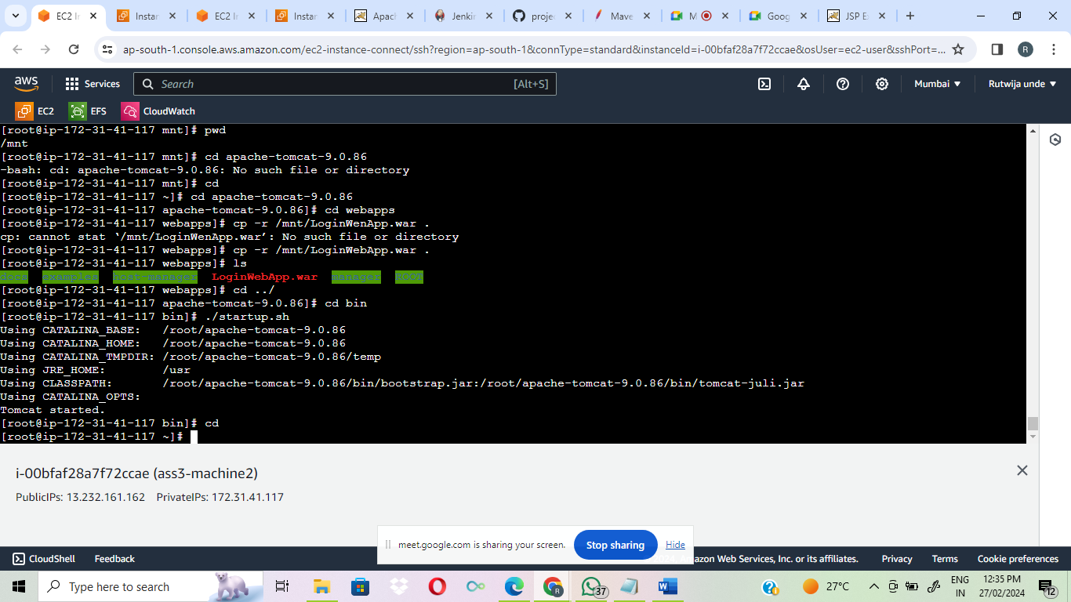

Can access LoginWebapp From 2nd machine:

