

**Dharmsinh Desai University, Nadiad**

Faculty of Technology

Department of Computer Engineering

B. Tech CE Semester – VI

Subject: Object Oriented Software Engineering

Project Title:

**R&R Parking**

**(Online Parking Management System)**

By:

1. Rutvik Kathrecha

CE-058

17CEUBS048

2) Rutwik Kikani

CE-062

17CEUOS068

Guided by: Prof. Prashant M. Jadav



**Dharmsinh Desai University, Nadiad**

Faculty of Technology

Department of Computer Engineering

**CERTIFICATE**

This is to certify that the Object Oriented Software Engineering project entitled **“R&R Parking (Online Parking Management System)”** is a bona fide report of the work carried out by

1. **Rutvik Kathrecha, Roll No: CE058, Student ID No: 17CEUBS048**
2. **Rutwik Kikani, Roll No: CE062, Student ID No: 17CEUOS068**

Of Department of Computer Engineering, Semester VI, academic year 2019-20, under the guidance and supervision for the subject Object Oriented Software Engineering.

(Project Guide) (HOD)

**Prof. Prashant M. Jadav Dr. C. K. Bhensdadia**

Associate Professor Head of Department

Department of Computer Department of Computer

Engineering, Engineering,

Faculty of Technology, Faculty of Technology,

Dharmsinh Desai University, Dharmsinh Desai University,

Nadiad Nadiad

Contents

Introduction 1

Software Requirement Specifications 2

Design 4

Implementation Detail 12

Testing 13

Screen-shots 16

Conclusion 20

Limitation and Future Extension 21

Bibliography 22

Abstract

In today’s world everyone has problem of traffic in the city, and the problem of traffic leads to the problem of parking. It’s becoming very hard to find parking place and get it before anyone else got that. So, we come with the idea of making this process easy and efficient – online car parking. People can view the parking places and can reserve parking slots for their vehicles. This type of applications is necessary now.

# Introduction

The objective of the project is to develop an application for providing online parking facility. Now it is becoming hard to find parking places and reserve it, because vehicles are increasing and parking places are very less. So, this application will make it easy for people to reserve their parking slot.

For parking reservation user has to follow some simple steps. User have to come to our portal and login. After that he/she has to search for the parking places where they want to park their vehicle, add vehicle details, select time slot, pay for the parking reservation and that’s it. User can also see their reserved parking in their profile.

Admin can add the parking places in the system. Admin can also update or delete parking place.

**Technology used:**

* .Net framework
* Windows Forms Application
* Entity Framework 6

**Platform used:**

* Visual Studio 2019

# Software Requirement Specifications

## **R.1 User**

**R.1.1 - Manage Account**

Description: In this, user can do basic CRUD operation on account like Create, Add, Update, and Delete.

**R.1.1.1 Create account**

Input: First name, Last name, email, mobile no, gender, and password

Output: Account will be created

Exception: If any of the data is invalid or user is already existing then account will not be created.

**R.1.1.2 Update account**

Input: User will have to enter the updated details.

Output: Account updated successfully.

**R.1.1.3 Delete account**

Input: Click the delete account button.

Output: entry of the user will be removed from the database and appropriate message will be displayed.

**R.1.2 – Login**

Description: By this user can login into the system.

Input: Email id and password.

Output: user will be logged in.

Exception: If credentials provided are wrong then user can’t login.

**R.1.3 – Manage Parking**

Description: User can reserve parking, view parking or cancel parking.

**R.1.3.1 Reserve Parking Plot**

Description: User can reserve parking plot by selecting parking area, adding vehicle details and making successful payment.

**R.1.3.1.1 Add Details**

Input: Vehicle type, model name, registration number, arrival time, departure time

Output: If parking plot available than redirected to payment page.

**R.1.3.1.2 Make Payment**

Input: Choose payment option and accordingly enter payment details.

Output: Successful message will be displayed if the payment is successful and parking plot will be reserved.

**R.1.3.2 Show Reservations**

Input: Click the Profile button.

Output: Currently active parking reservations will be displayed in reservations section.

**R.1.3.3 – Cancel Reservation**

Input: Cancel reservation tab selected.

Output: Parking reservation will be cancelled and appropriate message will be displayed.

**R.1.4 – View Parking plots**

Description: By this user view all the parking plots.

Input: Parking area

Output: All the parking plots will be displayed.

## **R.2 Admin**

**R.2.1 - Manage Parking**

Description: Admin can add the new parking places or can delete some parking places as required. Admin can also update information in existing parking places.

**R.2.1.1 Add Parking**

Input: Parking details like parking name, capacity, rate and address

Output: The new parking places appears in appropriate category on portal.

**R.2.1.2 Update Parking**

Input: details to be update

Output: Parking place details will be updated.

**R.2.1.3 Delete Parking**

Input: User selection

Output: Parking will be deleted and appropriate message will be displayed.

**R.2.2 – Manage Users**

Description: Admin can add user, show all users, find specific user and delete the user.

**R.2.1.1 Add User**

Input: First name, last name, email, mobile no, gender, and password

Output: user will be registered

**R.2.1.2 – Show Users**

Input: User selection

Output: All the users with their details will be displayed.

**R.2.1.3 – Find User**

Input: Email id

Output: details of the user will be displayed.

**R.2.1.4 – Delete User**

Input: Email id

Output: User will be deleted and appropriate message will be shown.

# Design

1. 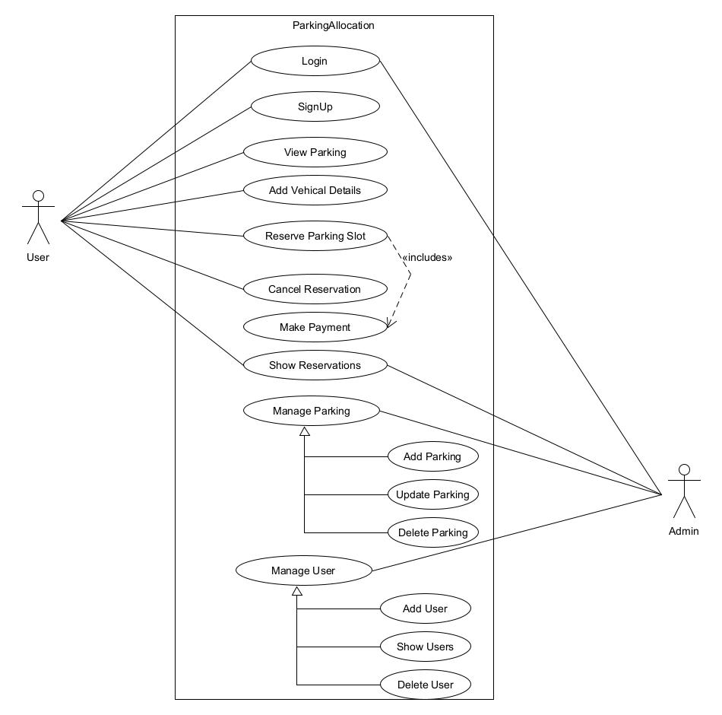Use Case Diagram
2. Class Diagram

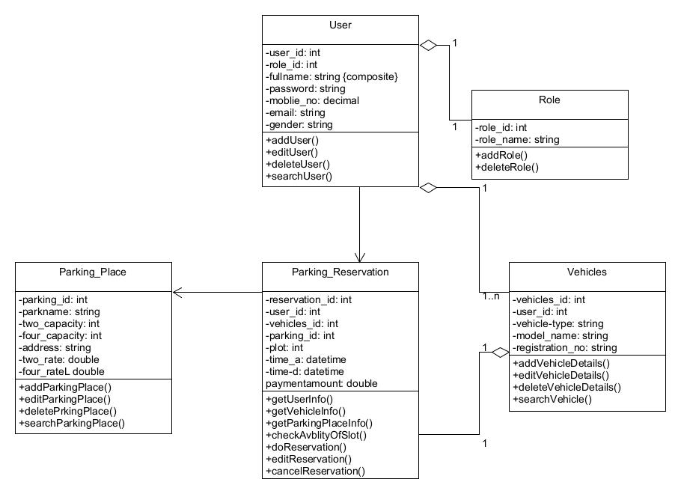

1. Sequence Diagram

Sequence diagram for parking reservation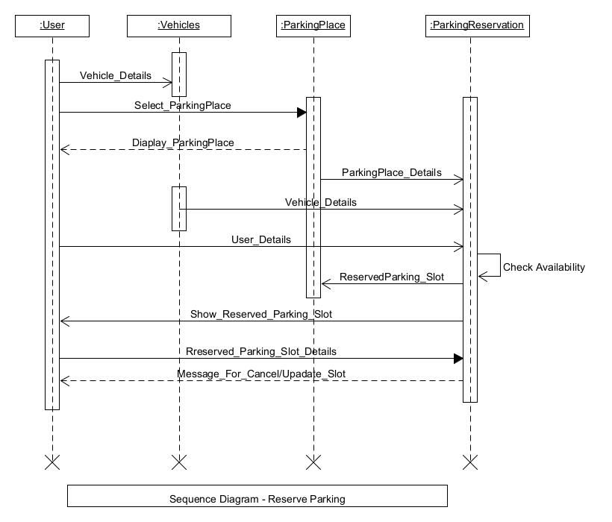

1. Activity Diagram
2. Activity diagram for parking reservation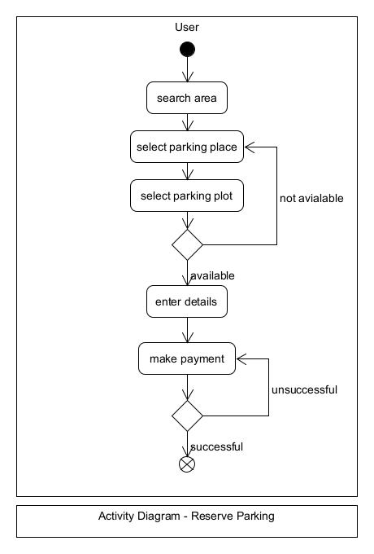
3. 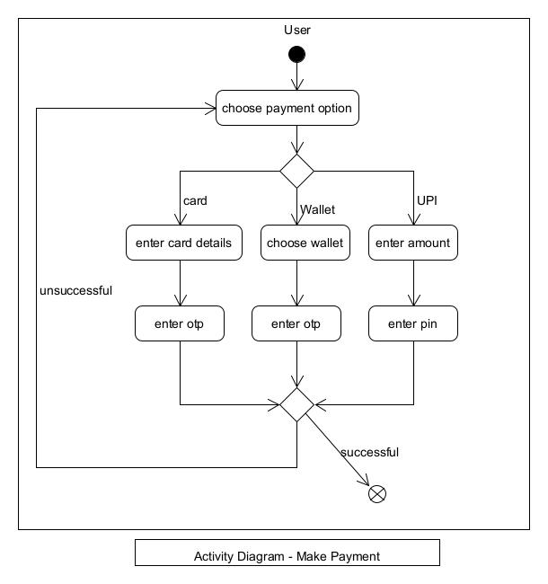Activity diagram for make payment
4. State Diagram

State diagram for parking plot

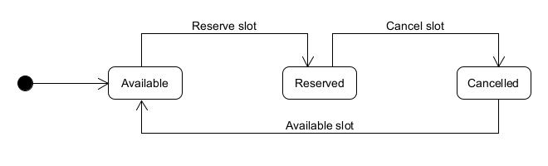

1. 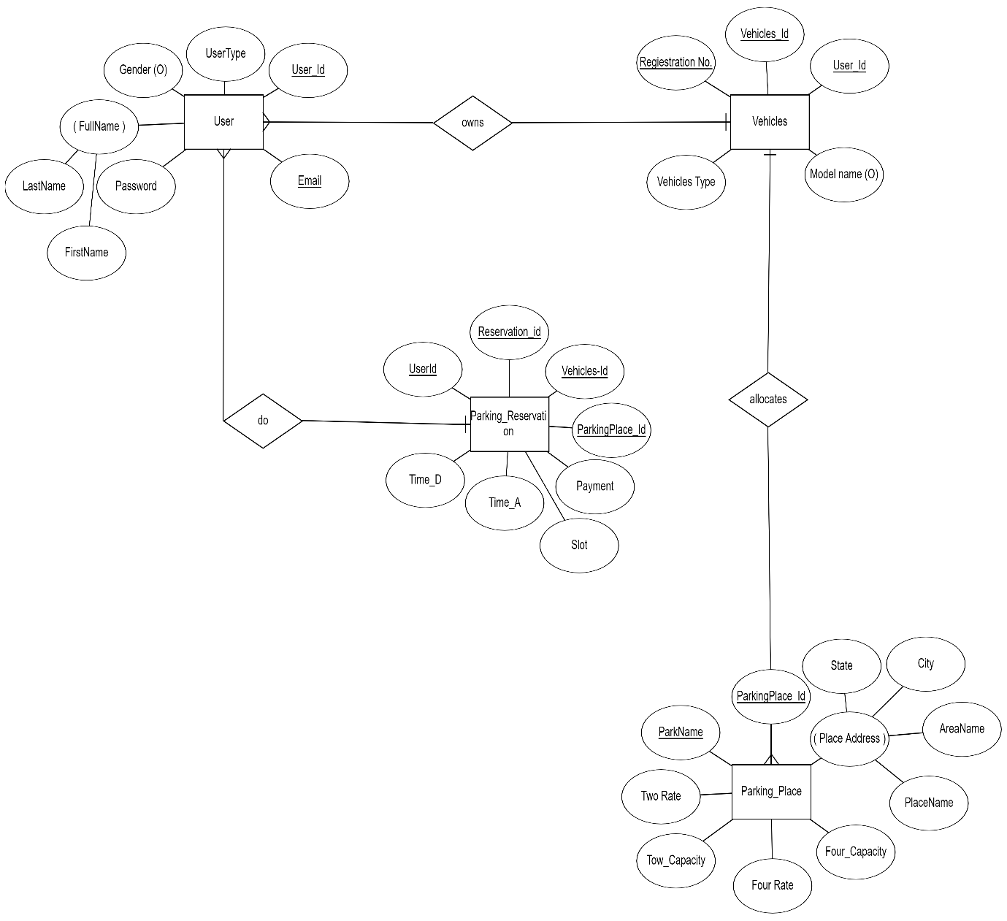E-R Diagram
2. Data Dictionary

|  |  |  |  |  |  |  |  |  |
| --- | --- | --- | --- | --- | --- | --- | --- | --- |
| **User** | | | | | | | | |
| **Sr No** | **Field Name** | **Data Type** | **Width** | **Required** | **Unique** | **PK/FK** | **Referenced Table** | **Description** |
| 1 | UserId | Number | 20 | Yes | Yes | PK |  | Primary Key for the user table |
| 2 | Full Name | Varchar2 | 30 | Yes |  |  |  | First name and Last name of the user |
| 3 | Password | Varchar2 | 10 | Yes |  |  |  | Password of the user |
| 4 | Mobile no. | Number | 10 | Yes | Yes |  |  | Mobile no. of the user |
| 5 | Email | Varchar2 | 40 | Yes | Yes |  |  | Email ID of the user |
| 6 | Gender | Varchar2 | 10 | Yes |  |  |  | Gender of the user |

|  |  |  |  |  |  |  |  |  |
| --- | --- | --- | --- | --- | --- | --- | --- | --- |
| **Parking_Place** | | | | | | | | |
| **Sr No** | **Field Name** | **Data Type** | **Width** | **Required** | **Unique** | **PK/FK** | **Referenced Table** | **Description** |
| 1 | ParkingId | Number | 20 | Yes | Yes | PK |  | Primary key for the parking table |
| 2 | ParkName | Varchar2 | 30 | Yes | Yes |  |  | Name of the parking area |
| 3 | Address | Varchar2 | 50 | Yes |  |  |  | Address of the parking place |
| 4 | Two_Capacity | Number | 10 | Yes |  |  |  | Capacity of the two wheelers |
| 5 | Four_Capacity | Number | 10 | Yes |  |  |  | Capacity of the four wheelers |
| 6 | Two_Rate | Number | 10 | Yes |  |  |  | Rates for the two wheelers |
| 7 | Four_Rate | Number | 10 | Yes |  |  |  | Rates for the four wheelers |

|  |  |  |  |  |  |  |  |  |
| --- | --- | --- | --- | --- | --- | --- | --- | --- |
| **Vehicle** | | | | | | | | |
| **Sr No** | **Field Name** | **Data Type** | **Width** | **Required** | **Unique** | **PK/FK** | **Referenced Table** | **Description** |
| 1 | VehicleId | Number | 30 | Yes | Yes | PK |  | Primary key for the vehicle table |
| 2 | UserId | Number | 10 | Yes |  | FK | User | User id |
| 3 | Vehicles Type | Varchar2 | 10 | Yes |  |  |  | Type of vehicle |
| 4 | Model Name | Varchar2 | 10 | Yes |  |  |  | Vehicle model name |
| 5 | Registration_number | Varchar2 | 40 | Yes |  |  |  | Vehicle number plate |

|  |  |  |  |  |  |  |  |  |
| --- | --- | --- | --- | --- | --- | --- | --- | --- |
| **Parking_Reservation** | | | | | | | | |
| **Sr No** | **Field Name** | **Data Type** | **Width** | **Required** | **Unique** | **PK/FK** | **Referenced Table** | **Description** |
| 1 | ReservationId | Number | 20 | Yes | Yes | PK |  | Primary key for the parking reservation table |
| 2 | UserId | Number | 20 | Yes |  | FK | User | User id |
| 3 | VehicleId | Number | 20 | Yes |  | FK | Vehicle | Vehicle id |
| 4 | ParkingId | Varchar2 | 30 | Yes |  | FK | Parking_Place | Parking Place id |
| 5 | Plot | Varchar2 | 10 | Yes |  |  |  | Parking space number |
| 6 | Payment | Number | 20 | Yes |  |  |  | Payment amount |
| 7 | Time_A | DateTime | 20 | Yes |  |  |  | Date and Time of the client arrive in parking space |
| 8 | Time_D | DateTime | 20 | Yes |  |  |  | Date and time of the client departs from parking space |

# Implementation Detail

Home Module:

In the home module user can view all the parking places. In each row details of the parking place will be shown like Parking place name, Address, two-wheeler and four-wheeler capacity available, two-wheeler and four-wheeler parking charges. User can reserve for any parking place which has capacity greater than zero by clicking the reserve button.

Login/Signup Module:

In signup module user can register themselves by providing details like name, email, password and mobile no. User will be validated at time of registration that it is previously exist or not and the details provided by them is valid or not. After registering themselves user can login into the system by providing email and password. At the time of login user will be validated.

Parking Reservation Module:

User can reserve parking plot in any parking place for their vehicle. For that user has to provide few details. These details contain vehicle information like vehicle type (2-Wheeler/4-Wheeler), vehicle name (company name + model name), and vehicle registration number. After that user has to choose the time slot for which he/she want to park his/her vehicle. After submitting the details correctly and validated by system successful message will come with the information of parking plot and amount payable.

Admin Module:

Admin of the system can add parking places. Admin can also update or delete parking place. To add a parking place admin has to provide information regarding it, like Parking place name, Address, two-wheeler and four-wheeler capacity available, two-wheeler and four-wheeler parking charges. After successfully submitting information parking place will be added to the list of parking places. To update admin has to provide updated details and for deleting admin has to press the delete button for parking place.

Profile Module:

In the profile page user can view their personal details. User can also view their reserved parking, It contains details of parking place and the user’s vehicle.

# Testing

1. Login

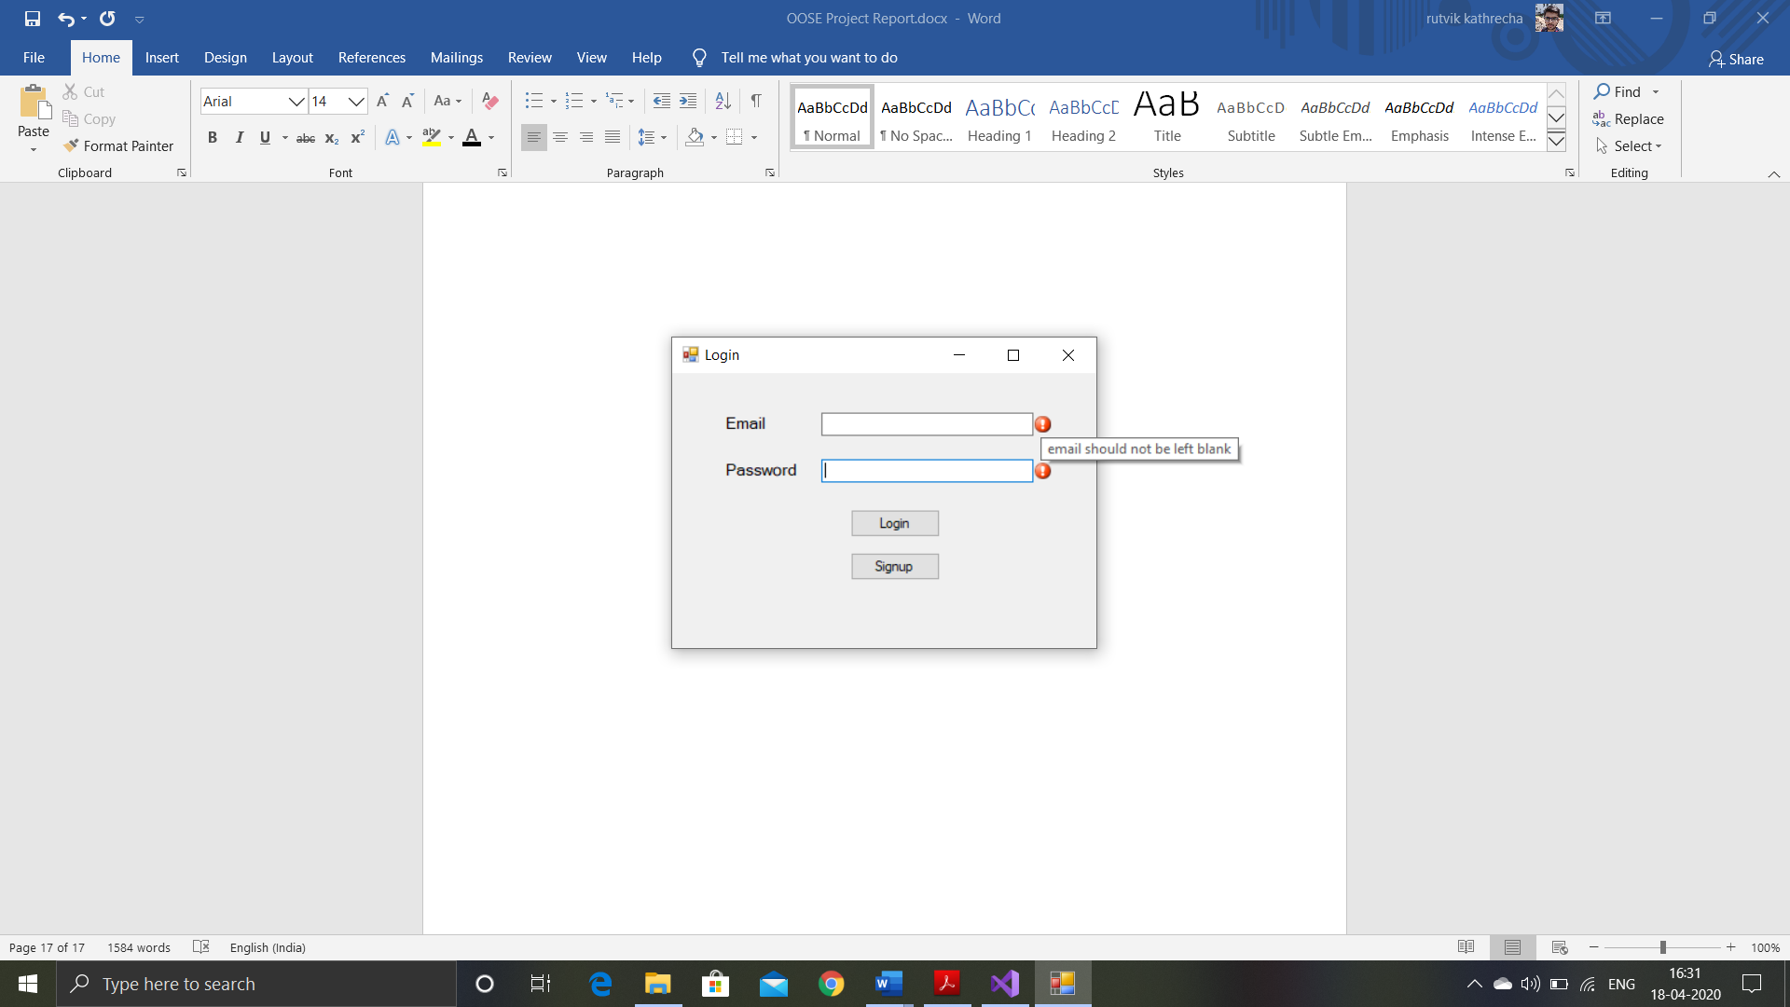If the login field are left blank then error message will be shown.

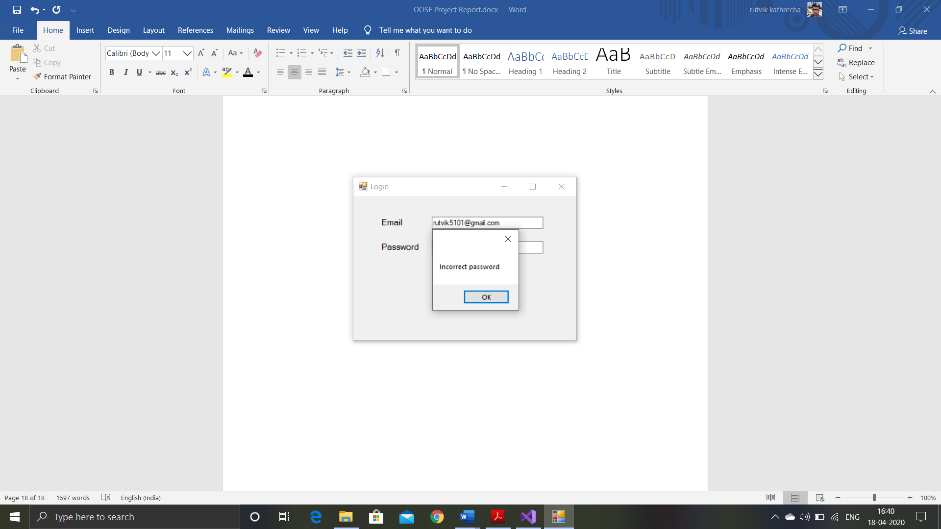If the username or password is wrong then appropriate message will be shown.

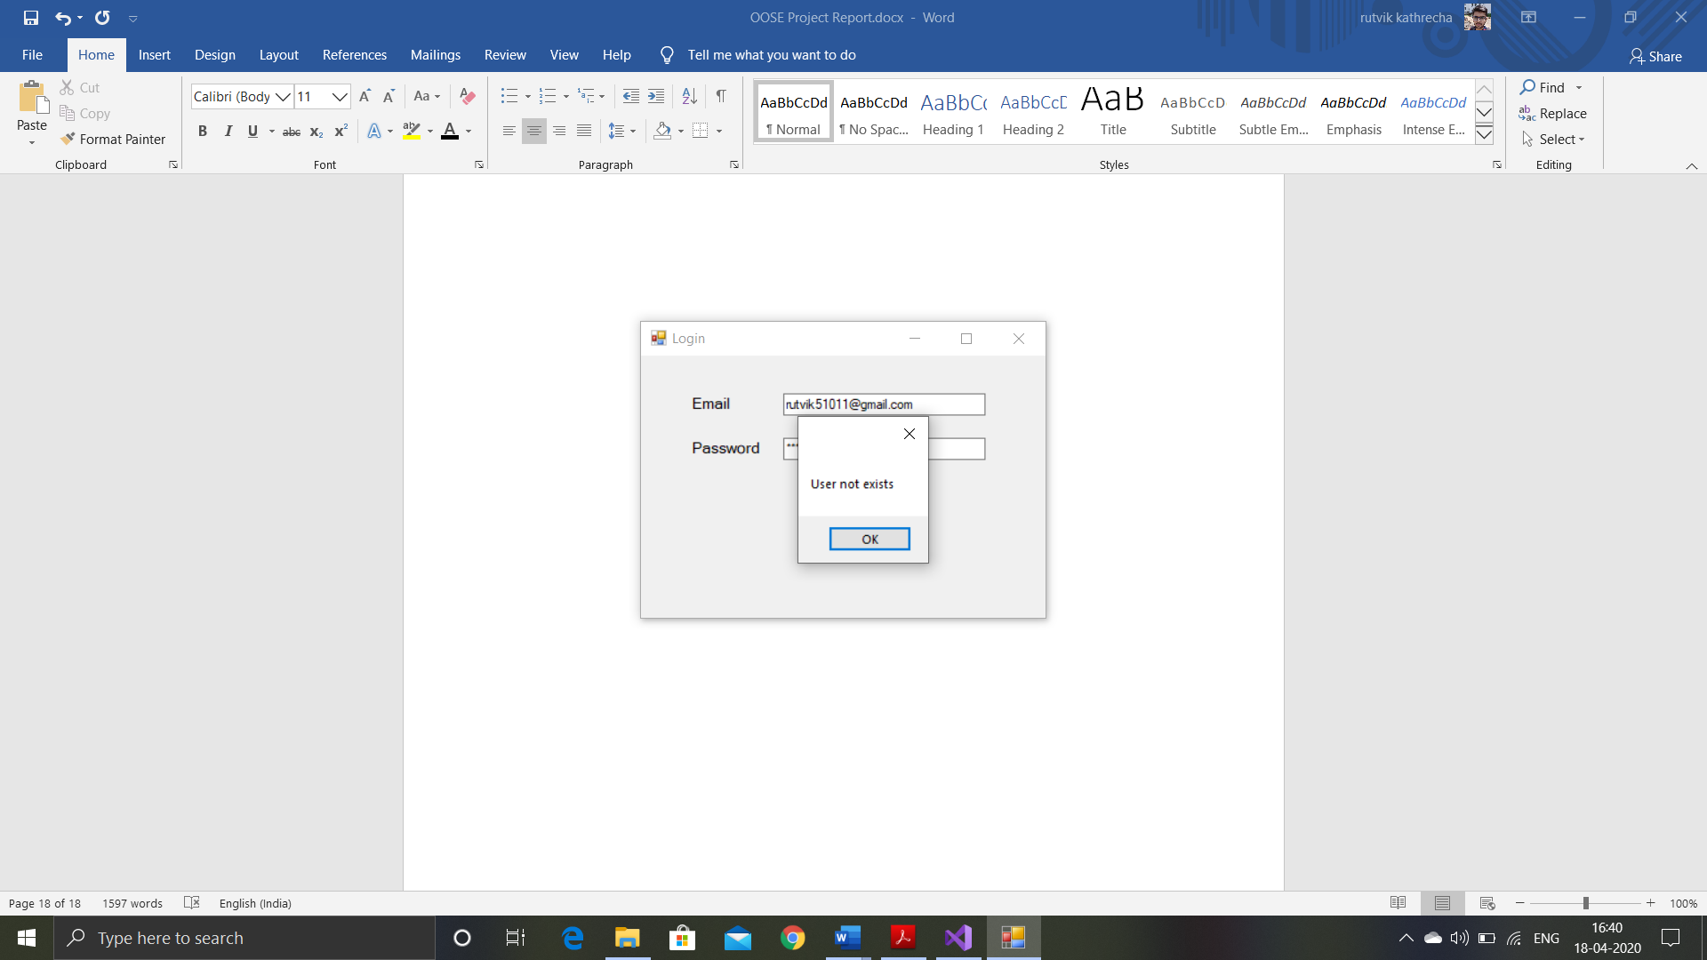

1. Signup

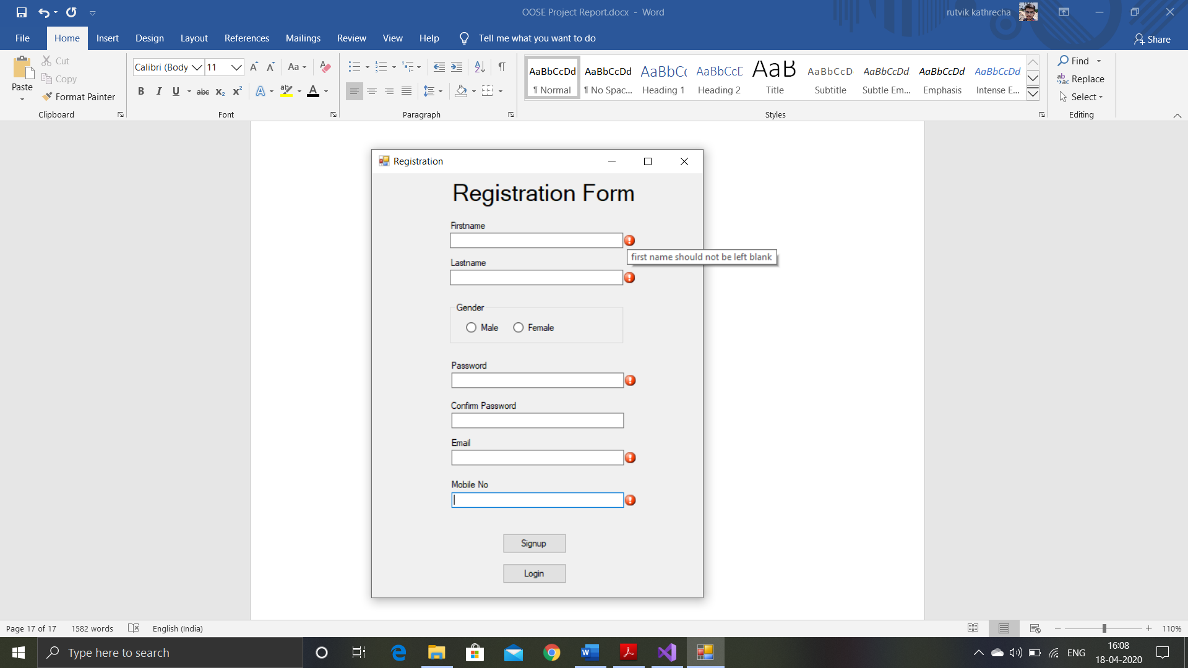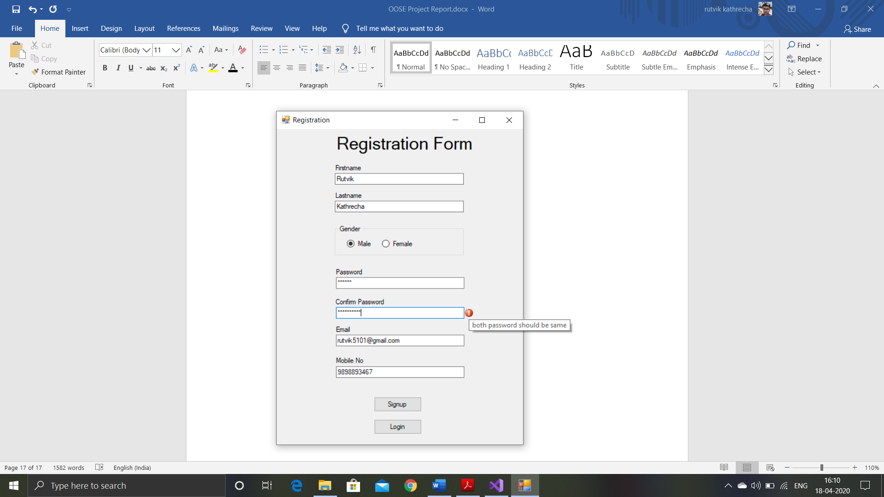If the signup fields are left blank or both the passwords are not matching then appropriate message will be shown.

Email and mobile no should be unique.

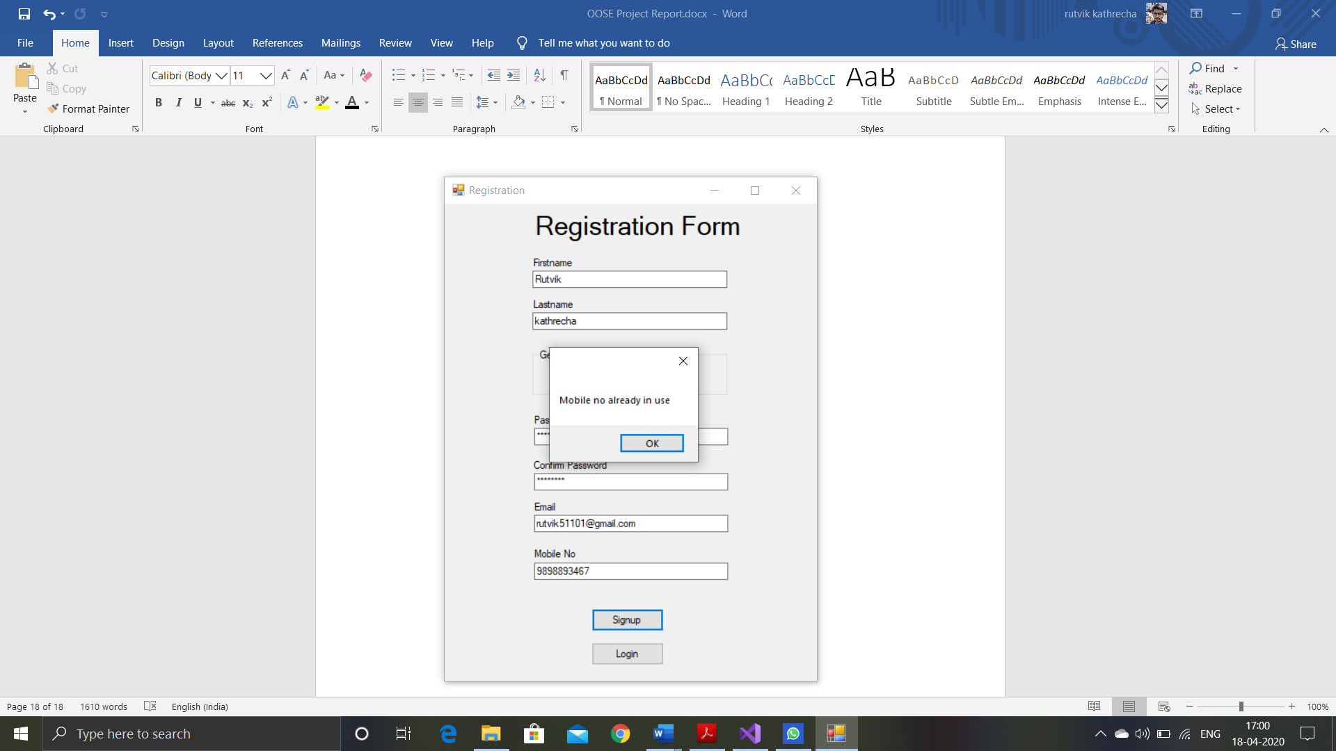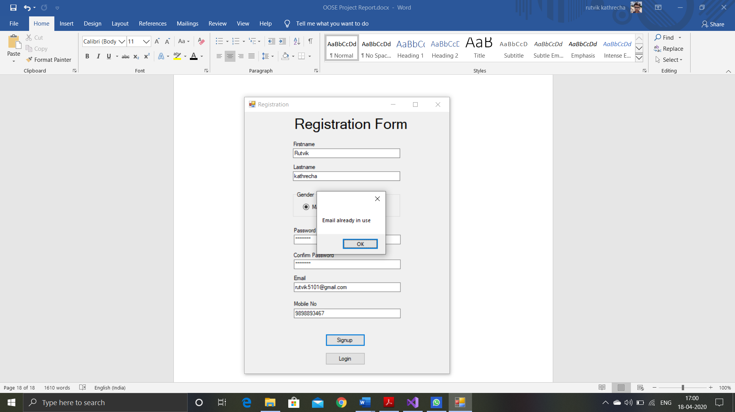

1. Parking Reservation

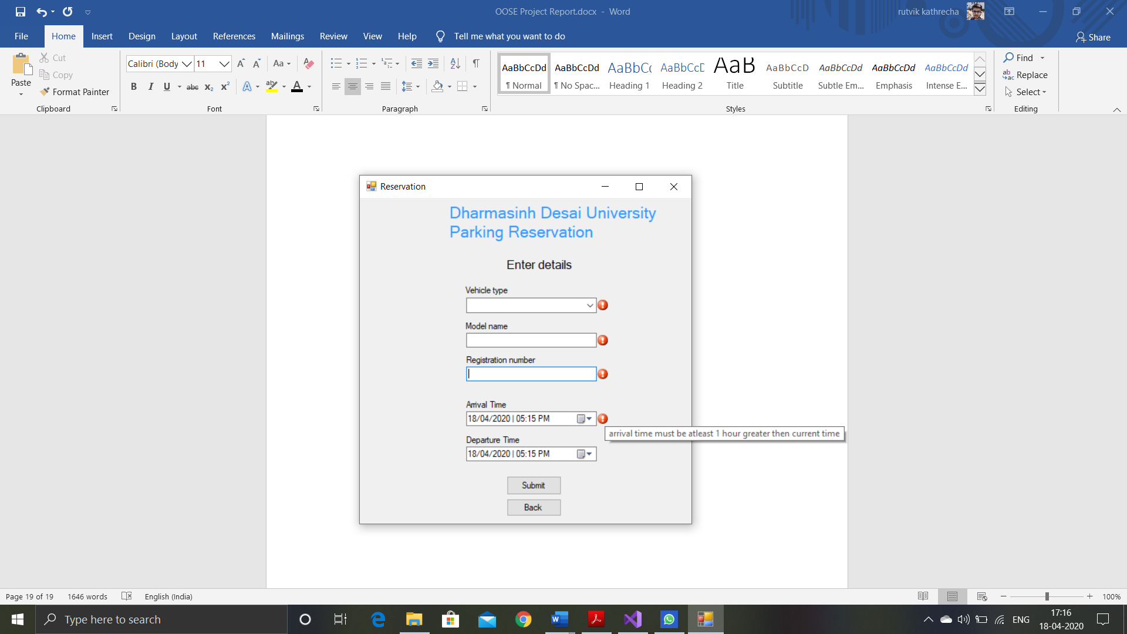Arrival time must be greater than current time

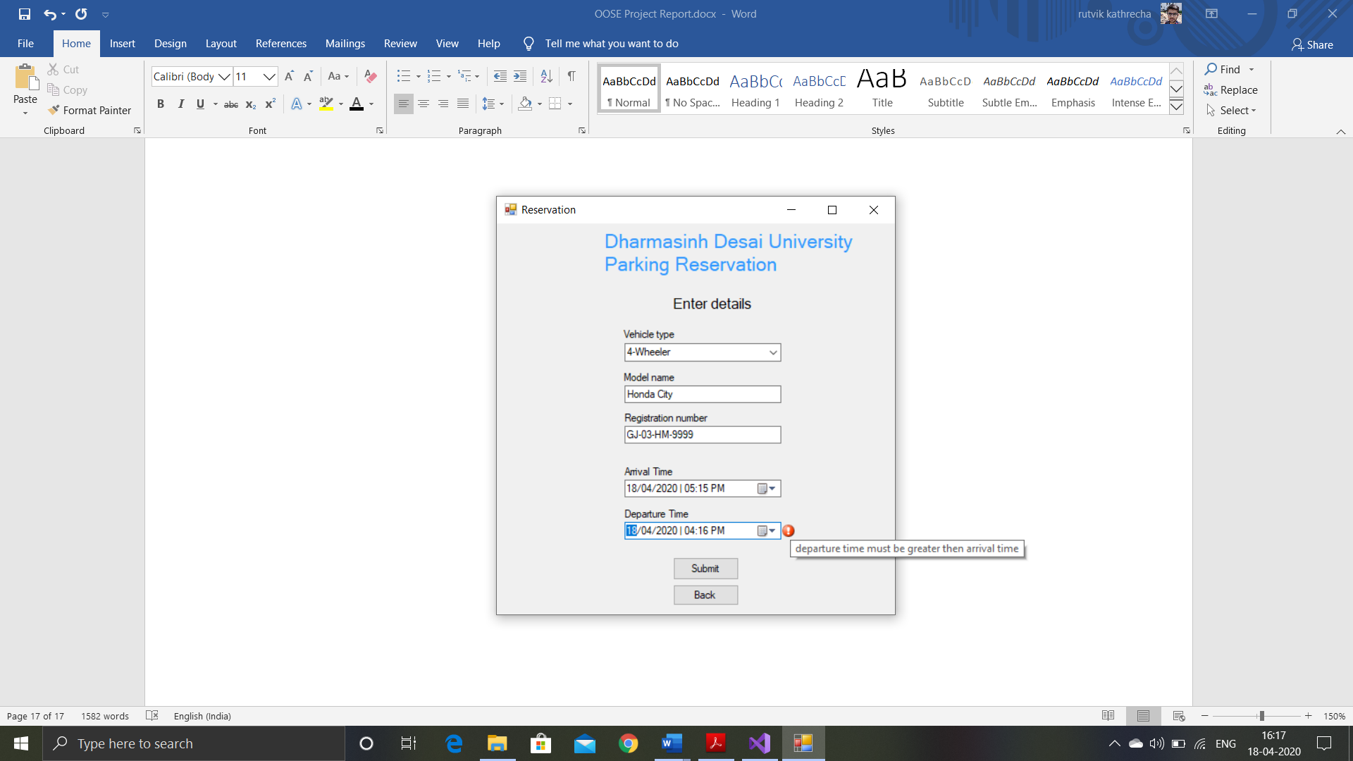Departure time must be greater than arrival time

# Screen-shots

Home Page

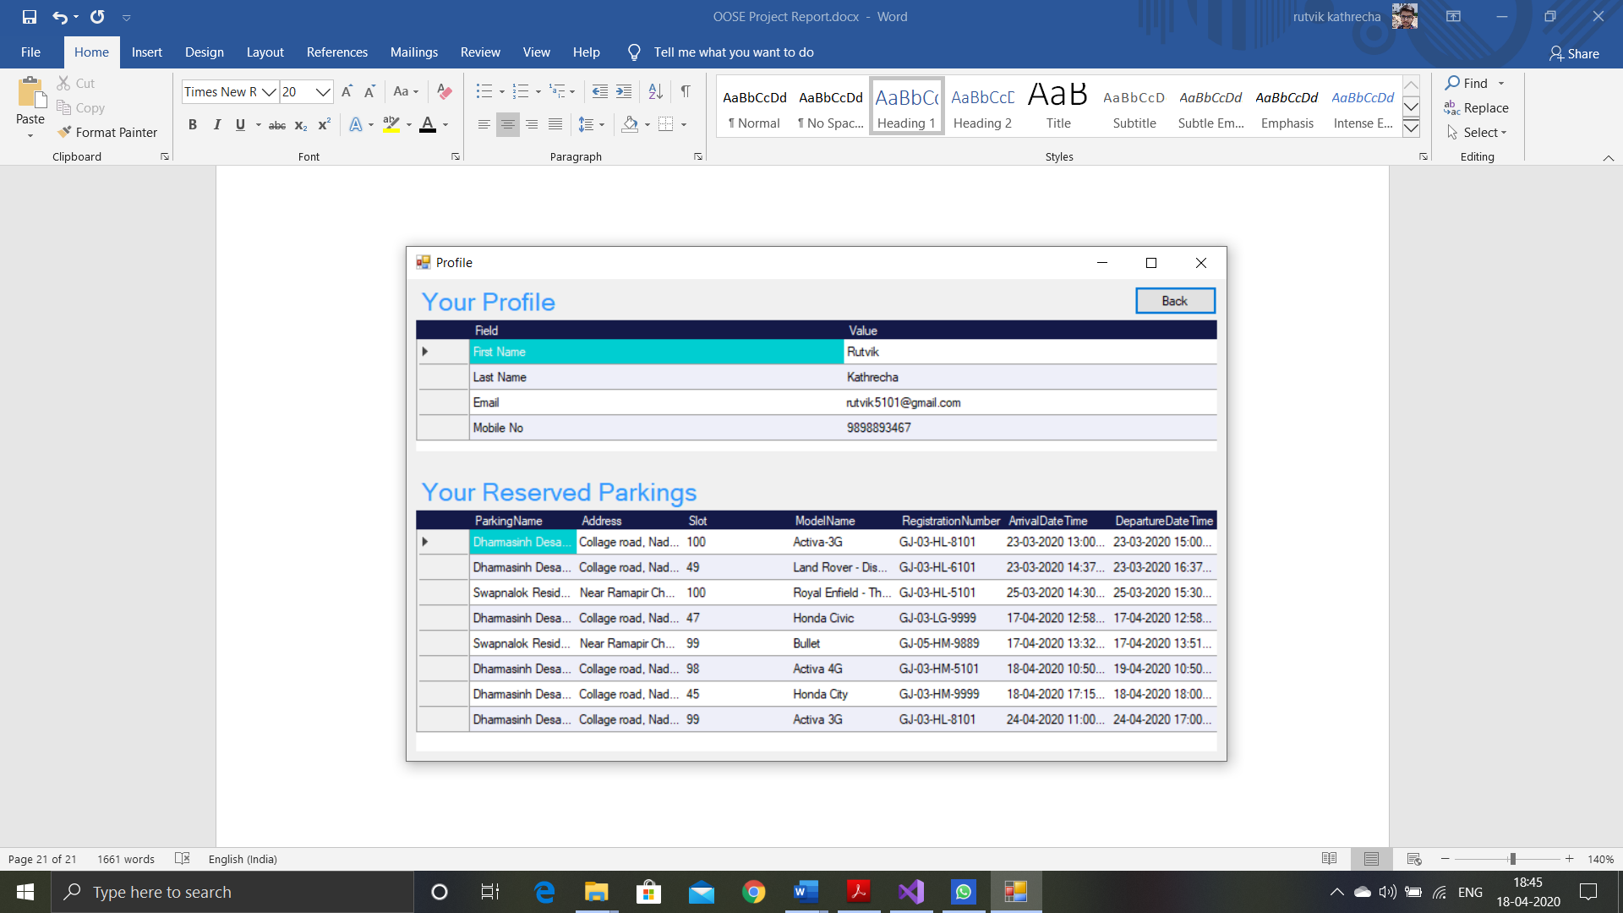

Profile Page

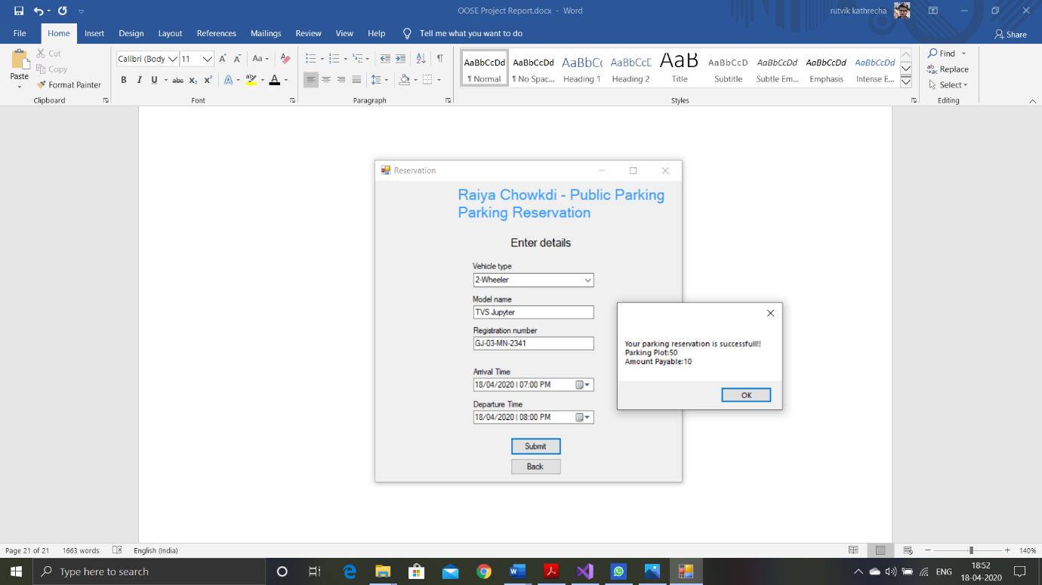

Parking Reservation Form with success message

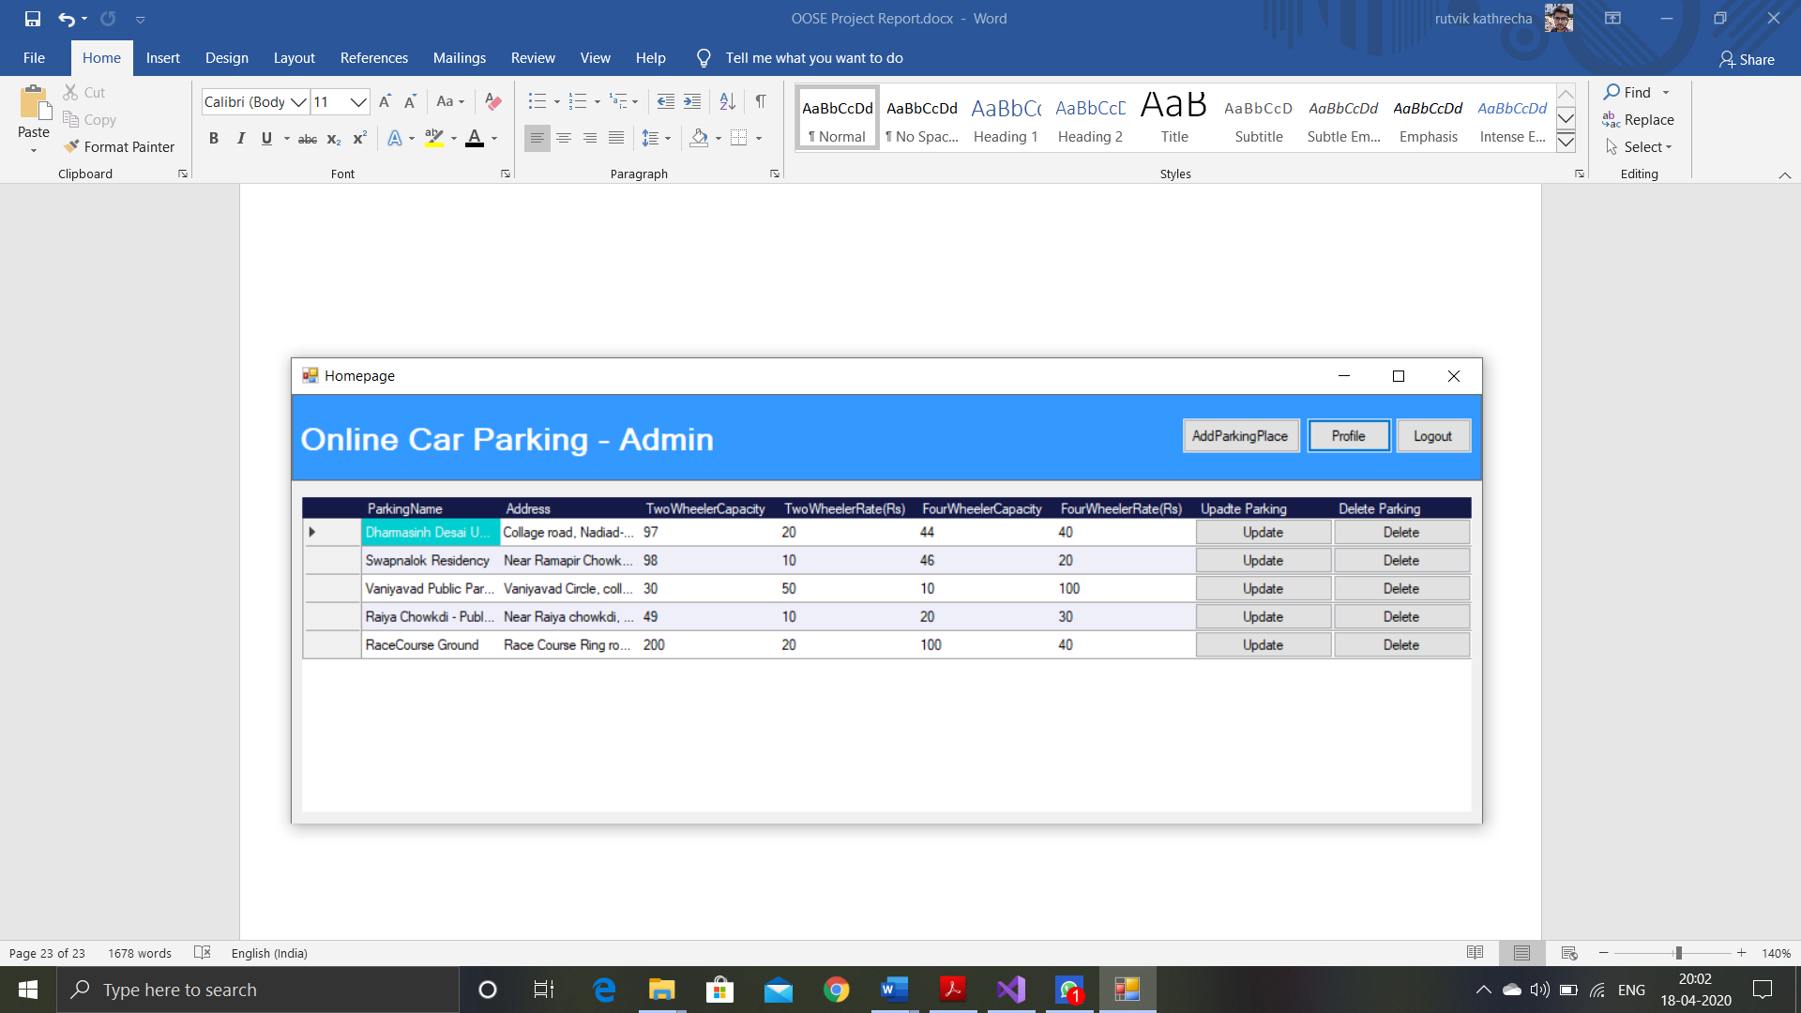

Admin Page

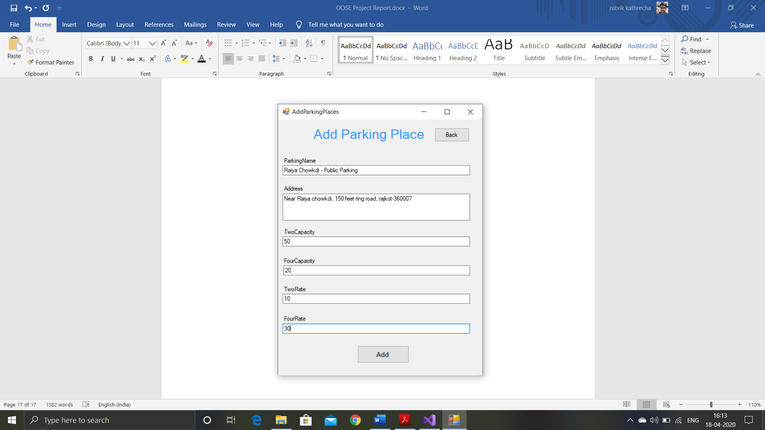

Add Parking Place Form for Admin

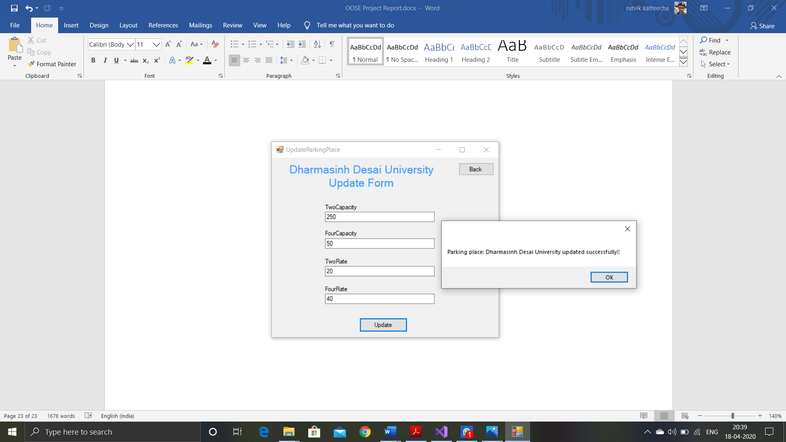

Update parking details form with successful message

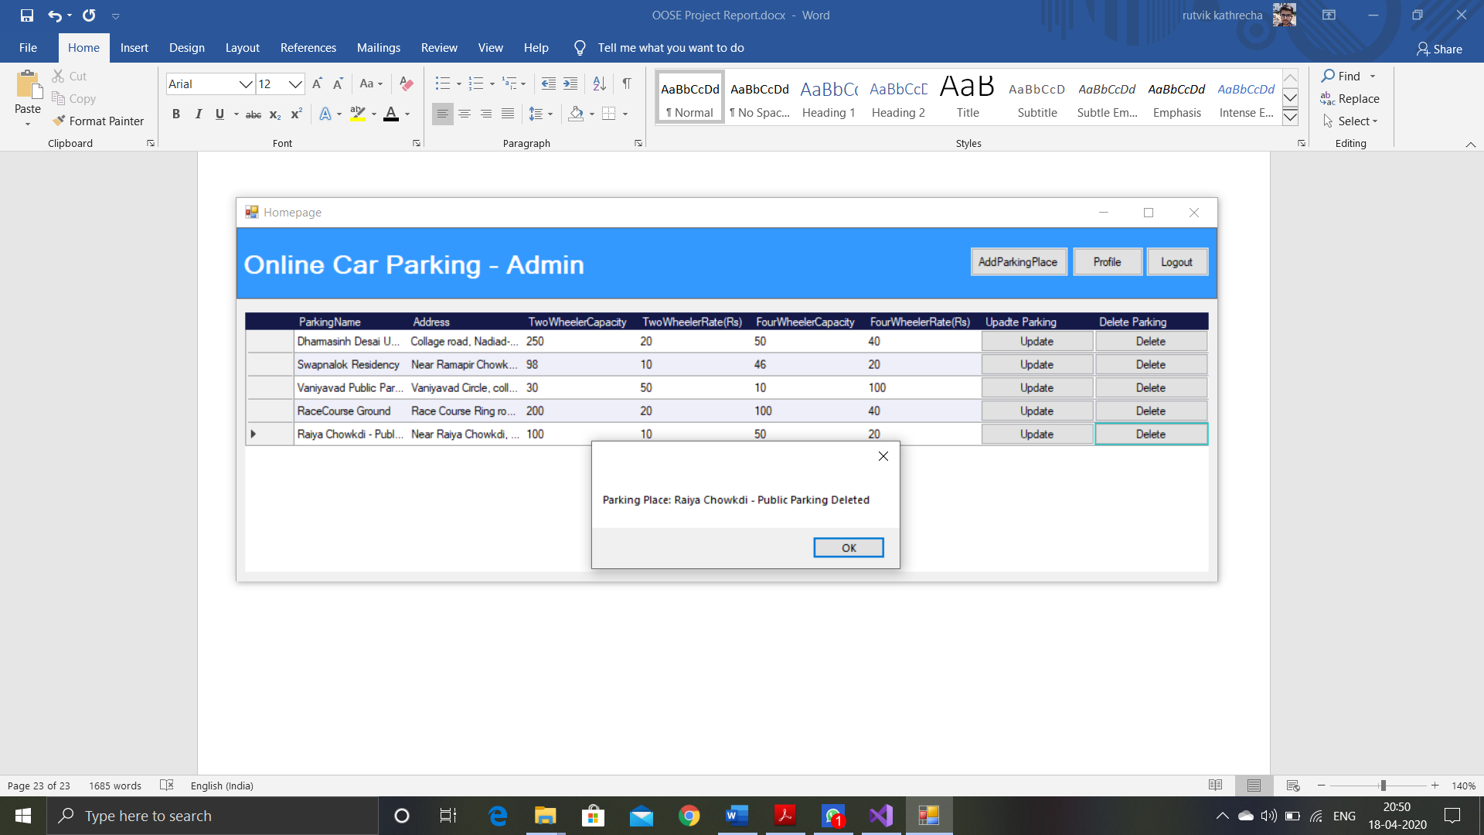Message after successful deletion of parking place

# Conclusion

In this project we have successfully build the online parking management application in which user can reserve the parking for their vehicles. Admin can add, update or delete the parking place. All the functionalities including login, signup and parking reservation are successfully implemented.

# Limitation and Future Extension

Limitations

We have not implemented the process related to payment of amount. We are also not providing the cancellation of parking reservation at this moment.

Future Extension

* To support more features related to online parking.
* To support better functionalities.
* To support better UI.

# Bibliography

* <https://docs.microsoft.com/>
* <https://www.c-sharpcorner.com/>
* <https://www.codeproject.com/>
* <https://stackoverflow.com/>