|  |  |  |  |  |  |  |  |  |  |
| --- | --- | --- | --- | --- | --- | --- | --- | --- | --- |
| Expense | | | | | | | | | |
| Sr. No. | Field Name | Data Type | Width | Required | Unique | PK/FK | Referenced Table | Description |
| 1 | Id | Number | 10 | Yes | Yes | PK |  | Primary Key for the Expense table |
| 2 | Subject Name | Varchar2 | 50 | Yes |  |  |  | Subject of Expense |
| 3 | Date | DateTime |  | Yes |  |  |  | By default, current Date Is provided User can change it also. |
| 4 | Amount | Number | 10 | Yes | Yes |  |  | Amount for the expense. |
| 5 | Category Name | Varchar2 | 10 | Yes | Yes |  |  | Category Name select from drop – down list. |
| 6 | Description | Varchar2 | 50 | No |  |  |  | User can add short description of expense. |

|  |  |  |  |  |  |  |  |  |
| --- | --- | --- | --- | --- | --- | --- | --- | --- |
| Category Item | | | | | | | | |
| Sr. No. | Field Name | Data Type | Width | Required | Unique | PK/FK | Referenced Table | Description |
| 1 | Category Name | Varchar2 | 10 | Yes | Yes | PK |  | Category Name is primary key for category table. |
| 2 | Category Image Resource Id | Number | 10 | Yes |  |  |  | Id number for Image Resource of Category |
| 3 | Category Index | Number | 10 | Yes |  |  |  | Index number for displaying category list in dropdown list |

|  |  |  |  |  |  |  |  |  |
| --- | --- | --- | --- | --- | --- | --- | --- | --- |
| Summary Item | | | | | | | | |
| Sr. No. | Field Name | Data Type | Width | Required | Unique | PK/FK | Referenced Table | Description |
| 1 | Category Name | Varchar2 | 10 | Yes | Yes |  |  | Category Name is for calculate summary for that category. |
| 2 | Percentage | Number | 10 | Yes |  |  |  | Represent percentage of category. |

Screen Shot for testing App.

 

HomePage AddExpensePage

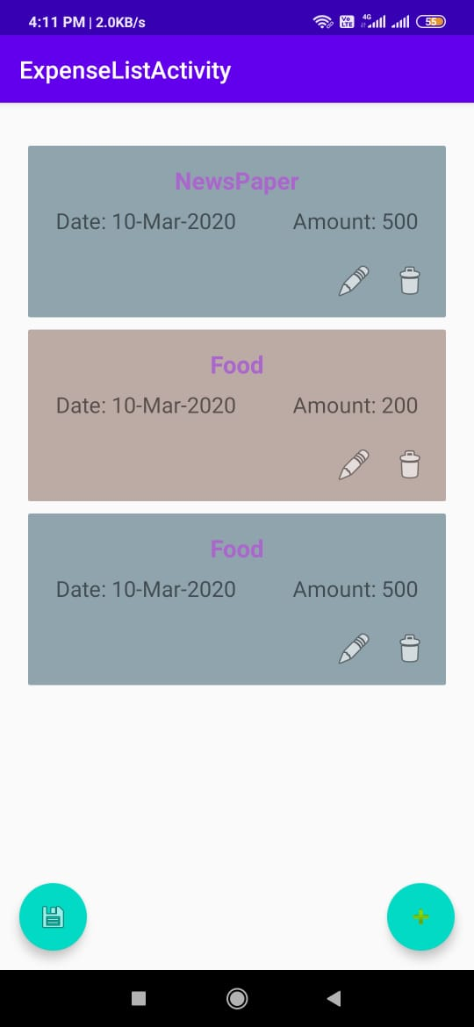 

ShowExpensePage AddingExpense

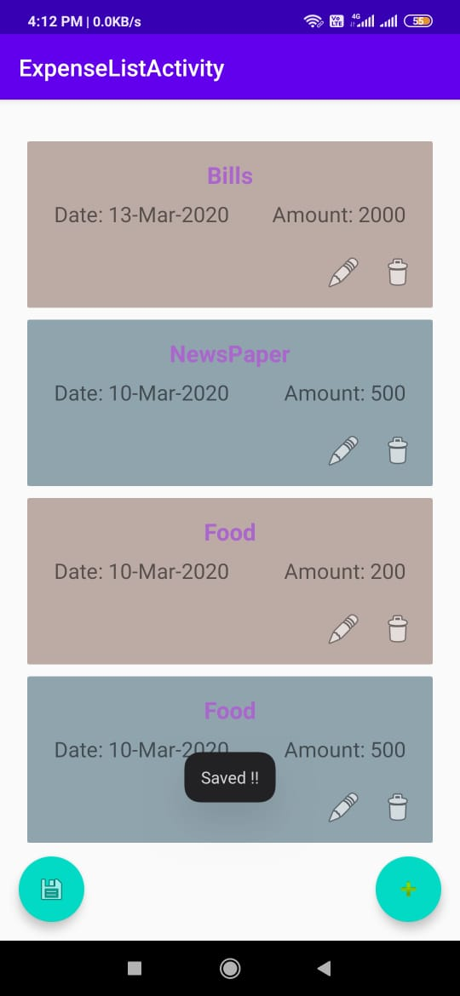 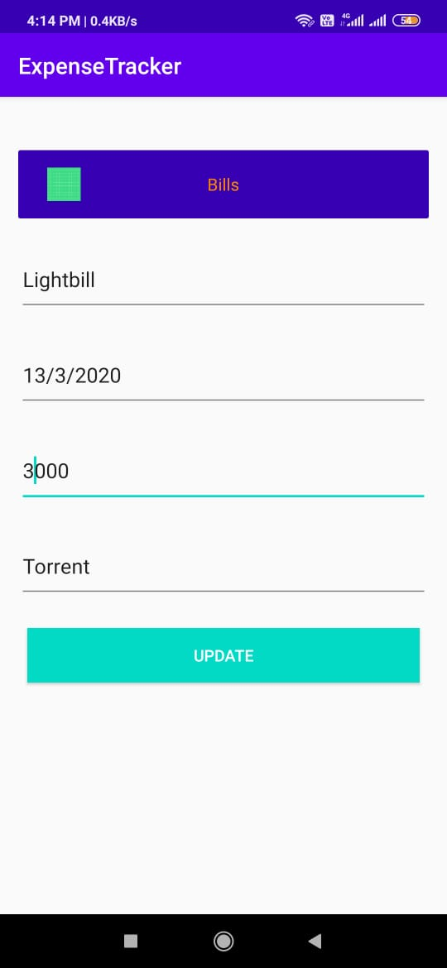

ShowExpense UpdateExpense

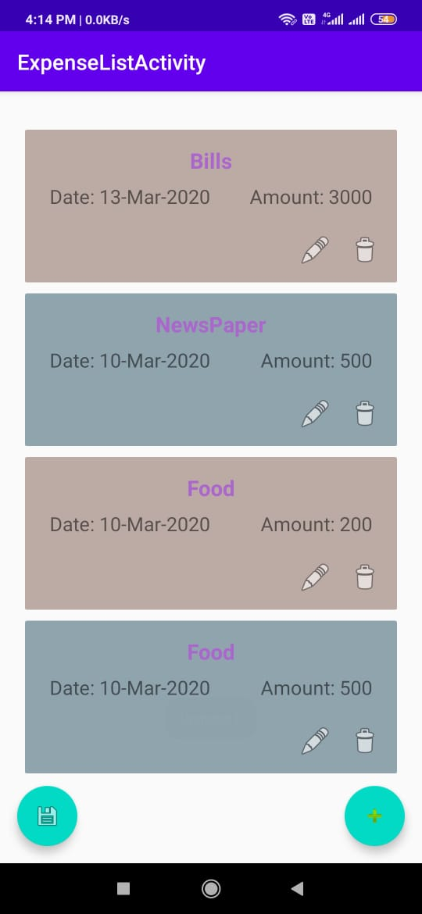 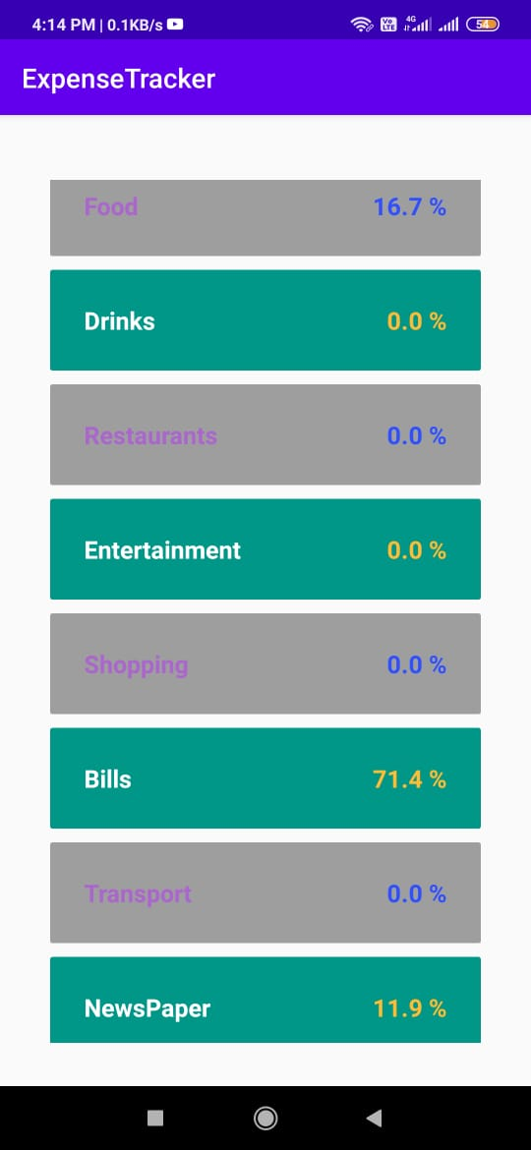

UpdatedList SummaryList

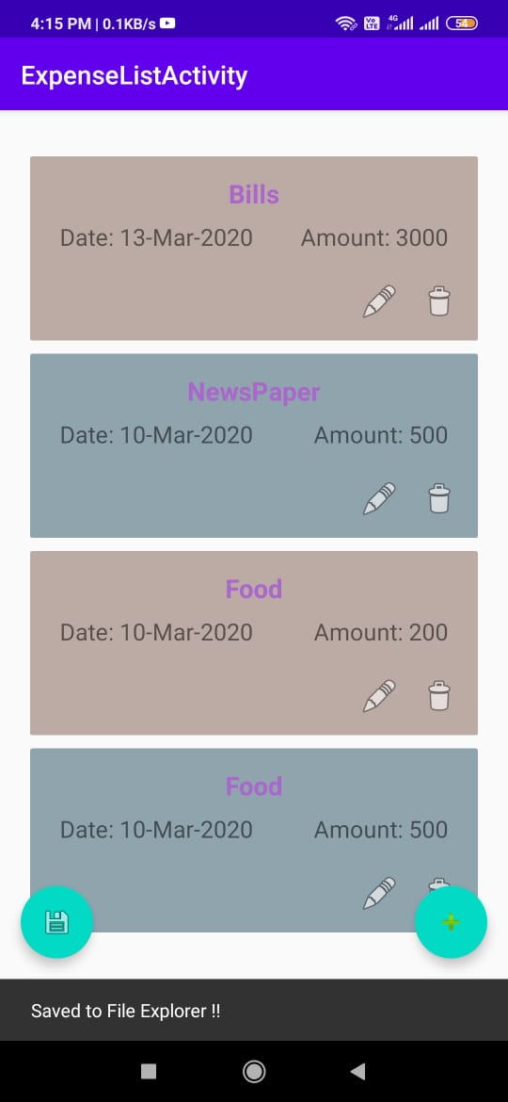 

Save As Pdf Pdf