

**Dharmsinh Desai University, Nadiad**

Faculty of Technology

Department of Computer Engineering

B. Tech CE Semester – VI

Subject: System Design Practice

Project Title:

**Expense Management Android Application**

By

Smit Hapani (CE-41) (17ceuos005)

Rutwik Kikani (CE-62) (17ceuos068)

Guided By:

Prof. Pandav K. Patel

Assistant Professor

Department of Computer Engineering



**Dharmsinh Desai University, Nadiad**

Faculty of Technology

Department of Computer Engineering

**CERTIFICATE**

This is certify that the System Design Practice project entitled **“Expense Management Android Application”** is a bona fide report of work carried out by

1. **Rutwik Kikani, Roll No: CE062, Student ID No: 17CEUOS068**
2. **Smit Hapani, Roll No: CE041, Student ID No: 17CEUOS005**

Of Department of Computer Engineerog, Semester VI, academic year 2019-20, under the guidance and supervision for the subject System Design Practice.

(Project Guide) (HOD)

**Prof. Pandav K. Patel Dr. C. K. Bhensdadia**

Assistant Professor Head of Department

Department of Computer Department of Computer

Engineering, Engineering,

Faculty of Technology, Faculty of Technology,

Dharmsinh Desai University, Dharmsinh Desai University,

Nadiad Nadiad

|  |  |  |
| --- | --- | --- |
| **No.** | **Contents** | **Page no.** |
| 1 | Introduction | 1 |
| 2 | Software Requirement Specifications | 2 |
| 3 | Design | 5 |
| 4 | Implementation Detail | 12 |
| 5 | Testing & Screen Short | 13 |
| 6 | Conclusion | 23 |
| 7 | Limitation and Future Extension | 24 |
| 8 | Bibliography | 25 |

# Abstract

Now a days there is everything on internet.People usually want to save the expense so that they can’t forget it.So, we have developed an android application for Expense management.User can add the expense in the application wherever he/she spent the money.They will have different options for choosing catagories for the particular expense.So, user can see all the expenses on just click and can see catagorywise summary for the expenses.

# Introduction

The objective of the project is to develop a system that automates the process and activities of Expense Management. The purpose of the system is to provide basic facility for adding,updating and viewing the expense summary.

User can Add & Update catagorywise expense.User can see the list of expenses in the decreasing order of date.He/She can also see the summary where he/she spent the money and can back up expense list as PDF file.

#### Technology used:

* Java
* Sqlite Database

#### Platform used:

* Android Studio

# Software Requirement Specification

## End User:

##### R1 - Add Expense

Description: In this, user can add expense details and amount.

R1.1 Select Catagory

Input: Select catagory from the list. Output:Catagory selected.

R1.2 Enter Subject

Input: User will have to enter the subject details. Output: Subject name.

R1.3 Enter date.

Input: Double tap to select a date. Output: Selected date.

Exception:If date is invalid,then exception msg will be shown.

##### R2 – Update Expense

Description: User can update expense details if required.

Input: Upadte detail which you required. Output: Updated expense.

##### R3 – Delete Expense

Description: User can delete expense details if required.

Input: Delete expense which you required. Output:Expense deleted .

##### R4 – View Expense list

Description: User can view expense details if required.

Input: Show expense list . Output:Expense list.

##### R5 – View Expense summary

Description: User can view expense summary if required.

Input: Show expense summary . Output:Expense summary in percentage.

##### R6 – Make PDF file

Description: User can store expense list as PDF file Input: Convert to PDF.

Output:PDF will be stored in external storage.

# Design

## Usecase Diagram

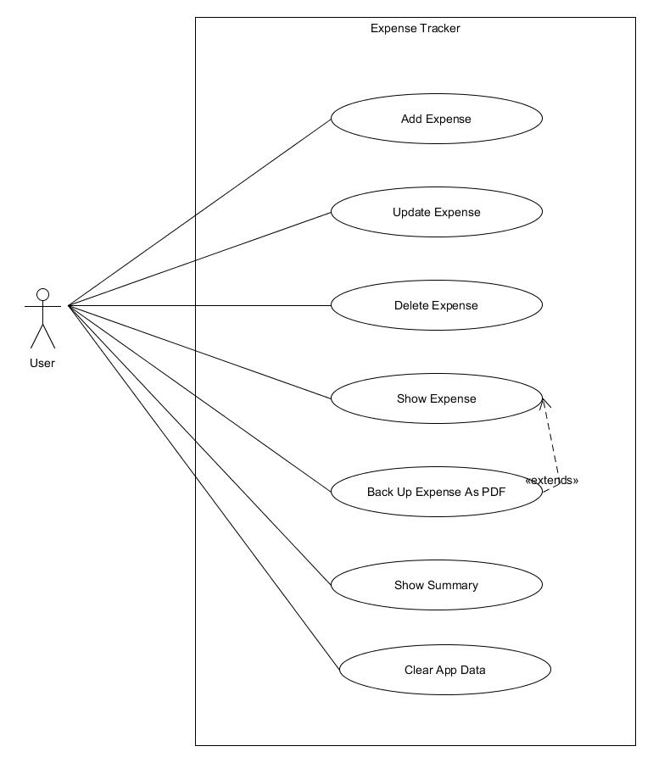

* 1. **ER Diagram**

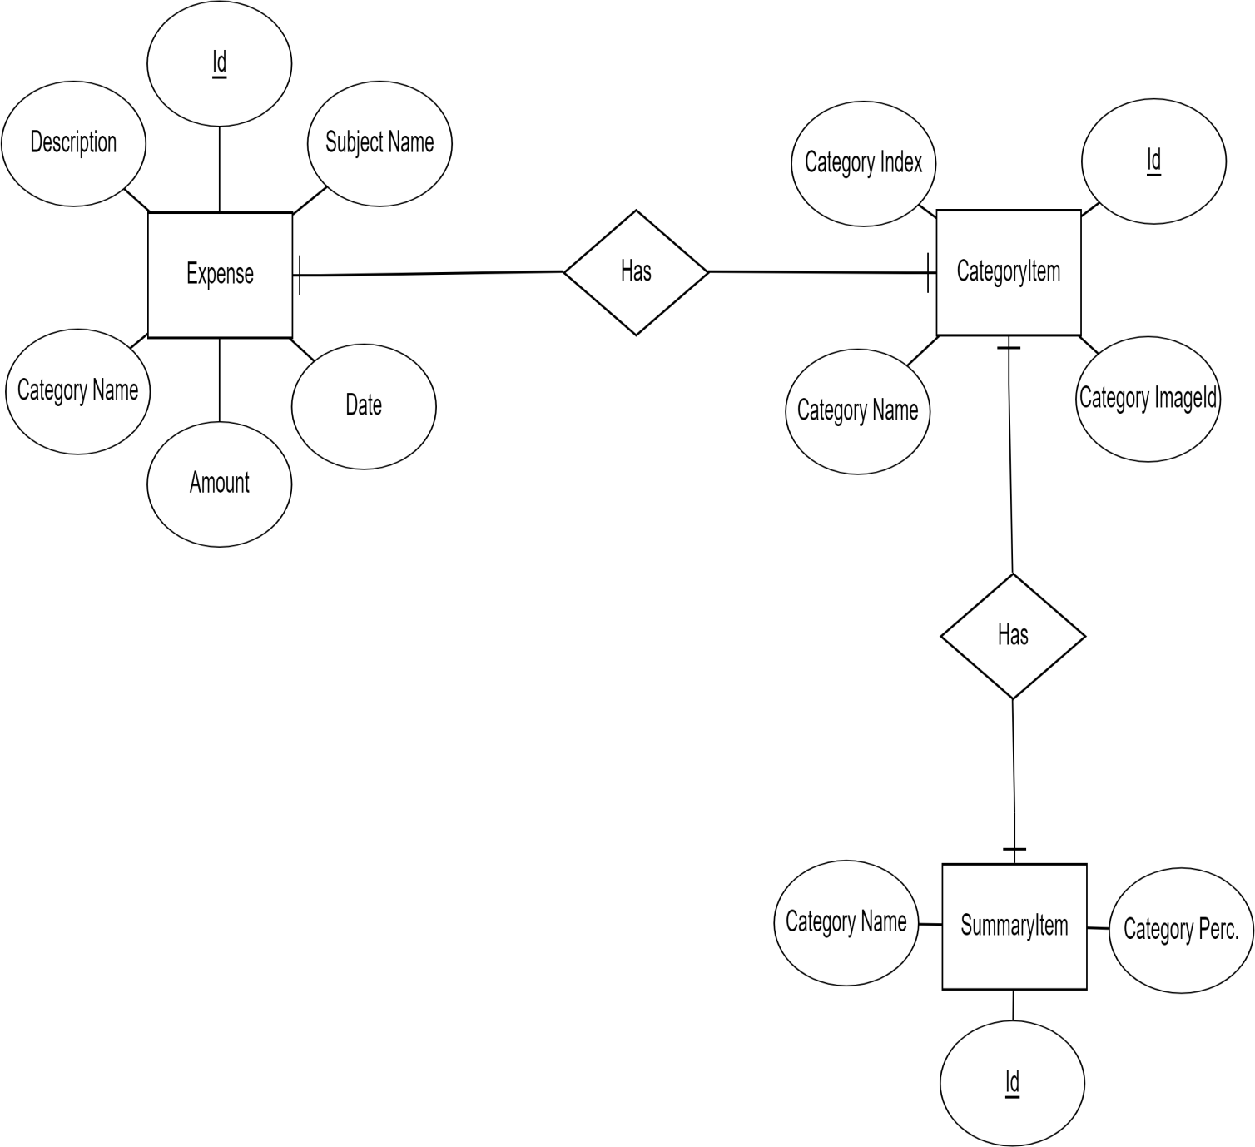

* 1. **Class Diagram**

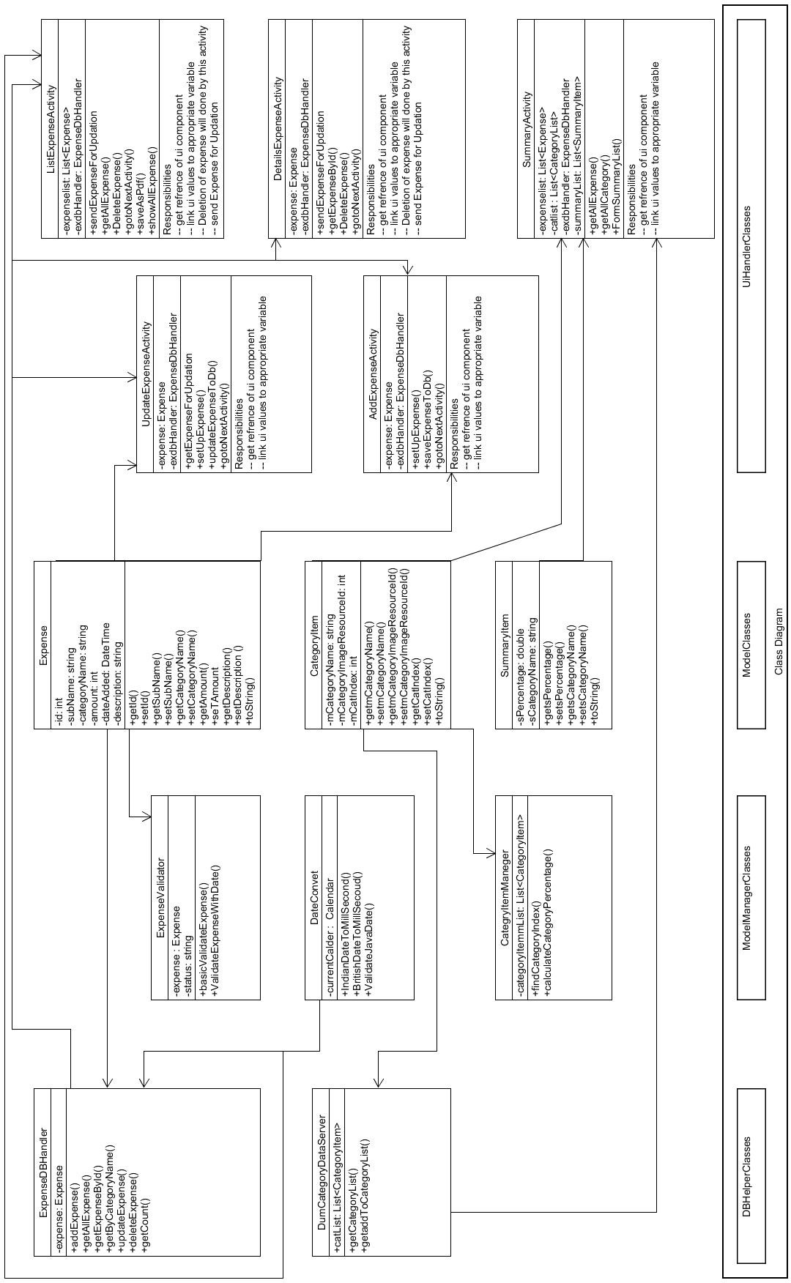

* 1. **Activity Diagram**

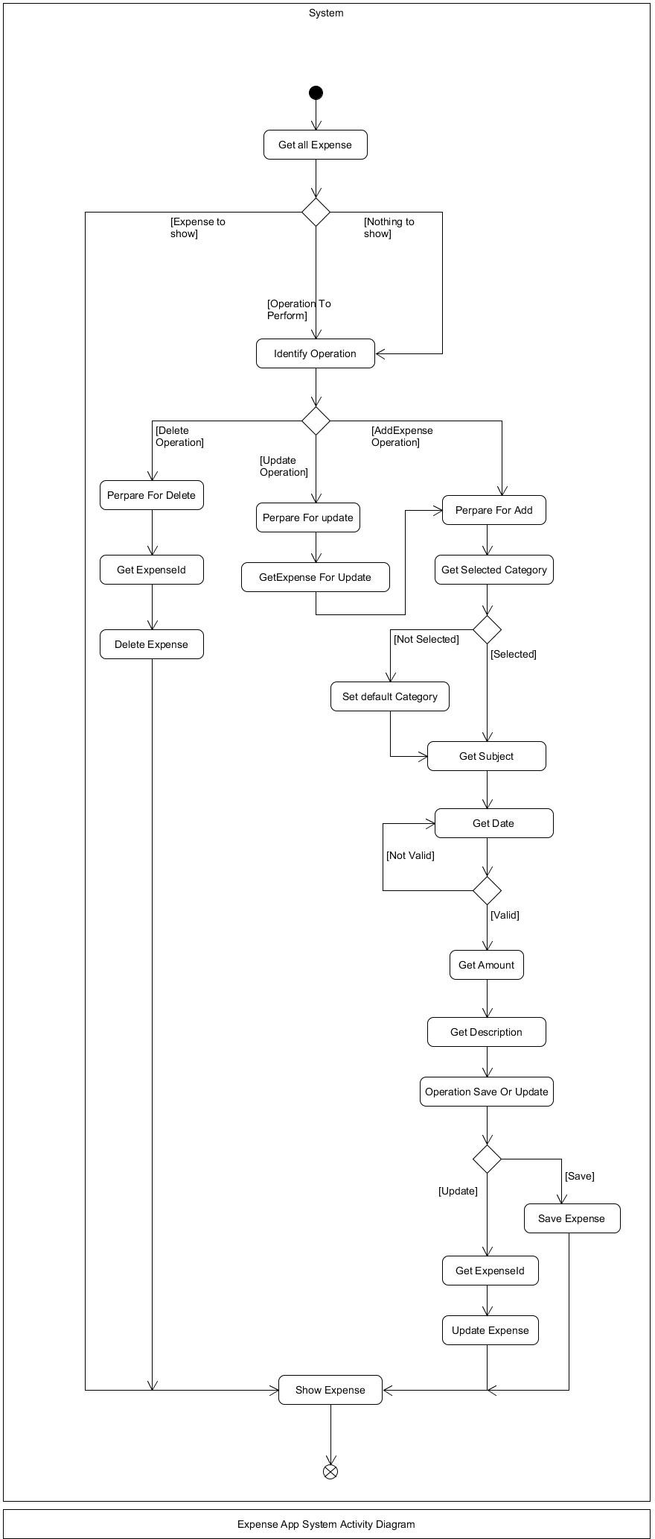

* 1. **Sequence Diagram**

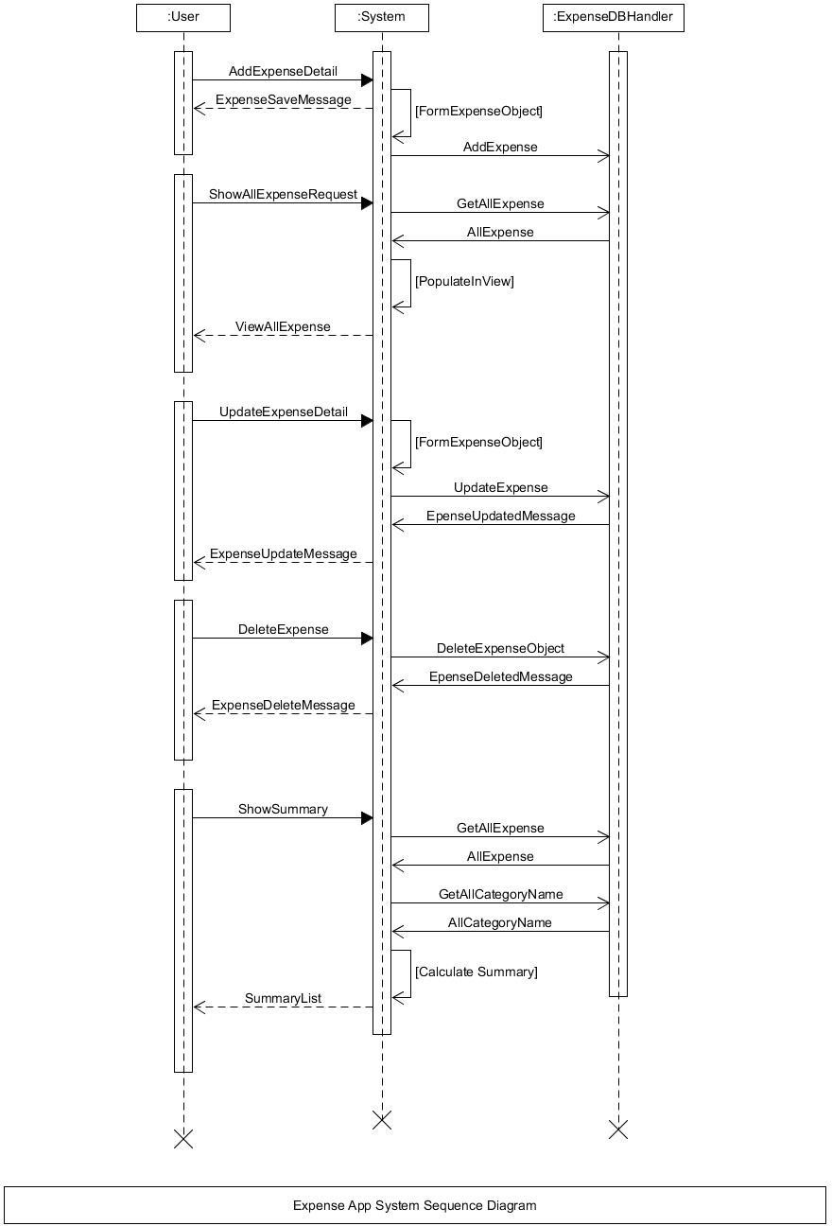

* 1. **DTD:**

|  |  |  |  |  |  |  |  |  |
| --- | --- | --- | --- | --- | --- | --- | --- | --- |
| Expense | | | | | | | | |
| Sr.  No. | Field Name | Data Type | Width | Required | Unique | PK/FK | Referenced Table | Description |
| 1 | Id | Number | 10 | Yes | Yes | PK |  | Primary Key for the  Expense table |
| 2 | Subject Name | Varchar2 | 50 | Yes |  |  |  | Subject of Expense |
| 3 | Date | DateTime |  | Yes |  |  |  | By default, current Date Is provided User can change it also. |
| 4 | Amount | Number | 10 | Yes | Yes |  |  | Amount for the expense. |
| 5 | Category Name | Varchar2 | 10 | Yes | Yes |  |  | Category Name select from drop – down list. |
| 6 | Description | Varchar2 | 50 | No |  |  |  | User can add short  description of expense. |

|  |  |  |  |  |  |  |  |  |
| --- | --- | --- | --- | --- | --- | --- | --- | --- |
| Category Item | | | | | | | | |
| Sr.  No. | Field Name | Data Type | Width | Required | Unique | PK/FK | Referenced Table | Description |
| 1 | Category Name | Varchar2 | 10 | Yes | Yes | PK |  | Category Name is primary key for category table. |
| 2 | Category Image Resource Id | Number | 10 | Yes |  |  |  | Id number for Image Resource of Category |
| 3 | Category Index | Number | 10 | Yes |  |  |  | Index number for displaying category list in dropdown list |

|  |  |  |  |  |  |  |  |  |
| --- | --- | --- | --- | --- | --- | --- | --- | --- |
| Summary Item | | | | | | | | |
| Sr.  No. | Field Name | Data Type | Width | Required | Unique | PK/FK | Referenced Table | Description |
| 1 | Category Name | Varchar2 | 10 | Yes | Yes |  |  | Category Name is for calculate summary for that  category. |
| 2 | Percentage | Number | 10 | Yes |  |  |  | Represent percentage of category. |

Implementation detail

##### Expense Module:

In the home page,there is shown Show Expense and Add expense button.By which,User and show the expense history and add new expense respectively.User can also update the expense details and delete specific expense.

##### Summary Module:

In Summary module,User can see catagorywise expense summary in percentage also.So,user can keep track of his/her expenses like where he/she spend more money.

# Screenshots

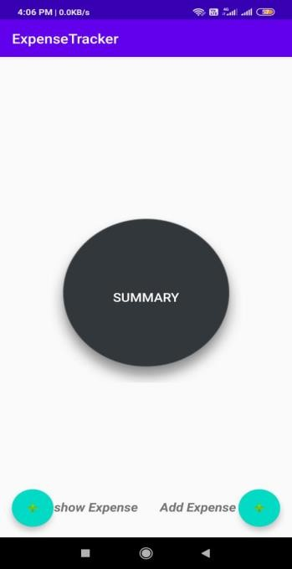 (Home page)

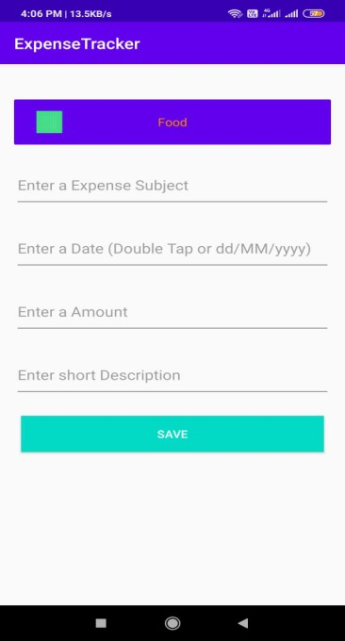(Add Expense)

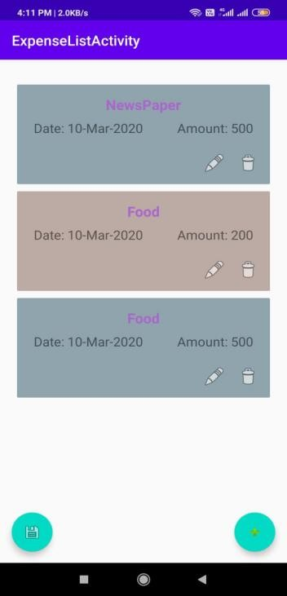(Expense list)

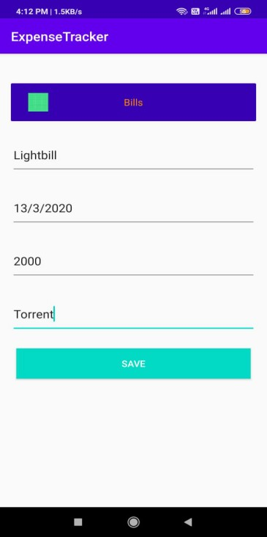(Adding the expense)

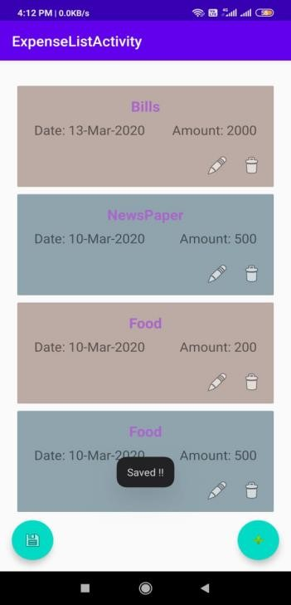(Expense Added)

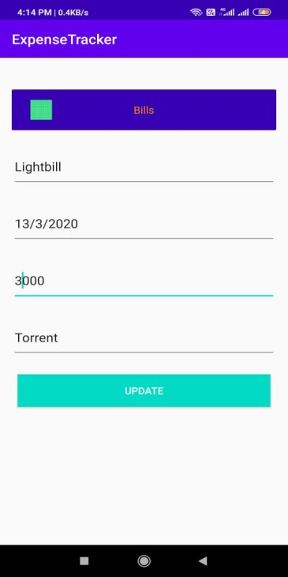(Updating expense)

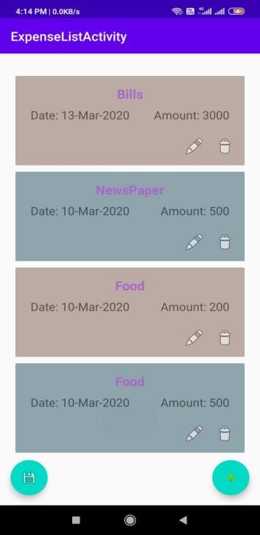(Updated Expense list)

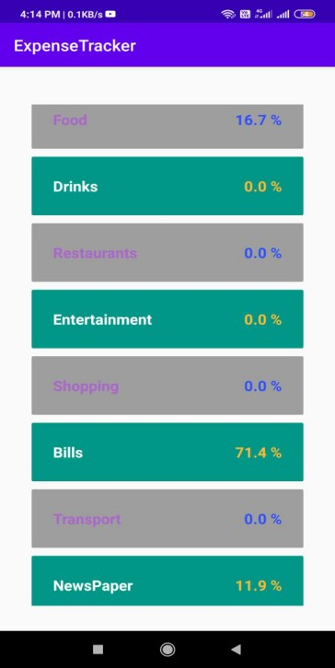(Summary)

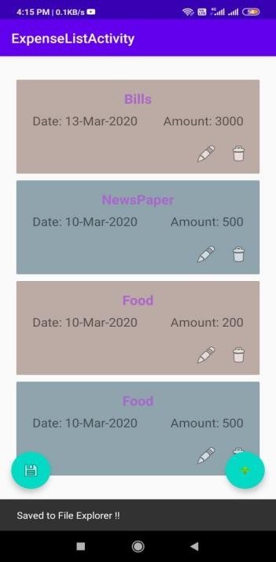(Save as PDF)

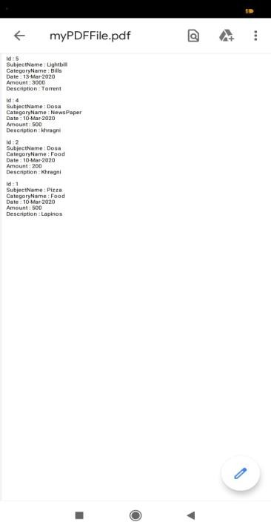

(PDF view of expense)

# Conclusion

In this project we have successfully implemented functionalities like Add expense,Update expense,Delete expense,View Expense-list,View Summary and convert Expense-list to PDF.In our android application,Expense list is shown in the decreasing order of date.We have put date validation in our Expense Tracker application.

# Limitations and Future Extension

### Limitations:

We have not implemented the Custom catagory functionality. Instead we have provided catagory list by which user can choose any catagory.We haven’t put datewise expense filter.

### Future Extension:

* + - Custom Catagory will be provided.
    - Datewise filter will be provided.
    - We are looking to implement pi-chart.

# Bibliography

<https://developer.android.com/training/data-storage/sqlite>

<https://developer.android.com/guide/components/intents-filters>

[https://stackoverflow.com/questions/12298835/how-to-retrieve-data-from-](https://stackoverflow.com/questions/12298835/how-to-retrieve-data-from-sqlite-database-in-android-and-display-it-in-textview) [sqlite-database-in-android-and-display-it-in-textview](https://stackoverflow.com/questions/12298835/how-to-retrieve-data-from-sqlite-database-in-android-and-display-it-in-textview)

<https://developer.android.com/reference/android/view/package-summary>