Headphone Mix

Version 1.1.0

Welcome
Thank you for downloading this fine plug-in. HeadphoneMix is a GUIless plugin which applies a little inter-channel crosstalk to compensate the so called in-head-localisation known from listening with headphones.
In order to get the most out of the HeadphoneMix, please spend a few moments reading this brief manual.

License
HeadphoneMix has a very simple license:

- HeadphoneMix is freeware. This means that you are free to use this plugin in any context. Also you are free to share it on a personal base (ie. give it to friends). However, only the entire unaltered archive, including this document, may be shared. Public redistribution is only allowed on request.
- Copyright of the code and the pre-compiled plug-in remain property of the Delphi ASIO & VST Project and namely Christian-W. Budde.
- This plug-in is provided at no cost; therefore the author Christian-W. Budde assume no responsibility for any negative effects that may occur to the end user or the equipment used to run the plug-in.
- Magazine editors are welcome to include the plug-in on cover mount discs or similar media; However, it is mandatory to inform the author Christian-W. Budde about this. A copy of the publication is always appreciated, but not expected.

The parameter
This plugin only has three parameter: effect, model and polarity.

Effect
The first of this three controls the amount of the effect. If set to zero, it’s bypassed. The maximum of 100% is slightly more effect than you would have in the reality. A setting of 80%-90% should just work fine normally.

Model
You can choose one out of three different models for the abandoned ear. In the below plot, green is the handcrafted curve, green a matched curve of the HDPHX and blue a matched curve to the average of the IRCAM HRTFs.
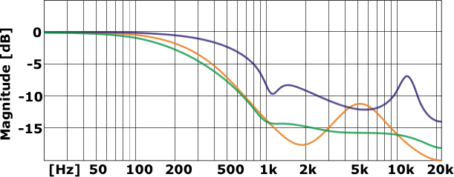

Polarity
The polarity parameter simply switches the polarity of the abandoned ear. The result is a loss of bass instead of a gain. This parameter was implemented for testing purpose only. The green curve is the normal state.
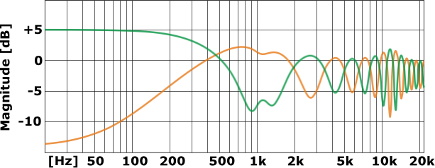
Feedback / Bug Reports
I am always eager to hear feedback or have bugs reported. The easiest way is to send me a mail to: Christian@savioursofsoul.de

Version History
  - First release!
  - Added HRTF mode and released as open source

Credits

• Programming: Christian W. Budde
• Documentation based on a template by Greg Pettit

VST name and technology © Steinberg GmbH
The VST logo is a trademark of Steinberg GmbH

