An LLM-Agent Intelligent Assistant for Energy Storage Battery Fault Diagnosis via Hybrid Retrieval and Tool-Augmented Reasoning
THIS IS A BLIND REVIEW. DO NOT INCLUDE AUTHOR INFORMATION.
ABSTRACT
Large-scale battery energy storage systems require maintenance decisions that combine real-time telemetry, alarm events, historical cases, device topology, and domain documents. In practice, these information sources are often isolated across monitoring platforms, databases, manuals, and expert workflows, making fault diagnosis slow and difficult to reproduce. This digest proposes an LLM-agent intelligent assistant for energy storage battery fault diagnosis. The system uses complexity-aware routing to select either a single-agent fast path for database queries, retrieval, visualization, and direct answers, or a multi-agent deep-research path for complex diagnostic reasoning. To improve reliability, the assistant integrates schema-constrained natural language database querying, hybrid text-image retrieval-augmented generation, and evidence-based report synthesis. The proposed design aims to reduce hallucination, preserve traceable evidence, and support actionable operation and maintenance decisions. Experimental evaluation with real operational data, knowledge documents, and expert-scored diagnostic cases will be added in the full paper.
Keywords: energy storage, battery fault diagnosis, large language model, multi-agent system, retrieval-augmented generation, natural language database query
INTRODUCTION
Battery energy storage systems have become essential assets for renewable integration, peak shaving, frequency regulation, and grid flexibility. However, modern storage plants contain thousands to millions of cells and multiple coupled subsystems, including battery management systems, power conversion systems, energy management systems, thermal control, fire protection, and operation platforms. Faults may propagate across cell, module, rack, and station levels, while early-stage degradation is often reflected in weak and intermittent signals such as voltage inconsistency, internal resistance drift, abnormal temperature rise, or alarm recurrence.
Existing maintenance workflows are still fragmented. Operators typically query alarms in one system, inspect time-series curves in another, search manuals or standards in a document library, and consult experts for final judgment. Classical machine-learning models have improved state estimation, anomaly detection, and remaining-life prediction, but they usually solve narrow tasks and do not provide a unified natural-language interface for multi-source diagnostic reasoning. Directly applying a general LLM is also insufficient because energy storage diagnosis requires private domain knowledge, controlled database access, traceable evidence, and conservative recommendations. This work therefore studies how to build a reliable LLM-agent assistant that can use retrieval, tools, and multi-agent reasoning for battery operation and maintenance.
RELATED WORK
Retrieval-augmented generation (RAG) combines parametric language models with explicit external memory, enabling generated answers to be grounded in retrieved passages [1]. Dense passage retrieval further showed that learned embeddings can outperform sparse retrieval for open-domain question answering [2]. For industrial diagnosis, however, exact device identifiers, fault terms, and table fields remain important, so a hybrid dense-sparse retrieval strategy is often preferable. Multimodal RAG extends this idea beyond text. MuRAG introduced multimodal memory over images and text [3], while ColPali showed that visually rich document pages can be retrieved directly by vision-language models [4]. These works motivate the proposed image-text evidence channel for maintenance documents containing flowcharts, SEM images, and waveform plots.
LLM agents provide a second line of related work. ReAct interleaves reasoning traces and actions to improve grounded decision making [5], Toolformer studies how language models can learn to call external tools [6], and Tree-of-Thoughts enables deliberate exploration over multiple reasoning paths [7]. Recent surveys further summarize LLM-based multi-agent systems as a practical architecture for complex tasks requiring role assignment, communication, and shared memory [8]. In parallel, Text-to-SQL research such as DIN-SQL and RESDSQL demonstrates that decomposition, schema linking, and constrained generation are critical for database reliability [9], [10]. These findings support our design choice: the LLM plans a query, while programmatic validators enforce table, field, route, time-window, and limit constraints before execution.
Battery fault diagnosis has been extensively studied using physical models, statistical monitoring, sensor fusion, and machine learning. Recent work has investigated small-fault detection in lithium-ion batteries [11], force and gas sensing for internal short circuit detection in large packs [12], online Gaussian-process health monitoring from field data [13], and early short-circuit detection under dynamic conditions [14]. BatteryAgent further bridges physics-informed features, explainable machine learning, and LLM reasoning to generate fault type, root-cause, and maintenance recommendations [15]. Compared with these studies, our contribution focuses on an operational assistant workflow that integrates structured databases, unstructured knowledge, visual evidence, and multi-agent diagnostic report generation.
PROPOSED SYSTEM ARCHITECTURE
Fig. 1 shows the planned system architecture. A user question first enters a complexity-aware router. Simple tasks, such as alarm summaries, recent measurements, single-step knowledge lookup, and chart generation, are handled by a single-agent supervisor that selects among DATABASE, RETRIEVE, CHART, and DIRECT actions. Complex tasks, such as root-cause analysis without a clearly specified device ID or cross-document diagnostic reasoning, are sent to a deep-research path. This path performs pre-retrieval, draft generation, supervisor-researcher coordination, finding compression, and final report synthesis.
Figure 1: Overall architecture of the proposed LLM-agent assistant. To be replaced by the final system diagram.
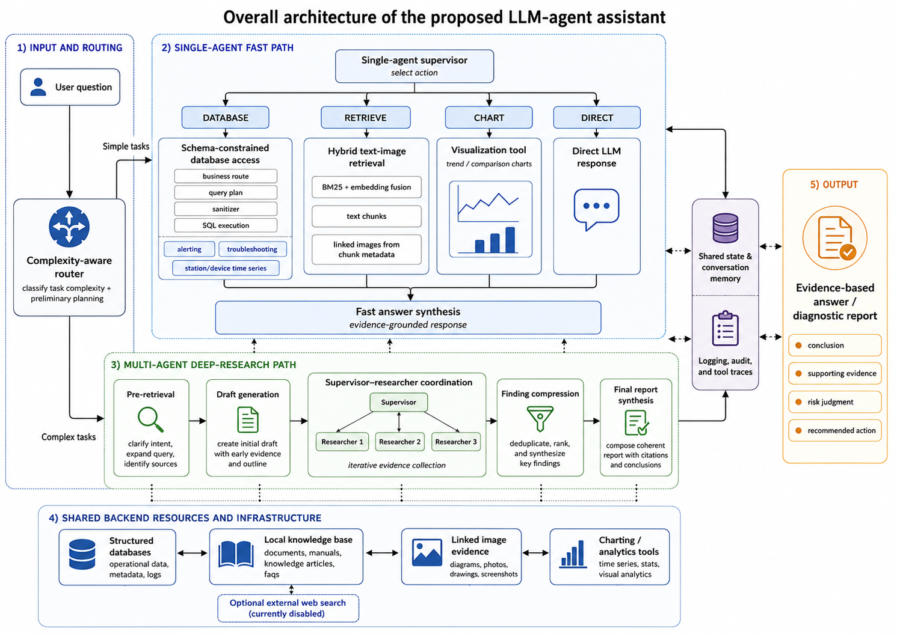
METHODOLOGY
The schema-constrained database module follows a plan-then-execute design. The LLM first predicts a business route, such as alerting, troubleshooting, or station/device time-series analysis. It then produces a structured query plan including table, selected fields, filters, time range, ordering, and limit. A deterministic sanitizer checks the plan against schema allowlists and route-table mappings, removes illegal fields, clamps unsafe limits, and only then builds executable SQL. The returned rows are converted into an evidence bundle for final explanation. This design avoids direct free-form SQL generation and makes each database action auditable.
The retrieval module uses a hybrid image-text RAG pipeline. Offline, domain documents are parsed into text chunks, and each chunk stores associated image metadata. Online, dense retrieval and BM25 retrieval are fused as s(d) = alpha*BM25(d) + (1-alpha)*Emb(d), where scores are normalized before fusion. Retrieved text supports language grounding, while the linked images provide visual evidence for diagnostic procedures, morphology analysis, and waveform interpretation. The final answer is organized as conclusion, supporting evidence, risk judgment, and recommended action.
The multi-agent path is designed for high-complexity diagnostic questions. A supervisor decomposes the request into focused research tasks, dispatches them to researcher agents, and decides when enough evidence has been gathered. Researcher agents perform retrieval and evidence compression before returning findings. The final generator combines the original user request, retrieved evidence, database results, draft report, and recent dialogue context into a structured diagnostic report. All node outputs are logged to support traceability and later expert review.
Figure 2: Schema-constrained natural language database query pipeline. To be replaced by the final flowchart.
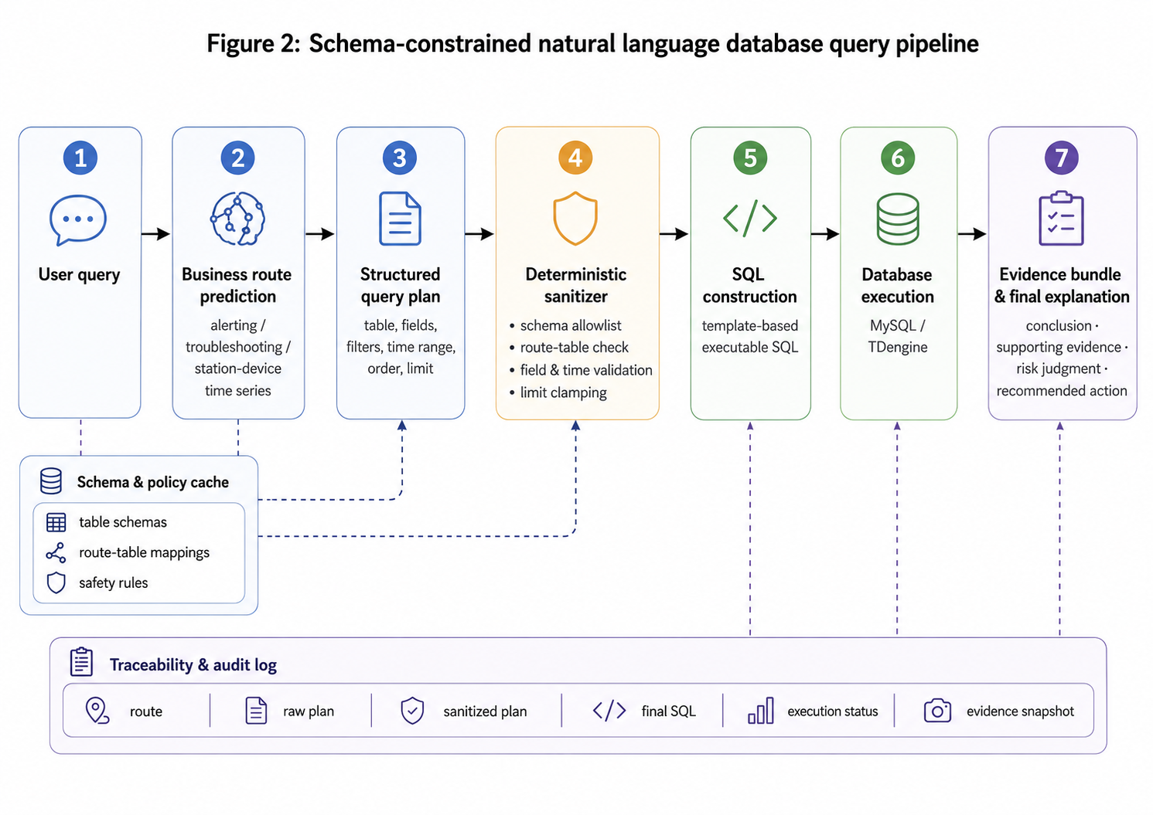

EXPERIMENTAL PLAN AND RESULT PLACEHOLDERS
The proposed assistant was evaluated using anonymized operational data and a private maintenance knowledge base collected from energy storage applications. The evaluation covers structured database access, domain-knowledge retrieval, visual-evidence retrieval, complexity-aware routing, and diagnostic reasoning. The statistics of the experimental resources and evaluation tasks are summarized in Table I.
Table I: Dataset, knowledge-base, and task-suite statistics. To be completed after data anonymization
Resource | Scale
Structured database | 3 business routes and 7 queryable tables
Knowledge base | 99 documents and 6,741 text chunks
Visual evidence | 717 images and 486 image-linked text chunks
Evaluation suite | 50 routing, 100 database-query, and 50 diagnostic-reasoning tasks
Table II compares the full system with three ablated variants. Complexity-aware routing increased action accuracy from 20.0% to 70.0%, improved answer quality from 3.20 to 4.44, and reduced latency from 87.45 s to 40.01 s. The schema-constrained SQL module achieved a 100% SQL-ready success rate, whereas removing schema validation resulted in 0%, despite slightly lower latency.
For multi-agent diagnosis, the full workflow improved the quality score from 3.60 to 4.80, while latency increased from 60.99 s to 95.33 s. Overall, routing improves both effectiveness and efficiency, schema constraints ensure reliable database access, and multi-agent collaboration strengthens the quality and traceability of diagnostic results.
Table II: Quantitative comparison with baselines. To be completed after experiments.
Component | Variant | Primary effectiveness metric | Quality | Latency
Routing | Full | 70.0% action accuracy | 4.44 | 40.01 s
 | w/o Routing | 20.0% | 3.20 | 87.45 s
SQL | Full | 100% SQL-ready success | — | 43.99 s
 | w/o Schema | 0% | — | 32.39 s
Diagnosis | Full | — | 4.80 | 95.33 s
 | w/o Multi-Agent | — | 3.60 | 60.99 s

CONCLUSIONS AND FUTURE WORK
This digest presents an LLM-agent assistant for energy storage battery fault diagnosis. The proposed framework differs from a general chatbot by combining complexity-aware routing, schema-constrained database access, hybrid text-image retrieval, multi-agent deep reasoning, and evidence-based report synthesis. Its intended contribution is to make AI assistance more reliable, auditable, and useful in real storage operation and maintenance workflows. The full paper will add the final system diagrams, anonymized dataset statistics, baseline comparison, ablation results, case studies, and expert evaluation. Future work will extend the framework with multimodal document retrieval, automatic schema expansion, and feedback-driven improvement of diagnostic reports.

REFERENCES
[1] P. Lewis et al., "Retrieval-Augmented Generation for Knowledge-Intensive NLP Tasks," in Proc. Advances in Neural Information Processing Systems (NeurIPS), 2020.
[2] V. Karpukhin et al., "Dense Passage Retrieval for Open-Domain Question Answering," in Proc. EMNLP, 2020.
[3] W. Chen, H. Hu, X. Chen, P. Verga, and W. W. Cohen, "MuRAG: Multimodal Retrieval-Augmented Generator for Open Question Answering over Images and Text," arXiv:2210.02928, 2022.
[4] M. Faysse et al., "ColPali: Efficient Document Retrieval with Vision Language Models," arXiv:2407.01449, 2024.
[5] S. Yao et al., "ReAct: Synergizing Reasoning and Acting in Language Models," arXiv:2210.03629, 2022.
[6] T. Schick et al., "Toolformer: Language Models Can Teach Themselves to Use Tools," arXiv:2302.04761, 2023.
[7] S. Yao et al., "Tree of Thoughts: Deliberate Problem Solving with Large Language Models," arXiv:2305.10601, 2023.
[8] T. Guo et al., "Large Language Model based Multi-Agents: A Survey of Progress and Challenges," arXiv:2402.01680, 2024.
[9] M. Pourreza and D. Rafiei, "DIN-SQL: Decomposed In-Context Learning of Text-to-SQL with Self-Correction," arXiv:2304.11015, 2023.
[10] H. Li, J. Zhang, C. Li, and H. Chen, "RESDSQL: Decoupling Schema Linking and Skeleton Parsing for Text-to-SQL," arXiv:2302.05965, 2023.
[11] L. D. Couto, J. M. Reniers, D. A. Howey, and M. Kinnaert, "Detection and Isolation of Small Faults in Lithium-Ion Batteries via the Asymptotic Local Approach," arXiv:2103.09936, 2021.
[12] T. Cai, P. Mohtat, A. G. Stefanopoulou, and J. B. Siegel, "Li-ion Battery Fault Detection in Large Packs Using Force and Gas Sensors," arXiv:2010.13519, 2020.
[13] J. Schaeffer et al., "Gaussian Process-based Online Health Monitoring and Fault Analysis of Lithium-Ion Battery Systems from Field Data," arXiv:2406.19015, 2024.
[14] C. Zhang, H. Zhao, and W. Zhang, "Accuracy and Robust Early Detection of Short-Circuit Faults in Single-Cell Lithium Battery," arXiv:2412.17234, 2024.
[15] S. Zhou et al., "BatteryAgent: Synergizing Physics-Informed Interpretation with LLM Reasoning for Intelligent Battery Fault Diagnosis," arXiv:2512.24686, 2025.

