[不確かさと意思決定]
[20.8] (1) “policy,” “Markov property,” “utility,” “Q-value,” and “model-free.”
[23.2] (1) “transition function,” “discount,” “reward,” “policy,” and “exploration function.”
[23.8] (1) “off-policy learning,” and “ε-greedy method.”
[25.8] (1) “transition function,” “discounting,” “policy,” “regret,” and “learning rate.”

[23.2] (4)
Explain what value iteration is and what policy iteration is. Discuss when it is effective to use a policy search in reinforcement learning.
[20.8] (2)
Explain what is a “policy iteration.” Explain how it differs from a “value-iteration.” Make your own example and use it for the explanation.

[23.2] (3)
Explain what “model free” in reinforcement learning is. Explain how it differs from “model based.” Write a concrete example and use it for the explanation.

[20.8] (3)
Describe the “Q-learning” algorithm.
[23.8] (3)
Consider the grids A–E given below where an agent is learning using Q-learning. D and E are the terminal states. At A and B the agent can only move to C, and at C it can only move to D and E. At D and E, only the exit action is possible. Given the following episode 1–3 in this order, iteratively update the Q-values, and report the latest Q-values. The discount ratio is 1, the learning ratio is 0.5, and the Q-values before the learning are all 0.
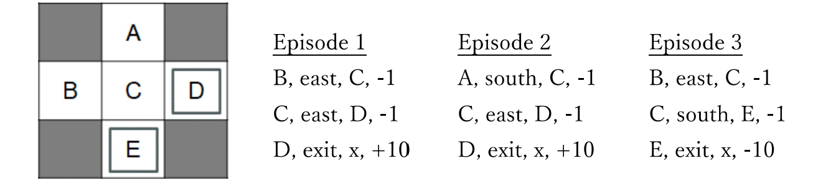
[25.8] (2)
In the context of Q-learning, suppose N(s, a) represents the number of executions of action a at state s. Write the exploration function using N(s, a), and write the equation to update the Q-value using that exploration function.
[25.8] (3)
Explain the difference between on-policy learning and off-policy learning. Make your own example and use it for the explanation.

[23.2] (2)
Explain the difference between Markov decision processes (MDPs) and reinforcement learning using terms “model,” “exploration,” and “regret.”
[20.8] (4)
Explain “exploration” and “exploitation” in reinforcement-learning using terms “ε-greedy method,” “exploration functions,” and “regret.”
[23.8] (4)
In which cases should we choose reinforcement learning among various machine-learning methods, and when should we not choose reinforcement learning? Discuss it with reference to a few concrete example applications. You need to at least include arguments about “training data,” “generalization,” and “regret” in your discussion.

[25.8] (4)
Discuss the pros and cons of using reinforcement learning for the self-driving of cars. You need to include at least arguments about “performance,” “exploration,” and “reward” in your discussion.
[20.8] (5)
Make your own example about the use of reinforcement learning for a problem with a large state-space, and then discuss how you should generalize the states to apply approximate Q-learning in order to enable efficient reinforcement learning.

