[確率的推論]
[24.8] (1) “joint probability distributions,” “marginal distributions,” “inference by enumeration,” “Gibbs sampling,” and “decision networks.”
[22.8] (1)“marginal distributions,” “posterior probability,” “events,” “independence,” and “inference by enumeration.”
[19.8] (1)“uncertainty,” “conditional independence,” “inference by enumeration,” “Bayes rule,” and “Markov property.”

[24.8] (2)
Below are the probabilistic distributions about the four random variables, X, Y, Z, and W.
Draw a Bayesian network for these four variables. And, calculate (P(W|Y=+y)).
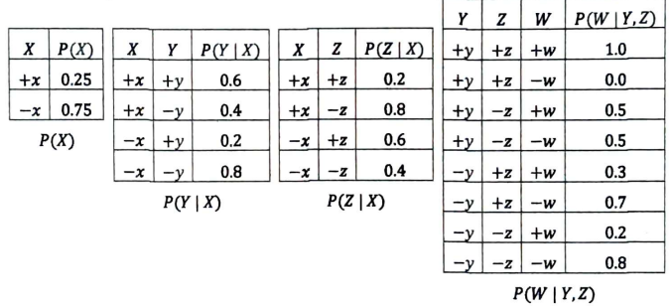
[24.8] (3)
Give all the conditional independence of the above Bayesian network.
[22.8] (2)
Describe an example of a Bayes’ net having three nodes, and use it to explain what a “conditional independence” is.
[22.8] (4)
Explain the merits of Bayes’ net using terms “causality,” “simplification,” “joint probability distribution,” and “learning.”

[24.8] (4)
In which cases should we use sampling for probabilistic inference for Bayesian network, and when should we not use sampling?
Discuss it with reference to a few concrete example applications.
[22.8] (5)
For probabilistic inference in Bayes’ nets, discuss when we should choose “variable elimination,” and when we should choose “sampling.”

[22.8] (3)
Describe an example of a decision network, and use it to explain what a “VPI (value of perfect information)” is.

[19.8] (2)
Explain what a “Hidden Markov Model” is.
Explain how it differs from a “Markov Model.”
Make your own example and use it for the explanation.

[19.8] (3)
Describe the “particle filtering” algorithm.

[19.8] (4)
Among various problems in Artificial Intelligence (for example, computer chess, map coloring, speech recognition, self-localization, and so on), in general, when should we select probabilistic reasoning techniques?
Discuss it with reference to a few example problems.
Make clear what condition(s) need(s) to be satisfied in order for reasoning to be possible.

