CHAPTER FOUR: SYSTEM DESIGN

4.0 Introduction
This chapter outlines the design of the proposed web-based Expense Management System for Great Zimbabwe University (GZU). The design process converts the requirements identified in Chapter Three into models and specifications that will guide system development. It covers functional and data modeling, system workflows, interface layouts, and security mechanisms. The design approach is informed by established practices in automating financial systems (Becker, Kugeler, & Rosemann, 2020; Gandhi & Singh, 2019).

4.1 Functional Modeling
Functional modeling illustrates how the system will handle information and interact with its users.

4.1.1 Context Diagram (Proposed System)
External Entities:
- Staff Member
- Department Head
- Dean’s Office
- Finance/Bursary Office
- Audit Office
System Process:
- Web-based Expense Management System
Data Flows:
- Staff submit expense requests and upload receipts.
- Department Head reviews and approves or rejects requests.
- Dean provides secondary approval or rejection.
- Finance Office verifies requests, authorizes payments, and updates budget records.
- Audit Office accesses reports and audit logs for compliance checks.
Outputs:
- Notifications on request status.
- Financial and audit reports.
- Real-time summaries of departmental budgets.
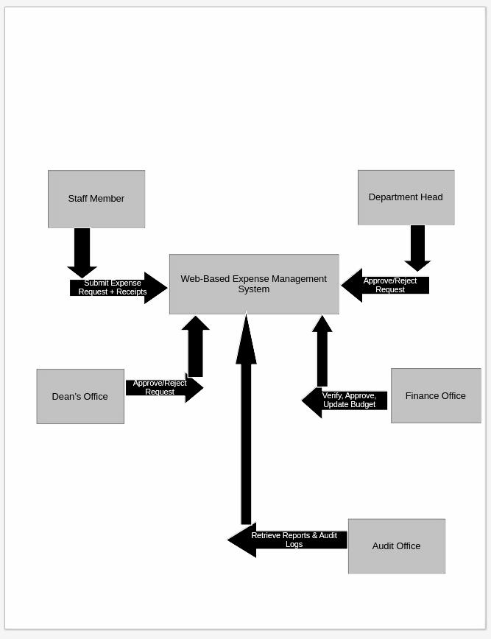

Figure 4.1: Context Diagram of the Proposed Web-Based Expense Management System
This digital workflow replaces paper-based processes, minimizing delays and reducing errors (Heeks, 2018).

4.1.2 Data Flow Diagram (DFD)
Level 0 (Overview):
- Central process: “Expense Management System.”
- Accepts requests, routes approvals, updates budgets, and generates reports.
Level 1 (Detailed):
- Request submission and receipt upload.
- Department Head approval with staff notification.
- Dean’s approval with staff notification.
- Finance verification and budget update.
- Report generation for auditing.
DFDs provide a clear picture of process flows and highlight data storage requirements (Silaen & Sitorus, 2022).

4.2 System Modeling

4.2.1 System Flowchart
The system flow follows these steps:
- User login
- Expense request submission
- Department Head approval
- Dean approval
- Finance verification
- Database update
- Notifications and report generation
Flowcharts simplify system logic and assist developers during implementation (Kumari & Gupta, 2021).

4.2.2 Entity Relationship Diagram (ERD)
Entities:
- User (Staff, Head, Dean, Finance)
- Expense Request
- Receipt
- Department
- Approval Status
- Budget
Relationships:
- Users create expense requests.
- Each request is linked to receipts.
- Requests are associated with departments.
- Requests carry approval status.
The ERD supports efficient database design for storing and retrieving financial records (Uyar & Kuzey, 2019).

4.2.3 Class Diagram
Classes:
- User: userID, name, role, email, password
- ExpenseRequest: requestID, date, amount, description, status
- Receipt: receiptID, filePath, expenseID
- Approval: approvalID, approverID, status, date
- Department: departmentID, name, budget
Class diagrams define the structure and relationships in object-oriented design (Becker et al., 2020).

4.2.4 Use Case Diagram
Actors: Staff, Department Head, Dean, Finance Officer
Use Cases:
- Submit expense request
- Upload receipts
- Approve or reject requests
- Track request status
- Generate reports
- Monitor budgets
Use cases clarify system functionality and user interactions (Gandhi & Singh, 2019).

4.3 Database and File Design
Database: MySQL
Tables:
- Users (userID, name, role, email, password)
- Expenses (expenseID, userID, departmentID, date, amount, description, status)
- Receipts (receiptID, expenseID, filePath)
- Approvals (approvalID, expenseID, approverID, date, status)
- Departments (departmentID, name, budget)
Centralized storage improves traceability and strengthens accountability (Mawere & Migiro, 2018).

4.4 Input/Output Design
Forms/Interfaces:
- Expense Request Form with fields for amount, description, department, and receipt upload.
- Approval Interface displaying pending requests with action options.
- Dashboard showing request status, departmental budgets, and summary reports.
Dialogue:
- Pop-up alerts for approvals or rejections.
- Confirmation messages for successful submissions.
Reports:
- Monthly and quarterly expense reports.
- Departmental budget reports.
- Audit trail reports.
Well-structured interfaces reduce user mistakes and enhance usability (Kumari & Gupta, 2021).

4.5 Security Design
- Role-based access control for staff, heads, deans, and finance officers.
- Password hashing and secure authentication.
- Encrypted communication via HTTPS.
- Backup and restore procedures.
- Activity logging for all transactions.
These measures safeguard financial data and prevent unauthorized access (Heeks, 2018; Silaen & Sitorus, 2022).

4.6 Process Specification
Processes:
- User authentication
- Request submission
- Approval routing
- Receipt upload
- Budget update
- Report generation
Each process is defined to guide coding and testing (Becker et al., 2020).

4.7 Conclusion
This chapter presented the design of the web-based Expense Management System for GZU. It included functional models, DFDs, ERDs, class diagrams, use cases, database design, interfaces, and security specifications. Together, these elements provide a blueprint for coding, testing, and implementation.

REFERENCES
Becker, J., Kugeler, M., & Rosemann, M. (2020). Process management: A guide for the design of business processes. Springer.
Gandhi, S., & Singh, S. (2019). Automation of financial processes in higher education institutions. International Journal of Information Systems and Management, 8(3), 55–66.
Great Zimbabwe University. (2023). Annual financial report. GZU Press.
Heeks, R. (2018). Information systems and developing countries: Failure, success, and local improvisations. Routledge.
Kumari, S., & Gupta, P. (2021). Digital transformation of financial workflows using web-based systems. International Journal of Computer Applications, 175(12), 20–27.
Mawere, M., & Migiro, S. (2018). Financial management practices in Zimbabwean tertiary institutions. Southern African Journal of Accounting Research, 32(4), 212–226.
Silaen, P., & Sitorus, R. (2022). Web-based expense management systems: Improving transparency and accountability. Journal of Information Technology and Systems, 14(1), 77–89.
Uyar, A., & Kuzey, C. (2019). Accounting information systems in public universities: Implications for decision-making and accountability. Journal of Accounting and Organizational Change, 15(1), 123–139.

