QUOTES RECOMMENDATION CHATBOT USING NLP
Team : 240
CHAPTER 1
INTRODUCTION

In recent years, the rapid development of artificial intelligence and machine learning technologies has significantly transformed the way humans interact with computer systems. One of the most important applications of artificial intelligence is the development of conversational agents, commonly referred to as chatbots. Chatbots are computer programs designed to simulate human conversation and interact with users through text or voice. These systems are widely used in different industries such as customer support, education, healthcare, banking, and entertainment. By providing instant responses and automating repetitive tasks, chatbots improve efficiency and enhance user experience.
Natural Language Processing (NLP) plays a crucial role in enabling chatbots to understand human language. NLP is a branch of artificial intelligence that focuses on the interaction between computers and human language. It allows machines to process, analyse, and interpret natural language inputs provided by users. Through NLP techniques, chatbots are able to recognize user intentions, extract meaningful information from text, and generate appropriate responses. This capability makes conversational systems more interactive and user-friendly.
Motivational and inspirational quotes have always played an important role in influencing human thoughts and emotions. Quotes from successful individuals, philosophers, and leaders can inspire people to overcome challenges, stay focused on their goals, and maintain a positive mindset. In modern society, individuals frequently experience stress, anxiety, and lack of motivation due to academic pressure, professional responsibilities, and personal challenges. Access to motivational content can help individuals regain confidence and improve their emotional well-being.
Despite the availability of numerous websites and mobile applications that provide motivational quotes, users often need to manually search through large collections of content in order to find quotes that match their mood or interests. This manual process can be time-consuming and inefficient. Furthermore, traditional quote platforms generally provide static lists of quotes without considering the user’s context or intent. As a result, users may not receive the most relevant or meaningful quotes for their situation.
The integration of conversational AI with quote recommendation systems can significantly improve this experience. A chatbot capable of understanding user input and recommending appropriate quotes can provide users with a more interactive and personalized platform. Instead of browsing through multiple websites or applications, users can simply communicate with the chatbot using natural language and receive relevant motivational quotes instantly.
The Quotes Recommendation Chatbot using Natural Language Processing is designed to address this need. The system uses NLP techniques to analyse user messages and determine their intent. Based on the identified intent, the chatbot recommends quotes related to different themes such as motivation, inspiration, success, love, and humour. This approach allows the system to provide meaningful responses and deliver content that is relevant to the user’s request.
The chatbot is implemented using the Rasa framework, which is an open-source platform for building conversational AI applications. Rasa provides powerful tools for natural language understanding, intent classification, and dialogue management. By training the chatbot with sample conversations, the system learns to recognize different user queries and respond appropriately. In addition to the conversational engine, a Flask-based web application is used to create a simple and interactive user interface. The web interface allows users to communicate with the chatbot directly through a browser.
The development of this project demonstrates how artificial intelligence technologies can be applied to create intelligent recommendation systems. By combining natural language processing, machine learning techniques, and web technologies, the chatbot provides an efficient and engaging platform for delivering motivational content.
Another important advantage of chatbot-based systems is their accessibility and availability. Unlike traditional applications that require users to navigate complex interfaces, chatbots provide a simple conversational interface that is easy to use. Users can interact with the chatbot at any time and receive instant responses without requiring human intervention. This capability makes chatbot systems highly scalable and suitable for a wide range of applications.
Furthermore, conversational systems can improve user engagement by providing interactive communication. When users receive responses in a conversational format, they feel more connected to the system and are more likely to continue interacting with it. In the context of motivational content delivery, this interactive experience can encourage users to seek inspiration and maintain a positive outlook.
The Quotes Recommendation Chatbot represents an innovative approach to delivering inspirational content through conversational AI. By understanding user input and recommending appropriate quotes, the chatbot provides users with a personalized and convenient way to access motivational messages. This system demonstrates the potential of natural language processing technologies in enhancing digital communication and improving user experience.
The development of intelligent chatbot systems has gained significant attention in recent years due to their ability to provide automated assistance and personalized user interaction. In many applications, chatbots are used to answer queries, recommend products, and guide users through digital services. The proposed Quotes Recommendation Chatbot extends this concept by focusing on delivering motivational and inspirational content through an interactive conversational interface.
The significance of this project lies in its ability to combine natural language processing, conversational AI, and recommendation systems into a single platform. By understanding user input and providing relevant quotes, the chatbot helps users access motivational content in a faster and more convenient manner. This approach eliminates the need for users to manually search through large collections of quotes on websites or mobile applications.
Another important aspect of this project is its contribution to mental well-being and emotional support. In modern society, individuals often face stressful situations related to education, work, and personal life. Motivational quotes and positive affirmations can help individuals maintain a positive attitude and overcome challenges. By providing motivational messages through a conversational interface, the chatbot can serve as a small but meaningful source of encouragement for users.
In conclusion, the development of a chatbot capable of recommending motivational quotes highlights the growing importance of artificial intelligence in modern software systems. As conversational AI technologies continue to evolve, chatbots are expected to play an increasingly important role in providing automated assistance, personalized recommendations, and meaningful interactions between humans and machines.

CHAPTER 2
LITERATURE REVIEW

A literature review is an important step in any research or development project as it provides an understanding of the existing technologies, methodologies, and systems related to the proposed work. It helps identify the strengths and limitations of previous systems and provides insight into how new solutions can improve upon them. In the context of chatbot development and recommendation systems, various studies and technological advancements have contributed to the development of intelligent conversational agents.
Chatbots have been studied and developed for several decades. One of the earliest chatbot systems was ELIZA, developed by Joseph Weizenbaum in the 1960s. ELIZA used simple pattern matching and substitution techniques to simulate conversation with users. Although ELIZA was limited in its capabilities, it demonstrated the potential for machines to interact with humans through natural language. The system responded to user inputs based on predefined patterns and rules, which made the interaction appear conversational. However, ELIZA lacked true understanding of language and could only respond based on programmed rules.
Following ELIZA, several other chatbot systems were developed using rule-based approaches. These systems relied on large sets of predefined responses and keyword matching techniques. Rule-based chatbots are relatively simple to design and implement, but they have significant limitations. They are unable to handle complex conversations or understand variations in user input effectively. As a result, their responses may appear repetitive or irrelevant in certain situations.
With the advancement of artificial intelligence and machine learning technologies, modern chatbots have become significantly more sophisticated. Natural Language Processing (NLP) techniques allow chatbots to analyse user input, identify the underlying intent, and generate appropriate responses. NLP involves several processes such as tokenization, part-of-speech tagging, intent classification, and entity recognition. These techniques enable computers to interpret and process human language in a more meaningful way.
In recent years, various frameworks and platforms have been developed to facilitate the creation of intelligent chatbots. Some of the most widely used chatbot development platforms include Rasa, Dialog flow, Microsoft Bot Framework, and IBM Watson Assistant. These platforms provide tools for natural language understanding, dialogue management, and integration with web or mobile applications. Among these frameworks, Rasa has gained significant popularity due to its open-source nature, flexibility, and strong community support.
Rasa is a powerful conversational AI framework that allows developers to build context-aware chatbots using machine learning techniques. It consists of two main components: Rasa NLU and Rasa Core. Rasa NLU is responsible for understanding user input by identifying intents and extracting entities from the text. Rasa Core manages the dialogue flow and determines how the chatbot should respond based on the conversation context. By training the system with example conversations, developers can create chatbots capable of handling complex interactions.
Recommendation systems are another important area related to this project. Recommendation systems are designed to provide users with personalized suggestions based on their preferences, behaviour, or context. These systems are widely used in platforms such as e-commerce websites, streaming services, and social media applications. For example, platforms like Netflix and Amazon use recommendation algorithms to suggest movies or products that users may be interested in.
In the context of motivational content, recommendation systems can help users discover quotes that align with their emotional state or interests. However, many existing quote recommendation platforms rely on simple categorization methods rather than intelligent user interaction. Users are typically presented with lists of quotes grouped by themes such as motivation, love, or success. While this approach provides some level of organization, it does not offer a personalized or interactive experience.
Recent research has explored the integration of conversational AI with recommendation systems. Conversational recommendation systems allow users to express their preferences through natural language interaction. Instead of selecting categories manually, users can simply describe their needs or feelings, and the system can recommend appropriate content. This approach enhances user engagement and improves the overall user experience.
Several studies have also highlighted the importance of motivational content in promoting mental well-being. Motivational quotes and positive affirmations can help individuals maintain a positive mindset, improve self-confidence, and cope with stressful situations. In educational and professional environments, motivational messages are often used to encourage individuals to achieve their goals and remain focused on their objectives.
Despite these benefits, accessing relevant motivational content remains a challenge for many users. Traditional platforms do not provide interactive assistance or contextual understanding of user queries. As a result, users may need to search through multiple sources to find quotes that resonate with them.
The proposed Quotes Recommendation Chatbot using Natural Language Processing aims to address these limitations by integrating conversational AI with motivational content delivery. By using NLP techniques and the Rasa framework, the chatbot is capable of understanding user input and recommending relevant quotes in real time. This approach combines the advantages of chatbot technology and recommendation systems to create a more engaging and user-friendly platform.
Another important aspect of modern chatbot systems is the use of web-based interfaces to improve accessibility. Web technologies such as HTML, CSS, and JavaScript enable developers to create interactive user interfaces that allow users to communicate with the chatbot easily. By integrating the chatbot with a Flask-based web server, the system can be accessed through any standard web browser without requiring specialized software.
In summary, the literature review highlights the evolution of chatbot technology from simple rule-based systems to advanced conversational AI platforms powered by natural language processing and machine learning. It also emphasizes the potential of conversational recommendation systems in improving user engagement and providing personalized content. The proposed chatbot system builds upon these advancements by combining NLP techniques, chatbot frameworks, and web technologies to deliver motivational quotes through an interactive conversational interface.
The insights gained from previous research and existing systems provide a strong foundation for the development of the proposed chatbot. By addressing the limitations of traditional quote platforms and incorporating modern AI technologies, the system aims to provide a more efficient, personalized, and engaging experience for users seeking motivational content.

CHAPTER 3
PROBLEM STATEMENT

In the modern digital era, individuals are constantly exposed to various forms of stress and pressure arising from academic responsibilities, professional commitments, and personal challenges. Maintaining motivation and a positive mindset has become increasingly important for individuals striving to achieve their goals and maintain emotional well-being. Motivational and inspirational quotes have long been recognized as powerful tools that can encourage individuals, boost confidence, and promote a positive outlook toward life.
Despite the widespread availability of motivational content on the internet, accessing relevant quotes that match a user's emotional state or interest can still be challenging. Most users rely on traditional methods such as searching through websites, reading blogs, or browsing social media platforms to find inspirational quotes. These methods require users to manually search through large volumes of content, which can be time-consuming and inefficient. Furthermore, many existing platforms present quotes in static lists or collections without considering the specific needs or intentions of the user.
Another limitation of traditional quote platforms is the lack of personalization and interaction. Users are often required to navigate through multiple categories such as motivation, success, love, or happiness in order to find quotes that are meaningful to them. Even after selecting a category, users may still need to scroll through numerous quotes before finding one that resonates with their current emotional state or situation. This process can reduce user engagement and make the experience less effective.
In addition, many existing systems do not provide a conversational interface that allows users to express their needs in natural language. Most quote websites rely on basic search functions or fixed categories rather than intelligent interaction. As a result, the system cannot interpret user input in a meaningful way or provide responses that are tailored to the user's request. This lack of interaction limits the potential of digital platforms to deliver motivational content in a more engaging and user-friendly manner.
With the advancement of artificial intelligence and natural language processing technologies, it is now possible to develop intelligent systems that can understand human language and respond accordingly. Chatbots equipped with natural language processing capabilities can interpret user queries, identify the intent behind the input, and generate appropriate responses. By leveraging these technologies, it is possible to create a system that allows users to request motivational quotes through natural conversation rather than manual searching.
The absence of such intelligent systems for motivational quote recommendation highlights the need for a more interactive and efficient solution. A chatbot capable of understanding user input and recommending relevant quotes can significantly improve the user experience. Instead of browsing multiple websites or applications, users can simply communicate with the chatbot and receive inspirational messages instantly.
Another challenge addressed by this project is the integration of different technologies required to build a complete conversational system. Developing a chatbot involves multiple components such as natural language understanding, dialogue management, data processing, and user interface design. Coordinating these components effectively is essential for ensuring that the system functions smoothly and provides meaningful responses to users.
The proposed Quotes Recommendation Chatbot using Natural Language Processing aims to address these challenges by creating an intelligent conversational system that can recommend motivational quotes based on user input. The system utilizes NLP techniques to analyse user queries and classify them into different categories such as motivation, inspiration, success, humour, or love. Based on the detected intent, the chatbot retrieves a relevant quote and presents it to the user through a conversational interface.
Furthermore, the development of this chatbot demonstrates how conversational AI technologies can be applied to create intelligent recommendation systems. The integration of NLP techniques with a web-based interface allows the system to provide real-time responses and maintain smooth interaction with users. This project highlights the potential of artificial intelligence in enhancing digital platforms and providing innovative solutions to everyday problems.
In summary, the primary problem addressed in this project is the lack of an intelligent, interactive system capable of recommending motivational quotes based on user input. Traditional platforms rely on manual browsing and static content delivery, which limits their effectiveness and usability. The proposed chatbot system seeks to overcome these limitations by using natural language processing to understand user queries and deliver relevant motivational quotes through a conversational interface.

CHAPTER 4
OBJECTIVES OF THE PROJECT

The development of intelligent software systems requires clearly defined goals and objectives that guide the design, implementation, and evaluation of the system. Objectives help in determining what the project aims to achieve and how the proposed system will address the identified problem. In the case of the Quotes Recommendation Chatbot using Natural Language Processing, the primary objective is to create an intelligent conversational system that can recommend motivational quotes to users through natural language interaction.
The project aims to utilize modern artificial intelligence technologies to improve the way users access inspirational content. By integrating natural language processing techniques with a conversational interface, the system seeks to provide an interactive platform where users can request motivational quotes and receive relevant responses instantly. The objectives of this project focus on developing a functional, efficient, and user-friendly chatbot system.
One of the main objectives of this project is to design and develop a chatbot that can understand user queries expressed in natural language. Unlike traditional search-based systems, the chatbot should be capable of interpreting user input and identifying the intention behind the message. This capability is achieved through natural language processing techniques that allow the system to analyse text, identify patterns, and classify user queries into predefined categories.
Another important objective of the project is to implement an intent classification mechanism that enables the chatbot to recognize different types of user requests. For example, users may ask for motivational quotes, inspirational messages, success-related quotes, humorous quotes, or quotes related to love and relationships. The chatbot must be trained using sample user inputs so that it can correctly identify the user's intent and respond with appropriate quotes. Accurate intent classification is essential for ensuring that the chatbot provides relevant responses and maintains meaningful conversations with users.
The project also aims to develop a structured database or collection of quotes that are categorized based on themes such as motivation, inspiration, success, love, and humour. Organizing quotes into different categories helps the chatbot retrieve relevant quotes quickly after identifying the user’s intent. This structure improves the efficiency of the recommendation process and ensures that users receive content that aligns with their interests or emotional needs.
Another objective of this project is to integrate the chatbot with a web-based user interface that allows users to interact with the system easily. The interface should be simple, responsive, and user-friendly so that individuals with different levels of technical knowledge can communicate with the chatbot without difficulty. The web interface allows users to type their messages and receive chatbot responses in real time, creating an interactive conversational experience.
The project also aims to implement the chatbot using modern development frameworks and technologies. The Rasa conversational AI framework is used to handle natural language understanding and dialogue management. Rasa allows developers to train chatbot models using sample conversations and define rules that guide the flow of interactions. In addition to Rasa, the Flask web framework is used to create the backend server that connects the chatbot engine with the web interface. These technologies provide a flexible and scalable environment for developing intelligent conversational systems.
Another objective of the project is to demonstrate the practical application of natural language processing techniques in real-world software systems. NLP plays a crucial role in enabling machines to interpret human language and generate meaningful responses. Through this project, the implementation of NLP techniques such as intent recognition and text processing can be explored in detail. This provides valuable insights into how conversational AI systems function and how they can be applied in different domains.
Improving user engagement is another important objective of the proposed system. Traditional quote websites often provide static content that does not involve interactive communication. In contrast, the chatbot system allows users to engage in natural conversations with the system. This interactive approach enhances user experience and encourages users to explore different types of motivational content through conversation.
The project also aims to create a system that is accessible and available at any time. Since the chatbot operates through a web interface, users can access it from any device with an internet connection and a web browser. This ensures that users can receive motivational quotes whenever they need encouragement or inspiration. The availability of such a system can contribute to improving the accessibility of motivational content for a wide range of users.
Furthermore, the development of this chatbot serves as an educational and practical learning experience in the fields of artificial intelligence, natural language processing, and web application development. Through the process of designing and implementing the chatbot, developers gain practical knowledge of how conversational AI systems are built and how different technologies can be integrated to create functional applications.
In addition to the primary objectives, another goal of this project is to ensure that the chatbot system remains scalable and adaptable for future enhancements. As technology evolves, conversational AI systems are expected to support more advanced capabilities such as sentiment analysis, voice interaction, and personalized recommendations. By designing the chatbot using flexible frameworks like Rasa and Flask, the system can be easily extended to incorporate new features in the future. This adaptability makes the project more valuable from both a research and development perspective.
Another objective is to ensure that the chatbot provides responses in a clear and meaningful manner. The quality of responses generated by a chatbot directly affects user satisfaction and engagement. Therefore, the system must be designed to deliver quotes that are relevant, understandable, and motivational. The responses should maintain a conversational tone so that users feel comfortable interacting with the chatbot. Ensuring clarity and relevance in responses improves the overall effectiveness of the system.
Finally, the project aims to highlight the growing importance of conversational interfaces in modern digital systems. As users increasingly prefer natural and intuitive interaction methods, chatbots are becoming an essential component of many online platforms. The Quotes Recommendation Chatbot represents a practical example of how conversational interfaces can be used to deliver meaningful content and enhance user interaction. Through the successful implementation of this system, the project showcases the potential of artificial intelligence technologies in improving the accessibility and delivery of motivational information.
In summary, the objectives of the Quotes Recommendation Chatbot project focus on developing an intelligent, interactive, and user-friendly system that can recommend motivational quotes based on user input. The project aims to combine natural language processing techniques, conversational AI frameworks, and web technologies to create an efficient platform for delivering inspirational content. By achieving these objectives, the system demonstrates the potential of artificial intelligence in enhancing digital communication and providing innovative solutions that improve user experience and accessibility.

CHAPTER 5
SYSTEM REQUIREMENTS

System requirements define the essential conditions and capabilities that must be satisfied for a system to function properly. They describe the functionalities that the system should perform as well as the constraints under which it operates. Identifying system requirements is an important step in the software development process because it helps developers understand the needs of users and ensures that the final system performs its intended tasks effectively.
For the Quotes Recommendation Chatbot using Natural Language Processing, system requirements are categorized into two main types: functional requirements and non-functional requirements. Functional requirements describe the specific features and operations that the system must perform, while non-functional requirements focus on the quality attributes and performance characteristics of the system.
The system requirements of this project have been defined based on the objective of creating an intelligent chatbot capable of understanding user queries and recommending motivational quotes through a conversational interface.

5.1 Functional Requirements
Functional requirements describe the specific functionalities that the chatbot system must provide in order to achieve its objectives. These requirements focus on the operations performed by the system when interacting with users.
One of the primary functional requirements of the system is the ability to accept user input through a web interface. The chatbot must allow users to enter messages in natural language through a text-based interface. This interface should be accessible through a web browser and provide a simple environment for user interaction.
Another important functional requirement is the processing of user input using natural language processing techniques. Once the user submits a message, the system must analyse the input text in order to understand its meaning. The chatbot uses NLP techniques to identify keywords, analyse sentence structure, and determine the intent behind the user’s message.
The system must also be capable of intent recognition. Intent recognition refers to the ability of the chatbot to determine the purpose of a user's query. For example, a user may ask for motivational quotes, inspirational messages, humorous quotes, or quotes related to success or love. The chatbot must classify the user input into one of these predefined categories so that it can generate an appropriate response.
Another essential functionality is quote retrieval and recommendation. After identifying the user's intent, the chatbot should retrieve a relevant quote from the database or dataset associated with the corresponding category. The system should then display the selected quote to the user as a response.
The chatbot must also provide real-time responses. Once the system processes the user query and identifies the appropriate quote, it should deliver the response instantly. Real-time interaction ensures that the conversation between the user and the chatbot remains smooth and engaging.
In addition, the system must support continuous conversation with users. The chatbot should allow users to send multiple queries during a single interaction session. Each new query should be processed independently while maintaining a conversational flow.
Another functional requirement is the integration of the chatbot engine with the web application. The backend server, implemented using the Flask framework, must connect the web interface with the Rasa chatbot engine. This integration allows the system to process user input and generate responses through the conversational AI model.
Furthermore, the system should allow easy training and updating of the chatbot model. Developers should be able to update training data files and retrain the chatbot to improve its ability to recognize new queries or categories. This functionality ensures that the chatbot can evolve and improve over time.

5.2 Non-Functional Requirements
Non-functional requirements describe the quality attributes and performance characteristics of the system. These requirements ensure that the system operates efficiently, reliably, and securely.
One of the most important non-functional requirements is system usability. The chatbot interface should be simple and easy to use so that users can interact with it without requiring technical knowledge. A clean and intuitive interface improves the overall user experience and encourages users to interact with the system more frequently.
Another key requirement is system performance. The chatbot should be capable of processing user queries quickly and generating responses with minimal delay. Fast response time is essential for maintaining a natural conversational experience. If the system takes too long to respond, users may lose interest in interacting with the chatbot.
System reliability is another important non-functional requirement. The chatbot should function consistently without crashes or unexpected errors. It should be able to handle multiple user queries and maintain stable performance during operation.
The system must also ensure accuracy in intent recognition. The natural language processing model should correctly classify user queries into appropriate categories. Accurate intent detection ensures that the chatbot provides relevant and meaningful responses to users.
Another requirement is scalability. The system should be designed in a way that allows future expansion and improvements. For example, additional quote categories, advanced NLP techniques, or new features such as voice interaction could be added in the future without requiring major modifications to the system architecture.
Accessibility is also an important factor in the design of the system. Since the chatbot is implemented as a web-based application, it should be accessible through standard web browsers on different devices such as laptops, tablets, and smartphones. This ensures that users can interact with the chatbot from various platforms.
Finally, maintainability is an essential non-functional requirement. The system should be designed with clear code structure and modular components so that developers can easily update or modify the system when necessary. Maintainable systems are easier to debug, improve, and expand over time.
In conclusion, defining system requirements helps ensure that the Quotes Recommendation Chatbot is designed and developed in a structured and efficient manner. Functional requirements describe the essential features of the chatbot, such as user interaction, intent recognition, and quote recommendation. Non-functional requirements focus on performance, usability, reliability, and scalability.

CHAPTER 6
SYSTEM ARCHITECTURE

System architecture describes the overall structure and organization of a software system. It defines how different components of the system interact with each other in order to perform the required tasks. A well-designed system architecture ensures that the system operates efficiently, maintains stability, and allows for future expansion or modification.
The Quotes Recommendation Chatbot using Natural Language Processing is designed using a modular architecture that integrates several components such as the user interface, web server, natural language processing engine, and the quote database. Each component plays a specific role in processing user input and generating appropriate responses. The architecture ensures smooth communication between these components so that the chatbot can function effectively.
The system follows a client-server architecture in which the user interacts with the chatbot through a web interface. The web interface sends user queries to the backend server, which processes the input using the natural language processing model and returns an appropriate response. This architecture allows the chatbot system to handle user interactions efficiently and maintain real-time communication.
The main components of the system architecture include the User Interface, Web Server, Natural Language Processing Engine, and Quote Dataset. These components work together to provide a seamless conversational experience for users.
The User Interface serves as the front-end component of the chatbot system. It is developed using web technologies such as HTML, CSS, and JavaScript. The user interface allows users to interact with the chatbot by typing messages in a chat window. When a user enters a message, the interface sends the input to the backend server for processing. The design of the interface is simple and user-friendly so that users can easily communicate with the chatbot without requiring technical knowledge.
The Web Server acts as an intermediary between the user interface and the chatbot engine. In this project, the web server is implemented using the Flask framework in Python. Flask is a lightweight web framework that enables developers to create web applications and manage server-side operations. When the user submits a message through the interface, the Flask server receives the request and forwards it to the chatbot engine for processing. Once the chatbot generates a response, the server sends the response back to the user interface.
The Natural Language Processing Engine is the core component of the chatbot system. It is responsible for analysing user input and determining the appropriate response. In this project, the Rasa framework is used to implement the natural language processing engine. Rasa provides tools for intent classification, entity recognition, and dialogue management. When a user message is received, the Rasa model processes the input text and identifies the intent behind the query. Based on the identified intent, the chatbot selects an appropriate response.
Another important component of the system architecture is the Quote Dataset or Knowledge Base. This dataset contains a collection of motivational and inspirational quotes organized into different categories. These categories may include motivation, success, love, humour, and inspiration. When the chatbot identifies the user's intent, it retrieves a relevant quote from the corresponding category in the dataset. The selected quote is then delivered to the user as the chatbot’s response.
The system architecture also includes training data and configuration files that help the chatbot understand user queries. Training data is stored in files such as nlu.yml, stories.yml, and rules.yml. These files contain examples of user inputs and conversation patterns that help train the chatbot model. During the training process, the chatbot learns how to recognize different types of queries and respond appropriately.
The workflow of the system follows a sequence of steps that ensure smooth communication between the components. First, the user enters a message in the chatbot interface. The message is sent to the Flask server through an HTTP request. The Flask server then forwards the message to the Rasa chatbot engine for analysis. The NLP engine processes the message, identifies the intent, and selects an appropriate response based on the trained model and dataset. Finally, the response is sent back through the Flask server to the user interface, where it is displayed to the user.
Another advantage of the chosen system architecture is its flexibility and scalability. Since the system is built using modular components, each component can be improved or replaced independently without affecting the entire system. For example, the quote dataset can be expanded to include additional categories, or the NLP model can be retrained with more data to improve accuracy. Similarly, the web interface can be enhanced with additional features such as voice input or graphical elements.
The architecture also ensures efficient communication between the frontend and backend components. By using web-based technologies and server communication protocols, the system can process user queries quickly and return responses in real time. This responsiveness is essential for maintaining a smooth conversational experience.
Security and reliability are also considered in the system architecture. The server is designed to handle multiple user requests and maintain stable performance during interactions. Proper handling of user input ensures that the system processes queries correctly and prevents errors or unexpected behaviour.
Another important aspect of the system architecture is its ability to support efficient communication between different modules of the system. Each component performs a specific function, and their interaction ensures that the entire system operates smoothly. The modular design allows developers to easily identify and resolve issues within individual components without affecting the rest of the system. This improves the maintainability of the chatbot and makes it easier to update or enhance specific parts of the application in the future.
Moreover, the architecture of the Quotes Recommendation Chatbot is designed to support future improvements and technological advancements. Additional features such as sentiment analysis, voice-based interaction, or personalized recommendation algorithms can be integrated into the system with minimal modifications. This flexibility ensures that the system remains adaptable to new requirements and emerging technologies in the field of conversational artificial intelligence. As chatbot technology continues to evolve, the system architecture provides a strong foundation for implementing more advanced capabilities and improving the overall user experience.
In conclusion, the system architecture of the Quotes Recommendation Chatbot provides a structured framework that integrates multiple components to deliver an intelligent conversational system. The combination of a web-based interface, Flask server, Rasa NLP engine, and categorized quote dataset enables the chatbot to process user queries and provide relevant motivational quotes efficiently. This architecture ensures scalability, flexibility, and reliability, making it suitable for further improvements and future development of conversational AI applications.

CHAPTER 7
TECHNOLOGIES USED

The development of the Quotes Recommendation Chatbot using Natural Language Processing involves the integration of several software technologies and frameworks. These technologies work together to enable the chatbot to process user queries, understand natural language, and generate appropriate responses. Selecting appropriate technologies is an important step in the development process because it ensures that the system performs efficiently and provides a smooth user experience.
The main technologies used in this project include Python programming language, Rasa conversational AI framework, Flask web framework, HTML, CSS, JavaScript, and YAML configuration files. Each of these technologies plays a specific role in the design and implementation of the chatbot system.

Python
Python is the primary programming language used for developing the chatbot system. It is widely recognized for its simplicity, readability, and extensive support for artificial intelligence and machine learning applications. Python provides a large collection of libraries and frameworks that make it suitable for developing intelligent systems such as chatbots.
One of the main advantages of using Python is its strong support for natural language processing and machine learning technologies. Many AI frameworks, including Rasa, are built using Python. This makes Python an ideal choice for implementing the chatbot’s backend logic and integrating different components of the system. Additionally, Python’s easy syntax allows developers to quickly develop and maintain the chatbot application.

Rasa Framework
Rasa is an open-source conversational AI framework used for building intelligent chatbots and virtual assistants. It provides powerful tools for natural language understanding and dialogue management. Rasa allows developers to create chatbots that can understand user queries, recognize user intentions, and respond appropriately.
The Rasa framework consists of two major components: Rasa NLU (Natural Language Understanding) and Rasa Core. Rasa NLU is responsible for processing user input and identifying the intent behind the message. It uses machine learning models to classify user queries into predefined categories. Rasa Core manages the flow of conversation and determines how the chatbot should respond based on the conversation context.
Another advantage of using Rasa is its flexibility and customization capability. Developers can train the chatbot using custom datasets and define specific conversation rules to guide the interaction between the user and the chatbot. This makes Rasa a powerful framework for building intelligent conversational systems.

Flask Framework
Flask is a lightweight web framework for Python that is used to build web applications and APIs. In this project, Flask acts as the backend server that connects the chatbot engine with the web interface. When a user enters a message through the chatbot interface, the request is sent to the Flask server. The server then forwards the message to the Rasa chatbot engine for processing.
Flask is widely used because of its simplicity and flexibility. It allows developers to create web applications with minimal setup and provides easy integration with other Python libraries and frameworks. By using Flask, the chatbot can be accessed through a web browser, making it convenient for users to interact with the system.

HTML (HyperText Markup Language)
HTML is the standard markup language used to create the structure of web pages. In this project, HTML is used to design the layout of the chatbot interface. It defines the elements that appear on the webpage, such as the chat window, message input field, and response display area.
HTML provides the basic structure of the chatbot interface and ensures that the web page can be properly displayed in web browsers. The HTML components interact with CSS and JavaScript to create an interactive user interface.

CSS (Cascading Style Sheets)
CSS is used to control the visual appearance and styling of the web interface. It allows developers to design the layout, colours, fonts, and spacing of different elements on the webpage. In the chatbot system, CSS is used to style the chat window, buttons, and text elements so that the interface appears clean and visually appealing.
A well-designed user interface improves user experience and encourages users to interact with the chatbot more frequently. By using CSS, developers can create a responsive and attractive design for the chatbot interface.

JavaScript
JavaScript is a scripting language used to add interactivity and dynamic behaviour to web pages. In the chatbot system, JavaScript is used to manage communication between the user interface and the backend server.
When a user enters a message in the chat interface, JavaScript captures the input and sends it to the Flask server through an HTTP request. Once the server processes the message and returns a response, JavaScript displays the chatbot’s reply in the chat window. This process enables real-time interaction between the user and the chatbot.

YAML Configuration Files
YAML (YAML Ain’t Markup Language) is a human-readable data serialization format used for configuration files. In the Rasa framework, YAML files are used to define training data, conversation flows, and chatbot configuration settings.
Important YAML files used in the project include:
- nlu.yml – Contains training examples for different user intents.
- stories.yml – Defines example conversation flows between the user and the chatbot.
- rules.yml – Contains rules that guide the chatbot’s behavior in specific situations.
- domain.yml – Defines chatbot responses, intents, and actions.
These configuration files help the chatbot learn how to interpret user queries and generate appropriate responses.

In conclusion, the successful development of the Quotes Recommendation Chatbot depends on the integration of several modern technologies and frameworks. Python provides the foundation for implementing the chatbot logic, while Rasa enables natural language processing and conversational capabilities. Flask acts as the backend server that connects the chatbot with the web interface, and web technologies such as HTML, CSS, and JavaScript provide an interactive platform for user communication. YAML configuration files support the training and configuration of the chatbot model. Together, these technologies create a complete system capable of delivering motivational quotes through an intelligent conversational interface.
Another important advantage of the technologies used in this project is their compatibility and ease of integration. Python serves as the core programming language that connects different components such as the Rasa chatbot engine, Flask web server, and the frontend interface. Because these technologies are designed to work well together, developers can efficiently integrate them into a single system. This compatibility simplifies the development process and allows the chatbot to operate smoothly without complex configurations.
In addition, the use of open-source technologies provides flexibility and cost efficiency in the development of the chatbot system. Frameworks such as Rasa and Flask are freely available and supported by active developer communities. This allows developers to access extensive documentation, tutorials, and community support when building intelligent conversational systems. By utilizing open-source tools, the project demonstrates how advanced artificial intelligence applications can be developed using accessible and widely available technologies.

CHAPTER 8
IMPLEMENTATION AND METHODOLOGY

The implementation phase is one of the most important stages in the development of any software system. During this phase, the conceptual design and planned architecture of the system are transformed into a working application. The Quotes Recommendation Chatbot using Natural Language Processing was implemented using modern technologies such as Python, Rasa, Flask, and web development tools. The implementation process involved preparing training data, configuring the chatbot framework, developing the web interface, and integrating all components to create a complete conversational system.
The methodology adopted for this project follows a structured approach that includes system design, data preparation, model training, and deployment of the chatbot application. Each stage of the development process plays a crucial role in ensuring that the chatbot performs efficiently and provides meaningful responses to users.
The first step in the implementation process was project setup and environment configuration. In this stage, the required development tools and frameworks were installed. Python was used as the main programming language, and the Rasa framework was installed to build the conversational AI model. Additional libraries and dependencies were also installed to support the functionality of the chatbot system.
After setting up the development environment, the next step was preparing the training data for the chatbot. Training data is essential for enabling the chatbot to understand different types of user queries. In the Rasa framework, training data is stored in YAML files such as nlu.yml. This file contains examples of user messages associated with specific intents. For example, user queries such as “I need motivation” or “Give me an inspirational quote” may belong to the motivational intent category. By providing multiple examples of user queries for each category, the chatbot learns to identify user intentions more accurately.
Another important part of the implementation process was defining conversation rules and dialogue flows. These were defined using files such as rules.yml and stories.yml. The rules file specifies how the chatbot should respond in certain situations, while the stories file provides examples of conversation patterns between the user and the chatbot. These files help the chatbot understand how to maintain a conversation and generate appropriate responses based on the context of the interaction.
The domain configuration was another essential step in the implementation process. The domain.yml file defines important elements of the chatbot system such as intents, responses, and actions. It contains predefined responses that the chatbot can use when responding to user queries. For example, when a user asks for a motivational quote, the chatbot retrieves a quote from the corresponding category and presents it as a response.
After preparing the training data and configuration files, the chatbot model was trained using the Rasa training command. During the training process, the machine learning model analyses the training data and learns to recognize patterns in user input. The trained model is then used to classify user queries and determine the appropriate response during conversations.
Once the chatbot model was successfully trained, the next stage involved developing the web-based user interface. The user interface was created using HTML, CSS, and JavaScript. The interface includes a chat window where users can type messages and view the chatbot's responses. The design of the interface was kept simple and intuitive to ensure that users can easily interact with the chatbot.
The Flask web framework was used to connect the chatbot engine with the web interface. Flask acts as the backend server that handles communication between the frontend interface and the Rasa chatbot model. When a user enters a message in the chatbot interface, the message is sent to the Flask server. The server then forwards the message to the Rasa chatbot for processing. After analysing the user input, the chatbot generates a response, which is sent back through the Flask server to the user interface.
The final stage of the implementation process involved running and deploying the chatbot application. The chatbot was executed by running the Rasa server and the Flask application simultaneously. Once both components were active, users could access the chatbot through a web browser and interact with it in real time. The chatbot processes user queries and provides motivational quotes based on the detected intent.
In conclusion, the implementation methodology followed in this project ensured the successful development of the chatbot system. The structured approach involving environment setup, training data preparation, model training, web interface development, and system integration allowed the project to achieve its objectives.

CHAPTER 9
SCREENSHOTS

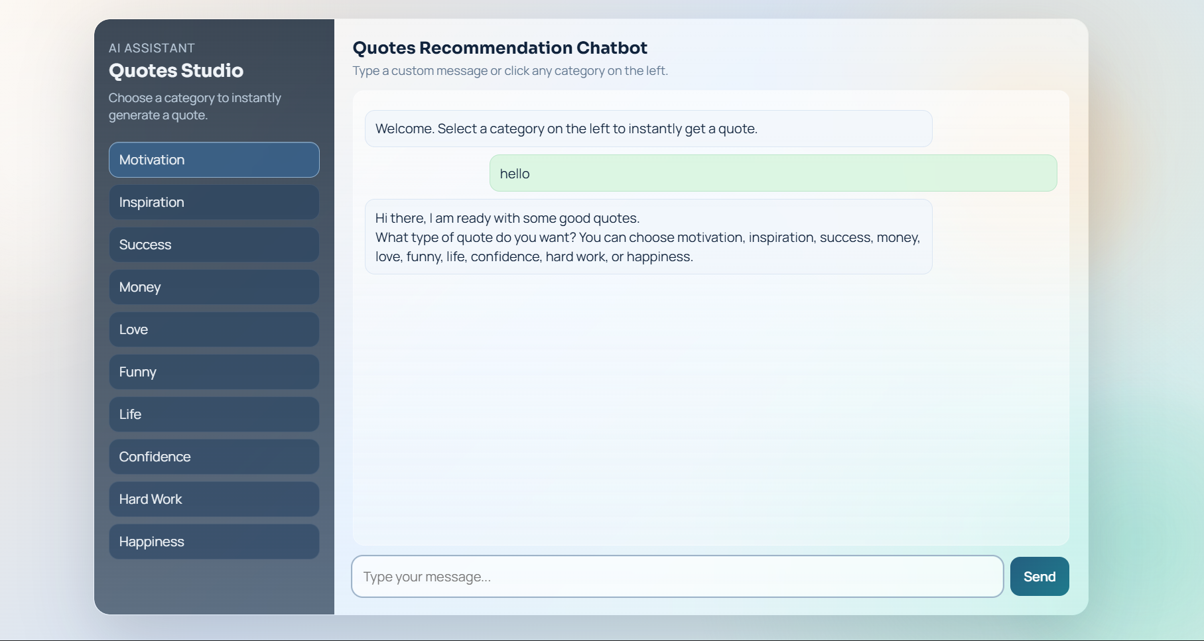
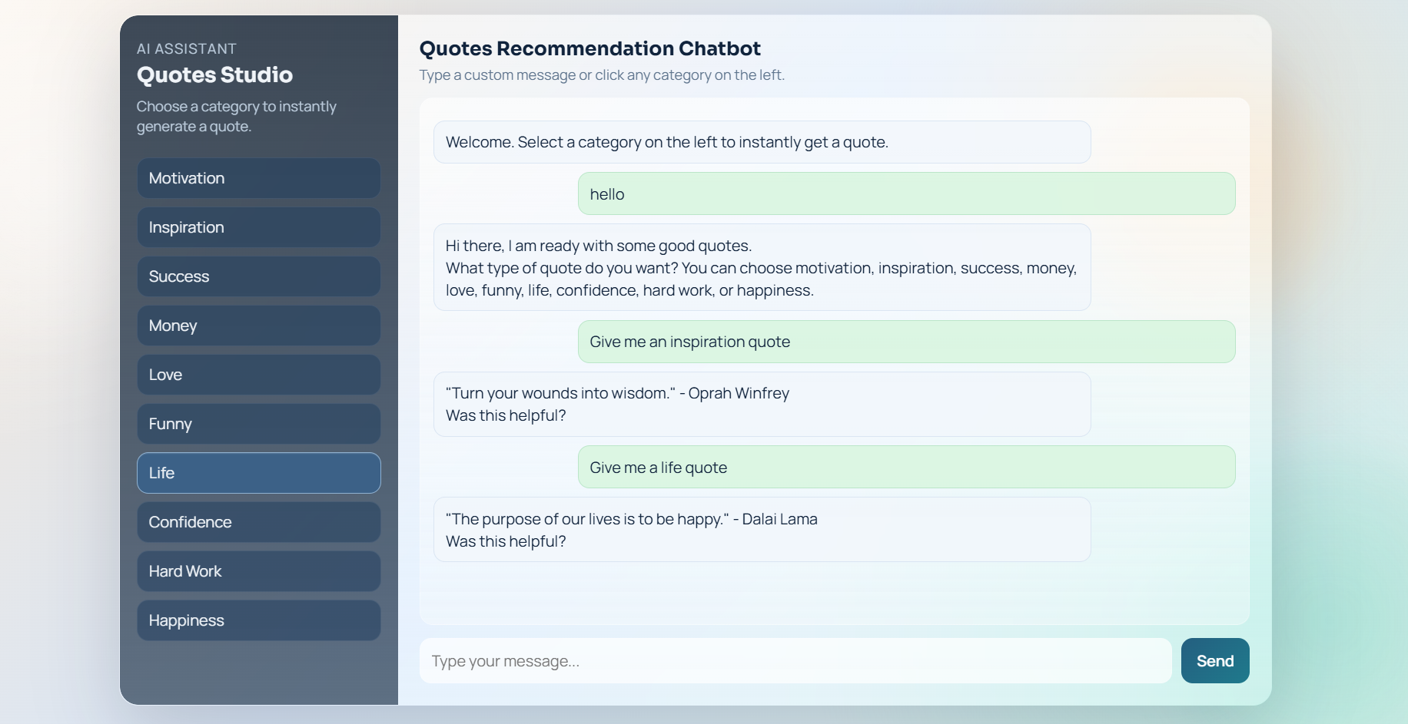
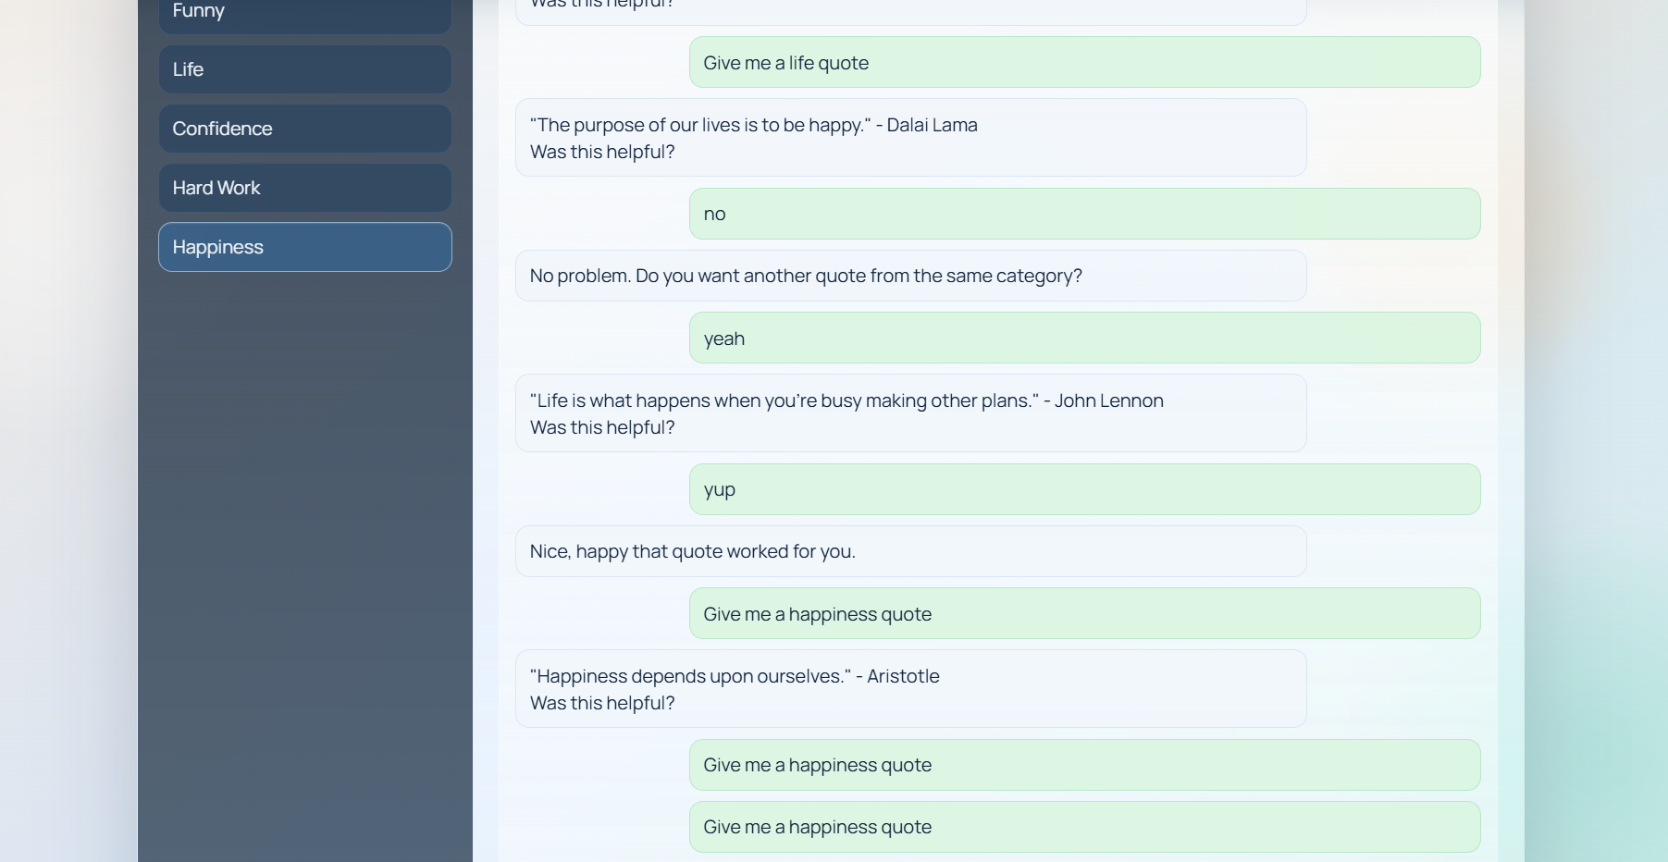

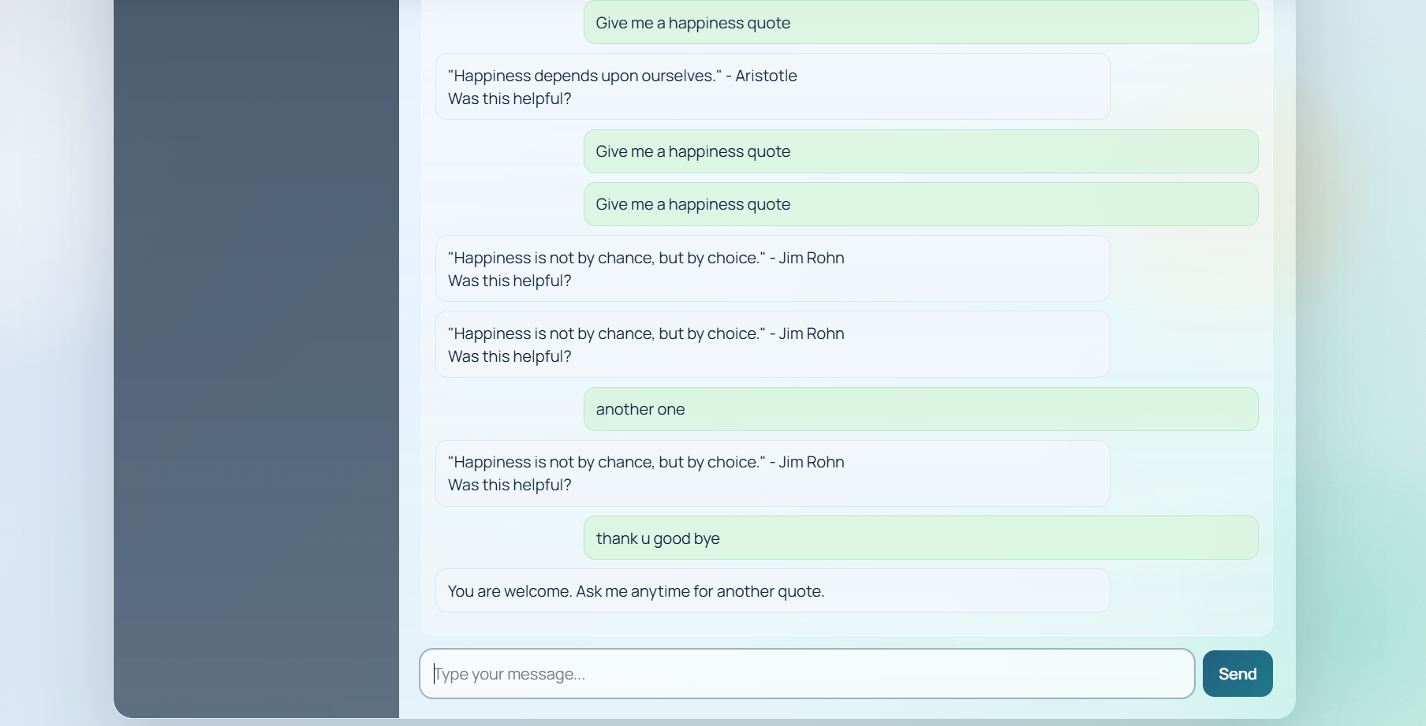

CHAPTER 10
TESTING AND EVALUATION

Testing is a crucial phase in the software development life cycle that ensures the developed system operates correctly and satisfies the specified requirements. It involves evaluating the functionality, performance, and reliability of the system in order to identify potential errors or issues. In the context of the Quotes Recommendation Chatbot using Natural Language Processing, testing was performed to ensure that the chatbot accurately understands user queries, correctly identifies user intent, and provides appropriate motivational quotes in response.
Since the chatbot system integrates multiple components such as the natural language processing model, the backend server, and the web interface, it is important to test each component individually as well as the overall system. Proper testing ensures that the chatbot can interact with users effectively and deliver relevant responses without errors or delays. The testing process for this project included several testing methods such as functional testing, intent recognition testing, interface testing, and performance testing.
Functional testing focuses on verifying that the system performs all the intended operations correctly. In this project, functional testing was conducted to ensure that the chatbot successfully accepts user input, processes the input using natural language processing techniques, identifies the correct intent, and returns an appropriate motivational quote. Various user queries were entered into the chatbot interface to test its functionality. Queries such as requests for motivational quotes, inspirational messages, and other related categories were used to verify the system’s behavior. The results indicated that the chatbot was able to process these queries and generate suitable responses based on the detected intent.
Intent recognition testing was performed to evaluate the accuracy of the natural language processing model used in the chatbot. Intent recognition is a critical component because it determines how the chatbot interprets user messages. During testing, different variations of user queries were provided to the chatbot in order to examine whether the system could correctly identify the intended category. For example, user inputs such as “Give me a motivational quote,” “I need inspiration,” and “Tell me something encouraging” were used to test the model. The chatbot successfully classified most queries into the appropriate categories, demonstrating that the trained model performs effectively in recognizing user intentions.
Interface testing was conducted to ensure that the chatbot’s web interface operates smoothly and provides a user-friendly environment for interaction. Since the chatbot is accessed through a browser-based interface, it is important that the interface elements function correctly. During testing, the chat window, message input field, and response display area were examined to ensure that they properly handle user input and display chatbot responses. The interface successfully allowed users to type messages and receive responses without technical issues. Additionally, the layout and design of the interface were checked to ensure that the interaction remains clear and visually organized.
Another important aspect of the testing process was performance testing. Performance testing evaluates the responsiveness and efficiency of the chatbot system when processing user queries. Since conversational systems are expected to respond quickly during interactions, it is important that the chatbot processes messages without noticeable delays. During performance testing, multiple queries were submitted to the system to observe response times. The chatbot processed the requests and generated responses within a short time period, demonstrating that the system performs efficiently under normal operating conditions.
In addition to these testing methods, overall system testing was also performed to verify that all components of the chatbot work together correctly. This included verifying the communication between the web interface, the Flask backend server, and the Rasa chatbot engine. When a user message is entered in the web interface, the message is sent to the Flask server, which forwards it to the Rasa model for processing. After the chatbot generates a response, the server sends the response back to the web interface for display. Testing confirmed that this communication process functions smoothly and that the chatbot system operates as an integrated application.
The results obtained during testing indicate that the Quotes Recommendation Chatbot performs effectively in understanding user queries and delivering relevant motivational quotes. The integration of natural language processing techniques with the web interface enables the system to provide a conversational experience for users. Although the system performs well for predefined intents and queries, additional improvements such as expanding the training dataset and incorporating advanced NLP models could further enhance its accuracy and conversational capabilities.
Overall, the testing and evaluation process confirms that the chatbot system meets its intended objectives and operates reliably. The chatbot successfully processes user input, recognizes user intent, and provides motivational quotes through a web-based interface. Through systematic testing, the functionality and performance of the system were verified, ensuring that the chatbot provides a stable and interactive platform for delivering inspirational content to users.

CHAPTER 11
RESULTS AND DISCUSSION

The results obtained from the development and testing of the Quotes Recommendation Chatbot using Natural Language Processing demonstrate that the system successfully achieves its intended objectives. The chatbot was designed to understand user queries expressed in natural language and recommend motivational quotes through an interactive conversational interface. The system integrates multiple components including the Rasa natural language processing engine, Flask backend server, and a web-based user interface. The implementation and evaluation of these components indicate that the chatbot performs effectively in providing motivational and inspirational quotes based on user input.
One of the major outcomes of this project is the successful implementation of a conversational interface that allows users to interact with the chatbot in a simple and intuitive manner. Users can type messages directly into the chatbot interface and receive responses instantly. The chatbot processes user queries using natural language processing techniques and identifies the intent behind each query. Once the intent is recognized, the chatbot retrieves an appropriate quote from the dataset and presents it to the user in the chat window. This process enables users to obtain motivational content quickly without the need to manually search through websites or applications.
The performance of the natural language processing model was also evaluated during the testing phase. The chatbot was trained using multiple examples of user queries associated with different intents. These intents include categories such as motivation, inspiration, success, love, and humour. During testing, the chatbot was able to correctly classify most user queries into their corresponding intent categories. This demonstrates that the trained model is capable of recognizing patterns in user input and responding appropriately.
Another important result of the project is the successful integration of the chatbot engine with the web-based interface. The Flask server acts as a bridge between the user interface and the Rasa chatbot model. When a user submits a query through the chat interface, the message is sent to the Flask server, which forwards it to the chatbot engine for processing. The response generated by the chatbot is then returned to the interface and displayed to the user. This communication process occurs in real time, allowing users to experience smooth and interactive conversations with the chatbot.
The chatbot system also demonstrates effective response generation based on predefined quote categories. Each category contains a collection of motivational or inspirational quotes that are delivered when the corresponding intent is detected. For example, when a user requests motivation, the chatbot selects a quote related to encouragement or determination. Similarly, when a user asks for inspiration, the system provides quotes that promote positivity and creativity. This structured approach ensures that the responses generated by the chatbot remain relevant to the user’s request.
The graphical interface of the chatbot also contributes to a positive user experience. The chat window provides a clear display of user messages and chatbot responses, allowing users to follow the conversation easily. The simple layout and responsive design make the interface accessible to users with varying levels of technical knowledge. Since the chatbot operates through a web browser, it can be accessed on different devices without requiring additional software installation.
During the evaluation process, the chatbot was tested using a variety of user inputs to observe how the system responds to different queries. The system successfully processed most of these queries and provided appropriate responses. This indicates that the chatbot performs well when interacting with users who request motivational content. However, certain complex or unexpected queries may not always produce accurate results, especially if they fall outside the predefined intent categories. Expanding the training dataset and incorporating more advanced natural language processing models could improve the chatbot’s ability to handle such queries in the future.
Another observation from the results is that the chatbot provides quick response times during interaction. Since the system processes user queries efficiently, responses are delivered almost immediately after the user submits a message. This fast response time enhances the conversational experience and makes the system more engaging for users.
Overall, the results of the project indicate that the Quotes Recommendation Chatbot successfully fulfils its intended purpose. The system effectively integrates natural language processing techniques, web technologies, and conversational AI frameworks to provide a platform where users can easily access motivational quotes. While the current implementation performs well for predefined categories and queries, future enhancements such as emotion detection, multilingual support, and voice interaction could further improve the capabilities of the chatbot system.
In conclusion, the results and discussion demonstrate that the chatbot provides an efficient and interactive solution for delivering motivational quotes. The successful implementation of the system highlights the potential of artificial intelligence and natural language processing technologies in creating intelligent conversational applications that enhance user experience and provide meaningful digital interactions.

CHAPTER 12
CONCLUSION

The Quotes Recommendation Chatbot using Natural Language Processing represents a practical implementation of conversational artificial intelligence designed to provide motivational and inspirational quotes through an interactive chatbot interface. The primary objective of the project was to develop an intelligent system capable of understanding user queries expressed in natural language and recommending relevant quotes based on the identified intent. The successful development and implementation of the chatbot demonstrate the effectiveness of combining natural language processing techniques with modern web technologies to create an interactive and user-friendly system.
Throughout the development process, various technologies and frameworks were utilized to build the chatbot system. The Rasa conversational AI framework was used for natural language understanding and intent classification, enabling the chatbot to interpret user queries accurately. Python served as the core programming language, while the Flask framework was used to establish communication between the chatbot engine and the web-based user interface. In addition, web development technologies such as HTML, CSS, and JavaScript were used to create a simple and accessible interface through which users could interact with the chatbot.
The implementation of the chatbot involved several stages including system design, preparation of training data, development of conversation rules, training of the NLP model, and integration of the chatbot with the web interface. The training data played a crucial role in enabling the chatbot to recognize different user intents such as motivation, inspiration, success, humour, and love. By analysing patterns in user input, the chatbot was able to classify queries and generate appropriate responses from the available quote dataset.
Testing and evaluation of the system confirmed that the chatbot performs effectively in processing user queries and delivering motivational quotes. The chatbot successfully accepts user input through the web interface, processes the input using natural language processing techniques, identifies the correct intent, and provides a suitable quote as a response. The system also demonstrated efficient response times, allowing users to interact with the chatbot smoothly and receive responses almost instantly.
The project highlights the importance of conversational AI in enhancing user interaction with digital systems. Instead of manually searching for quotes on websites or social media platforms, users can simply communicate with the chatbot using natural language and receive inspirational messages in real time. This interactive approach improves accessibility and provides a more engaging user experience compared to traditional quote platforms.
Another significant aspect of the project is the demonstration of how open-source technologies can be used to develop intelligent applications. The use of frameworks such as Rasa and Flask allowed the development of a flexible and scalable chatbot system without requiring proprietary tools or complex infrastructure. This demonstrates the potential of open-source platforms in supporting innovation and experimentation in the field of artificial intelligence.
Although the chatbot successfully fulfils its primary objectives, there is still room for further improvement. The current implementation relies on predefined intent categories and a fixed dataset of quotes. Expanding the dataset and incorporating advanced natural language processing models could further improve the chatbot’s ability to understand complex queries and provide more personalized responses.
In conclusion, the Quotes Recommendation Chatbot using Natural Language Processing successfully demonstrates how conversational AI can be applied to recommendation systems that deliver motivational and inspirational content. The integration of natural language processing techniques with a web-based interface enables the system to provide meaningful responses in a conversational format. The project not only fulfils its intended objectives but also provides a strong foundation for future enhancements and further research in the field of conversational AI and intelligent recommendation systems.

CHAPTER 13
FUTURE ENHANCEMENTS

Although the Quotes Recommendation Chatbot using Natural Language Processing successfully fulfils its primary objectives, there are several opportunities for further improvement and expansion. Future enhancements can significantly increase the intelligence, usability, and accessibility of the chatbot system. By incorporating advanced technologies and additional features, the chatbot can evolve into a more sophisticated conversational platform capable of delivering highly personalized and interactive experiences.
One possible enhancement is the integration of advanced emotion detection using natural language processing techniques. In the current implementation, the chatbot responds based on predefined intent categories such as motivation or inspiration. However, future versions of the system can incorporate sentiment analysis to detect the emotional state of the user, such as happiness, sadness, stress, or excitement. By analysing the sentiment of user messages, the chatbot can recommend quotes that more closely match the user's emotional condition, thereby improving the relevance and effectiveness of the responses.
Another important enhancement is the implementation of machine learning–based personalization. By storing user interaction history and analysing frequently requested quote categories, the system can learn user preferences over time. This adaptive approach allows the chatbot to recommend quotes that are tailored to individual users, making the system more personalized and engaging. Machine learning models can analyse patterns in user behaviour and continuously improve the quality of recommendations.
The chatbot can also be expanded to support multilingual communication. Currently, the system primarily operates in a single language, which may limit accessibility for users from diverse linguistic backgrounds. By integrating language detection and translation technologies, the chatbot can provide motivational quotes in multiple languages such as Hindi, Telugu, or other regional and international languages. This enhancement would make the chatbot more inclusive and accessible to a wider audience.
Another potential improvement is the introduction of voice-based interaction. Instead of typing messages, users could interact with the chatbot using voice commands. Speech recognition technology can convert spoken input into text, while text-to-speech systems can enable the chatbot to respond verbally. This feature would enhance accessibility, particularly for visually impaired users or individuals who prefer hands-free interaction.
Furthermore, the chatbot can be integrated with popular messaging and social media platforms such as WhatsApp, Telegram, or Facebook Messenger. Deploying the chatbot on widely used communication platforms would increase its reach and make it more convenient for users to access motivational quotes within the applications they use regularly.
Future versions of the system could also include dynamic quote recommendation through external APIs. Instead of relying only on static quotes stored in the system database, the chatbot could retrieve quotes from online quote APIs or external datasets. This would ensure greater variety and freshness in the responses, reducing repetition and making the chatbot more engaging for long-term use.
Additionally, implementing a user feedback and rating system would allow users to evaluate the relevance of the quotes they receive. This feedback could be used to refine the chatbot’s recommendation system and improve response accuracy over time. Collecting user feedback would also help developers identify areas for improvement and enhance the overall performance of the chatbot.
Finally, the chatbot system could benefit from cloud deployment and scalability improvements. Deploying the system on cloud platforms would allow it to handle a larger number of users simultaneously while ensuring high availability and performance. Advanced natural language processing models such as transformer-based architectures could also be integrated to improve intent recognition and conversational depth.
In conclusion, these future enhancements have the potential to transform the Quotes Recommendation Chatbot into a more intelligent, personalized, and scalable conversational system. By incorporating advanced AI technologies and expanding system capabilities, the chatbot can provide a richer and more engaging user experience while continuing to serve as an effective platform for delivering motivational and inspirational content.

CHAPTER 14
REFERENCES

The references section lists all books, research papers, websites, and documentation used during the development of the project. These sources provide theoretical background, technical guidance, and implementation support for the chatbot system.
- Rasa Documentation. Available at: https://rasa.com/docs
- Python Software Foundation. Python Documentation. Available at: https://www.python.org/doc/
- Jurafsky, D., & Martin, J. H. (2020). Speech and Language Processing. Pearson Education.
- Bird, S., Klein, E., & Loper, E. (2009). Natural Language Processing with Python. O’Reilly Media.
- Flask Web Framework Documentation. Available at: https://flask.palletsprojects.com
- W3Schools. HTML, CSS, and JavaScript Tutorials. Available at: https://www.w3schools.com
- Rasa Open Source GitHub Repository. Available at: https://github.com/RasaHQ/rasa
- Various online articles and research papers related to chatbot development and natural language processing.

