Credit Risk & Customer Financial Health Analytics
for a Digital Lending Provider
Strategic Insights Report
Prepared for the Executive Board of FinTrust Digital Finance
Prepared by: Data Science Consulting Team — ITS 2122 Group Project
Semester 3, 2026

Table of Contents
Executive Summary 3
Introduction 4
Data & Methodology 4
Credit Risk & Repayment Analysis 5
Customer Segmentation & Strategy 6
Data Enrichment via API 8
Recommendations, Ethics & Limitations 8

Executive Summary
FinTrust Digital Finance holds a portfolio of 30,000 credit-card accounts, of which 22.1% defaulted in the following month. This is a costly and largely unmanaged risk: collections decisions today are manual and intuitive rather than data-driven. This report translates six months of billing, repayment, and demographic history into an evidence-based, ready-to-deploy risk-monitoring framework.
Three findings stand out. First, default risk is overwhelmingly a behavioural signal, not a demographic one: the single most predictive variable in the portfolio is a customer's most recent repayment status, far outweighing age, education, or marital status. Second, risk compounds rather than adds: customers who are both running close to their credit limit and repaying weakly default at more than double the rate of customers with only one of those problems. Third, when we translate these behavioural signals into a four-tier segmentation, one segment representing 21.5% of the book (6,453 customers) accounts for a default rate of 47.8% — more than double the portfolio average and nearly four times the rate of our healthiest customers.
Our top three recommendations are:
- Deploy the recency-weighted risk score built in this project as the primary early-warning trigger for collections and credit-review workflows, since the most recent month’s repayment behaviour carries far more predictive weight than older history.
- Treat credit-limit exposure and repayment capacity as a joint decision, not two separate checks — a high-utilisation customer who still pays reliably should be managed very differently from one who is also falling behind.
- Route the "Critical/Intervention" segment (21.5% of accounts, 47.8% default rate) into a structured, supportive restructuring pathway rather than blanket collections pressure, while reserving light-touch reminders for the much larger and much safer "Healthy" and "Watchlist" segments.
Implemented together, this framework lets FinTrust concentrate its limited collections and credit-review resources on the smaller pool of accounts that drive a disproportionate share of realised losses, while treating the majority of customers fairly and without unnecessary friction.

Introduction
FinTrust Digital Finance issues credit cards and short-term personal credit to salaried customers and has accumulated substantial account and repayment history. Historically, credit monitoring and collections decisions have relied on manual review and individual judgement rather than systematic analysis. As the loan book has grown, this approach no longer scales and exposes the business to inconsistent decisions and avoidable losses.
The board commissioned this analysis to answer five questions: how default risk varies across customer groups; which repayment behaviours are the strongest early-warning signals; where the company is over-exposed through the combination of high credit limits and weak repayment; whether customers can be grouped into meaningful financial-health segments; and how each segment should be managed differently while remaining fair and transparent. This report answers each question in turn, moving from descriptive analysis through to a deployable segmentation and action framework.
Our objective throughout has been to produce something the board can act on directly, not simply a description of the data. Every section below is built around a decision: which customers need attention this month, which behavioural signal should trigger that attention, and what a fair and proportionate response looks like once a customer has been flagged. Where the data supports a clear, testable conclusion, we state it plainly; where a finding should be treated as a starting hypothesis rather than a settled fact, we say so explicitly in the Limitations section, so the board can weigh confidence alongside each recommendation.

Data & Methodology
The analysis is based on the public "Default of Credit Card Clients" dataset (UCI Machine Learning Repository), comprising 30,000 customer accounts with demographics, granted credit limits, six months of billing and repayment history (in New Taiwan Dollars), and a flag for default in the following month.
Before analysis, the data was audited and cleaned. No missing values or duplicate records were found. However, the demographic fields contained undocumented codes: EDUCATION included three codes (0, 5, 6) beyond the four documented categories, and MARRIAGE included one undocumented code (0). Rather than deleting these records — which together represent under 2% of the base but still correspond to hundreds of real customer accounts — we labelled them explicitly as "Unknown" so they remain visible and auditable rather than silently disappearing or being folded into an existing category. All numeric fields (age, repayment-status codes, bill and payment amounts) were validated against plausible ranges and no invalid values were found; negative bill amounts were retained deliberately, since they represent genuine credit or overpayment balances rather than data errors.
We then engineered a set of behavioural features to power the analysis: average bill and payment amounts across the six months, a payment-to-bill ratio measuring repayment capacity, a count of delayed months and maximum delay observed, a balance-trend indicator comparing the most recent and oldest bills, and a credit-utilisation ratio comparing average outstanding balance to the granted limit. Where a calculation risked dividing by zero — for example, computing a payment-to-bill ratio for a customer with no outstanding balance in a given month — we applied an explicit rule rather than letting the calculation fail or silently produce a misleading figure, treating a fully-covered zero balance as a ratio of 1.0 and an untouched zero balance as 0.0. The cleaned, feature-engineered dataset was exported to a CSV file for reproducibility and forms the basis for every subsequent phase of this report, including the segmentation model and the currency enrichment described later.
This methodology was deliberately kept interpretable at every step. Rather than fitting a black-box predictive model, we built each risk indicator from a named, explainable calculation, so that any figure quoted in this report — or any customer’s segment label — can be traced back to a specific, auditable rule. We consider this an important design choice for a credit-risk tool that will directly influence how real customers are treated, and we return to the trade-offs of this choice in the Limitations section.

Credit Risk & Repayment Analysis
The overall default rate across the portfolio is 22.1%. This varies meaningfully across customer groups, but the variation is smaller than many stakeholders might expect. By age, the youngest band (18-25) and oldest band (60+) show the highest default rates, at 26.7% and 26.8% respectively, against a low of 19.4% for customers aged 31-35 — a life-stage effect rather than a simple "younger customers are riskier" story. By credit-limit tier, default rates fall steadily from 31.8% in the lowest tier to 14.0% in the highest, reflecting that the issuer’s own historical underwriting has already screened out some risk at the point of granting larger limits. Education and marital status show more modest differentiation, with High School-educated and "Others" marital-status customers defaulting somewhat more often than Graduate School-educated or Married customers.
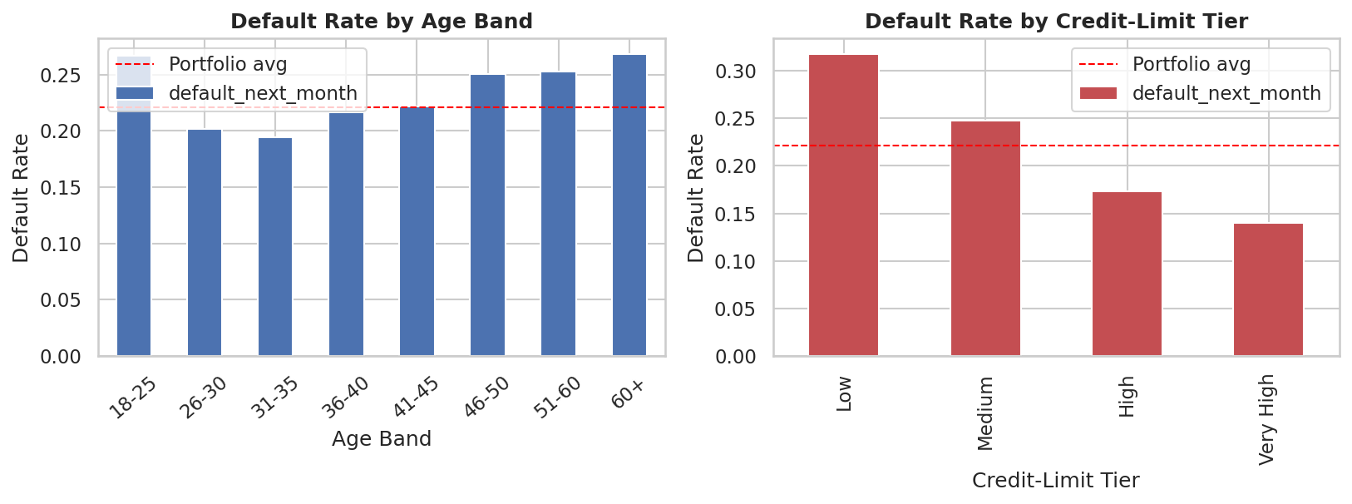
Figure 1. Default rate by age band and credit-limit tier, against the portfolio average (red dashed line).
Far more powerful than any demographic split is repayment behaviour itself. When we compare each of the six monthly repayment-status codes to next-month default, the correlation is strongest for the most recent month (0.325) and weakens steadily for each month further in the past (down to 0.187 for the oldest month). Customers who go on to default carry a visibly more delinquent repayment status in every one of the preceding six months, and the gap between defaulting and non-defaulting customers is widest in the most recent statement cycle. This is the clearest actionable insight in the analysis: a monitoring system that weights the most recent 1-2 months of repayment status will catch far more genuine risk than one that treats all six months equally, or one that relies primarily on demographic profiling.
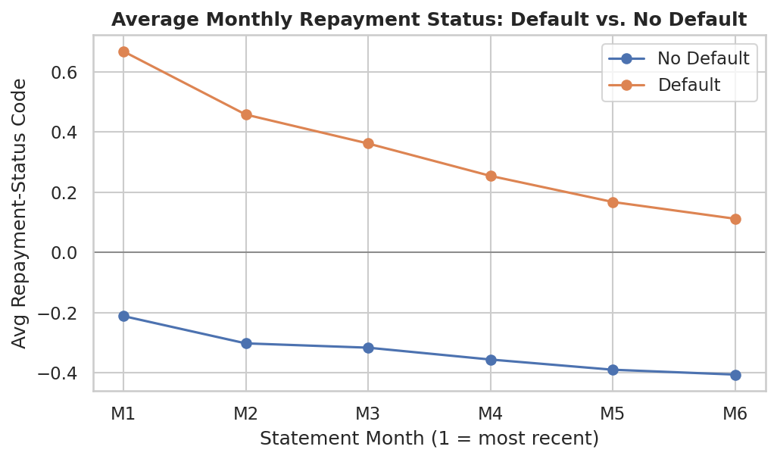
Figure 2. Average monthly repayment-status code for defaulting vs. non-defaulting customers (Month 1 = most recent).
Financial position tells a complementary story. Customers who default do not necessarily carry larger bills — median average bill amounts are broadly similar between defaulting and non-defaulting customers — but they pay back substantially less relative to what they owe. The median payment-to-bill ratio for defaulting customers (0.06) is roughly half that of non-defaulting customers (0.11). This confirms that repayment capacity, not bill size alone, is the financially meaningful signal, and it is why our segmentation framework treats capacity as an independent risk dimension rather than folding it into raw balance figures.
A correlation analysis across the full set of behavioural and financial variables reinforces this picture: the number of delayed months (correlation 0.398) and the maximum delay observed (0.370) are far more strongly associated with default than the granted credit limit (-0.154) or raw bill size (-0.013). Credit utilisation also correlates positively with default (0.116), foreshadowing the exposure analysis in the next section. In short, delinquency behaviour, not customer demographics or account size, is the dominant driver of default risk in this portfolio.

Customer Segmentation & Strategy
To convert these findings into an operational tool, we built an interpretable, RFM-style risk-scoring framework across three behavioural dimensions: Delinquency (a combination of the number of delayed months and the maximum delay observed), Repayment Capacity (the payment-to-bill ratio), and Exposure (credit utilisation, i.e. average outstanding balance relative to the granted limit). Each dimension was scored from 1 (lowest risk) to 5 (highest risk) using quantile binning, so that each score band contains a comparable number of customers, and the direction of scoring was validated by confirming that default rates rise from score 1 to score 5 on every dimension. The three scores were combined into a single overall risk score using a weighted, reusable scoring function, with delinquency weighted most heavily (50%), followed by repayment capacity (30%) and exposure (20%), reflecting the relative strength of these signals found in the repayment analysis above.
The overall risk score was then mapped into four business-friendly segments: Healthy, Watchlist, At-Risk, and Critical/Intervention. The resulting segments are validated directly against realised default outcomes. Healthy customers (4,384 accounts, 14.6% of the book) default at 13.2%, closely followed by the much larger Watchlist segment (10,554 accounts, 35.2% of the book) at 12.3% — together, these lower-risk segments make up exactly half of the portfolio and default at close to half the portfolio average. Risk then rises sharply: the At-Risk segment (8,609 accounts, 28.7% of the book) defaults at 19.4%, and the Critical/Intervention segment (6,453 accounts, 21.5% of the book) defaults at 47.8% — more than double the portfolio average and roughly 3.6 times the rate of the Healthy segment. This is a highly actionable concentration of risk: just over a fifth of the book accounts for a hugely disproportionate share of expected defaults, meaning collections and review capacity can be targeted with real precision rather than spread evenly across the whole customer base.
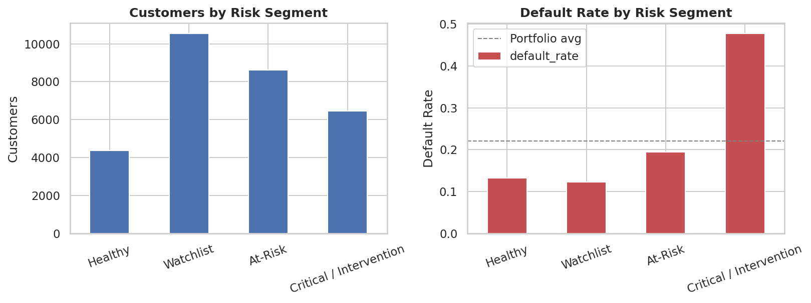
Figure 3. Customer count and validated default rate by financial-health segment.
Segmentation alone, however, does not tell the whole story. We specifically investigated the hypothesis that customers combining high credit utilisation with weak repayment capacity are disproportionately risky. The results confirm this clearly: customers using less than 30% of their credit limit default at 17.9%, rising steadily to 22.0% for moderate utilisation (30-60%), 28.8% for high utilisation (60-100%), and 34.2% for customers who are effectively over their limit. Crucially, this risk compounds with weak repayment capacity rather than simply adding to it: among over-limit customers, those with the weakest capacity score default at 38.4%, compared with roughly 15% for low-utilisation customers with strong capacity — a more than two-and-a-half-fold difference. This means utilisation and capacity should never be assessed in isolation: a customer running near their limit but paying reliably is a fundamentally different risk case from one who is both over-extended and falling behind, and a monitoring policy should distinguish between them explicitly rather than flagging both as simply "high utilisation."
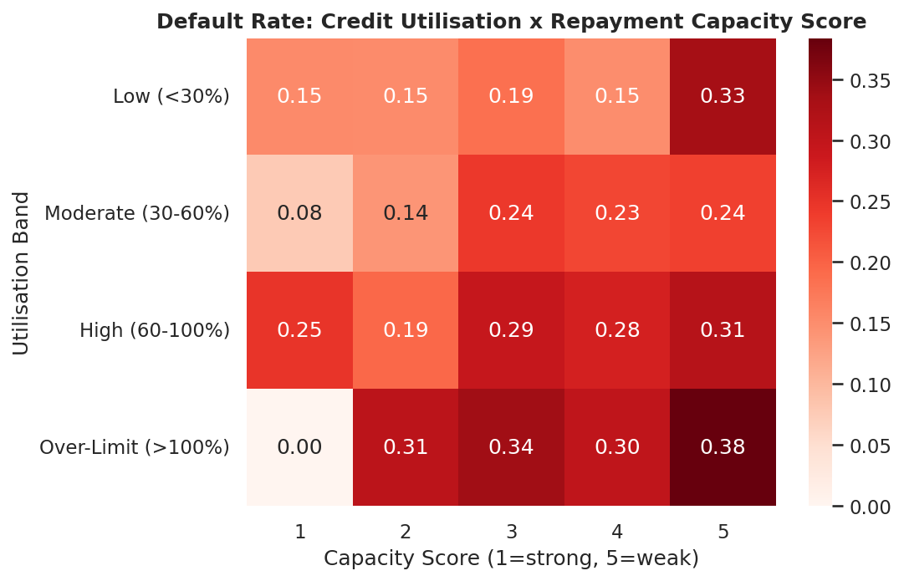
Figure 4. Default rate by credit-utilisation band and repayment-capacity score — risk compounds where both are weak.
Translating segments into action, we recommend: Healthy customers receive no intervention and are candidates for proactive limit increases or retention offers; Watchlist customers receive automated payment reminders and financial-wellness nudges with ongoing monitoring for deterioration; At-Risk customers receive proactive outreach, a freeze on further limit increases, and the option of a structured repayment plan; and Critical/Intervention customers are routed to a formal hardship or restructuring offer alongside a credit-line reduction, with referral to financial-wellness support. Every action is supportive or protective rather than punitive, and — importantly — segment membership is driven purely by behavioural repayment data rather than by sex, education, or marital status, keeping the framework auditable, defensible, and fair.

Data Enrichment via API
To support international reporting, we enriched the dataset with a live currency conversion, fetched via the Frankfurter public exchange-rate API (a free, key-free service built on European Central Bank reference rates), converting NTD-denominated credit limits and balances into USD. The integration was built with graceful error handling: if the live API call fails for any reason, the notebook automatically falls back to a documented static rate rather than breaking, ensuring reproducibility in any environment. Using the retrieved rate, the average granted credit limit across the portfolio converts to approximately USD 5,153, giving the executive board and any international stakeholders a directly comparable figure without needing to manually convert currencies in every future report. This kind of enrichment is a small but genuinely useful step: it turns a one-off analysis into something that stays current automatically each time the notebook is re-run, and lays the groundwork for layering in further external context, such as interest-rate or inflation data, in future iterations of this framework.

Recommendations, Ethics & Limitations
Beyond the three headline recommendations in the Executive Summary, we recommend that FinTrust operationalise this framework in three concrete ways. First, integrate the overall risk score into existing account-monitoring dashboards so that relationship and collections teams see a live segment label rather than raw transaction data. Second, re-run the underlying scoring model on a regular cycle (for example, monthly) so that segment membership reflects a customer’s most recent behaviour rather than a static snapshot, consistent with our finding that recent repayment status is the strongest predictor available. Third, pilot the utilisation-and-capacity joint policy on a subset of At-Risk and Critical accounts before full rollout, to confirm that the recommended actions reduce realised defaults in practice and not only in historical data.
On fairness and ethics, we deliberately excluded sex, education, and marital status from the risk-scoring formula itself, using them only for descriptive analysis; this avoids embedding demographic proxies into automated decisions and keeps the framework’s outputs explainable purely in terms of a customer’s own repayment behaviour. We also chose to relabel rather than delete customers with undocumented demographic codes, so that no group of real accounts is silently excluded from monitoring or support. We recommend FinTrust maintain this principle as the framework evolves: any future variable added to the score should be behavioural and within the customer’s control, not a fixed personal characteristic.
This analysis has some important limitations. The underlying dataset is a historical snapshot from a single market and time period, so absolute default-rate figures may not transfer unchanged to FinTrust’s current book or to other markets; the framework should be recalibrated on FinTrust’s own live data before full deployment. The risk-scoring weights (50/30/20 across delinquency, capacity, and exposure) were chosen based on the relative strength of correlations observed in this dataset and are a reasonable starting point rather than a formally optimised model; they should be revisited once outcome data from the new segmentation itself becomes available. The quantile-based scoring approach also means segment boundaries are defined relative to FinTrust’s own customer base rather than against a fixed external standard — this is useful for prioritising internal resources but means a "Healthy" customer today is not necessarily comparable to a "Healthy" customer under a materially different future portfolio mix, and boundaries should be revisited periodically as the book evolves.
Finally, this is a rules-based, interpretable scoring framework rather than a machine-learning classifier — a deliberate choice for transparency and auditability, but one that means it may leave some predictive accuracy on the table compared to a more complex model, a trade-off we consider appropriate for a customer-facing risk and collections process. We would encourage the board to treat this framework as a first production-ready iteration rather than a finished system: as more months of outcome data accumulate under the new segmentation, FinTrust will be well placed to test whether the recommended actions actually reduce realised default rates, and to refine both the scoring weights and the segment-level strategies accordingly.

