COCONUT DISEASE IDENTIFICATION AND ADVISORY SYSTEM
INDIVIDUAL THESIS

Isuri Darshika Harischandra
(IT22549204)

Individual component: AI-Based Coconut Disease Image Classification and RAG Advisory Chatbot
Group ID: R26-IT-019

Report submitted in partial fulfilment of the requirements for the
B.Sc. (Hons) Degree in Information Technology
Department of Information Technology
Sri Lanka Institute of Information Technology
Sri Lanka

October 2026

DECLARATION AND SUPERVISOR CERTIFICATION
Candidate declaration. I declare that this thesis is my own work and does not incorporate, without acknowledgement, material previously submitted for a degree or diploma at any university or institute of higher learning. To the best of my knowledge, it contains no material previously published or written by another person except where acknowledgement is made in the text. I grant the Sri Lanka Institute of Information Technology the non-exclusive right to reproduce and distribute this thesis, in whole or in part, in print, electronic, or other media, while retaining the right to use the content in future work.
Academic integrity and AI disclosure. I have disclosed the use of generative AI and other automated tools in accordance with the module policy. I remain responsible for the accuracy, originality, citations, code, data, analyses, and conclusions in this thesis.
Student name: Isuri Darshika Harischandra
Student ID: IT22549204
Signature: ______________________________ Date: __________________
Supervisor certification. The above candidate carried out this research for the bachelor's degree thesis under supervision.
Role | Name | Signature | Date
Supervisor | [Confirm official name]
Co-supervisor, if applicable | [Confirm or remove]

ABSTRACT
Coconut leaf pests and diseases can produce visible symptoms that require interpretation, while image classifiers trained on a fixed set of categories may still assign predictions to unfamiliar inputs. Users may also need disease-related explanations beyond a predicted label. This research develops an AI-based coconut disease identification and advisory component comprising an EfficientNet-B0 image classifier, a feature-based out-of-distribution (OOD) checking mechanism, and a retrieval-augmented generation (RAG) chatbot. The classifier was trained on four categories—Coconut Caterpillar Infestation, Gray Leaf Spot, Healthy Leaves and Leaf Rot—using a 70/15/15 train-validation-test split and a two-stage transfer-learning procedure. The notebook reports a test accuracy of 98.89% and test loss of 0.3841 on 723 test images. The OOD mechanism extracts 256-dimensional feature embeddings and uses class means, a shared covariance estimate and Mahalanobis distance; its threshold was set to the 99th percentile of in-distribution validation distances (594.53). The notebook reports that 0.97% of in-distribution test images exceeded this threshold, but no representative external OOD evaluation is documented. The chatbot ingests 16 PDFs, creates 1,606 text chunks, embeds them using BAAI/bge-large-en-v1.5 and indexes them in Pinecone for retrieval before generating responses through an OpenRouter-connected language model. The implementation demonstrates the integration of visual classification and document-grounded conversational access to coconut disease information. However, the classifier's high test score does not establish field generalisation, and formal evaluation of chatbot factuality and retrieval quality remains necessary. The individual contribution is the implementation and technical evaluation of these three functions within the defined scope.
Keywords: Coconut disease classification, EfficientNet-B0, out-of-distribution detection, retrieval-augmented generation, agricultural advisory chatbot

ACKNOWLEDGEMENTS
I would like to express my sincere gratitude to my research supervisor for the guidance, feedback and academic support provided throughout the development of this research. I also thank the co-supervisor and relevant academic staff for their advice and support. I am grateful to my research group members for their collaboration and coordination within the wider project. I acknowledge the authors and organisations whose publications and technical resources informed the development of the coconut disease knowledge base and the methods discussed in this thesis. Finally, I thank my family and friends for their encouragement during the research and thesis-writing process.
Before submission, replace or supplement these acknowledgements with the correct names and specific contributions of the people who supported this work. Do not acknowledge funding or technical assistance that was not received.

TABLE OF CONTENTS
In Microsoft Word, right-click this section and select Update Field after applying heading styles. This draft uses Word heading styles so an automatic table of contents can be generated.
1 INTRODUCTION
2 LITERATURE REVIEW AND RELATED WORK
3 RESEARCH METHODOLOGY
4 PRODUCT AND SOLUTION DESIGN
5 IMPLEMENTATION, INTEGRATION AND TESTING
6 RESULTS AND VALIDATION
7 DISCUSSION
8 COMMERCIALISATION AND SUSTAINABILITY
9 CONCLUSION AND FUTURE DIRECTIONS
REFERENCES
GLOSSARY
APPENDICES

LIST OF FIGURES
Figure 3.1. Image classification and OOD workflow
Figure 3.2. RAG chatbot workflow
Figure 4.1. Conceptual component architecture

LIST OF TABLES
Table 3.1. Dataset distribution
Table 3.2. Principal technologies used
Table 6.1. Test classification report
Table 6.2. RAG pipeline implementation statistics
Table 7.1. Threats to validity and mitigation

LIST OF ABBREVIATIONS
Abbreviation | Definition
AI | Artificial intelligence
BGE | BAAI General Embedding (model family name)
CCI | Coconut Caterpillar Infestation
CNN | Convolutional neural network
ID | In-distribution
LLM | Large language model
OOD | Out-of-distribution
RAG | Retrieval-augmented generation
PDF | Portable Document Format
ReLU | Rectified linear unit

1 INTRODUCTION

1.1 Overall project context
Coconut cultivation is an important agricultural activity in tropical regions, including Sri Lanka. Coconut palms can be affected by insect pests and leaf diseases, and the visible symptoms may require interpretation before appropriate action is considered. The coconut caterpillar, Opisina arenosella, is a pest associated with damage to coconut leaf tissues. Leaf diseases such as Gray Leaf Spot and Leaf Rot are also relevant to the disease categories considered in this component. Visual examination can provide useful initial evidence, but symptom appearance can vary with severity, environmental conditions, leaf age and image quality. Automated image analysis is therefore a potential support tool, rather than a substitute for qualified agricultural assessment.
Deep learning methods have been widely investigated for image-based plant disease recognition. Mohanty et al. demonstrated the use of deep neural networks for classifying plant disease images [1]. For coconut-related problems, Vidhanaarachchi et al. examined deep-learning-based image processing for coconut disease and pest assessment [2]. These studies provide context for applying computer vision to agricultural imagery, while their results should not be assumed to transfer unchanged to another dataset or deployment setting.
A classifier trained on a fixed collection of categories may output one of those categories even when the input differs from the training distribution. Out-of-distribution detection investigates methods for recognising inputs that are atypical of the data used to train a model [3]. A separate but related challenge is explaining a prediction or responding to follow-up questions. Retrieval-augmented generation combines a retrieval stage over an external knowledge source with language-model generation, providing a way to ground responses in retrieved text [4]. This thesis brings these strands together in an individual component for preliminary coconut disease identification and information access.

1.2 Individual component context
The individual component has three functions. First, an EfficientNet-B0-based classifier predicts one of four image classes: CCI_Caterpillars, Gray Leaf Spot, Healthy_Leaves and Leaf Rot. Second, a feature-based OOD mechanism represents an image as a 256-dimensional vector and calculates its Mahalanobis distance relative to the known class distributions. Third, a RAG chatbot retrieves passages from a curated collection of coconut disease PDFs and supplies those passages as context to a language model.
EfficientNet was introduced by Tan and Le as a convolutional neural network family using compound scaling to balance model depth, width and input resolution [5]. The implementation in this project uses an ImageNet-pretrained EfficientNet-B0 backbone and a custom classification head. The chatbot uses BAAI/bge-large-en-v1.5 embeddings, a Pinecone vector index with cosine similarity, and a language model accessed through OpenRouter. The notebooks show the implementation pipeline; the exact deployed application architecture and configured model identifier should be verified against the final application before submission.

1.3 Problem statement
The problem addressed is how to implement and assess a component that can (i) classify coconut leaf images into four supported categories, (ii) flag potentially unfamiliar inputs rather than treating every prediction as equally suitable, and (iii) provide conversational access to disease-related information retrieved from a curated knowledge base. A class label alone may not give users enough context, while a language model without an evidence-retrieval step may produce plausible but unsupported statements. Conversely, retrieval does not guarantee that a generated answer is complete or factually correct. The research therefore focuses on implementing the three functions and describing their performance and limitations using evidence from the available notebooks.

1.4 Research gap
Prior work establishes that deep learning can be used for plant disease classification [1], that EfficientNet offers an efficient image-classification architecture [5], that OOD detection can be performed using statistical information from learned representations [3], and that RAG can combine external retrieval with text generation [4]. The practical focus of this thesis is the integration of these approaches for a defined coconut disease component: four-class image classification, feature-distance-based OOD checking, and a three-topic RAG advisory chatbot. This is a component-level engineering and evaluation focus, not a claim that these techniques are individually new or that no similar system exists.
The gap should be treated as provisional until the full Chapter 2 literature review compares the component with relevant coconut disease recognition studies, OOD evaluation methods and RAG answer-quality studies. The current notebook evidence also leaves a clear evaluation limitation: the OOD threshold was calibrated from in-distribution validation distances, while a representative external OOD test set and a formal chatbot factuality evaluation are not documented.

1.5 Aim and objectives
Aim: To develop and evaluate an AI-based coconut disease identification and advisory component combining image classification, feature-based OOD checking and retrieval-augmented conversational assistance.
The objectives are:
- Review relevant work on coconut pest and disease recognition, deep learning image classification, OOD detection and RAG.
- Train and evaluate an EfficientNet-B0 model for CCI_Caterpillars, Gray Leaf Spot, Healthy_Leaves and Leaf Rot.
- Implement a feature-based Mahalanobis-distance OOD mechanism and document its thresholding procedure.
- Develop a RAG chatbot that indexes a curated set of coconut disease PDFs and retrieves context for user questions.
- Integrate and test the individual functions and report results supported by the implementation notebooks.
- Identify limitations and recommend further evaluation of external OOD detection and RAG answer reliability.

1.6 Research questions
- RQ1: How effectively does the EfficientNet-B0 model classify the four supported coconut leaf image categories on the held-out test dataset?
- RQ2: What behaviour does the implemented Mahalanobis-distance OOD mechanism show at its selected validation threshold, and what evidence is available about its ability to detect genuinely unfamiliar inputs?
- RQ3: How is the RAG chatbot configured to retrieve coconut disease information and generate responses, and what testing evidence is available for retrieval relevance and answer reliability?
- RQ4: What technical limitations affect the use of the component for preliminary image classification and disease-information access?

1.7 Scope, limitations and assumptions
The image-classification scope consists of four categories and the dataset described in Chapter 3. The OOD mechanism uses the model's 256-dimensional embedding and a Mahalanobis-distance threshold. The chatbot's stated conversational scope is Coconut Caterpillar Infestation, Coconut Leaf Rot and Coconut Gray Leaf Spot. Its notebook ingests 16 PDFs, but the inclusion of a PDF in the index does not automatically mean that every document is relevant to these three topics; retrieval quality and source selection need to be reviewed.
The work does not include the originally proposed crowdsourced farmer reporting platform, NLP classification of farmer reports, community response confidence scoring or geographic infestation heatmaps unless those features were separately implemented and verified. Weligama Coconut Leaf Wilt Disease is outside this individual component and is excluded. Limitations include an imbalanced dataset, only 19 Healthy_Leaves test images, no documented representative OOD dataset, no formal user study, and no controlled quantitative evaluation of chatbot factuality. The system is intended for preliminary support, not definitive diagnosis or autonomous treatment recommendations.

1.8 Individual contribution
The individual contribution documented here is the implementation of the EfficientNet-B0 classifier, the 256-dimensional feature extraction and Mahalanobis-distance OOD pipeline, and the RAG-based coconut disease chatbot. The image notebook records dataset splitting, augmentation, transfer learning, test metrics and model export attempts. The chatbot notebook records PDF ingestion, text chunking, BGE embeddings, Pinecone indexing, multilingual interaction handling and language-model response generation. Shared project-level contributions must be distinguished from the user's own work in the final submission and confirmed against the group's agreed task allocation.

1.9 Thesis structure
Chapter 1 introduces the research context, problem, gap, aim, questions and scope. Chapter 2 reviews the domain and relevant literature. Chapter 3 describes the research design, datasets, model training, OOD method, RAG pipeline and evaluation measures. Chapter 4 presents requirements and component design. Chapter 5 documents implementation, integration and testing. Chapter 6 reports measured results and available validation evidence. Chapter 7 interprets the findings and discusses limitations. Chapter 8 considers value, sustainability and deployment issues. Chapter 9 concludes the thesis and identifies future work.

2 LITERATURE REVIEW AND RELATED WORK

2.1 Review method and scope
This chapter organises the literature around the technical functions implemented in the component: plant disease image classification, EfficientNet-based feature learning, OOD detection and retrieval-augmented generation. The review should prioritise peer-reviewed research and authoritative agricultural publications, using the supplied knowledge-base PDFs for domain-specific disease information. The current draft uses a small set of foundational sources to explain the methods; it is not a substitute for a complete systematic search. Before submission, add the bibliographic metadata and findings from the 16 supplied PDFs and document the search terms, databases, inclusion criteria and exclusion criteria used.

2.2 Domain and theoretical foundations

2.2.1 Image-based plant disease recognition
Image-based plant disease recognition maps visual input to a disease or health category. A supervised classifier learns from labelled examples and predicts a category for an unseen image. Mohanty et al. showed the potential of deep neural networks for plant disease image classification [1]. However, reported performance depends on dataset construction, image capture conditions, label quality and the separation between training and test data. An evaluation set should be independent of training examples and should represent the target task as honestly as possible.

2.2.2 Transfer learning and EfficientNet-B0
Transfer learning starts from parameters learned on a large source dataset and adapts them to a target task. It can reduce the amount of task-specific training required when the target dataset is limited. EfficientNet scales network depth, width and input resolution in a coordinated way [5]. In this project, an ImageNet-pretrained EfficientNet-B0 backbone is combined with a custom head containing a linear projection from 1,280 features to 256, batch normalisation, ReLU, dropout and a final four-class linear layer. The notebook uses a frozen-backbone phase followed by partial fine-tuning.

2.2.3 Out-of-distribution detection
OOD detection addresses inputs that do not resemble the data distribution represented during training. Lee et al. proposed a framework using class-conditional Gaussian distributions and Mahalanobis distance in feature space [3]. In the present implementation, the image is mapped to a 256-dimensional embedding, and its distance to the learned class distributions is calculated. The minimum distance is compared with a threshold. The chosen threshold is the 99th percentile of in-distribution validation distances. This calibration controls the validation-distance cutoff, but it does not independently measure detection performance on external or unknown disease images.

2.2.4 Retrieval-augmented generation
RAG combines a retrieval system with a generative language model. The retriever searches an external knowledge collection for passages relevant to a question; the retrieved text is then supplied as context to the generator [4]. In this project, PDF text is extracted, split into overlapping chunks, embedded and indexed in Pinecone. The chatbot retrieves candidate passages before asking a language model to compose a response. Retrieval can improve access to domain documents, but the system still requires evaluation for relevance, evidence support, completeness, language quality and safe handling of questions not covered by the knowledge base.

2.3 Related research
Mohanty et al. [1] provide a foundational example of deep learning applied to plant disease images. Their work supports the use of CNN-based image features but does not validate the particular coconut dataset or model used here. Tan and Le [5] describe the EfficientNet architecture family and its scaling strategy; this motivates the selected backbone but does not establish that EfficientNet-B0 is optimal for the present classes. Lee et al. [3] provide the statistical feature-distance basis for OOD checking. Lewis et al. [4] describe the retrieval-augmented generation paradigm used by the chatbot.
For a complete related-work analysis, the supplied coconut disease documents must be examined individually. In particular, sources concerning coconut leaf spots, leaf rot symptoms and management, coconut pest management and biological control should be used to establish the domain facts and to distinguish scientific evidence from general recommendations. Do not include unrelated disease information as if it were part of the classifier's four categories or chatbot's three-topic scope.

2.4 Existing systems, products and techniques
Technique | Purpose | Strength | Limitation relevant to this project
CNN image classification | Map leaf image to a known category | Fast, consistent predictions for trained categories | May force a label on unfamiliar input
EfficientNet-B0 transfer learning | Reuse pretrained visual features | Moderate model size and effective learned features | Performance remains dataset-dependent
Mahalanobis-distance OOD check | Measure distance from learned class distributions | Produces a configurable distance score | Threshold needs representative evaluation; OOD not guaranteed
Vector retrieval with embeddings | Find semantically related document chunks | Can surface domain passages without exact keyword matching | May retrieve irrelevant or incomplete passages
RAG with a language model | Generate a natural-language answer using retrieved context | Combines document search with conversational output | Fluent output may still be unsupported or incorrect

2.5 Gap synthesis and conceptual framework
The reviewed methods address complementary tasks rather than one identical problem. Image classification produces a category prediction; OOD detection assesses whether the feature representation appears atypical; RAG retrieves document passages and generates a conversational answer. The component's practical focus is to integrate these functions in a coconut disease setting and to document what the available experiments demonstrate. The conceptual framework therefore separates visual inference from document retrieval and does not treat chatbot output as confirmation of an image prediction.
The contribution should be assessed through transparent reporting: held-out classification metrics, clear documentation of the OOD calibration and external test limitations, and structured testing of chatbot retrieval and answer support. A stronger research evaluation would compare the chatbot against a baseline and use a question set with reference answers and source passages. Such an evaluation is not evidenced by the supplied notebook and must be conducted before any claim of improved RAG reliability is made.

3 RESEARCH METHODOLOGY

3.1 Research design
The work follows an applied design-and-evaluation approach. A software component is implemented using existing machine-learning and retrieval techniques, then evaluated using the available held-out image dataset and functional tests. The methodological focus is on reproducible implementation details and an honest interpretation of the evidence. The image classifier has quantitative test metrics. The OOD notebook reports threshold calibration and the percentage of in-distribution test samples above the threshold. The chatbot notebook records successful ingestion and interactive sample conversations, but does not document a controlled answer-quality benchmark.

3.2 Data and study materials

3.2.1 Image dataset
The image notebook reports four original class counts before splitting: 990 CCI_Caterpillars images, 2,135 Gray Leaf Spot images, 123 Healthy_Leaves images and 1,559 Leaf Rot images. A 70/15/15 split was applied at the class level. The resulting original split counts are shown in Table 3.1. Training images were augmented and balanced to 2,000 examples per class, resulting in 8,000 training examples. Validation and test data were not expanded to 2,000 per class.
Class | Original total | Train | Validation | Test
CCI_Caterpillars | 990 | 693 | 148 | 149
Gray Leaf Spot | 2,135 | 1,494 | 320 | 321
Healthy_Leaves | 123 | 86 | 18 | 19
Leaf Rot | 1,559 | 1,091 | 234 | 234
Total | 4,807 | 3,364 | 720 | 723

The original split counts sum to 4,807 images. The very small Healthy_Leaves class, especially the 19 test examples, limits the certainty of its class-specific metric. The thesis should also verify that augmented variants or near-duplicate images do not cross split boundaries. The notebook indicates splitting before training augmentation, but a file-level duplicate or source-image audit is not shown.

3.2.2 Knowledge-base documents
The chatbot notebook reports ingesting 16 PDF documents and indexing 1,606 text chunks. PDF text is extracted using pypdf, normalised, and split into chunks of approximately 900 characters with a 150-character overlap. The supplied PDF set is a collection used by the implementation, not automatically a validated or fully authoritative corpus. The final thesis should include a source inventory listing each PDF's full title, author or organisation, publication year, topic and reason for inclusion. It should also record documents excluded from retrieval or retained only as background material. In particular, documents unrelated to the three supported chatbot topics can reduce retrieval precision if left in the same index.

3.3 Experimental and development procedure

3.3.1 Image preprocessing and training
Images are resized to 224 × 224 pixels and normalised using the ImageNet channel means [0.485, 0.456, 0.406] and standard deviations [0.229, 0.224, 0.225]. Training augmentation is applied to the training set and the notebook balances each training category to 2,000 samples. The model uses ImageNet-pretrained EfficientNet-B0 weights. Its custom classifier maps the backbone output of 1,280 features to a 256-dimensional intermediate representation and then to four class logits.
Training occurs in two phases. In Phase 1, the backbone is frozen and the classification head is trained. The notebook reports early stopping after validation performance ceased improving. In Phase 2, approximately the last 30% of the backbone feature layers are unfrozen while batch-normalisation layers remain frozen; a small learning rate is used for fine-tuning. The loss function is cross-entropy with label smoothing of 0.1. Final test evaluation is performed with the model in evaluation mode and without gradient updates.

3.3.2 OOD method
The OOD module extracts a 256-dimensional embedding immediately before the final four-class linear layer. It computes class means from embeddings of the original training split and estimates a shared covariance-related precision matrix. For a new embedding, class-conditional Mahalanobis distances are calculated and the smallest distance is compared with a threshold. The threshold is the 99th percentile of in-distribution validation distances, reported as 594.53. The notebook reports that 0.97% of in-distribution test samples exceed the threshold.
This percentage is an in-distribution flag rate under the reported threshold, not a measure of OOD detection accuracy. A valid OOD performance study would need a separate set of examples that are genuinely outside the four supported classes, together with metrics such as true-positive rate, false-positive rate and AUROC where appropriate. That external evaluation is not documented in the supplied notebook.

3.3.3 RAG ingestion and response procedure
The chatbot uses pypdf to extract text from the knowledge-base PDFs. Text is cleaned and split into overlapping chunks. The BAAI/bge-large-en-v1.5 Sentence Transformers model creates 1,024-dimensional embeddings, which are stored in Pinecone using cosine similarity. The notebook's indexing output reports 1,606 chunks from 16 PDFs and a vector index configured for 1,024 dimensions. At question time, the system embeds the query, retrieves relevant passages, combines them with the question and conversation context, and sends the prompt through an OpenAI-compatible client configured for OpenRouter.
The notebook supports English and Sinhala interaction by translating the question or answer where needed and keeps conversation history within a session. The final thesis should verify the exact model identifier, retrieval top-k value, prompt template, API settings and handling of missing or weak evidence from the code used for the final application. Secrets and API keys must never be included in the thesis, notebook exports or screenshots.

3.4 Measures and evaluation metrics
For image classification, the notebook reports accuracy, test loss, class-level precision, recall, F1-score and support. Accuracy is the proportion of correct predictions among all evaluated examples. Precision measures the proportion of predicted class instances that are correct, while recall measures the proportion of actual class instances recovered. F1-score is the harmonic mean of precision and recall. Reporting class-level results is important because the test set is imbalanced.
For OOD checking, the documented metrics are the validation-distance threshold and the proportion of in-distribution test samples flagged. These values describe calibration and in-distribution behaviour, not external OOD sensitivity. For the chatbot, the available evidence is functional: successful ingestion, chunk count and example conversations. There is no formal evaluation set, reference-answer rubric, retrieval precision measure or independent human scoring in the supplied notebook. The thesis must state this explicitly.

3.5 Data analysis
The classification analysis uses the held-out test predictions to calculate aggregate and class-specific metrics and a confusion matrix. The notebook's output is reported in Chapter 6. Interpretation considers both overall performance and class imbalance. OOD analysis reports the distribution of in-distribution validation distances, the selected percentile threshold and the in-distribution test flag rate. The chatbot analysis is descriptive because the notebook contains manual interactions rather than a controlled benchmark. It is not possible to infer factual accuracy or superiority over an alternative system from example conversations alone.

3.6 Ethics, privacy, security and responsible AI
The image dataset should be used in accordance with its licence and source conditions. Where photographs contain people, identifiable property or location information, these details should not be unnecessarily disclosed. API keys are managed through environment variables or the notebook platform's secrets facility and should not be printed in logs or included in a public repository. Disease-related advice should be framed as preliminary information, with appropriate referral to agricultural experts for decisions with financial or environmental consequences.
The chatbot may generate incomplete or unsupported content, even when retrieval is used. The knowledge base should be maintained with source provenance, and outputs should not be represented as expert-approved unless a qualified expert has reviewed them. English and Sinhala responses should be checked for meaning preservation, especially where technical or treatment terminology is involved. The final submission should disclose AI assistance according to SLIIT module policy and describe the student's verification responsibility.

3.7 Reproducibility and research artefacts
The image notebook records a CUDA-enabled Tesla T4 runtime, PyTorch/Torchvision model construction, dataset split counts, training logs, test metrics and model-export attempts. The notebook indicates export of model weights and a TorchScript model, plus an ONNX export attempt that emitted a warning that the requested opset 13 could not be guaranteed and opset 18 might be retained. Therefore, do not claim successful opset-13 export without verifying the resulting ONNX file.
The chatbot notebook records its dependencies, embedding model, Pinecone index dimension and metric, PDF ingestion count, chunk count and interactive test. Reproducibility also requires the exact versions of libraries, model identifier, index configuration, prompt template and retrieval settings. The final thesis appendix should include non-secret configuration information and the versions captured from the final environment.

4 PRODUCT AND SOLUTION DESIGN

4.1 Requirements
The principal functional requirement for the image pathway is to accept a coconut leaf image and return a predicted category from the four supported classes. The OOD function must calculate a distance score and indicate whether it exceeds the configured threshold. The advisory pathway must accept a user question, retrieve relevant knowledge-base passages, pass the passages to the configured language model and return a response. The chatbot supports questions about CCI, Gray Leaf Spot and Leaf Rot, with English/Sinhala handling as implemented in the notebook.
Non-functional requirements include reasonable response time, clear output, reproducible model configuration, secure API-key handling and honest communication of uncertainty. The component should not imply a definitive diagnosis when a prediction is uncertain or the input appears unfamiliar. The chatbot should not imply that a response is fully evidence-supported unless that property is evaluated and shown.

4.2 Component architecture within the complete solution
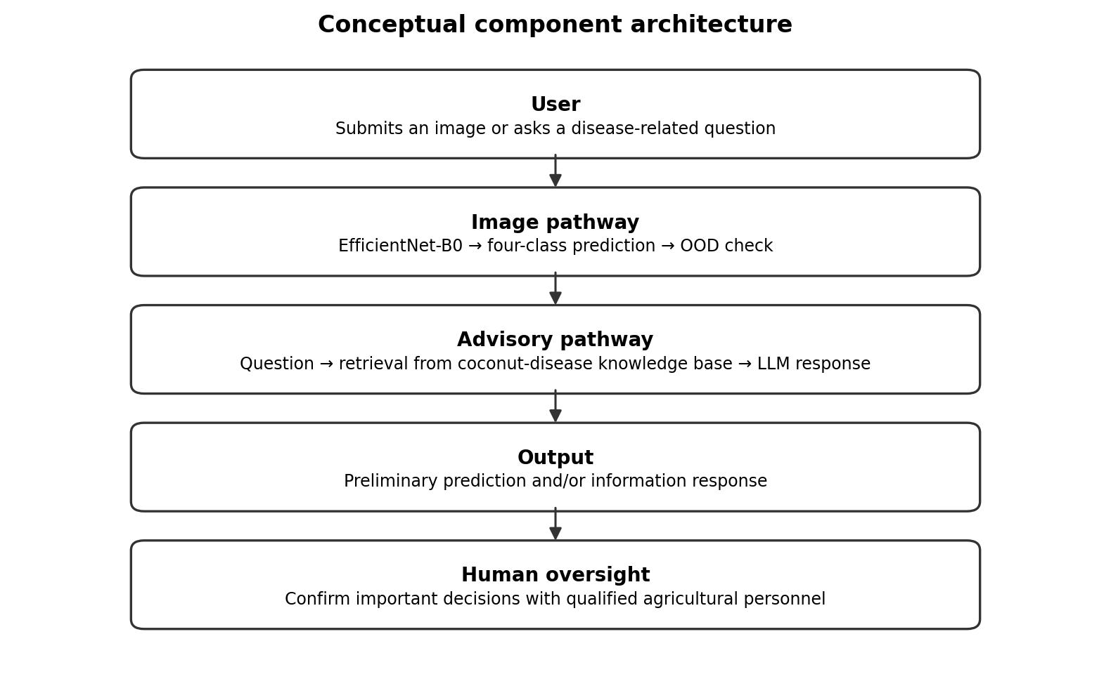
Figure 4.1. Conceptual architecture of the individual component.
The component has two pathways. The image pathway processes a leaf image through the classifier and OOD mechanism. The advisory pathway retrieves document passages in response to a natural-language question and uses a language model to generate an answer. The pathways are complementary, but the supplied notebooks do not demonstrate a strict technical coupling in which every image prediction automatically determines the chatbot response. The thesis therefore presents them as related functions within one component rather than claiming an unverified automated hand-off.

4.3 Design alternatives and decisions
EfficientNet-B0 was selected as the image backbone and adapted through transfer learning. A feature-distance method was used for OOD checking because the classifier already exposes an intermediate feature representation. For the advisory function, semantic vector retrieval was selected to locate passages based on meaning rather than exact keyword overlap. Pinecone provides managed vector indexing, while BGE embeddings provide 1,024-dimensional representations. These decisions fit the implementation shown in the notebooks; however, no controlled comparison with alternative backbones, embedding models or vector stores is included in the supplied evidence.

4.4 Detailed design

4.4.1 Image pathway
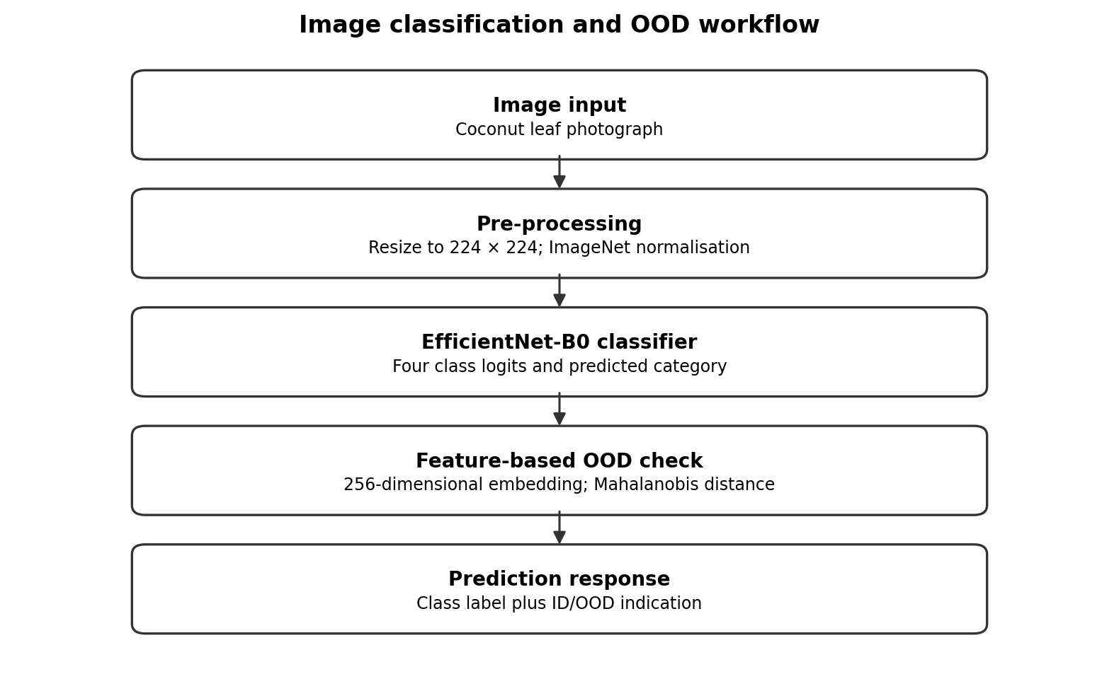
Figure 4.2. Image classification and OOD checking workflow.
The input image is resized to 224 × 224 and normalised. EfficientNet-B0 extracts visual features, followed by a custom head that projects the feature vector into 256 dimensions and produces four class scores. The OOD branch uses the intermediate 256-dimensional representation, computes Mahalanobis distances to the class distributions and compares the minimum distance with the threshold of 594.53. The final interface should display both the predicted category and OOD indication distinctly.

4.4.2 Advisory pathway
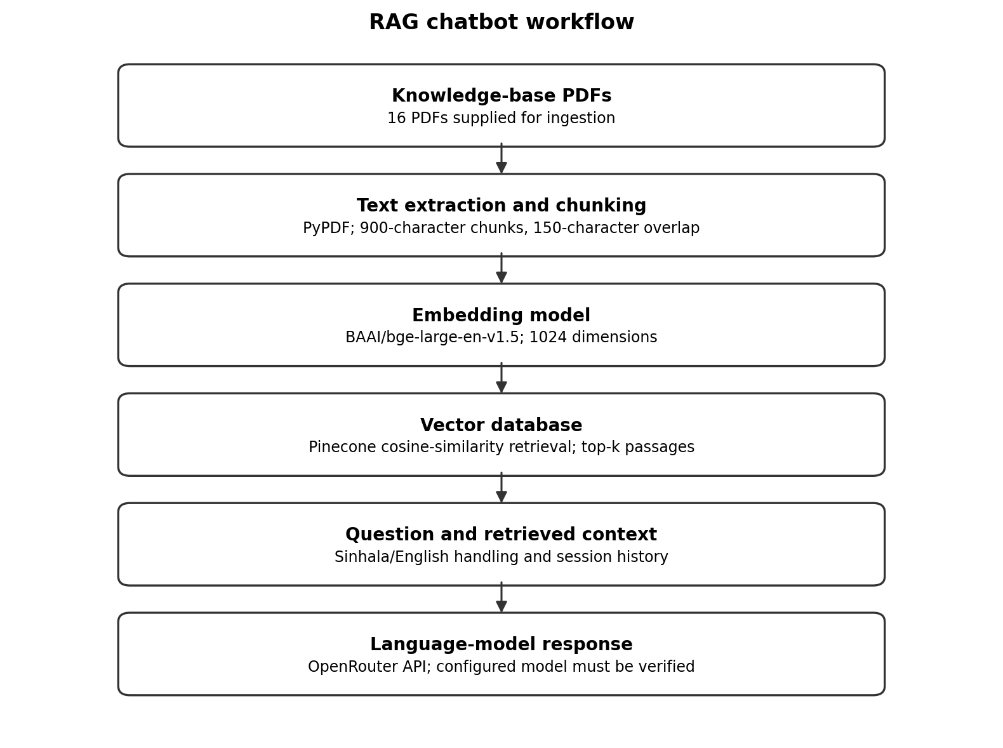
Figure 4.3. RAG chatbot ingestion and response workflow.
The ingestion process reads the PDFs, extracts text, normalises whitespace and divides the content into overlapping chunks. Each chunk is embedded and indexed with its source information. At question time, the query is embedded and used to retrieve relevant chunks from Pinecone. The retrieved text is combined with the user's question and relevant session context before being sent to the language model. The generated response is then presented to the user, with language handling applied where configured.

4.5 Standards and professional practice
The thesis follows the SLIIT documentation guidelines provided for the assignment: Times New Roman, 12-point body text, 14-point bold uppercase chapter headings, 12-point bold section headings, 1.5 line spacing for body text, 40 mm left and bottom margins, and 25 mm top and right margins. The guidelines specify single spacing for the abstract and some tables, and page numbering with Roman numerals for preliminary pages and Arabic numerals for the main text and appendices. Final page numbering and automatic contents fields must be checked in Word before submission. IEEE referencing is used in this draft, subject to any updated module instruction.

5 IMPLEMENTATION, INTEGRATION AND TESTING

5.1 Development environment and technology stack
Area | Technology evidenced in notebook | Role
Image modelling | Python, PyTorch, Torchvision | EfficientNet-B0 training and inference
Image preprocessing | PIL, torchvision transforms, NumPy | Image loading, resizing, normalisation and augmentation
Model evaluation | scikit-learn metrics (notebook output) | Classification report and confusion matrix
Model artefacts | PyTorch state dict, TorchScript, attempted ONNX | Export and later inference
PDF ingestion | pypdf | Text extraction from knowledge-base PDFs
Text embeddings | Sentence Transformers; BAAI/bge-large-en-v1.5 | 1024-dimensional document/query vectors
Vector database | Pinecone | Store and retrieve chunk embeddings using cosine similarity
LLM interface | OpenAI-compatible client through OpenRouter | Generate answers from question and retrieved context
Runtime | Notebook GPU runtime; Tesla T4 reported for image notebook | Training and embedding operations

5.2 Component implementation

5.2.1 Classifier implementation
The model is built from ImageNet-pretrained EfficientNet-B0 weights. The original classifier is replaced by a head with dropout, a linear layer from 1,280 to 256 units, batch normalisation, ReLU, a second dropout layer and a final linear layer with four outputs. Phase 1 freezes the backbone and trains the classifier head. Phase 2 unfreezes approximately the last 30% of feature layers, while keeping batch-normalisation layers frozen, and fine-tunes using a low learning rate. Early stopping is used based on validation performance.

5.2.2 OOD implementation
A FeatureExtractor wrapper exposes the 256-dimensional representation immediately before the final class logits. Embeddings are extracted from the original, non-augmented training split to avoid having synthetic augmented copies directly distort the estimated class centres and covariance. The method calculates class means and a shared precision matrix and persists the settings, threshold and label mapping for later inference. The notebook's example input receives a CCI_Caterpillars prediction with confidence 0.9333 and a Mahalanobis distance of 310.79, below the 594.53 threshold. This is one illustrative in-distribution example, not a validation of overall OOD performance.

5.2.3 RAG chatbot implementation
The chatbot uses pypdf to read the source documents and splits extracted text into chunks of 900 characters with a 150-character overlap. The BAAI/bge-large-en-v1.5 model creates 1,024-dimensional embeddings. The Pinecone index is configured with cosine similarity, and the notebook reports 1,606 chunks indexed from 16 PDFs. The query flow retrieves relevant passages and supplies them to the language model. The notebook also maintains session-specific conversational history and provides a command to translate the last response.

5.3 Integration with the other components
At the component level, the classifier and OOD check share the same learned image representation, so the predicted class and OOD score can be produced for a submitted image. The chatbot operates through a separate text retrieval and generation pipeline. The supplied notebooks demonstrate each pathway, but they do not provide complete evidence of a production web interface, backend API contract, deployment configuration or automatic image-to-chatbot hand-off. Those items should be described only if verified in the final application source code.

5.4 Verification and software testing
The image notebook contains a held-out test run, classification report and confusion matrix output. It also contains a sample inference run that displays a predicted class, class probabilities, Mahalanobis distance and OOD threshold. The RAG notebook demonstrates PDF ingestion and interactive question answering, including a sample question about coconut caterpillar infestation. These are useful functional checks but do not constitute comprehensive software testing.
For a stronger final validation, record tests for corrupted or unsupported image files, images from outside the four classes, low-quality images, retrieval with relevant and irrelevant questions, questions unsupported by the knowledge base, English and Sinhala phrasing, and failures of the vector database or language-model API. If these tests are not completed before submission, list them as future work rather than reporting invented outcomes.

5.5 Deployment and operation
The image notebook exports model artefacts and supporting OOD configuration. It attempts ONNX export, but the output contains a warning about the requested opset version; the actual exported file should be checked before describing the format as successfully supported. The chatbot requires access to a Pinecone index and an OpenRouter-connected language-model endpoint. API credentials should be stored as secrets rather than embedded in the source code. Operational deployment also requires monitoring API costs, retrieval failures, latency and knowledge-base updates.

6 RESULTS AND VALIDATION

6.1 Research results

6.1.1 Image classification results
The final test run recorded a test accuracy of 0.9889 and a test loss of 0.3841 on 723 images. The class-level results reported by the notebook are shown in Table 6.1.
Class | Precision | Recall | F1-score | Support
CCI_Caterpillars | 1.00 | 1.00 | 1.00 | 149
Gray Leaf Spot | 0.98 | 0.99 | 0.99 | 321
Healthy_Leaves | 1.00 | 1.00 | 1.00 | 19
Leaf Rot | 0.99 | 0.97 | 0.98 | 234
Macro average | 0.99 | 0.99 | 0.99 | 723
Weighted average | 0.99 | 0.99 | 0.99 | 723

The results indicate high measured performance on this particular test split. Gray Leaf Spot has the largest test support, while Healthy_Leaves has only 19 examples. The apparent 1.00 precision, recall and F1-score for Healthy_Leaves should therefore be interpreted cautiously: a small support value can produce an apparently perfect score without demonstrating robust performance across diverse field conditions. The result also depends on the integrity of the split and the absence of near-duplicate leakage.

6.1.2 Training and validation behaviour
During Phase 1, the notebook reports validation accuracy rising from 0.9764 at the first epoch to a best value of approximately 0.9931 before early stopping. During Phase 2, validation accuracy reached 0.9944, after which early stopping occurred. These values describe validation performance used during model selection; they should not be confused with the final test accuracy of 0.9889. The small difference between validation and test performance is consistent with strong performance on the available split, but does not establish generalisation to new farms, cameras or environmental conditions.

6.2 Product and technical results

6.2.1 OOD results
The OOD notebook reports that the extracted training embeddings had shape (3364, 256). Validation Mahalanobis distances ranged from 138.95 to 682.05, with a mean of 273.14. The 99th-percentile threshold was 594.53. At that threshold, 0.97% of in-distribution test examples were flagged as OOD. This result provides evidence about the behaviour of the selected threshold on the known-data test set. It does not report the true-positive rate for unfamiliar inputs because no representative external OOD test set is documented.

6.2.2 RAG pipeline results
Item | Notebook evidence
PDFs ingested | 16
Text chunks indexed | 1,606
Embedding model | BAAI/bge-large-en-v1.5
Embedding dimension | 1,024
Vector database | Pinecone
Similarity metric | Cosine
Interaction modes | English/Sinhala handling in notebook
Response model access | OpenRouter through OpenAI-compatible client; verify exact configured model

The notebook shows that the ingestion process completed and that a sample question about Coconut Caterpillar Infestation produced a response with identification, prevention and management suggestions. This demonstrates that the pipeline can retrieve context and generate a response in an interactive session. It does not measure factual accuracy, evidence faithfulness, retrieval precision, response completeness or consistency across a representative question set.

6.3 User or stakeholder validation
No formal user study, expert rating protocol or documented participant evaluation is present in the supplied notebooks. Therefore, this thesis does not claim user acceptance, usability improvement or expert validation. A future validation study could use a predefined set of disease questions and have qualified agricultural reviewers assess correctness, completeness and whether recommendations are supported by the cited source passages.

6.4 Integration results
The notebooks demonstrate that the image classifier and OOD mechanism can be executed in the same image pipeline, and that the RAG chatbot can index documents and answer interactive questions. They do not by themselves prove a complete deployed application with production-level integration between image predictions and the chatbot. The final report should include screenshots or test logs from the actual integrated application if that application exists and is part of the assessed deliverable.

6.5 Summary of findings
The main quantitative result is 98.89% test accuracy for the four-class classifier on 723 test images. The OOD implementation uses a 594.53 threshold derived from the 99th percentile of in-distribution validation distances and flags 0.97% of in-distribution test images. The RAG implementation indexed 1,606 chunks from 16 PDFs and demonstrated interactive response generation. The evidence supports the successful implementation of the core pipelines, while external OOD performance and formal RAG answer quality remain unverified.

7 DISCUSSION

7.1 Interpretation of findings
The classifier achieved 98.89% accuracy on the held-out test split. This indicates that the model distinguished the four dataset categories effectively under the evaluated conditions. The result should not be interpreted as 98.89% accuracy in all real-world coconut plantations. Dataset imbalance, the small Healthy_Leaves test support, image acquisition differences and possible similarity between images can affect the generality of the score. A future evaluation should include images collected independently from the training source and, where possible, from different locations and capture conditions.
The OOD threshold provides a mechanism for flagging inputs whose learned features are distant from the known class distributions. The observed 0.97% in-distribution test flag rate suggests that a small portion of known test images exceeded the threshold. It does not show how many unfamiliar images would be caught. That requires external OOD examples, such as unrelated plant images, non-leaf images and coconut conditions outside the four classes, with a clear evaluation protocol.
The chatbot implementation combines retrieval with language generation, enabling natural-language access to the indexed knowledge base. The main technical result is pipeline functionality and successful indexing. Since the notebook lacks a benchmark dataset and answer-quality scoring, it cannot support claims that RAG improved correctness over a language model without retrieval. Responses should be treated as informational, and management recommendations should be checked against the source documents and authoritative agricultural guidance.

7.2 Comparison with literature and existing solutions
The classifier follows the broader direction of deep-learning-based plant disease recognition reported by Mohanty et al. [1] and coconut-related image analysis discussed by Vidhanaarachchi et al. [2]. EfficientNet-B0 is grounded in the architecture proposed by Tan and Le [5]. The OOD design follows the feature-distribution and Mahalanobis-distance approach described by Lee et al. [3], while the advisory pipeline follows the RAG paradigm introduced by Lewis et al. [4]. These citations establish methodological relationships; they do not constitute a quantitative comparison because the datasets, class definitions, thresholds and evaluation protocols differ.

7.3 Research contribution
The defensible contribution is the implementation and documentation of a combined coconut disease component with four-class EfficientNet-B0 classification, feature-based Mahalanobis OOD checking and a document-retrieval chatbot for three disease topics. The classifier has reported test metrics, while the OOD and RAG functions have implementation-level results and identified evaluation gaps. The thesis does not claim a new classification architecture, a novel OOD algorithm or a proven improvement in RAG factuality.

7.4 Product contribution
From a product perspective, the component combines a visual prediction pathway and a conversational information pathway. A user can receive a category prediction for a supported image and ask follow-up questions about selected coconut disease topics. The OOD signal may help communicate that an image differs from the known data. To be appropriate for practical use, the interface should explain that predictions are preliminary, avoid unsupported treatment certainty and provide a route to qualified agricultural advice.

7.5 Limitations and threats to validity
Threat | Potential effect | Mitigation or future action
Class imbalance; only 19 Healthy_Leaves test examples | Unstable class-level estimate | Collect more diverse healthy images and report confidence intervals
Potential near-duplicate or source-image leakage | Inflated test performance | Audit image hashes, original sources and grouping before splitting
No external OOD benchmark documented | Cannot estimate OOD sensitivity | Create an independent unknown-input test set and report AUROC/FPR/TPR
No formal RAG benchmark | Cannot quantify answer correctness or evidence support | Use a fixed question set, reference answers and independent scoring
Knowledge base may contain unrelated PDFs | Irrelevant retrieval and misleading answers | Curate scope, tag sources and filter retrieval by topic/source
No formal user or expert study | No evidence of usability or expert acceptance | Conduct a documented review with qualified participants
Model/API dependency changes | Results may not reproduce exactly | Record model IDs, versions, prompts, index settings and date

7.6 Implications
The findings show that a high-performing image classifier can be implemented alongside a retrieval-based conversational interface, but they also demonstrate why system-level trust cannot be inferred from a single accuracy figure. Image prediction, unfamiliar-input detection and generated advice need distinct evidence. For agricultural use, a responsible system should communicate uncertainty, preserve source provenance, avoid overconfident treatment claims and make clear when the available information is insufficient.

8 COMMERCIALISATION AND SUSTAINABILITY

8.1 Value proposition and target users
The potential value of the component is to provide preliminary image-based categorisation and convenient access to disease-related information in a single workflow. Potential users could include coconut growers, agricultural students and extension personnel who need an initial reference point. These are prospective users only; the supplied evidence does not include a user study establishing demand or usability.

8.2 Market and competitive position
The component combines image classification, a feature-distance OOD signal and RAG-based information access. This combination may distinguish its workflow from a standalone classifier or a generic conversational assistant, but a defensible competitive claim requires a systematic comparison with existing agricultural apps, official advisory channels and research prototypes. No market-size estimate or competitor benchmark is established by the supplied notebooks, so such figures should not be invented.

8.3 Business or sustainability model
Possible sustainability models include institutional deployment, collaboration with agricultural extension services, or a low-cost information service supported by a research or public-sector partner. These are options for future exploration, not an established business model. Operational costs would include API usage, vector database hosting, maintenance of the document corpus, model updates, user support and testing. Any financial estimate should be based on measured usage and current service pricing.

8.4 Scalability, intellectual property and compliance
Scaling the component would require reliable hosting, authentication where applicable, monitoring, backups, controlled knowledge-base updates and clear ownership of the curated document collection. The licence and reuse terms of every PDF and image dataset must be checked before public or commercial distribution. The system should not expose API keys or private user data in logs. A production deployment would also require load testing, security review and a documented process for correcting inaccurate advisory content.

8.5 Contribution to Sustainable Development Goals
The component may be relevant to the broad aims of sustainable agriculture and innovation because it explores digital support for plant health information. However, this research does not measure changes in crop yield, pesticide use, farmer income or environmental outcomes. The thesis should therefore describe potential alignment with relevant Sustainable Development Goals as a possible future benefit rather than a demonstrated impact.

9 CONCLUSION AND FUTURE DIRECTIONS

9.1 Conclusion
This thesis documents an AI-based coconut disease identification and advisory component comprising an EfficientNet-B0 image classifier, a feature-based OOD checking mechanism and a RAG chatbot. The classifier predicts four categories and achieved a reported test accuracy of 98.89% on 723 images. The OOD module extracts 256-dimensional embeddings and uses Mahalanobis distance with a threshold of 594.53 derived from the 99th percentile of in-distribution validation distances. The chatbot indexed 1,606 chunks from 16 PDFs using BGE embeddings and Pinecone and demonstrated interactive question answering through a language model.
The results show that the principal technical pipelines were implemented and can be executed. They do not establish universal field accuracy, reliable detection of all unfamiliar images or factual correctness of all generated advice. The work should therefore be regarded as a preliminary decision-support component that requires broader validation before use in consequential agricultural decisions.

9.2 Achievement of objectives
Objective | Evidence in supplied notebooks | Status
Review relevant techniques | Foundational methods are described; full source-by-source literature review remains necessary | Partially evidenced
Train and evaluate four-class image classifier | Test report, confusion matrix output and 98.89% accuracy | Evidenced
Implement feature-based OOD checking | 256-D embeddings, Mahalanobis distance, threshold 594.53 | Implemented; external OOD validation incomplete
Build RAG chatbot | 16 PDFs, 1,606 chunks, BGE embeddings, Pinecone and interactive test | Implemented at notebook level
Integrate and test functions | Image pathway and chatbot are demonstrated separately in notebooks | Partial; verify full application integration
Evaluate and report limitations | Classifier metrics and pipeline logs available; formal RAG/OOD benchmarks absent | Partially evidenced

9.3 Individual research and product contributions
The individual contribution is the implementation of the four-class image classifier, the Mahalanobis-distance OOD mechanism and the RAG-based advisory chatbot for selected coconut disease topics. The work connects computer vision and document retrieval in a common agricultural-support context and records the limits of the available evaluation evidence.

9.4 Future directions
- Expand the image dataset, especially the Healthy_Leaves class, and evaluate on independently collected images from different locations and capture conditions.
- Audit dataset duplication and source-image relationships to reduce the risk of data leakage.
- Evaluate OOD detection using a representative external set of unknown inputs and report false-positive and true-positive rates and AUROC where suitable.
- Create a fixed chatbot evaluation set with reference answers and source passages; measure retrieval relevance, factual correctness, evidence support, completeness and abstention on insufficient-evidence questions.
- Curate the 16-PDF index to prioritise the three supported chatbot topics and retain source metadata for each chunk.
- Test English and Sinhala responses separately, including technical terminology and questions that cannot be answered from the knowledge base.
- Add explicit citations or source references to chatbot answers and design a safe insufficient-evidence response.
- Conduct a documented review with agricultural specialists and prospective users before making claims about usability or practical effectiveness.

REFERENCES
[1] S. P. Mohanty, D. P. Hughes, and M. Salathé, “Using deep learning for image-based plant disease detection,” Frontiers in Plant Science, vol. 7, Art. no. 1419, 2016, doi: 10.3389/fpls.2016.01419.
[2] S. Vidhanaarachchi, J. L. Wijekoon, W. A. S. P. Abeysiriwardhana, and M. Wijesundara, “Early diagnosis and severity assessment of Weligama coconut leaf wilt disease and coconut caterpillar infestation using deep learning-based image processing techniques,” IEEE Access, vol. 13, pp. 24463–24480, 2025, doi: 10.1109/ACCESS.2025.3537664. [Use only for the coconut-caterpillar-related context; Weligama disease is outside this individual component.]
[3] K. Lee, K. Lee, H. Lee, and J. Shin, “A simple unified framework for detecting out-of-distribution samples and adversarial attacks,” in Advances in Neural Information Processing Systems, vol. 31, 2018. [Online]. Available: https://proceedings.neurips.cc/paper_files/paper/2018/hash/abdeb6f575ac5c6676b747bca8d09cc2-Abstract.html
[4] P. Lewis et al., “Retrieval-augmented generation for knowledge-intensive NLP tasks,” in Advances in Neural Information Processing Systems, vol. 33, 2020. [Online]. Available: https://arxiv.org/abs/2005.11401
[5] M. Tan and Q. V. Le, “EfficientNet: Rethinking model scaling for convolutional neural networks,” in Proc. 36th International Conference on Machine Learning, vol. 97, pp. 6105–6114, 2019. [Online]. Available: https://proceedings.mlr.press/v97/tan19a.html
[6] BAAI, “BGE: General embedding models,” model documentation and model card for BAAI/bge-large-en-v1.5. [Online]. Available: https://huggingface.co/BAAI/bge-large-en-v1.5. Accessed: Oct. 10, 2026.
[7] Pinecone, “Vector database documentation.” [Online]. Available: https://docs.pinecone.io/. Accessed: Oct. 10, 2026.
[8] PyTorch, “PyTorch documentation.” [Online]. Available: https://pytorch.org/docs/stable/index.html. Accessed: Oct. 10, 2026.
[9] Sentence Transformers, “Sentence Transformers documentation.” [Online]. Available: https://www.sbert.net/. Accessed: Oct. 10, 2026.
[10] OpenRouter, “API documentation.” [Online]. Available: https://openrouter.ai/docs. Accessed: Oct. 10, 2026.
[11] pypdf contributors, “pypdf documentation.” [Online]. Available: https://pypdf.readthedocs.io/. Accessed: Oct. 10, 2026.

GLOSSARY
Term | Definition
In-distribution (ID) | An input considered sufficiently similar to the data distribution represented by the known training classes.
Out-of-distribution (OOD) | An input that differs from the distribution represented by the model's training data.
Embedding | A numerical vector representing an image or text segment in a feature space.
Mahalanobis distance | A distance measure that accounts for covariance when comparing a point with a distribution.
Retrieval-augmented generation (RAG) | A pipeline that retrieves external information and provides it as context to a generative language model.
Vector database | A system that stores vector representations and supports similarity-based retrieval.

APPENDICES

Appendix A – Extended implementation and results
The submitted notebooks should be retained as supplementary research artefacts. The image notebook contains model construction, training logs, test metrics, confusion-matrix output, embedding extraction and OOD threshold configuration. The chatbot notebook contains dependency setup, PDF ingestion, embedding and indexing logic, retrieval and interactive sample conversations. In the final thesis, include selected non-secret code snippets or screenshots only where they support a claim in the main text. Do not include API keys, private credentials or excessively long code listings.

Appendix B – Knowledge-base inventory
Complete this table using the actual metadata from the 16 PDFs indexed by the chatbot. The filenames alone are not sufficient for a full reference entry. Verify each title page, author or institution, publication year, journal or publisher, volume/pages and DOI/URL. Mark whether each source is directly relevant to CCI, Gray Leaf Spot or Leaf Rot, and whether it is retained in the final retrieval index.
No. | Full document title | Author/organisation | Year | Topic / reason included
1 | [Extract from PDF title page] | [Verify] | [Verify] | [Verify relevance]
2 | [Extract from PDF title page] | [Verify] | [Verify] | [Verify relevance]
3 | [Extract from PDF title page] | [Verify] | [Verify] | [Verify relevance]
4 | [Extract from PDF title page] | [Verify] | [Verify] | [Verify relevance]
5 | [Extract from PDF title page] | [Verify] | [Verify] | [Verify relevance]
6 | [Extract from PDF title page] | [Verify] | [Verify] | [Verify relevance]
7 | [Extract from PDF title page] | [Verify] | [Verify] | [Verify relevance]
8 | [Extract from PDF title page] | [Verify] | [Verify] | [Verify relevance]
9 | [Extract from PDF title page] | [Verify] | [Verify] | [Verify relevance]
10 | [Extract from PDF title page] | [Verify] | [Verify] | [Verify relevance]
11 | [Extract from PDF title page] | [Verify] | [Verify] | [Verify relevance]
12 | [Extract from PDF title page] | [Verify] | [Verify] | [Verify relevance]
13 | [Extract from PDF title page] | [Verify] | [Verify] | [Verify relevance]
14 | [Extract from PDF title page] | [Verify] | [Verify] | [Verify relevance]
15 | [Extract from PDF title page] | [Verify] | [Verify] | [Verify relevance]
16 | [Extract from PDF title page] | [Verify] | [Verify] | [Verify relevance]

Appendix C – Academic integrity and AI-use disclosure
Complete this section according to the module policy. Record any generative AI or automated tools used, their purpose, the parts of the thesis or artefacts affected, and the verification performed by the student. A possible disclosure template is: “Generative AI was used to support organisation, language editing and drafting of explanatory text. All technical descriptions were checked against my implementation notebooks, and citations and claims were reviewed by the student. The student remains responsible for the final thesis, including factual accuracy, analysis and conclusions.” Edit this statement so that it accurately describes the actual assistance used and complies with the university's requirements.

Appendix D – Final pre-submission verification checklist
- Replace supervisor/co-supervisor placeholders and verify official degree and group details.
- Confirm all 16 PDF titles, authors, dates and publication metadata; add them to IEEE references only when cited.
- Check every in-text citation against the reference list and ensure numbering follows first appearance.
- Confirm final image dataset split, training settings, test results and no-leakage procedure.
- Do not claim external OOD detection performance unless an external OOD evaluation was completed.
- Do not claim chatbot factuality or user validation without a documented evaluation.
- Verify the exact LLM model ID, retrieval top-k, prompt and API configuration in the final code.
- Insert actual application screenshots only if they exist; number and refer to each figure in the text.
- Generate/update the table of contents and lists in Microsoft Word; check Roman and Arabic pagination.
- Review SLIIT formatting instructions, plagiarism report and AI-use disclosure requirements.

