EC5070 – DATABASE SYSTEMS

Task 3

SACHINTHANI W.M.R.

2019/E/117

GROUP A7

SEMESTER 5

21 OCT 2022

EER DIAGRAM

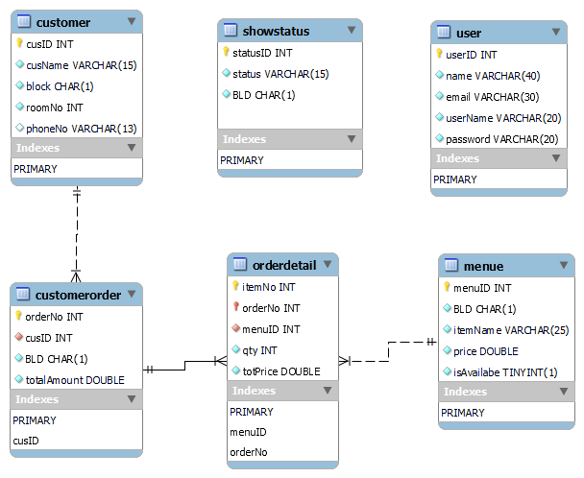

ER DIAGRAM

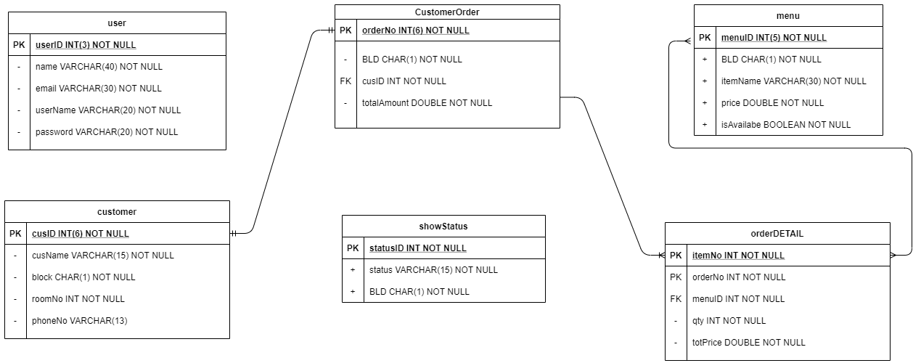

Registration

**Adding** New user to the system using sequalize method in node js

const express = require("express");

const router = express.Router();

const {user} = require('../models');

router.get("/", async (req, res) => {

    //res.send("hello world");

    const listOfUsers = await user.findAll();

    res.json(listOfUsers);

});

router.post("/", async (req, res) => {

    const users = req.body;

    await user.create(users);

    res.json(users);

});

router.delete("/", async (req, res) => {

    const userId = userId.req.body;

    await user.delete(userId);

    res.json(userId);

});

module.exports = router

User>

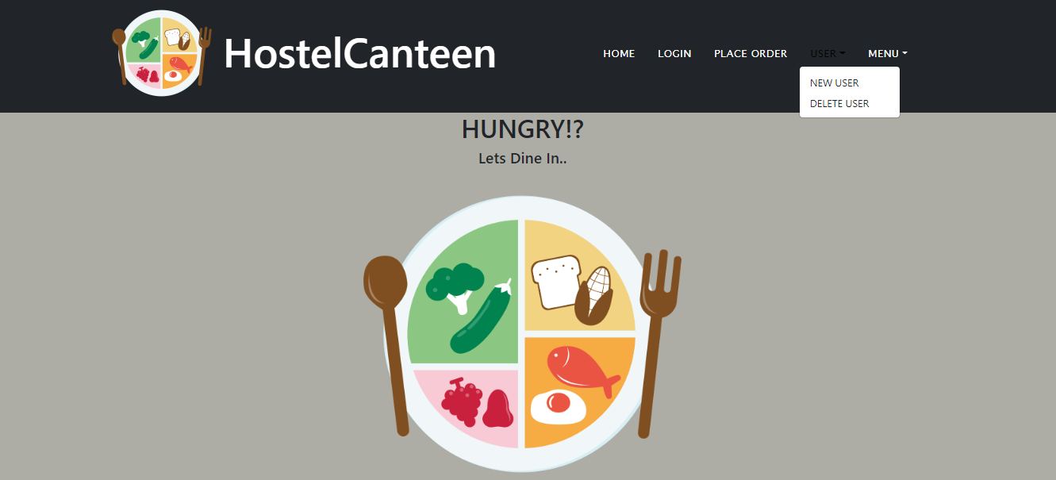

User>New User

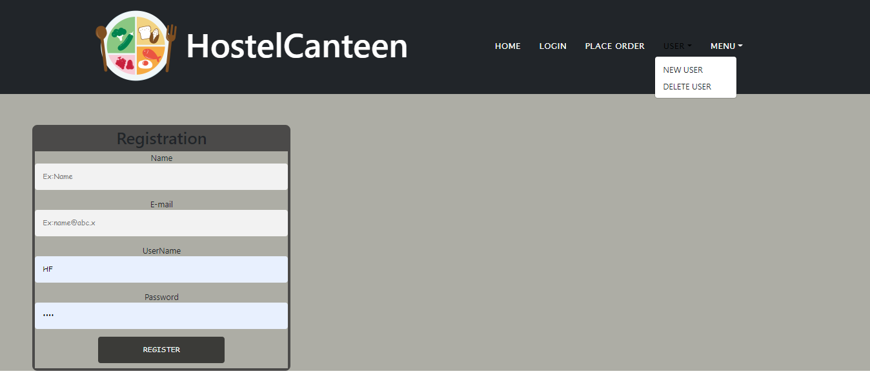

Fill the details about New User and click the button

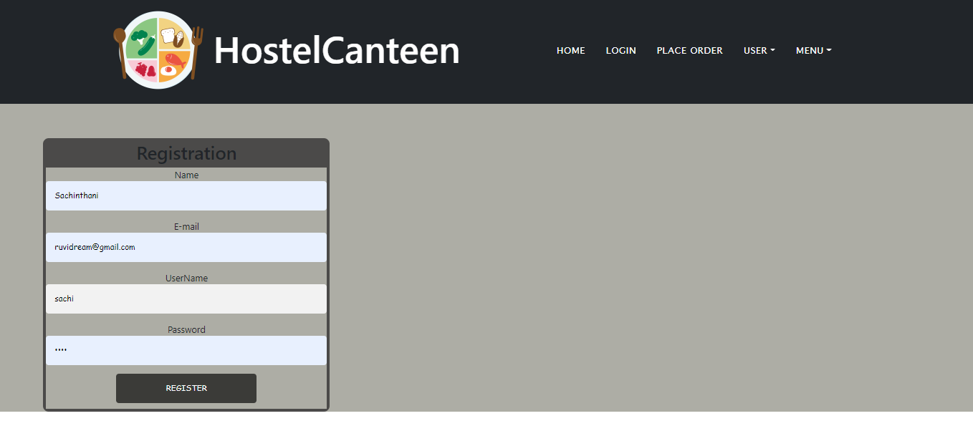

GitHub Repository link

<https://github.com/Ruvindya/hostelcanteenWbApplication.git>

GitHub Profile link

<https://github.com/Ruvindya>