Python and Mongodb

Assignment 04

COHDCBIS182F – 004

R.S. Abeysinghe.

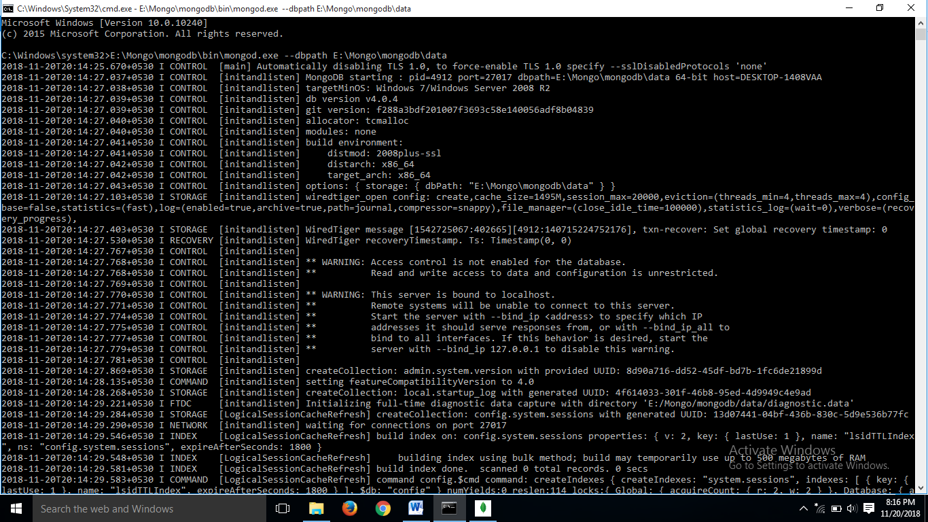**Setting the path**

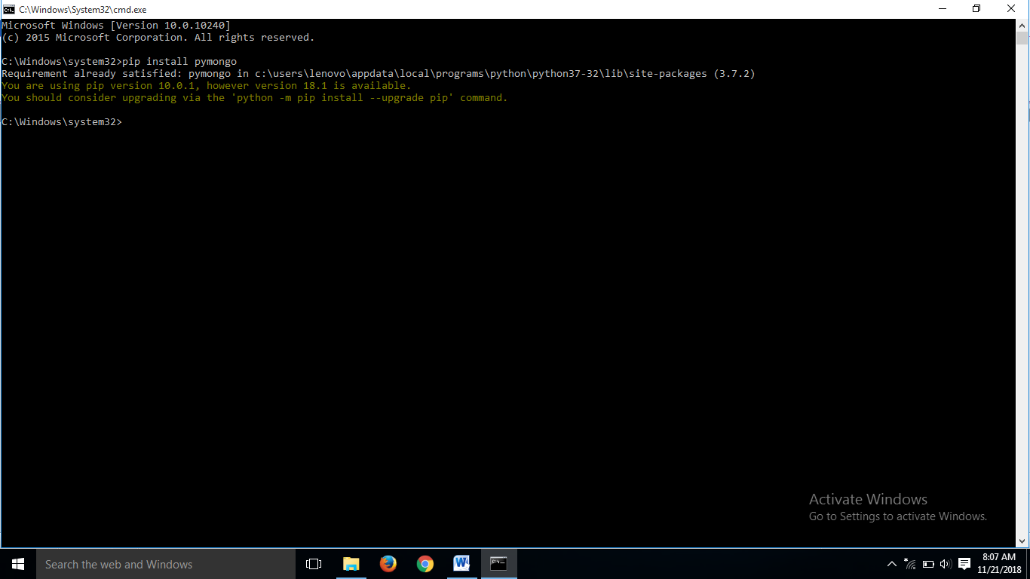**Installing pymongo(Already installed).**

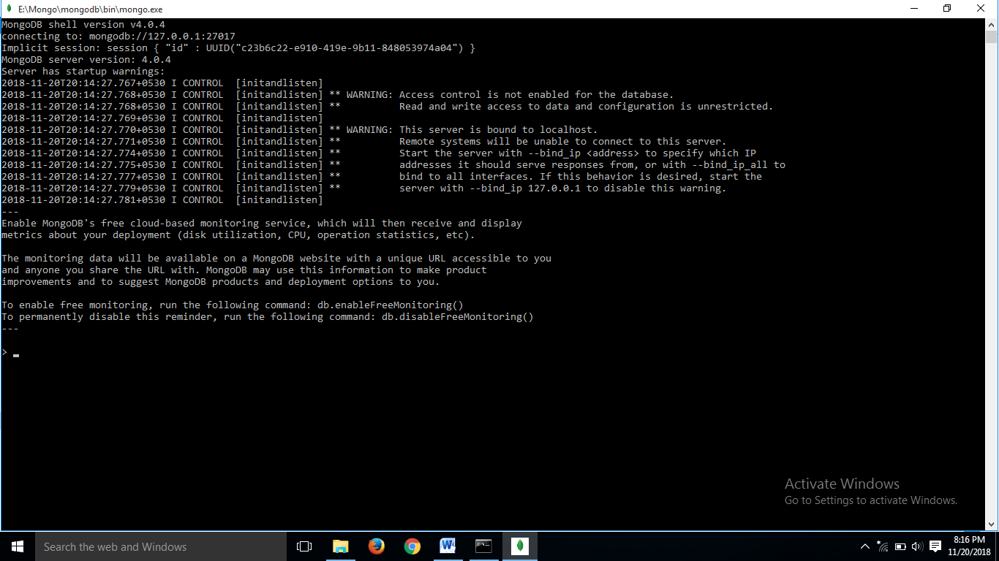**Running the mongo.exe file in the command prompt.**

**Creating the database, collection and insertion of data.**

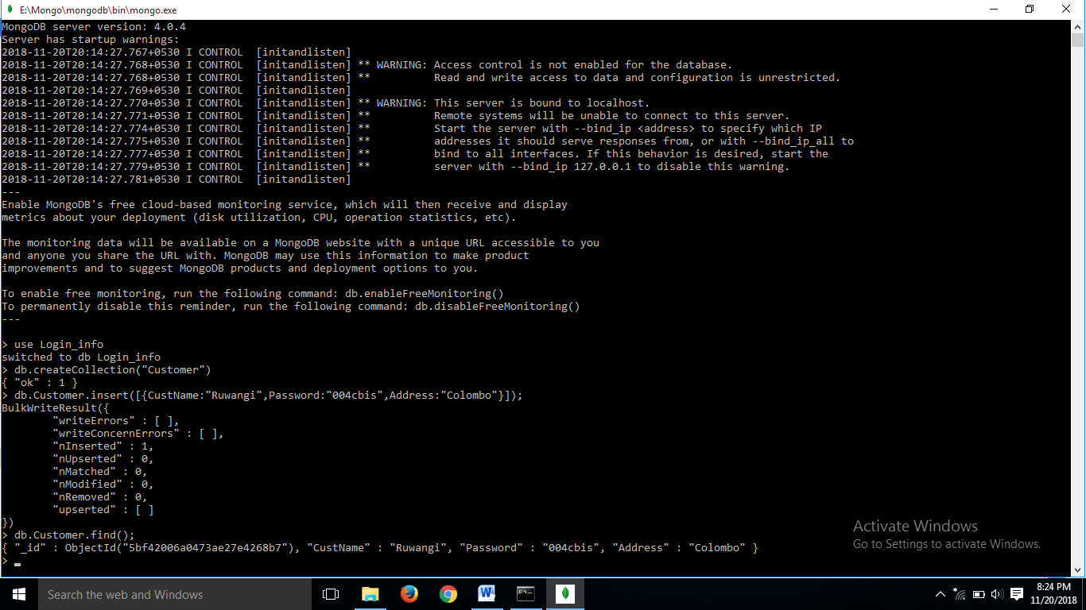

**Customer login form code.**

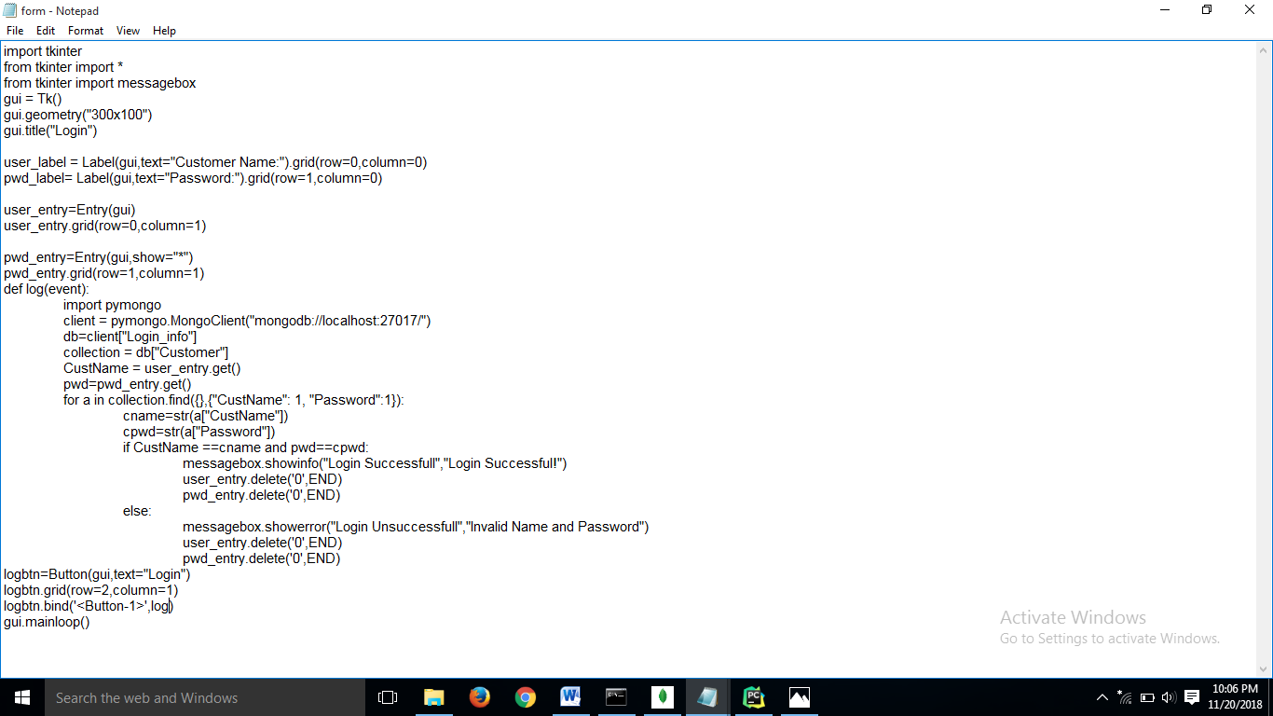

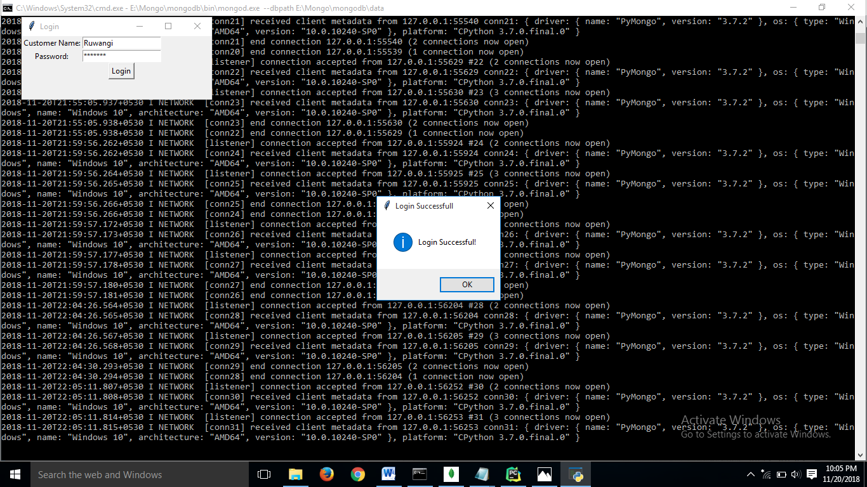**Executing and entering accurate data.**

**Executing and entering false data.**

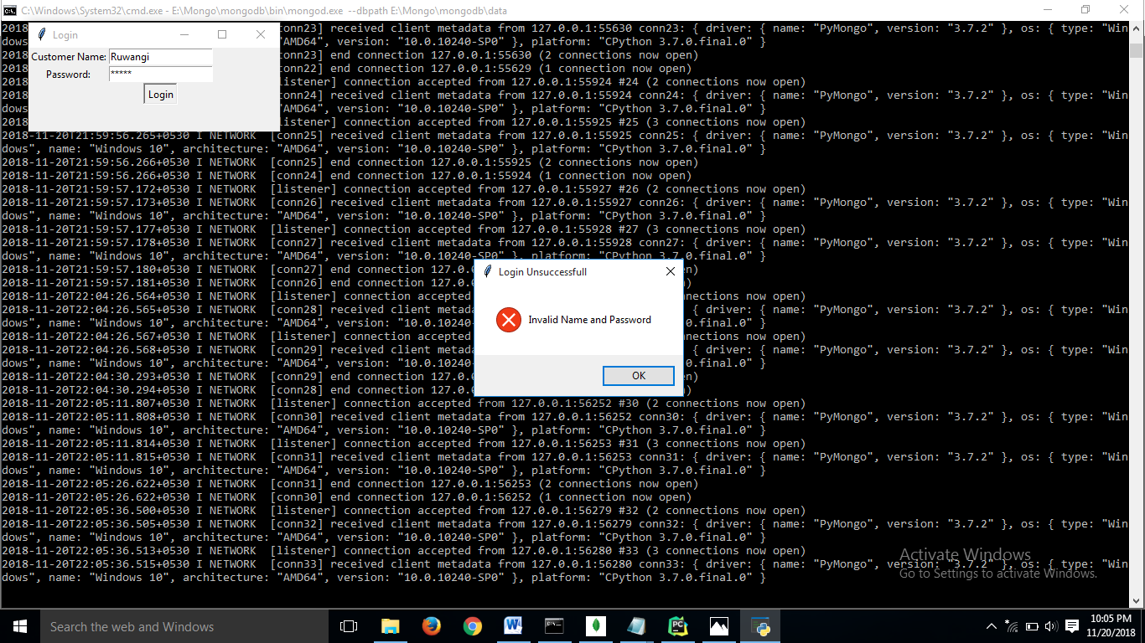

**All connections.**

