Technical Documentation (Frontend + Backend + Database)
Project: Spital platform
Scope: End-to-end architecture of the mobile client, Laravel API, and relational database model.

1. High-Level Architecture
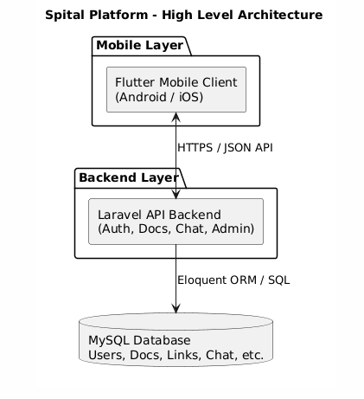

2. Repository Structure (Tree View)

2.1 Frontend tree (spital_app)
The Flutter frontend uses role-driven navigation and centralized localization. Authentication state is resolved in the startup gate, then users are redirected to role-specific dashboards (patient/companion/doctor/hospital admin/global admin).
Screen widgets orchestrate interaction and rendering, while service classes isolate API communication concerns. This separation keeps UI components lightweight and reduces coupling between layout and network logic.
Backend message literals are normalized to localization keys through a dedicated mapper before being rendered. This protects multilingual UX from raw server messages and keeps all user-facing errors translatable.
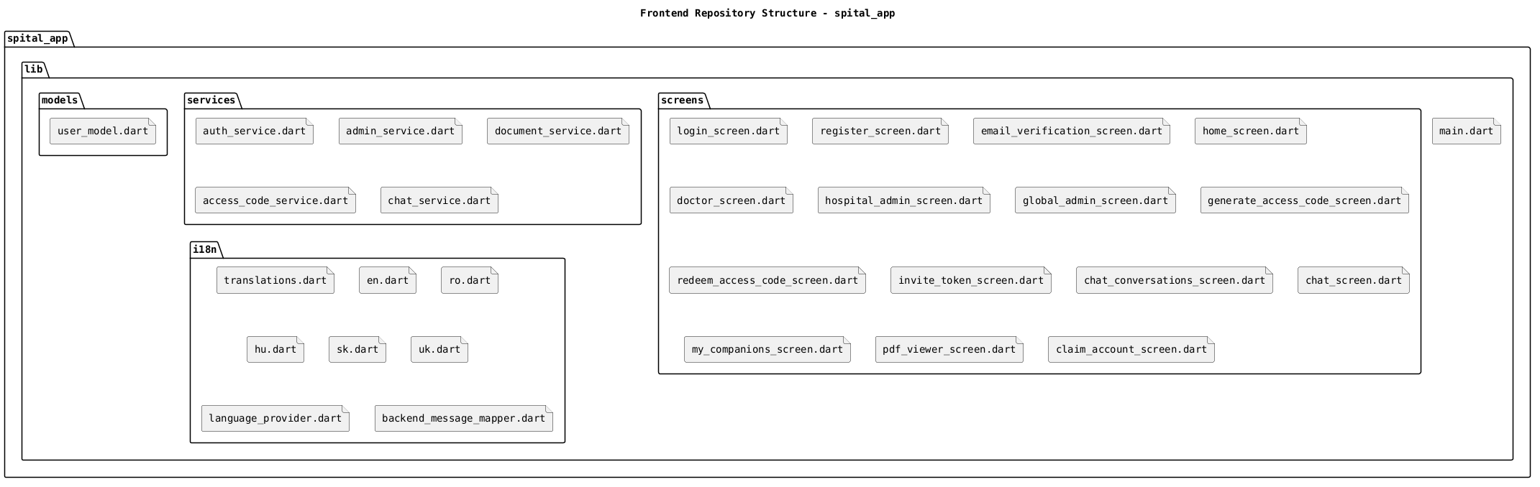

2.2 Backend tree (spital-backend)
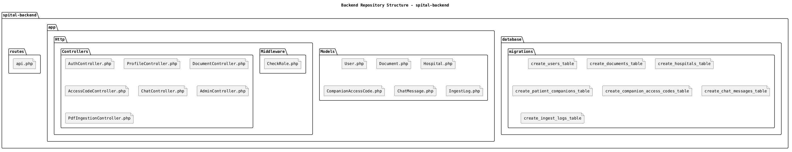

3. Frontend Technical Details

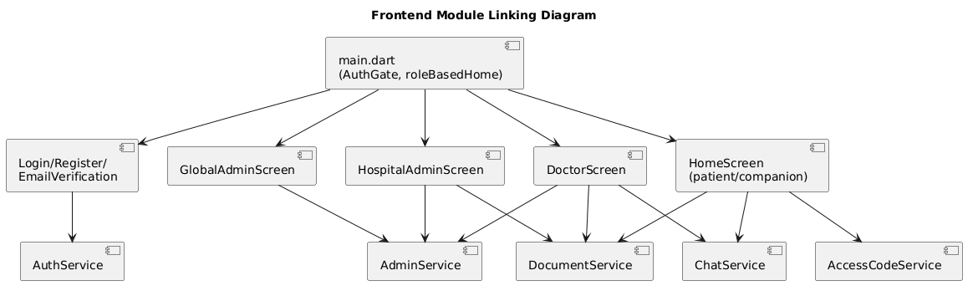
3.1 Frontend module linking diagram

3.2 FE responsibilities by layer
Layer | Files | Responsibility
Bootstrap | main.dart | App startup, locale wiring, role-based navigation
Presentation | lib/screens/* | UI, user interactions, flow orchestration
Service/API | lib/services/* | HTTP calls, auth headers, response normalization
Model | models/user_model.dart | User role and identity data shape
Localization | lib/i18n/* | Language maps, language persistence, backend message key mapping

3.3 Frontend deployment/distribution notes
- Current internal Android distribution supports APK builds.
- For manual install flow, create APK and upload it to Google Drive.
- Users download APK from Drive and install it on Android devices.
FE operational note requested: upload APK to Drive so users can install the app from the shared link.

4. Backend Technical Details

4.1 API route map (functional groups)
Group | Endpoints | Controller | Access
Auth | register, login, verify-email, resend-verification, logout, me | AuthController | Public + Authenticated
Profile | profile update | ProfileController | Authenticated
Documents | documents list/upload/delete | DocumentController | Authenticated, role-filtered in controller
Access Codes | generate/redeem code, invite/redeem invite | AccessCodeController | Authenticated, role-aware
Companion links self-service | my-companions, my-patients | AccessCodeController | Authenticated
Chat | conversations, messages, send | ChatController | Authenticated, conversation access checks
Admin users/hospitals | users CRUD, hospitals CRUD, companions link/unlink | AdminController | role middleware: global_admin / hospital_admin / doctor

4.2 Backend module linking diagram

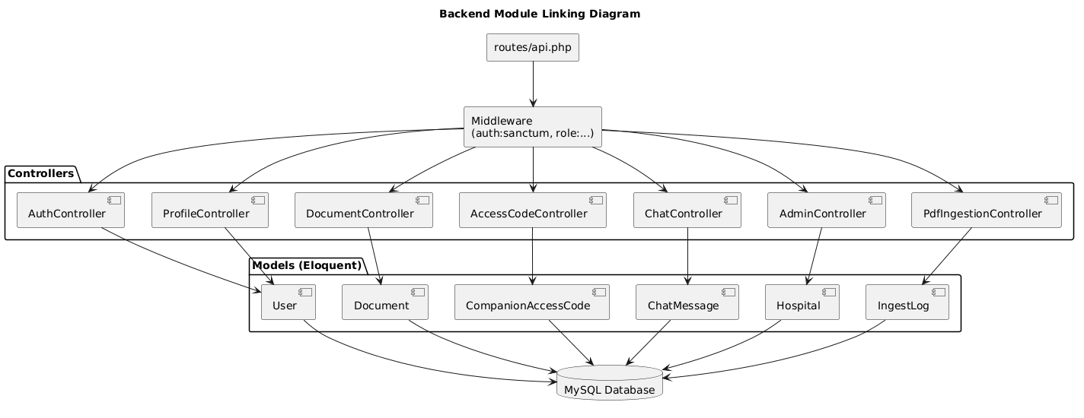
The Laravel backend is organized by route groups and middleware boundaries. auth:sanctum enforces authenticated access while role middleware validates authorization scope for protected modules.
Controllers implement domain-specific business rules: AuthController (account lifecycle), DocumentController (medical files), AccessCodeController (patient-companion linking), ChatController (conversation state), AdminController (admin operations), and PdfIngestionController (ingestion pipeline).
Unread logic uses per-user, per-conversation checkpoints in conversation_last_seen, allowing precise unread_count computation without expensive message-diff logic on the client.

4.3 Authorization chain
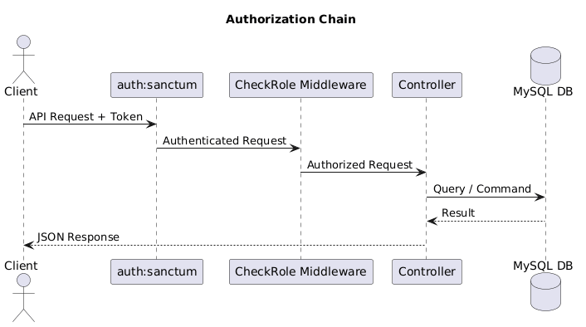

5. Database Technical Details

5.1 Entity relationship diagram (logical)
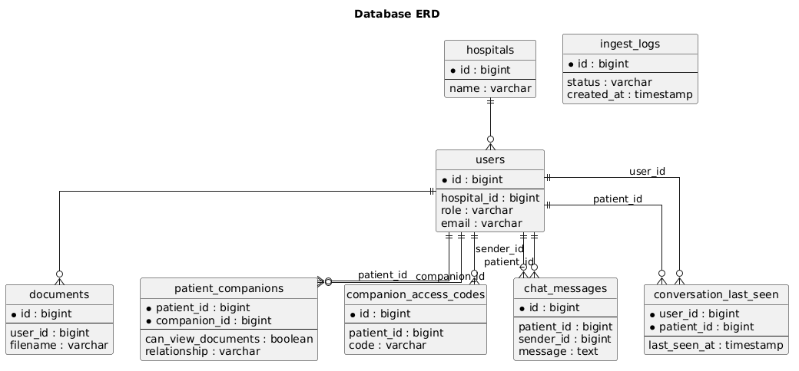
The schema is centered on users and role-aware relations. documents attaches file ownership to users, patient_companions models many-to-many access links, and companion_access_codes stores temporary credentials for secure pairing.
chat_messages stores conversation events by patient context, and conversation_last_seen stores visibility cursors needed for unread counters. ingest_logs provides observability for ingestion outcomes and operational troubleshooting.

5.2 Table purpose matrix
Table | Primary Purpose | Main Links
users | All system identities and roles | hospital_id, documents.user_id, chat_messages.sender_id, patient_companions
hospitals | Hospital master records | users.hospital_id
documents | Medical file metadata and ownership | user_id -> users.id
patient_companions | Patient-to-companion many-to-many links | patient_id -> users.id, companion_id -> users.id
companion_access_codes | Temporary code/token access grants | patient_id -> users.id
chat_messages | Conversation messages per patient context | patient_id -> users.id, sender_id -> users.id
conversation_last_seen | Unread tracking cursor per user/conversation | user_id + patient_id
ingest_logs | Ingestion operational telemetry | Document ingest lifecycle events

6. Cross-Layer Traceability (FE -> BE -> DB)
Feature | Frontend | Backend Endpoint/Controller | Database Tables
Login | login_screen + auth_service | POST /login, AuthController@login | users, personal_access_tokens
Email verification | email_verification_screen + auth_service | POST /auth/verify-email, AuthController@verifyEmail | users
Document upload/list/delete | home_screen, doctor_screen + document_service | /documents, DocumentController | documents, users
Companion linking | generate/redeem/invite screens + access_code_service | /access-codes/*, AccessCodeController | companion_access_codes, patient_companions, users
Chat unread and messaging | home/chat screens + chat_service | /chat/conversations, /chat/messages, ChatController | chat_messages, conversation_last_seen, users
Admin user/hospital management | global_admin_screen, hospital_admin_screen + admin_service | /users, /hospitals, AdminController | users, hospitals, patient_companions

7. Operational Build/Run Commands

7.1 Frontend
ip addr #to replace the ip address in auth_service
flutter pub get
flutter run
flutter build apk --release –split-per-abi #upload the app-x86_64-release.apk file on drive to download on you device in order to test

7.2 Backend
php artisan key:generate
php artisan migrate
php artisan serve --host=0.0.0.0 --port=8000

